Project | Human Factor for Immersive Content Working Group  <http://sites.ieee.org/sagroups-3079/ >
Title | Reference Model of the Hardware System for Immersive Fitness Content
DCN | 3079-21-0003-00-0002
Date Submitted | February 01, 2021
Source(s) | Jeong, Sangkwon Peter ceo@joyfun.kr (JoyFun Inc.)  Lee, GookHwan ghlee@joyfun.kr (JoyFun Inc.)  Choi, Soojin soojin_choi@joyfun.kr (JoyFun Inc.)  Seo, Dong Il Dillon mailto::dillon.seo@dtcp.capital (DTCP)
Re:
Abstract | This document synchronizes beam project and depth camera with gesture recognition. Through the data interlocking between them. This standard suggests conference model of hardware system for providing fitness content instructing and controlling user’s movement.
Purpose | The purpose of this document is to define the conference model of hardware system for providing immersive fitness content.
Notice | This document is offered as a basis for discussion and is not binding on the contributing individual(s) or organization(s). The material in this document is subject to change in form and content after further study. The contributor(s) reserve(s) the right to add, amend or withdraw material contained herein.
Release | The contributor grants a free, irrevocable license to the IEEE to incorporate material contained in this contribution, and any modifications thereof, in the creation of an IEEE Standards publication; to copyright in the IEEE’s name any IEEE Standards publication even though it may include portions of this contribution; and at the IEEE’s sole discretion to permit others to reproduce in whole or in part the resulting IEEE Standards publication. The contributor also acknowledges and accepts that IEEE 3079 may make this contribution public.
Patent Policy | The contributor is familiar with IEEE patent policy, as stated in Section 6 of the IEEE-SA Standards Board bylaws <http://standards.ieee.org/guides/bylaws/sect6-7.html#6> and in Understanding Patent Issues During IEEE Standards Development http://standards.ieee.org/board/pat/faq.pdf

Reference Model of Hardware System for Immersive Fitness Content

1. A general outline

To provide a realistic interactive fitness content, it is required to identify the minimum composition of hardware device, and present an appropriate standard reference model by identifying the roles and performance system for each composition. In order to induce an interaction between the shape of each joint extracted from the user's motion and the real-time motion guide, the depth camera for motion recognition, display for the action guide, and projection for posture corrections should follow the reference model which is synchronized with the system part.

2. Context of the standard

This standard presents a hardware system reference model for realistic interactive fitness content production. It is composed of the system and projector, which distributes data and drives programmed fitness content, Display, and motion recognition part. and it clearly defines the role of each module and present the hardware reference model. and then describes the interface for each function in each module.

3. The outline of realistic Interactive Fitness Content

Based on realistic interactive content, the fitness system is a system that allows users to train their physical strength anytime, anywhere, regardless of location and time by using realistic interactive content. The hardware system reference model for implementing a fitness system based on realistic interactive content uses a projector which projects exercise guides on the floor, and the motion recognition sensor detects motion and displays it to the Display, allowing users to maximize their workout effects.
Organizing an augmented virtual fitness space using such realistic interactive content requires projecting the realistic interactive fitness content to the floor through a projector. and this whole process should be synchronized to interact organically.
This composition can be expressed as shown in Figure 3-1.

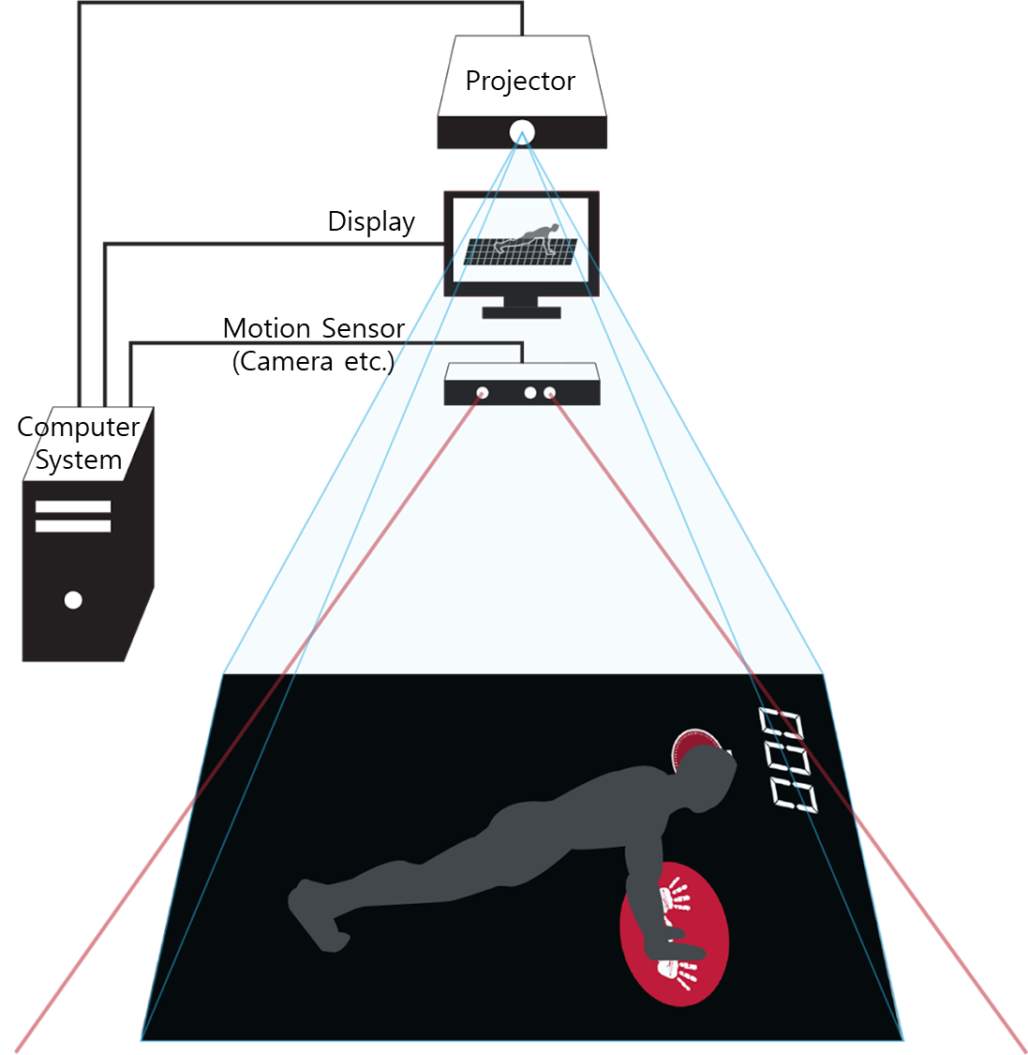
(Figure 3-1) Examples of hardware system configuration arrangements for realistic interactive fitness content

4. Hardware system reference model

The hardware reference model for realistic interactive fitness content consists of Computer System Part, Projector Part, Display Part, and Motion Recognition Part for effective fitness content.
This reference model standard defines the interface between each module and a hardware system based on realistic interactive content which maximizes the effectiveness of the exercise by providing a content with realized experiences and emotions.

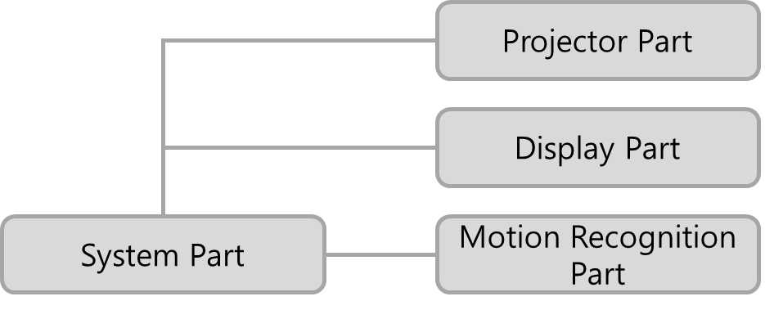
(Feature 4-1) Hardware Reference Model for Realistic Interactive Fitness Content
4.1. Hardware system composition module

A hardware system for exercise systems based on realistic interactive fitness content consists of modules in (Figure 4-2).
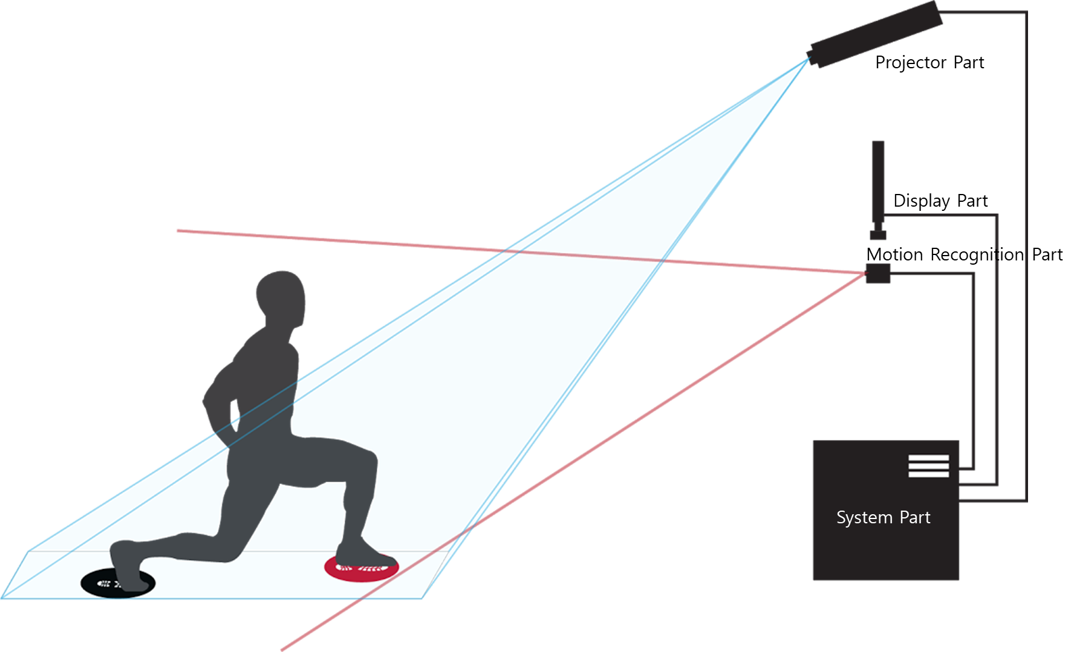
(Figure 4-2) Examples of hardware for realistic interactive fitness content
4.1.1. System

The System is a module that has the role of delivering data for organic connection between projector part, display part, and motion recognition sensor

4.1.2. Projector

The projector is a module that guides the user's movements or transmits interaction interface images for the user to learn, which can control the user's movement.

4.1.3. Display

The display is an information output module which plays a role for guiding the user's movement or presents various information related to the progress of exercise. What is different from the projector unit is that it does not provide an interactive interface that directly controls the user's motion.

4.1.4. Motion recognition part

The Motion Recognition part is a device module that has the role of detecting and tracking user motions, such as a depth camera, which detects how accurately the user expresses fitness motion according to the interaction interface image presented by the projector part.

4.2. Features of the hardware reference model

Each module that constitutes a hardware system for providing realistic interactive fitness content has its own role and performance system. In this regard, the role and performance schemes for each configuration module are as follows:
(Figure 4-3) Role and process of performing hardware modules

4.2.1. System

The System Part receives data from the Projector, Display, and Motion Recognition Sensor and presents the initial data based on the initial data entered by the manager, and compares the data entered by the Motion Recognition part and motions presented by the system to the Display.

4.2.2. Projector

The projector Part outputs image data transmitted by the system Part on the floor to augmented the projected images and enables fitness training in the space. it plays a role in presenting and controlling the user's motion through this role.

4.2.3. Display

The Displaying Part performs three roles by presenting image data transmitted by the system Part from the front.
First, it provides an interface for users to communicate, allowing users to run fitness programs smoothly. To this end, various UI including main menu are presented.
Second, it guides the user in real-time the motion that user needs to learn.
Third, it prints out the current motion of the user received from the motion recognition Part to help them recognize their motion status and to suggest how to correct their posture.

4.2.4. Motion recognition part

The motion recognition part detects and tracks the user's motion through a depth camera, and this recognized data is sent to the system Part so that the user can analyze the motion and transmit proper images to the Display and projector Part.
Of the various data transferred from motion recognition to system, all the information required to analyze the user's motion is performed according to what is defined in the software system's reference model.

4.3. Hardware module-to-module interface

The realistic interactive fitness content hardware system implements an augmented virtual space through the projector unit, display unit, motion recognition unit, and the system unit that analyzes and supports their synchronized motion, and allows users to enjoy fitness programs in augmented virtual space.
Realistic interactive fitness content outputs an augmented image in the user's exercise space which guides the user's movement through the projector Part, and when the user takes action according to the exercise program, the motion recognition Part detects the user's movement and delivers it to the system Part. The System Part provides a fitness environment where users can feel the same way as reality by synchronizing their movements with fitness programs.
The exercise program, augmented by the projector Part in the user's exercise space, is based on realistic interactive content that causes human senses and cognition to expand real-life experiences and sensibilities, and interacts with people, objects, and virtual objects. In other words, fitness programs store sequences of users' motions, and the system Part outputs sequences of stored motions through a projector. Sequences can be stored in various forms, such as table form, markup language in XML form, and data structure. The stored program is interpreted by the system unit and printed through the projector.
The motion recognition unit consists of at least one camera, a depth camera, an infrared sensor, or a combination of them, which detects user and user movement in front. Multiple above motion recognition sensors are installed around the user (front and rear left and right) to generate multi-view images to recognize the user's motion. These collected users, their movements, and spatial information are sent to the system part, providing users with a more lively, three-dimensional fitness interface optimized for them and enabling precise user motion recognition.
The Displaying Part displays exercise information, user information, exercise evaluation and results, calorie information, health information of individuals, check their exercise content, or a combination of them, allowing users to exercise more efficiently.

4.3.1. Motion Recognition and System Part

The operation recognition Part analyzes skeleton data, image data, etc. of the user input through the depth camera, collects the operation data, and delivers it to the system part. The System Part analyzes the data received from the Operational Recognition Part to verify that the user's motion conforms to the programmed data.

4.3.2. Projector and System Part

Projector Part is responsible for projecting images from the system part into a specific space. The system part also provides an interface for interacting with users, and provides a guide to the motions that users need to perform using the Projector Part.

4.3.3. Display and System part

The Displaying unit, like the projector unit, is responsible for outputting images transmitted from the system unit. In particular, the image data received from the depth camera of the motion recognition unit to the system unit is printed on the Display so that users can display the motion, and the corrective action is presented against the programmed motion.

4.3.4. Projector and Display part

The projector unit and the display unit are fully synchronized by the mutual system unit, which acts as a display that outputs image data of the system unit, and allows users to perform a smooth fitness process

