Project | Human Factor for Immersive Content Working Group  <http://sites.ieee.org/sagroups-3079/ >
Title | The Quantification Procedures for Quality of Interaction of Mixed Reality Content
DCN | 3079-20-0055-00-0002
Date Submitted | October 17, 2020
Source(s) | Jeong, Sangkwon Peter ceo@joyfun.kr (JoyFun Inc.,)  Lee, Beom-Ryeol lbr@etri.re.kr (ETRI)  Yoon, Kyoungro yoonk@konkuk.ac.kr (Konkuk Univ.)  Bae, Hyo Chul th1q@nate.com (Konkuk Univ.)
Re:
Abstract | The standard includes identifying factors affecting the quality of interaction to quantify user interaction satisfaction driving mixeded reality content, generating objective indicators reflecting characteristic information for each element, and quantifying the results of quality of interaction analysis using indicators.
Purpose | This standard is to provide quantification methods and procedures through objective indicators for the quality of interaction of users who drive and experience mixed reality content.
Notice | This document is offered as a basis for discussion and is not binding on the contributing individual(s) or organization(s). The material in this document is subject to change in form and content after further study. The contributor(s) reserve(s) the right to add, amend or withdraw material contained herein.
Release | The contributor grants a free, irrevocable license to the IEEE to incorporate material contained in this contribution, and any modifications thereof, in the creation of an IEEE Standards publication; to copyright in the IEEE’s name any IEEE Standards publication even though it may include portions of this contribution; and at the IEEE’s sole discretion to permit others to reproduce in whole or in part the resulting IEEE Standards publication. The contributor also acknowledges and accepts that IEEE 3079 may make this contribution public.
Patent Policy | The contributor is familiar with IEEE patent policy, as stated in Section 6 of the IEEE-SA Standards Board bylaws <http://standards.ieee.org/guides/bylaws/sect6-7.html#6> and in Understanding Patent Issues During IEEE Standards Development http://standards.ieee.org/board/pat/faq.pdf

The Quantification Procedures for Quality of Interaction of Mixed Reality Content

1 Coverage

This standard is for quantifying the satisfaction with the reflection of the user's interaction result in the process of manipulating and experiencing the object presented on the mixed reality content screen through the user interface of the mixed reality content in the mixed reality content experience environment. .

2 Quotation standards

None

3 Definition of terms

3.1 Quality of Interaction; QoI

It is a quantified result value indicating the degree of agreement with the user's motion intention when a user experiencing mixed reality content proceeds to manipulate objects constituting the user interface and the mixed reality space to drive the content.

4 Abbreviation

QoI | Quality of Interaction

5 Interaction satisfaction quantification procedure of mixed reality content

5.1 outline
This standard contains content to provide an objectified evaluation scale so that mixed reality content developers can predict and control the interaction satisfaction (QoI) of mixed reality content users.
In order to predict interaction satisfaction that can occur while users experience mixed reality content, the correlation between interaction satisfaction and driving characteristic variables of mixed reality content must be identified. By constructing an interaction satisfaction prediction model using this, it is possible to predict the interaction satisfaction experienced by the user when driving mixed reality content.
Based on the measured value of the predicted interaction satisfaction for mixed reality content, an objective quantification measure that can adjust the user's interaction satisfaction to a desired level is presented.

5.2 Composition of the standard
This standard consists of the ability to extract characteristic parameters of the interaction satisfaction of mixed reality content that can affect the interaction satisfaction of users experiencing mixed reality content, the ability to analyze and model the interaction satisfaction, the ability to quantify the interaction satisfaction, the ability to rate the user satisfaction, and the application service function of the user satisfaction.

5.3 Content of the standard

5.3.1 Interaction satisfaction quantification procedure
In order to utilize the correlation between characteristic parameters of mixed reality content to quantify interaction satisfaction, (Figure 5-1) describes a procedure for predicting the interaction satisfaction of users experiencing mixed reality content.

(Figure 5-1) Quantification procedure of interaction satisfaction with mixed reality content

5.3.2 Key functions for quantifying interaction satisfaction

5.3.2.1 Interaction satisfaction characteristic parameter extraction function
Characteristic parameters that affect interaction desirability include, as shown in Figure 5-2, mixed-reality content driven environment information that can affect the genre-specific classification of mixed-reality content and user interaction desirability, spatial composition object information of mixed-reality content, characteristic information by user interaction unit, and personalized user information.

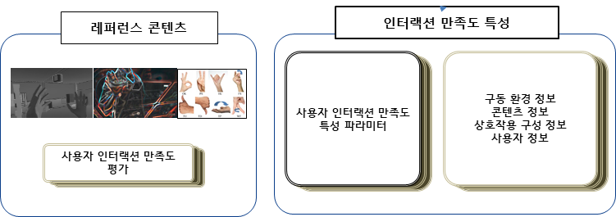
(Figure 5-2) Feature parameter extraction function of interaction satisfaction

5.3.2.2 Interaction satisfaction analysis and modeling function
(Figure 5-3) shows the correlation for the function of extracting, analyzing, and modeling characteristic parameters for evaluating interaction satisfaction. In order to extract the characteristics related to the quantification of the interaction satisfaction, the image characteristic elements of the mixed reality content are extracted, and the user's gaze information and the emotional information related to the interaction intention of the user bar are extracted. The extracted characteristic elements are analyzed and a modeling process is performed to reflect each characteristic.

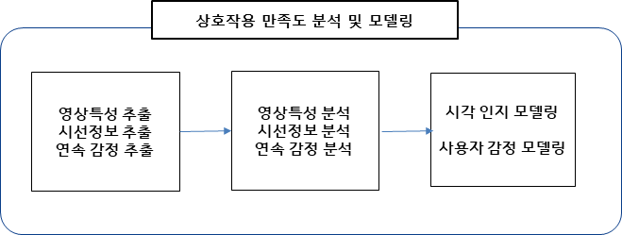
(Figure 5-3) Interaction satisfaction analysis and modeling function

5.3.2.3 Interactive satisfaction quantification mapping function
In order to quantify the interaction satisfaction of users experiencing mixed reality content, the process of generating the interaction satisfaction reference value through interaction satisfaction mapping is shown in (Figure 5-4). In order to perform a quantification algorithm for interaction satisfaction, a characteristic model reflecting the interaction satisfaction is used.
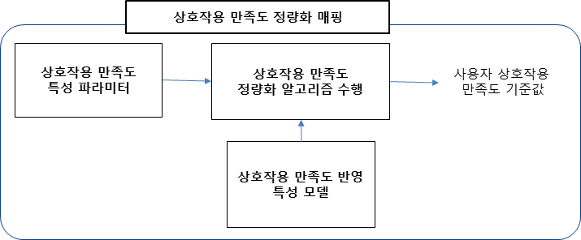
(Figure 5-4) Quantification mapping function of interaction satisfaction

5.3.2.4 Interaction satisfaction rating function
(Figure 5-5) shows the process of grading and calculating interaction satisfaction. As a reference value for the user's interaction satisfaction, the level of user interaction satisfaction is calculated through an interaction satisfaction rating process. In order to perform the grading algorithm, a quantification model for interaction satisfaction is used. The classification of the level of the interaction satisfaction used here can be used by classifying it with an appropriate level of likert scale for user convenience.

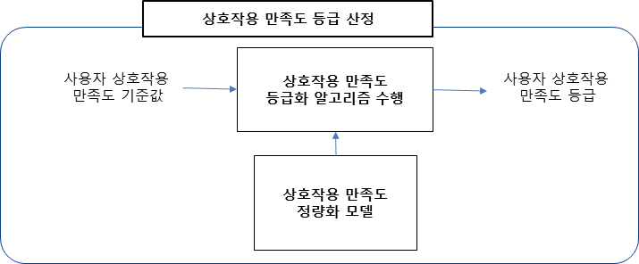
(Figure 5-5) Interaction satisfaction rating function

5.3.3 Application service for interaction satisfaction quantification function
(Figure 5-6) shows an example of the environment for use in the production and operation of mixed reality content services by utilizing the results of quantification of interaction satisfaction.
The basic unit of interaction applied to the quantification of the interaction satisfaction experienced by the user driving the mixed reality content is the interaction between users participating in the mixed reality space, and the interaction with the actual object expressed in the mixed reality space by scanning the actual space. It can be defined as interactions, interactions with virtual objects for constructing virtual spaces in mixed reality content spaces, and interactions with virtual objects for virtual space augmentation in mixed reality content spaces.
-Basic unit of interaction for quantifying user interaction satisfaction
. Interaction with users who access mixed reality content
. Interaction with real objects in mixed reality space
. User interface for driving mixed reality contents
. Interaction with virtual objects for composition of mixed reality space
. Interaction with virtual objects for augmented mixed reality space
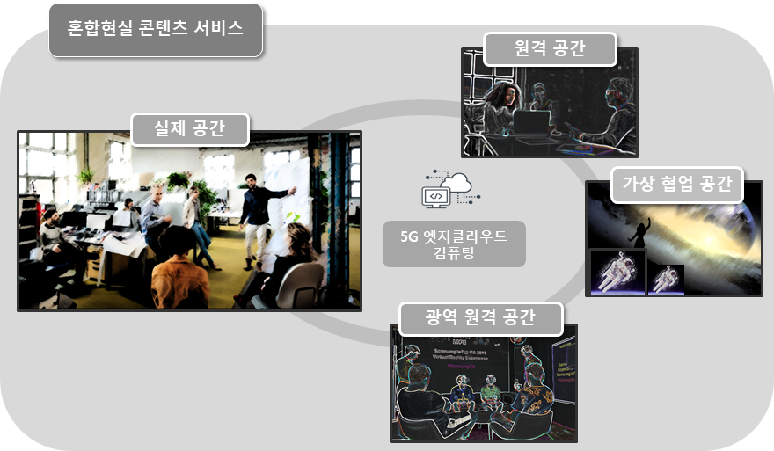
(Figure 5-6) Example of operating space and operating environment of mixed reality content service

Users who experience mixed reality content can evaluate interaction satisfaction through a single configuration or multiple configurations of the basic unit of interaction.
In order to evaluate the user's interaction satisfaction, the perceived response of the user to the delay in presentation time of 3D image information and 3D sound information constituting mixed reality content can be considered.
In order to evaluate the user's interaction satisfaction, consideration according to the configuration of the user interface driving mixed reality content and the user's perceived response to the response delay time for each user interface can be considered.
In order to evaluate the user's interaction satisfaction, it is necessary to establish and utilize a standard for a system environment that drives mixed reality content.
In order to evaluate the user's interaction satisfaction, reference content for mixed reality content for formal evaluation must be available.
In order to evaluate the user's interaction satisfaction, an objective index on how to quantify interaction satisfaction should be used, and subjective evaluation criteria for interaction satisfaction should be presented and referenced.

