Project | Human Factor for Immersive Content Working Group  <http://sites.ieee.org/sagroups-3079/ >
Title | I/O Interactive Guideline of Content & User
DCN | 3079-20-0052-00-0002
Date Submitted | October 12, 2020
Source(s) | Jeong, Sangkwon Peter ceo@joyfun.kr (JoyFun Inc.,)  Nam, HyeonWoo hwnam@dongduk.ac.kr (Dongduk Women’s University)  Dong Soo Choi soochoi@dau.ac.kr (Dong-A University)  Kim, Seoul seoul_kim@joyfun.kr (JoyFun Inc.,)
Re:
Abstract | This standard synchronizes the depth camera with motion recognition function and the beam projector, and effectively guides and interacts with the user's motion when content in a manner that directs and controls the user's movement through data linkage between them is serviced. I/O interface is defined so that it can be used.
Purpose | The purpose of this standard is to define the input/output interface interaction for developing and serving content using a motion recognition-based sensor using a depth camera and a projection display.
Notice | This document is offered as a basis for discussion and is not binding on the contributing individual(s) or organization(s). The material in this document is subject to change in form and content after further study. The contributor(s) reserve(s) the right to add, amend or withdraw material contained herein.
Release | The contributor grants a free, irrevocable license to the IEEE to incorporate material contained in this contribution, and any modifications thereof, in the creation of an IEEE Standards publication; to copyright in the IEEE’s name any IEEE Standards publication even though it may include portions of this contribution; and at the IEEE’s sole discretion to permit others to reproduce in whole or in part the resulting IEEE Standards publication. The contributor also acknowledges and accepts that IEEE 3079 may make this contribution public.
Patent Policy | The contributor is familiar with IEEE patent policy, as stated in Section 6 of the IEEE-SA Standards Board bylaws <http://standards.ieee.org/guides/bylaws/sect6-7.html#6> and in Understanding Patent Issues During IEEE Standards Development http://standards.ieee.org/board/pat/faq.pdf

I/O Interactive Guideline of Content & User

- Coverage

In this standard, a user's motion is recognized using a depth camera, and several interaction interface guidelines for interaction are defined in developing content using a project based on the recognized information. For smooth content service progress, a user must accurately interact with a projected virtual object or menu, and in this regard, guidelines for optimizing the placement of virtual objects, checking commands for user input, and optimizing user display expressions are included.

- Quotation standards

None

- Definition of terms

None

- Abbreviation

None

5. I/O interface interaction between content and users

5.1. Optimization of the layout of the interaction UI

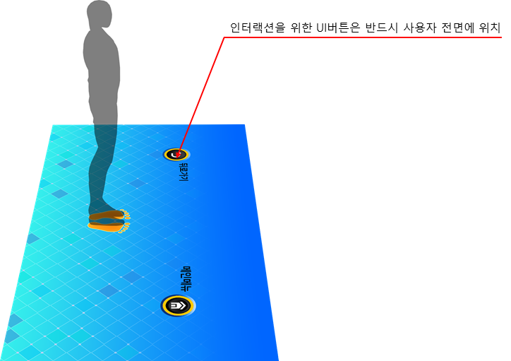
The user uses the content by reacting to the projected image, and the interaction in this process greatly affects the user's usability.
In a situation where a user attempts to input information into a specific virtual object of a projected image with the intention of interaction, if a phenomenon in which the desired virtual object is not visible due to the user's shadow occurs, the user faces a very perplexing situation.
Therefore, so that the user's shadow does not interfere with the control for the interaction, it is necessary to review the user scenario of the content and optimize the display expression by arranging the interaction UI suitable for the user interface.
That is, the virtual object must be positioned in front of the user to secure a view so that visual recognition is possible, and must be arranged so that it is not obscured by a shadow generated by projection.

5.2. Confirmation of commands for user input

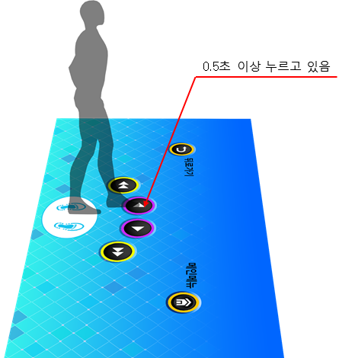

The user generates continuous interaction within the range of the already programmed area. Therefore, it is very likely that the user behavior pattern in a very wide area differs from the intention of the person who planned the content.
In this case, if the content immediately reacts according to the user's unintended actions, this may fit the planning intention, but since a command that does not match the user's intention is input, it can be said that a serious error has been created.
Therefore, the content needs to confirm and reflect the exact intention of the user.
For this process, when an action is requested to the user to input a certain command, the action needs to be clearly communicated by allowing the action to be continued for a while.
In other words, when the user wants to input a corresponding command as an action, a sufficient time (0.5 seconds or more) can be secured for the action to meet the intention. In addition, securing too much time should be avoided in consideration of user convenience.

5.3. 사용자 디스플레이 표현 최적화

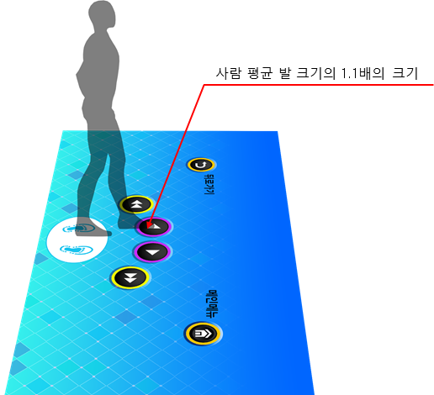

In order to provide an interface for user interaction, a UI through projection mapping should be provided. The UI image provided at this time refers to the recognizable range of the sensor for reacting to the actual user's behavior as well as the role of inducing the user's behavior.
Therefore, this part should have an appropriate error margin.
In order to prevent a user's input error, the UI image drawn on the floor reacts with a part of the user's body, so it must be 1.1 times the size of the body area.
At this time, the size of the interaction UI area is based on the average body size in Korea in 30s announced by the Ministry of Health and Welfare every year.

6. Application of interactive interface

- The size of the interface can be changed at will, but the contents specified in 5-1 must be observed.

- For those not specified in this standard or insufficient in this standard, it is recommended to follow the combination of basic motion recognition or organize the guidelines according to the motion recognition method.

Appendix Ⅰ-1
(This annex is intended to supplement the standard and is not part of the standard)
Intellectual Property Rights Agreement Information

Ⅰ-1.1 Intellectual Property Rights Agreement

-Title of invention: 3D character-based user motion verification system
-Name of right holder: Joyfun Co., Ltd.
-Application number: 10-2019-0094261
-Date of application: Aug. 02, 2019
-Execution conditions: Fair, reasonable, non-discriminatory grant (FRAND)
-Confirmation receipt date: Aug. 05, 2019

※ In addition to the above-described intellectual property rights agreement, there may be agreements received after the publication of this standard, so please check the TTA website.

Appendix Ⅰ-2
(This annex is intended to supplement the standard and is not part of the standard)
Matters related to test certification

Ⅰ-2. Whether it is subject to examination

- None.

Ⅰ-2.2 Status of establishment of test standards

- None.
Appendix Ⅰ-3
(This annex is intended to supplement the standard and is not part of the standard)
Family standard of this standard

Ⅰ-3.1 Quotation standards

- None

Appendix Ⅰ-4
(This annex is intended to supplement the standard and is not part of the standard)
References

- None

※ In addition to the above-described intellectual property rights agreement, there may be agreements received after the publication of this standard, so please check the TTA website.

Appendix Ⅰ-5
(This annex is intended to supplement the standard and is not part of the standard)
English standard commentary

- None.

Appendix Ⅰ-6
(This annex is intended to supplement the standard and is not part of the standard)
Standard history

Edition | Date of adoption | Standard number | Contents | Committee in charge
First edition | December 16, 2015 | TTAK.KO-10.0869 | - | Digital Contents Project Group  (PG610)
Second edition | December 09, 2020 |  | - | Digital Contents Project Group  (PG610)

Standard item | Before change | after change | Reason for change
5.1 | - Optimizing the placement of virtual objects | - Optimization of the layout of the interaction UI | - A more intuitive title
5.2 | - Make sure that you have enough time (more than 1 second) to make the operation meet your intentions. | - Sufficient time (0.5 seconds or more) | - With the development of user gesture recognition technology, the time required to check for an error in which an'input of a command that does not match the user's intention' occurs becomes sufficient to 0.5 seconds. A user can get bored even for a second, and even 0.5 seconds is enough to grasp the intention of the user.
 | - '(Figure 5-2) Conceptual Diagram of Guidelines for Confirming Intention by User Behavior','Must hold for 3 seconds' | - 'Must hold down for 0.5 seconds'
5.3 | - In order for a virtual image to be augmented by projection and to allow interaction through the augmented image, a region that is reacted by the user's action must be designated. The shaped image at this time also serves to induce the user's behavior, but it means the recognizable range of the sensor to react to the actual user's behavior.  - Therefore, if this part does not have an appropriate error margin, it may attenuate the user's motion and act as a factor that hinders the sense of immersion.  - In order to prevent such an error, the size of the shape drawn on the floor that reacts with a part of the human body should be 1.5 times the size of the area desired to be input.  - The size of the area desired to be input at this time is based on the average body size in Korea in their 30s announced by the Ministry of Health and Welfare every year. | - In order to provide an interface for user interaction, a UI through projection mapping should be provided. The UI image provided at this time refers to the recognizable range of the sensor for reacting to the actual user's behavior along with the role of inducing the user's behavior.  - Therefore, this part should have an appropriate error margin.  - In order to prevent a user's input error, the UI image drawn on the floor reacts with a part of the user's body, so it must be 1.1 times the size of the body area.  - The size of the interaction UI at this time is based on the average body size in Korea's 30s announced by the Ministry of Health and Welfare every year. | - As technology advances, it is possible to provide a sophisticated UI that does not require an error margin of up to 1.5 times.  - In particular, as a UI image as large as 1.5 times the entire screen is disposed, it becomes impossible to provide a beautiful UI, and a situation arises where the area for providing various information is insufficient.

