Project | Human Factor for Immersive Content Working Group  <http://sites.ieee.org/sagroups-3079/ >
Title | Guideline for Interface Mapping of the Projector by Depth Camera
DCN | 3079-20-0051-00-0002
Date Submitted | October 12, 2020
Source(s) | Jeong, Sangkwon Peter ceo@joyfun.kr (JoyFun Inc.,)  Nam, HyeonWoo hwnam@dongduk.ac.kr (Dongduk Women’s University)  Dong Soo Choi soochoi@dau.ac.kr (Dong-A University)  Kim, Seoul seoul_kim@joyfun.kr (JoyFun Inc.,)
Re:
Abstract | This standard defines a projection mapping system that produces content so that the UI or reactive objects provided by the projector in implementing motion-reactive hybrid reality can be represented on the screen with the specified location and area size.
Purpose | The purpose of this standard is to perform projection mapping so that the size of the image to be provided to the user does not change and can be provided fixedly when adjusting the projection image of the projector required for realization of motion-responsive mixed reality with keystone.
Notice | This document is offered as a basis for discussion and is not binding on the contributing individual(s) or organization(s). The material in this document is subject to change in form and content after further study. The contributor(s) reserve(s) the right to add, amend or withdraw material contained herein.
Release | The contributor grants a free, irrevocable license to the IEEE to incorporate material contained in this contribution, and any modifications thereof, in the creation of an IEEE Standards publication; to copyright in the IEEE’s name any IEEE Standards publication even though it may include portions of this contribution; and at the IEEE’s sole discretion to permit others to reproduce in whole or in part the resulting IEEE Standards publication. The contributor also acknowledges and accepts that IEEE 3079 may make this contribution public.
Patent Policy | The contributor is familiar with IEEE patent policy, as stated in Section 6 of the IEEE-SA Standards Board bylaws <http://standards.ieee.org/guides/bylaws/sect6-7.html#6> and in Understanding Patent Issues During IEEE Standards Development http://standards.ieee.org/board/pat/faq.pdf

Guideline for Interface Mapping of the Projector by Depth Camera

- application

When this standard provides a motion-responsive mixed reality service, there are cases in which the overall image size of the projection image used for projection mapping is adjusted according to the user's environment. The projected image increases or decreases in size according to the projector's keystone. In this situation, the service provider does not want to adjust the image size and change the position value of the image coordinates accordingly for the consistency of the interface for delivery to the user. do. To this end, an interface corresponding to a certain size and position value is provided to a user by utilizing a depth camera used for measuring user motion.

- Quote Standard

None

- Definition of terms

3.1 Depth camera

A camera that acts as a sensor that uses functions such as using two or three lenses or reflected waves of infrared rays to grasp the movement and position of objects

- Abbreviations

None

- Projection Mapping

  - Projection Mapping Overview

Projection mapping refers to expressing a virtual image as if it actually exists through image projection using a projector in a specific space. In this standard, a virtual image expressed through projection mapping is used as an interface to interact with a user. This interface can deliver messages and can be used as an interface for interaction.

  - Necessity of Interface Mapping Guidelines Using Projectors

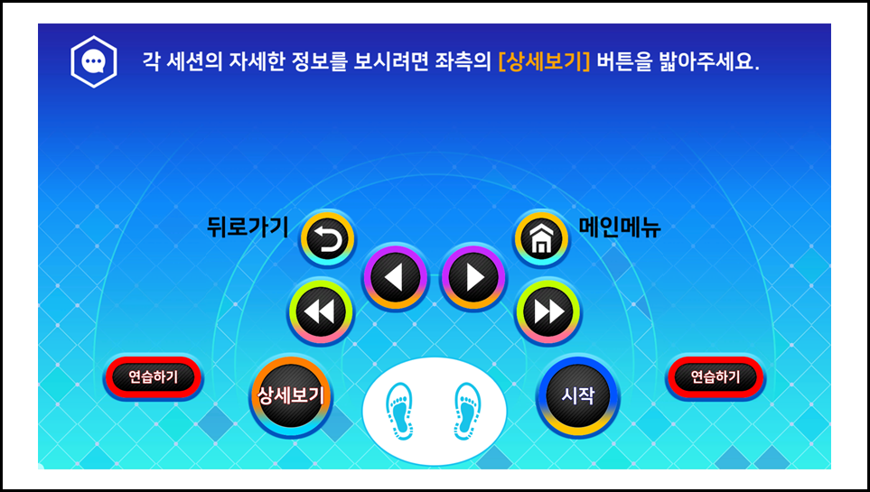

(Figure 5-1) is an image of the actual size that is expressed to interact with the user for projection mapping.
However, the projector can make the required image smaller or larger than the actual size through keystone adjustment. In this case, the area of the image can be enlarged as shown in (Figure 5-2).
In this case, all the coordinate values set to interact with the user are changed. In other words, even if you press the existing'start' position value for'start', no reaction occurs because the'start' position coordinate value in (Figure 5-1) and the'start' position coordinate value in (Figure 5-2) are different.
In order to prevent such a situation, there is a need for a method of assigning an absolute value so that coordinate values for each interaction image can be fixed even if the keystone of the projector is adjusted.
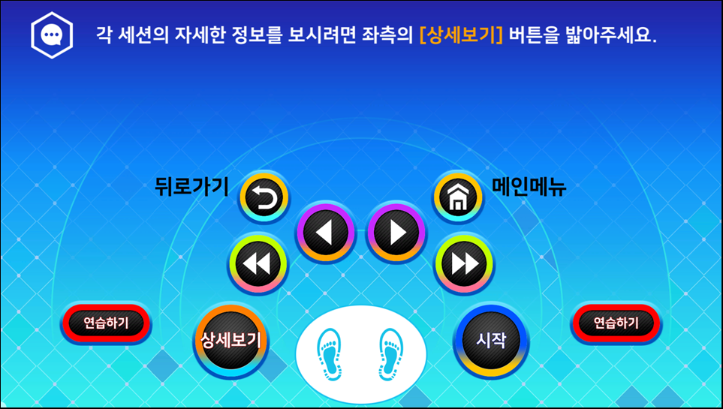
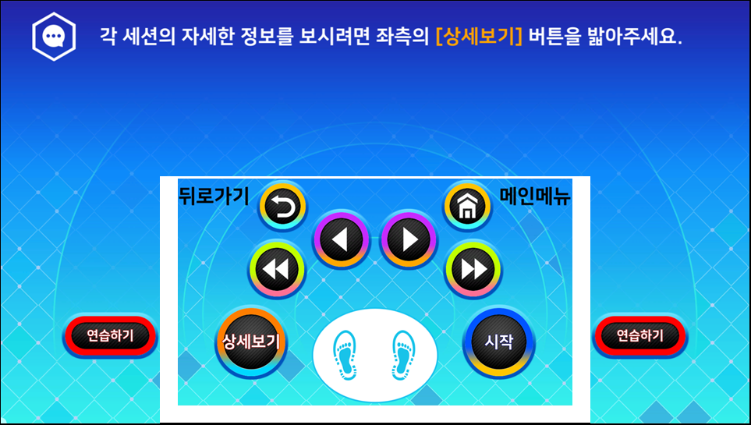

(Figure 5-3) is a fixed size of the interaction image so that, unlike (Figure 5-2), the keystone changes can maintain its coordinate value. Only when this is possible can the interaction interface be uniformly provided according to the user's height or various body sizes.

- How to set the working area

  - Default Settings
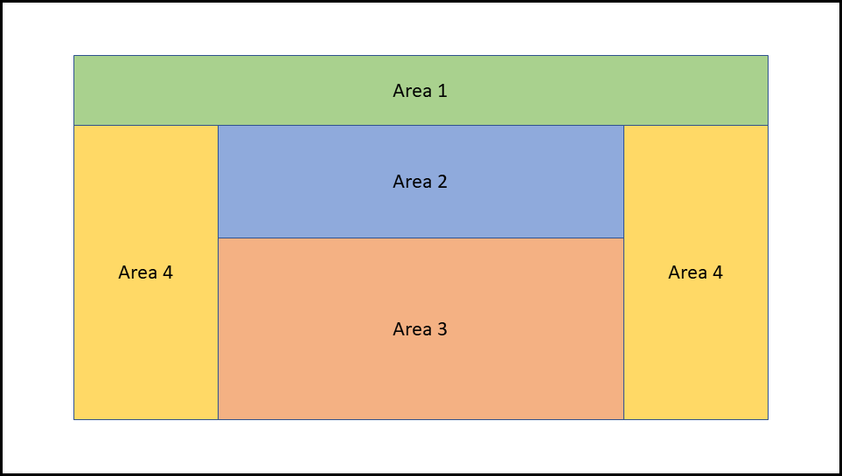
0 The purpose is to fix the size and position of area 3.
① Area 2 and area 3 have the same width.
② Measure the height of area 2 and area 1 and measure the ratio.
③ The height of area 4 is the remainder of the total height minus the height of area 1.
④ The width of area 4 is the remainder of area 2 or 3 minus the width.
⑤ Measure the resolution area ratio in the minimum keystone area of the projector.
⑥ Based on the measured value, the ratio of the resolution area in the different keystone areas of the projector can be measured and compared and set as shown in (Figure 6-1).

  - Expected result of application of technology

(Figure 6-2) is the screen when the keystone area of ​​the projector is applied to the maximum.
0 When expanding the entire image area by adjusting the projector's keystone, the coordinates of area 3 change.
① If the basic setting is made, the absolute position is applied to the area 3, so when the images of all images are enlarged, the area 3 remains in place, so the relative position is located at the top.
② As Area 3 is located at a fixed coordinate value, the lower part of Area 2 overlaps with the upper part of Area 3, but forcibly raise Area 2 so that it does not overlap with Area 3.
③ At this time, the ratio of Area 2 and Area 1 should be maintained as measured in ③ of 6.1.
④ When magnifying the image by adjusting the projector's keystone, the coordinates of Area 3 can maintain a fixed value.
⑤ Therefore, the size of Area 3 is the same as before, so it can be seen as a relatively smaller area compared to other areas, and Area 2 can also be reduced by the width of Area 3.
⑥ As the widths of the Area 2 and Area 3 decrease, the Area 4 increases, and as the Area 1 decreases the height of the Area 4 increases.

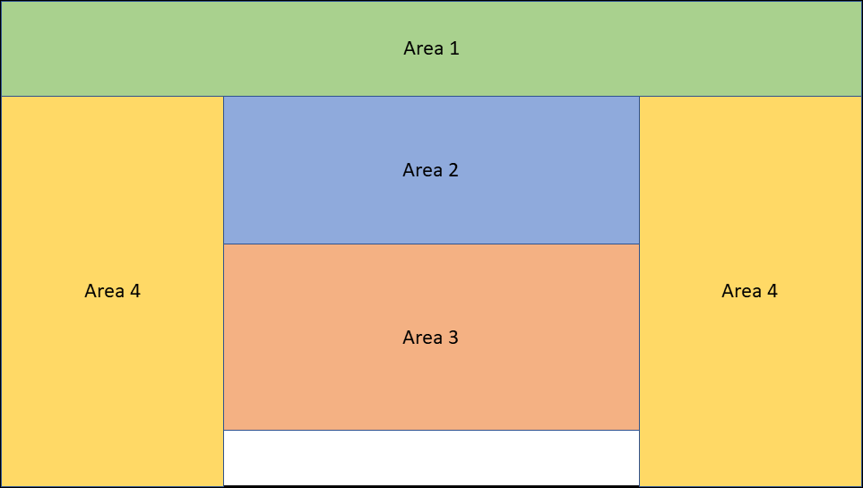
- system application

  - How to apply

0 Manipulate the projector's keystone to make the projected image the smallest rectangular size.
① In the image area created with the minimum size, using the depth camera, position the user at each vertex as shown in (Figure 7-1) and store the user's position coordinate value for the corresponding image area point.
② Using the saved coordinate values, match the image area created in the minimum size with the user's location coordinates one-to-one.
③ If the keystone area of ​​the projector changes, place the user at each vertex again, store the user's position coordinate value for the image area point, and repeat ③.
④ Now, whenever the keystone area of ​​the projector changes, use ④ to compare the coordinates in the image area created at the minimum size with the coordinates when the keystone area of ​​the projector changes, and reduce the size of the UI by the ratio of the increased coordinate ratio.

  - System Application Flow

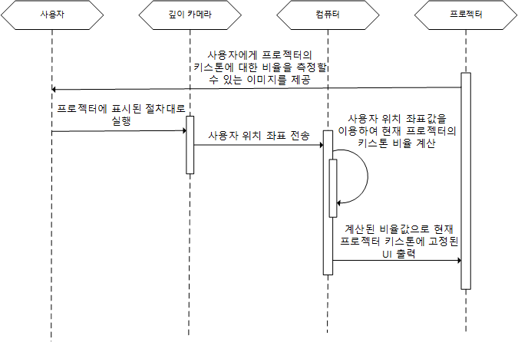

- Application result

Regardless of the size of the projector's keystone area, an interface that allows users to always interact in the same size area can be provided.
The same size and coordinates can always be provided for parts that need to maintain coordinates, and other UI areas can be flexibly changed according to the keystone, thereby providing a natural interface to the user.
Appendix Ⅰ-1
(This annex is intended to supplement the standard and is not part of the standard)
Intellectual Property Rights Agreement Information

Ⅰ-1.1 Intellectual Property Rights Agreement

-Title of invention: 3D character-based user motion verification system
-Name of right holder: Joyfun Co., Ltd.
-Application number: 10-2019-0094261
-Date of application: Aug. 02, 2019
-Execution conditions: Fair, reasonable, non-discriminatory grant (FRAND)
-Confirmation receipt date: Aug. 05, 2019

※ In addition to the above-described intellectual property rights agreement, there may be a confirmation letter received after the publication of this standard. Please check the TTA website.

Appendix Ⅰ-2
(This annex is intended to supplement the standard and is not part of the standard)
Matters related to test certification

Ⅰ-2.1 Whether it is subject to test certification

- None.

Ⅰ-2.2 Status of establishment of test standards

- None.
Appendix Ⅰ-3
(This annex is intended to supplement the standard and is not part of the standard)
Family standard of this standard

Ⅰ-3.1 quoted standard

- None

Appendix Ⅰ-4
(This annex is intended to supplement the standard and is not part of the standard)
references

- None

※ In addition to the above-described intellectual property rights agreement, there may be a confirmation letter received after the publication of this standard. Please check the TTA website.

Appendix Ⅰ-5
(This annex is intended to supplement the standard and is not part of the standard)
English Standard Manual

- None

Appendix Ⅰ-6
(This annex is intended to supplement the standard and is not part of the standard)표준의 이력 history of standard

Edition | Date of adoption | Standard number | Contents | Committee in charge
First edition | Dec 16, 2020 |  | - | Digital Contents Project Group (PG610)

