Project | Human Factor for Immersive Content Working Group  <http://sites.ieee.org/sagroups-3079/ >
Title | Interface of Gesture Correction by Motion Sensor
DCN | 3079-20-0050-00-0002
Date Submitted | October 12, 2020
Source(s) | Jeong, Sangkwon Peter ceo@joyfun.kr (JoyFun Inc.,)  Nam, HyeonWoo hwnam@dongduk.ac.kr (Dongduk Women’s University)  Lee, Gookhwan ghlee@joyfun.kr (JoyFun Inc.,)  Kim, Seoul seoul_kim@joyfun.kr (JoyFun Inc.,)
Re:
Abstract | This standard defines an interface that users can recognize so that they can monitor and correct their behavior status when viewing and copying actions based on three-dimensional characters or creating learning content aimed at them.
Purpose | The purpose of this standard is to define an interface that intuitively expresses a user's perception when he/she corrects the behavior after checking and analyzing whether he/she is following or learning the behavior correctly in various movements, including dance, dance, yoga, etc. of the user using three-dimensional characters.
Notice | This document is offered as a basis for discussion and is not binding on the contributing individual(s) or organization(s). The material in this document is subject to change in form and content after further study. The contributor(s) reserve(s) the right to add, amend or withdraw material contained herein.
Release | The contributor grants a free, irrevocable license to the IEEE to incorporate material contained in this contribution, and any modifications thereof, in the creation of an IEEE Standards publication; to copyright in the IEEE’s name any IEEE Standards publication even though it may include portions of this contribution; and at the IEEE’s sole discretion to permit others to reproduce in whole or in part the resulting IEEE Standards publication. The contributor also acknowledges and accepts that IEEE 3079 may make this contribution public.
Patent Policy | The contributor is familiar with IEEE patent policy, as stated in Section 6 of the IEEE-SA Standards Board bylaws <http://standards.ieee.org/guides/bylaws/sect6-7.html#6> and in Understanding Patent Issues During IEEE Standards Development http://standards.ieee.org/board/pat/faq.pdf

Interface of Gesture Correction
by Motion Sensor

- application

This standard applies to systems for producing content that is used when users learn to imitate or imitate various movements, including dance, dance, yoga, etc. The system consists of an 'input processing unit' that recognizes the user's behavior and an 'output processing unit' that provides feedback graphically or sound based on the recognized behavior.
The ‘input processing unit’ consists of an ‘analysis module’ that analyzes the behavior of the entered user, a ‘comparison module’ that compares the behavior of the analyzed user with the behavior of the sample user, and a ‘verification part’ that determines and verifies the behavior.
The 'output processing unit' typically consists of a 'screen output' that provides visual operational information, a 'floor output' that provides spatial operational information on the floor where the user is located, and an 'audio output' that provides operational information using sound. This standard defines interfaces expressed in 'screen output' and 'floor output'.

- Quote Standard

해당 사항 없음

- Definition of terminology

The terms of this standard are 'Three-Dimensional Character Based User Behavior Verification System Architecture' (TTAK).See KO-10.1191.
  - Video Projector
An image projector that receives a video signal and projects the image to the projection screen using a lens system.

- Abbreviations

Not applicable

- User Behavior Verification System Architecture

  - Overview

이미지 카메라 또는 깊이 카메라 센서에 의하여 입력된 표본 사용자의 골격 정보를 입력 받아 생성된 3차원 캐릭터의 동작을 이용하여 애니메이션을 제작한다.
이렇게 제작된 애니메이션을 통하여 사용자는 따라하거나 또는 따라하기 위한 학습을 시도한다.
An animation is produced using the behavior of a three-dimensional character created by inputting bone information of a sample user entered by an image camera or depth camera sensor.
Through these animations, users attempt to imitate or learn to imitate
In this process, bone information about a user's behavior is extracted, compared, and analyzed to verify that the user's behavior accurately mimics that of the sample user.
At this time, the user should be calibrated through the analyzed results, which is most efficient to express the directionality of each action.

  - System Configuration
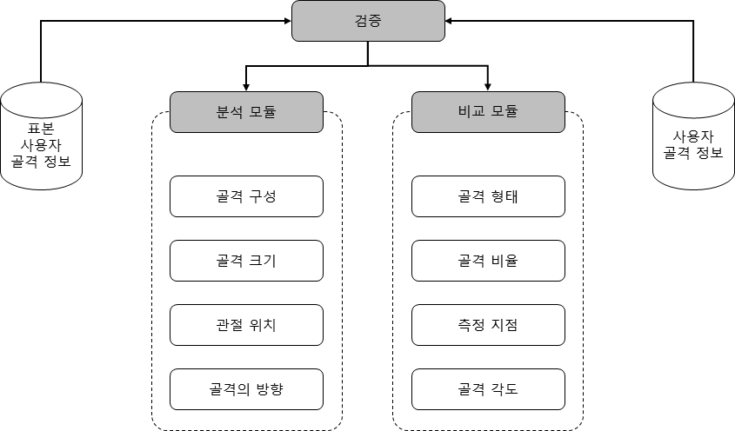
The verification system consists of ‘an analysis module’ and ‘a comparison module’ as shown in (Figure 5-1).

    - Analysis Module

The analytical module checks information from extracted skeletal information such as composition of bone, size of bone, location of joint and direction of bone. Each item is analyzed through a comparison module with each confirmed information value.
    - Comparison Module

The comparison module compares the data to be compared as shown in (Figure 5-2) for the shape of the bone, the ratio of the bone, the point at which the bone should be measured, and the angle of the bone, based on the items identified by the analysis module.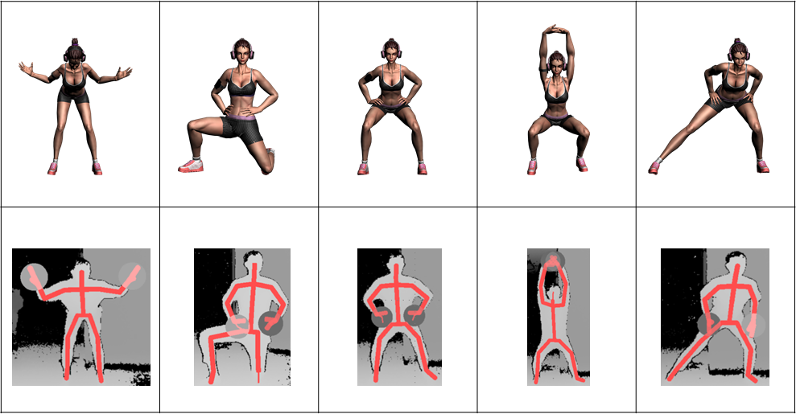

- Output Processing Unit

The Output Processing Unit' provides a graphical or sound-type user interface for results processed by the Input Processing Unit. This standard refers only to graphical user interfaces.
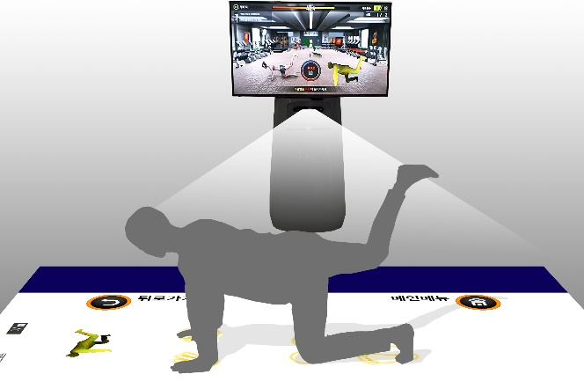 | 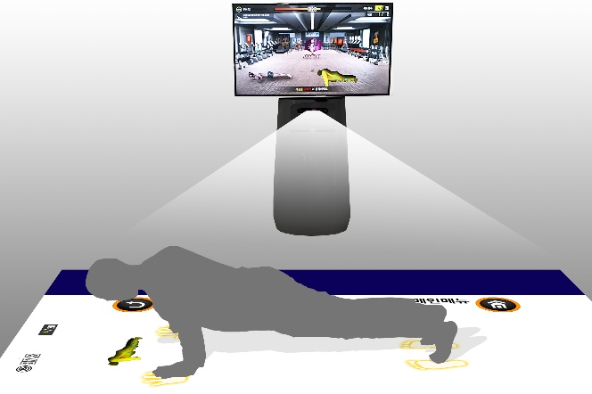
The "output processing unit" can be divided into the "screen output" using the display panel and the "floor output" using the projector, as shown in (Figure 6-1).

  - Screen Output Part
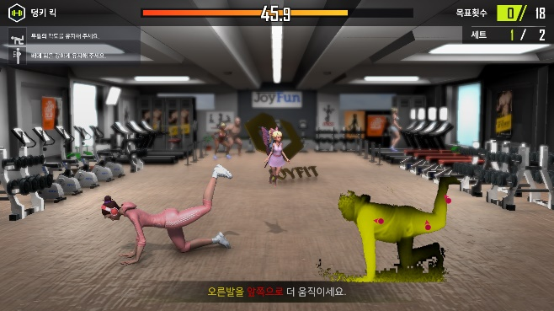 | 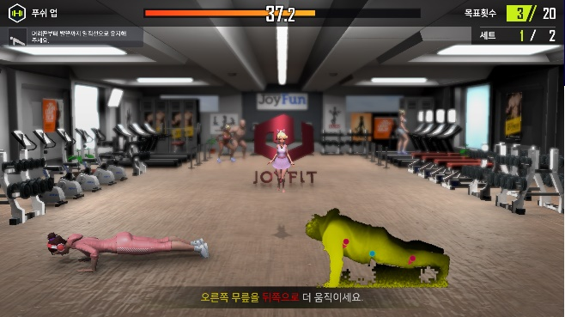
The screen output is a device that outputs visual motion guide information to the user as shown in (Figure 6-2) and is displayed on the display panel of the mixed reality device.

  - Floor Output Part
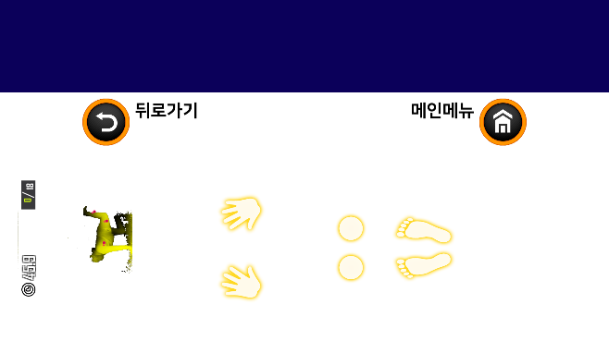 | 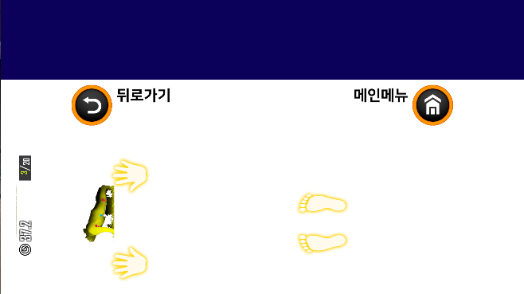
The floor output is a device that outputs spatial motion guide information that presents the position of the user's feet, hands, etc., as shown in (Figure 6-3) and is usually displayed on the floor through an image projector of a mixed-reality device.

- Attitude Calibration Information Display Interface

Correct posture must be taken for postural correction. For this, information is presented so that the user can intuitively correct the posture by expressing the direction of movement on each body part that needs to move in the correct direction.

    - Screen Output Section Calibration Information Display Interface

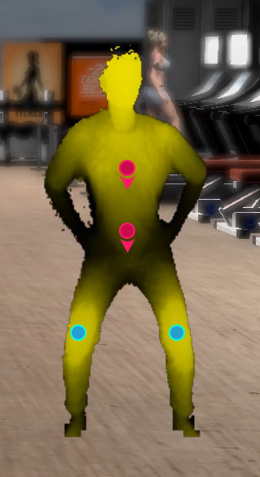 | 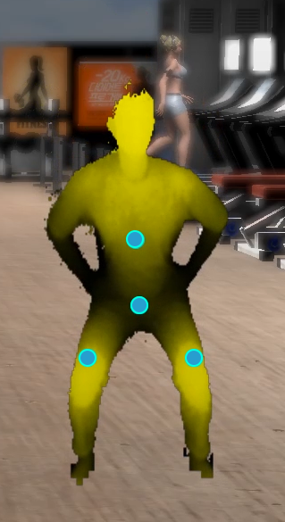
As shown in (Figure 7-1), the user's outline or image is displayed on the front screen output interface, and the direction to be moved is intuitively indicated by augmenting the mark on each reading area with arrows.
When each part is correctly positioned in the correct position, it is marked in blue to indicate that it is well positioned in the corrected position.

    - Floor Output Section Calibration Information Display Interface
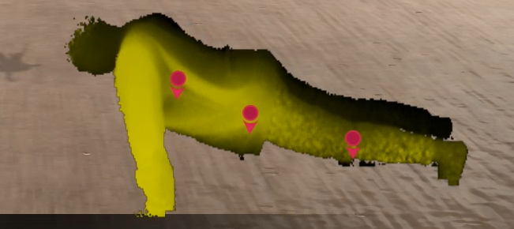 | 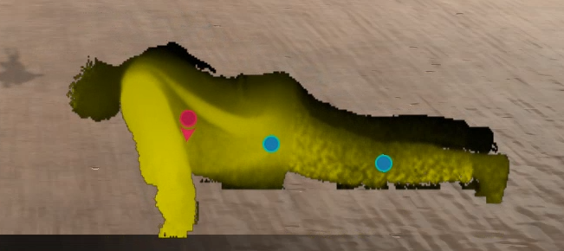
As shown in (Fig. 7-2), if you cannot stand and see the front, but you need to see the floor, the user's outline or image is displayed on the screen output interface of the floor, and the mark is augmented with arrows at each reading area Intuitively indicate the direction you need to move.
When each part is correctly positioned in the correct position, it is marked in blue to indicate that it is well positioned in the corrected position.

Appendix Ⅰ-1
(This annex is intended to supplement the standard and is not part of the standard)
Intellectual Property Rights Agreement Information

Ⅰ-1.1 Intellectual Property Rights Agreement

-Title of invention: 3D character-based user motion verification system
-Name of right holder: Joyfun Co., Ltd.
-Application number: 10-2019-0094261
-Date of application: August 02, 2019
-Execution conditions: Fair, reasonable, non-discriminatory grant (FRAND)
-Confirmation receipt date: Aug. 05, 2019

※ In addition to the above-described intellectual property rights agreement, there may be agreements received after the publication of this standard, so please check the TTA website.
Appendix Ⅰ-2
(This annex is intended to supplement the standard and is not part of the standard)
Matters related to test certification

Ⅰ-2.1 Whether it is subject to test certification

- None.

Ⅰ-2.2 Status of establishment of test standards

- None.

Appendix Ⅰ-3
(This annex is intended to supplement the standard and is not part of the standard)
Family standard of this standard

Ⅰ-3.1 Quotation standards

- None

Appendix Ⅰ-4
(This annex is intended to supplement the standard and is not part of the standard)
References

- TTAK.KO-10.1191 3D Character-based User Motion Verification System Architecture

※ In addition to the above-described intellectual property rights agreement, there may be agreements received after the publication of this standard, so please check the TTA website.

Appendix Ⅰ-5
(This annex is intended to supplement the standard and is not part of the standard)
English standard commentary

- None.

Appendix Ⅰ-6
(This annex is intended to supplement the standard and is not part of the standard)
Standard history

Edition | Date of adoption | Standard number | Contents | Committee in charge
First edition | Dec 16, 2019 |  | - | Digital Contents Project Group  (PG610)

