Project | Human Factor for Immersive Content Working Group  <http://sites.ieee.org/sagroups-3079/ >
Title | User Body Size Optimize System for Gesture Cognitive Interface
DCN | 3079-20-0049-00-0002
Date Submitted | October 12, 2020
Source(s) | Jeong, Sangkwon Peter ceo@joyfun.kr (JoyFun Inc.,)  Nam, HyeonWoo hwnam@dongduk.ac.kr (Dongduk Women’s University)  Lee, Gookhwan ghlee@joyfun.kr (JoyFun Inc.,)  Kim, Seoul seoul_kim@joyfun.kr (JoyFun Inc.,)
Re:
Abstract | This standard defines an interface that users can recognize so that they can monitor and calibrate their behavior status when viewing and copying actions based on three-dimensional characters or creating learning content aimed at them
Purpose | The purpose of this standard is to define an interface that intuitively expresses it so that users can recognize a variety of benchmark movements, including dance, dance, yoga, etc. when the program verifies and analyzes the user's learning and corrects it.
Notice | This document is offered as a basis for discussion and is not binding on the contributing individual(s) or organization(s). The material in this document is subject to change in form and content after further study. The contributor(s) reserve(s) the right to add, amend or withdraw material contained herein.
Release | The contributor grants a free, irrevocable license to the IEEE to incorporate material contained in this contribution, and any modifications thereof, in the creation of an IEEE Standards publication; to copyright in the IEEE’s name any IEEE Standards publication even though it may include portions of this contribution; and at the IEEE’s sole discretion to permit others to reproduce in whole or in part the resulting IEEE Standards publication. The contributor also acknowledges and accepts that IEEE 3079 may make this contribution public.
Patent Policy | The contributor is familiar with IEEE patent policy, as stated in Section 6 of the IEEE-SA Standards Board bylaws <http://standards.ieee.org/guides/bylaws/sect6-7.html#6> and in Understanding Patent Issues During IEEE Standards Development http://standards.ieee.org/board/pat/faq.pdf

User Body Size Optimize System
for Gesture Cognitive Interface

- Coverage
This standard applies to systems for producing content that is used when users learn to imitate or imitate various movements, including dance, dance, yoga, etcThe system consists of an 'input processing unit' that recognizes the user's behavior and an 'output processing unit' that provides feedback graphically or sound based on the recognized behavior.
'Input Processing Unit' consists of 'Analysis Module', 'Comparison Module' and 'Verification Department'. The 'analytical module' analyzes the behavior of the entered user. 'Comparison module' compares the analyzed user behavior with 'sample user' behavior. The 'verification department' determines and verifies this.
The 'output processing unit' typically consists of a 'screen output' that provides visual operational information, a 'floor output' that provides spatial operational information on the floor where the user is located, and an 'audio output' that provides operational information using sound. This standard defines interfaces expressed in 'screen output' and 'floor output'.

- Quote Standard

Not applicable

- Definition of terminology

The terms of this standard are 'Three-Dimensional Character Based User Behavior Verification System Architecture' (TTAK).See KO-10.1191.

- Abbreviations

Not applicable

- User Behavior Verification System Architecture

  - Overview

An animation is produced using the behavior of a three-dimensional character created by inputting bone information of a sample user entered by an image camera or depth camera sensor.
Through these animations, users attempt to learn to imitate or imitate.
In this process, bone information about a user's motion is extracted, compared, and analyzed to verify that the user's motion accurately mimics that of the sample user.
However, depending on the user's height difference, the verification module should have a different way of determining it. For this purpose, a standard height should be established and a user height optimization system should be presented for the action recognition interface that is linked to it.

  - System Configuration
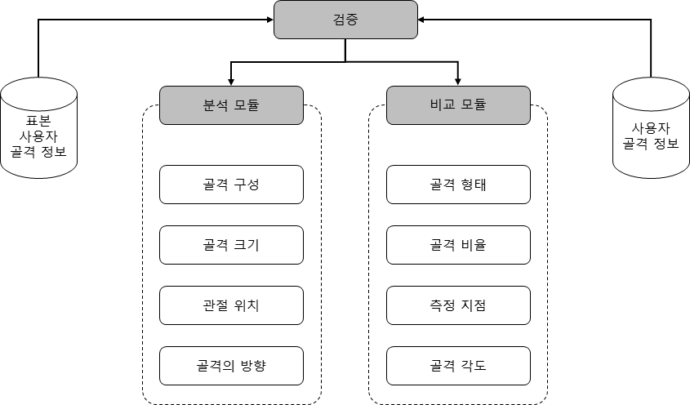
The verification system consists of an ‘analysis module’ and a ‘comparison module’ as shown in (Figure 5-1).

    - Analysis Module

The analytical module checks information from extracted skeletal information such as composition of bone, size of bone, location of joint and direction of bone. Each item is analyzed through a comparison module with each confirmed information value.

    - Comparison Module

The comparison module compares the data to be compared as shown in (Figure 5-2) for the shape of the bone, the ratio of the bone, the point at which the bone should be measured, and the angle of the bone, based on the items identified by the analysis module.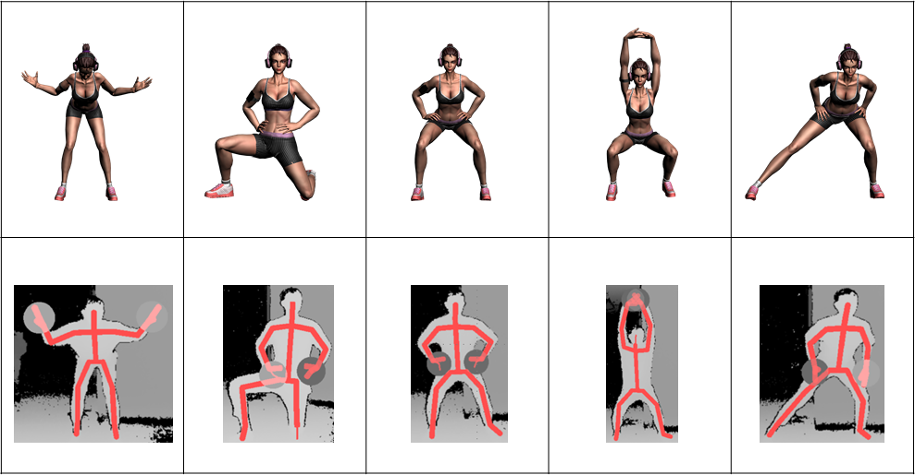

- User Motion Guide Interface

To compare the motion of users in a mixed-reality-based user motion verification system, the guide presented in the 'floor output' shows the body parts touching the floor, such as hands, feet and knees, as shown in (Figure 6-1). At this time, the positions of both feet and hands should be spaced according to the user's height.
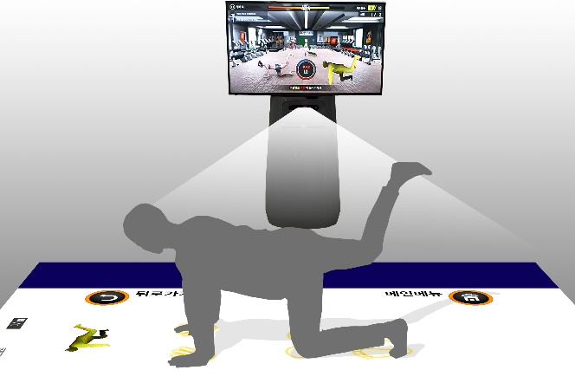 | 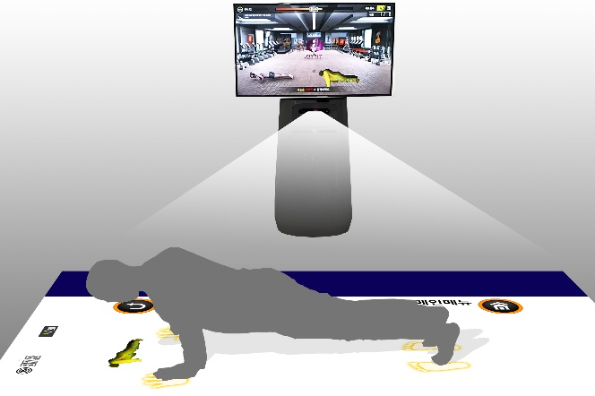

  - User Height Optimization Formula

Guide criteria that require presentation according to the user's height require a gap between the two feet, and a gap between the feet and the hands.
    - Two-legged Gap

The interval according to the user's height is 173.5 cm, the average height of Korean men, and the gap between the feet is 30 cm, and is provided proportionally.

- 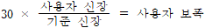
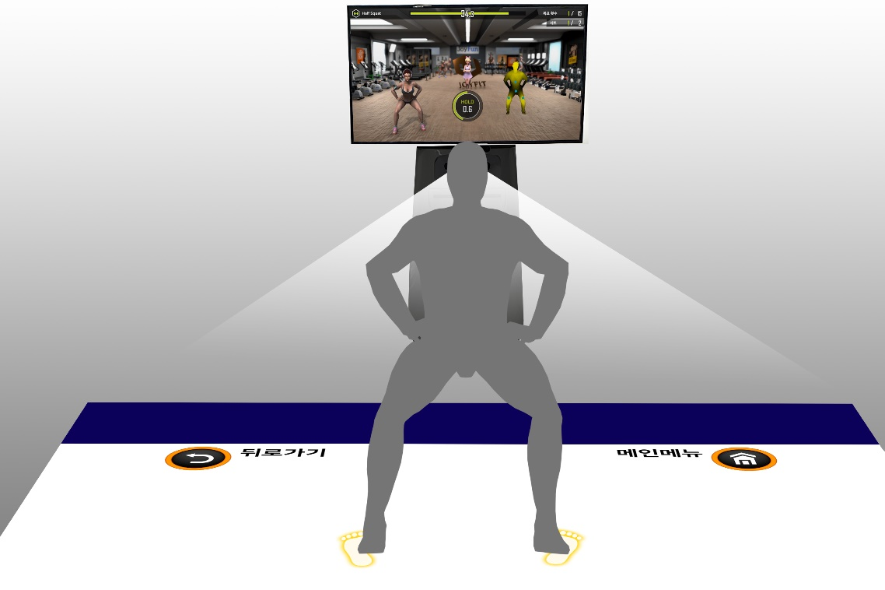
For half squat positions (Figure 6-2), the stride of both feet shall be changed according to the height of the user in proportion to the reference height (Figure 6-3).

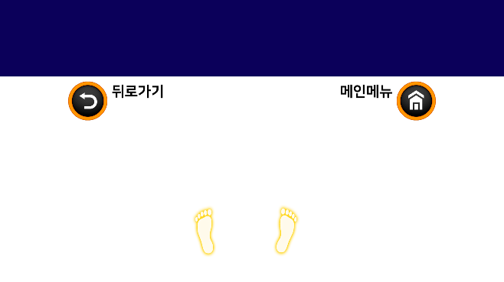

    - Gap between feet and hands

The gap between the two feet and the two hands is provided proportionally based on 121 cm, when the average height of the Korean male is 173.5 cm.

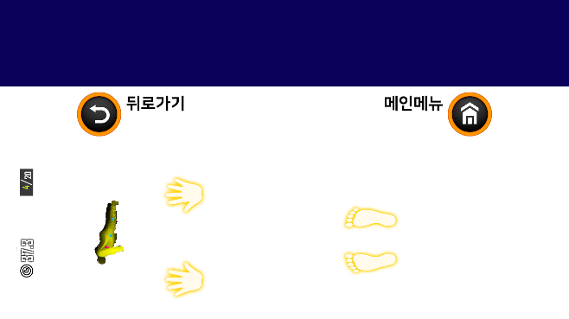 | 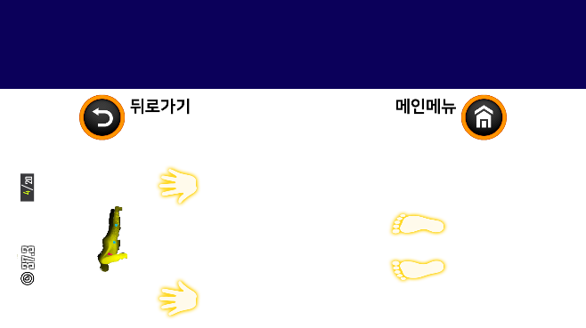
As such, the reference distance (width, distance between hands and feet, etc.) should be defined according to the reference height and the user's interface should be optimized according to the corresponding ratio formula.
Each person may have a deviation, but the deviation is ignored in this service.
Height | Two-legged Gap |  | Gap between feet and hands |  | Remarks
(cm) | distance (cm) | distance (Ratio) | distance (cm) | distance (Ratio)
110 | 19.02 | 63.40% | 76.71 | 63.40%
115 | 19.88 | 66.28% | 80.20 | 66.28%
120 | 20.75 | 69.16% | 83.69 | 69.16%
125 | 21.61 | 72.05% | 87.18 | 72.05%
130 | 22.48 | 74.93% | 90.66 | 74.93%
135 | 23.34 | 77.81% | 94.15 | 77.81%
140 | 24.21 | 80.69% | 97.64 | 80.69%
145 | 25.07 | 83.57% | 101.12 | 83.57%
150 | 25.94 | 86.46% | 104.61 | 86.46%
155 | 26.80 | 89.34% | 108.10 | 89.34%
160 | 27.67 | 92.22% | 111.59 | 92.22%
165 | 28.53 | 95.10% | 115.07 | 95.10%
170 | 29.39 | 97.98% | 118.56 | 97.98%
173.5 | 30 | 100.00% | 121 | 100.00%
175 | 30.26 | 100.86% | 122.05 | 100.86%
180 | 31.12 | 103.75% | 125.53 | 103.75%
185 | 31.99 | 106.63% | 129.02 | 106.63%
190 | 32.85 | 109.51% | 132.51 | 109.51%
195 | 33.72 | 112.39% | 135.99 | 112.39%
200 | 34.58 | 115.27% | 139.48 | 115.27%

AppendixⅠ-1
(This annex is intended to supplement the standard and is not part of the standard)
Intellectual Property Rights Agreement Information

Ⅰ-1.1 Intellectual Property Rights Agreement

-Title of invention: 3D character-based user motion verification system
-Name of right holder: Joyfun Co., Ltd.
-Application number: 10-2019-0094261
-Date of application: August 02, 2019
-Execution conditions: Fair, reasonable, non-discriminatory grant (FRAND)
-Confirmation receipt date: August 05, 2019

※ In addition to the above-described intellectual property rights agreement, there may be agreements received after the publication of this standard, so please check the TTA website.

AppendixⅠ-2
(This annex is intended to supplement the standard and is not part of the standard)
Matters related to test certification

Ⅰ-2.1 Whether it is subject to examination

- None.

Ⅰ-2.2 Status of establishment of test standards

- None.
AppendixⅠ-3
(This annex is intended to supplement the standard and is not part of the standard)
Family standard of this standard

Ⅰ-3.1 인용 표준

- None.

AppendixⅠ-4
(This annex is intended to supplement the standard and is not part of the standard)
References

- None.

※ In addition to the above-described intellectual property rights agreement, there may be agreements received after the publication of this standard, so please check the TTA website.

AppendixⅠ-5
(This annex is intended to supplement the standard and is not part of the standard)
English standard commentary

- None.

AppendixⅠ-6
(This annex is intended to supplement the standard and is not part of the standard)
Standard history

Edition | Date of adoption | Standard number | Contents | Committee in charge
First edition | December 16, 2020 |  | - | Digital Contents Project Group (PG610)

