Project | Human Factor for Immersive Content Working Group  <http://sites.ieee.org/sagroups-3079/ >
Title | Guideline for Interface Mapping of the Projector by Depth Camera
DCN | 3079-20-0038-00-0000
Date Submitted | July 9, 2020
Source(s) | Sangkwon Peter Jeong ceo@joyfun.kr (JoyFun Inc.,)  HyeonWoo Nam hwnam@dongduk.ac.kr (Dongduk Women’s University)  Dong Soo Choi soochoi@dau.ac.kr (Dong-A University)
Re:
Abstract | This document defines development guidelines for implementing projection mapping using depth cameras and projectors in motion-responsive mixed reality implementations.
Purpose | The purpose of this document is to provide guidelines for projection mapping using depth cameras and projectors to implement motion-responsive mixed reality.
Notice | This document is offered as a basis for discussion and is not binding on the contributing individual(s) or organization(s). The material in this document is subject to change in form and content after further study. The contributor(s) reserve(s) the right to add, amend or withdraw material contained herein.
Release | The contributor grants a free, irrevocable license to the IEEE to incorporate material contained in this contribution, and any modifications thereof, in the creation of an IEEE Standards publication; to copyright in the IEEE’s name any IEEE Standards publication even though it may include portions of this contribution; and at the IEEE’s sole discretion to permit others to reproduce in whole or in part the resulting IEEE Standards publication. The contributor also acknowledges and accepts that IEEE 802.21 may make this contribution public.
Patent Policy | The contributor is familiar with IEEE patent policy, as stated in Section 6 of the IEEE-SA Standards Board bylaws <http://standards.ieee.org/guides/bylaws/sect6-7.html#6> and in Understanding Patent Issues During IEEE Standards Development http://standards.ieee.org/board/pat/faq.pdf

- Projection mapping

  - Overview of projection mapping

Projection mapping refers to representing a virtual image that is actually present through image projection using a projector in a specific space. In this standard, a virtual image expressed through projection mapping is used as an interface for interacting with a user. This interface can deliver a message to the user, or it can be used as an interface for interaction.

  - Necessity of interface mapping guidelines using projectors
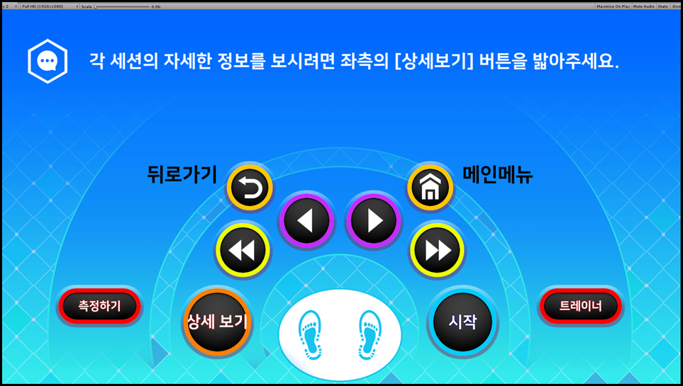
Figure 1 Real-sized image used for projection mapping

Figure 1 shows a real-sized image represented to interact with the user for projection mapping.
The projector can reduce or enlarge the required image to the actual size by adjusting the keystone. Figure 2 shows a case where the image area is reduced by adjusting the projector's keystone.
When the keystone adjustment of the project occurs, all coordinate values set to interact with the user are changed.

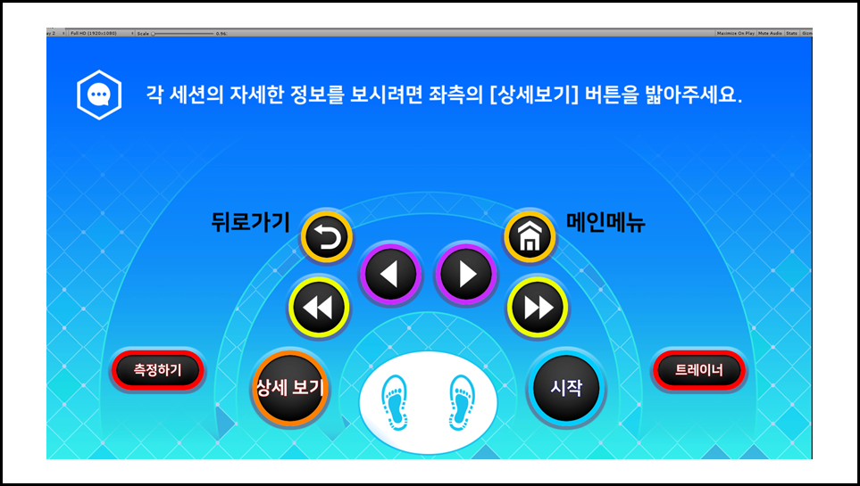
Figure 2 Reduced size image by keystone adjustment on projector
For example, even if the user presses the existing 'start' position value for 'start', no reaction occurs because the 'start' position coordinate value in Figure 1 and the 'start' position coordinate value in Figure 2 are different.
In order to prevent malfunctions caused by mismatch of coordinates, a method is required to provide an absolute value so that coordinate values for each interaction image can be fixed even if the keystone of the projector is adjusted.

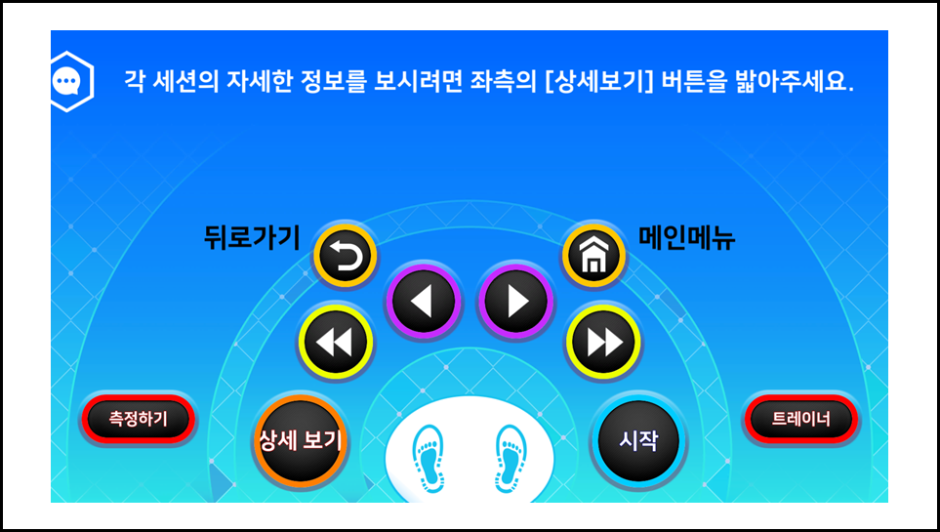
Figure 3 Interface image that maintains absolute value even when the projector's keystone is adjusted

Unlike in Figure 2, Figure 3 shows that the size of the interaction image is fixed so that the coordinate values can be maintained even if the projector's keystone is changed.
If the function of maintaining the coordinates is possible, the system can provide a constant interaction interface according to the user's height or various body sizes.

- Workspace Settings

  - Basic Settings

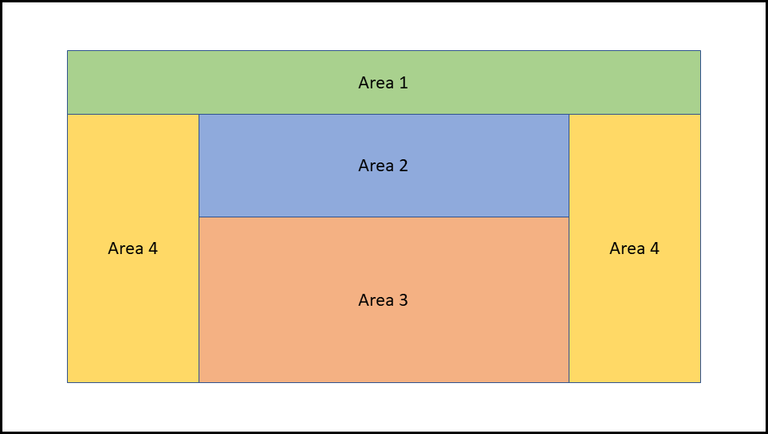
Figure 4 Area allocation for basic settings

In order to fix the size of the interaction image so that the coordinate values can be maintained even if the keystone of the projector is changed, the size and position of area 3 in Figure 4 must be fixed.

- The following shows the conditions necessary to fix the size and position of area 3.
- The width of area 2 and area 3 are the same.
- The height of area 2 maintains the ratio of the height of area 2 and area 1.
- The height of area 4 is the total height minus the height of area 1.
- The width of area 4 is the rest of the area 2 or 3 minus the width.
- Measure the resolution area ratio in the minimum keystone area of the projector.
- Based on the measured value, the ratio of the resolution area in the different keystone areas of the projector can be measured and compared to set as shown in Figure 4.

  - Expected results of application of technology

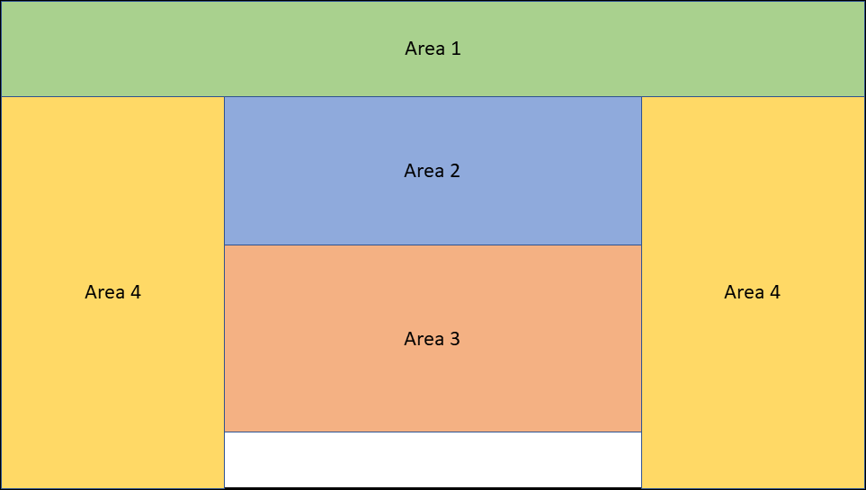
Figure 5 Projection screen with technology

Figure 5 shows the case where the keystone area of the projector is applied to the maximum. When the keystone area of the projector increases, the center of area 3 also changes.

- The following shows the process of changing the center of area 3 when the keystone area of the projector increases.
- By applying the technology, it was marked at the absolute position, and area 3 was moved up on the screen.
- The height of areas 1 and 2 is also adjusted by the set ratio.
- When the keystone area of the projector is maximum, the size of area 3 must be reduced to maintain a fixed size.
- If the size of area 3 is reduced, you can see all of it, and area 2 is also reduced by the width of area 3.
- As the width of No. 2 and No. 3 decreases, the No. 4 area increases, and the No. 1 area decreases, and the No. 4 area increases.

- Application of the system

  - Application result

Systems with standard technology can provide an interface that allows users to interact in the same sized area at all times, regardless of the size of the projector's keystone area.
The system can always provide the same size and coordinates to the parts where coordinates need to be maintained, and other UI areas can be flexibly changed according to keystones, thereby providing a natural interface to the user.

