Project | Human Factor for Immersive Content Working Group  <http://sites.ieee.org/sagroups-3079/ >
Title | Guideline for Projection Mapping Using by Depth Camera and Projector
DCN | 3079-20-0037-00-0000
Date Submitted | July 7, 2020
Source(s) | Sangkwon Peter Jeong ceo@joyfun.kr (JoyFun Inc.,)  HyeonWoo Nam hwnam@dongduk.ac.kr (Dongduk Women’s University)  Dong Soo Choi soochoi@dau.ac.kr (Dong-A University)
Re:
Abstract | This document defines development guidelines for implementing projection mapping using depth cameras and projectors in motion-responsive mixed reality implementations.
Purpose | The purpose of this document is to provide guidelines for projection mapping using depth cameras and projectors to implement motion-responsive mixed reality.
Notice | This document is offered as a basis for discussion and is not binding on the contributing individual(s) or organization(s). The material in this document is subject to change in form and content after further study. The contributor(s) reserve(s) the right to add, amend or withdraw material contained herein.
Release | The contributor grants a free, irrevocable license to the IEEE to incorporate material contained in this contribution, and any modifications thereof, in the creation of an IEEE Standards publication; to copyright in the IEEE’s name any IEEE Standards publication even though it may include portions of this contribution; and at the IEEE’s sole discretion to permit others to reproduce in whole or in part the resulting IEEE Standards publication. The contributor also acknowledges and accepts that IEEE 802.21 may make this contribution public.
Patent Policy | The contributor is familiar with IEEE patent policy, as stated in Section 6 of the IEEE-SA Standards Board bylaws <http://standards.ieee.org/guides/bylaws/sect6-7.html#6> and in Understanding Patent Issues During IEEE Standards Development http://standards.ieee.org/board/pat/faq.pdf

- Projection mapping with depth camera

  - Interaction with projection mapping

The system for projection mapping basically consists of a motion recognition sensor (ex. depth camera) for recognizing motion, a projector, and a computer that enables flexible interworking of the two.
When configuring the system, the number of motion recognition sensors and projectors that can be used in the system is not limited.
However, be careful about Occulusion and Cross Talk problems that can occur in the system.
The depth camera and projector must have a coordinate system synchronized.
If the depth camera recognizes that the user's arm or foot enters the area of a specific UI image projected by the projector, then the corresponding UI works.

  - System action for projection mapping

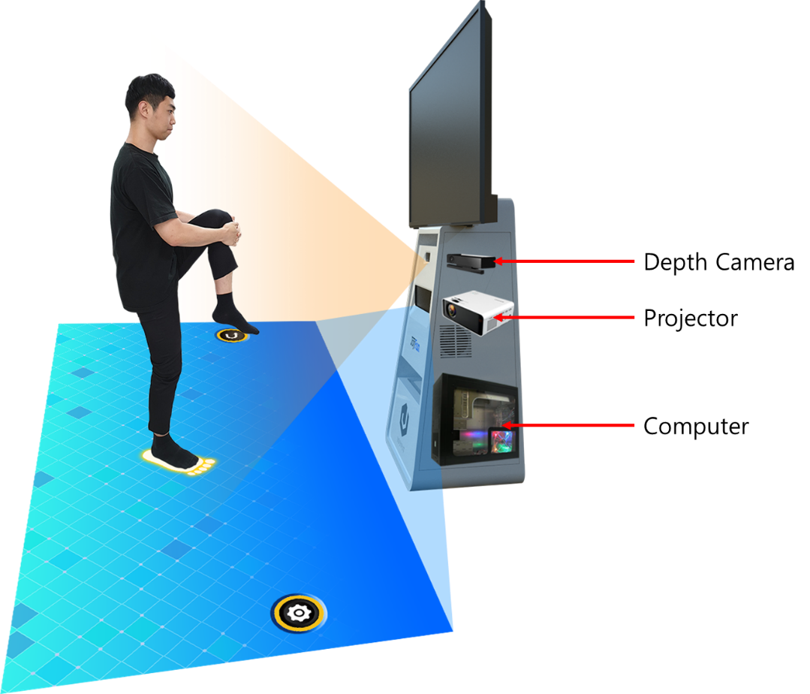
Figure 1 Example of the basic structure of a motion-responsive mixed reality system

Figure 1 shows the interaction interface image projected by the projector and the user's interaction.
When the user steps on or presses the interaction interface image projected by the projector, the depth camera recognizes the user's motion event as a command at the coordinates already programmed, and executes the command for it.
The user's coordinates are read through the depth camera and mapped to the interface coordinate system on the projector.
When overlapping with a specific interface according to the coordinates declared on a specific part such as a hand or foot through the user's motion or action, the command is performed by the corresponding interface.

- Application of the system

Figure 2 projection screen to match the projection area with the user's location coordinates

Figure 2 shows the projection screen to match the projector's projection area with the user's location coordinates.

- The following shows the process of reading the user's coordinates through the depth camera and matching the projector's projection area with the user's location coordinates.
- In the area of the projector shown in Figure 2, the user is stored at each point to store the value.
- Use the saved values to match the projector's area with the user's location coordinates.

For example, the system may allow the corresponding UI to operate only when the position of the user's hand has entered the UI area and the height of the hand is below a certain criterion.

- Application result

The system may provide interaction through an interaction interface image set as an image area generated through projection of the projector.
The system may use various motion-responsive mixed reality content such as games or games based on various motions through an interaction interface.

