Project | Human Factor for Immersive Content Working Group  <http://sites.ieee.org/sagroups-3079/ >
Title | I/O Interactive Guideline of Content & User
DCN | 3079-20-0034-00-0000
Date Submitted | July 7, 2020
Source(s) | Sangkwon Peter Jeong ceo@joyfun.kr (JoyFun Inc.,)  Dong Soo Choi soochoi@dau.ac.kr (Dong-A University)  HyeonWoo Nam hwnam@dongduk.ac.kr (Dongduk Women’s University)
Re:
Abstract | This document defines input/output interface to interact and guide movement of user effectively when depth camera with gesture recognition function and beam project are synchronized, and content guiding and controlling user's movement is serviced through data exchange between depth camera and beam project.
Purpose | The purpose of this document is to define input/output interface interaction to develop and service content utilizing projection display and sensor based on gesture recognition using depth camera.
Notice | This document is offered as a basis for discussion and is not binding on the contributing individual(s) or organization(s). The material in this document is subject to change in form and content after further study. The contributor(s) reserve(s) the right to add, amend or withdraw material contained herein.
Release | The contributor grants a free, irrevocable license to the IEEE to incorporate material contained in this contribution, and any modifications thereof, in the creation of an IEEE Standards publication; to copyright in the IEEE’s name any IEEE Standards publication even though it may include portions of this contribution; and at the IEEE’s sole discretion to permit others to reproduce in whole or in part the resulting IEEE Standards publication. The contributor also acknowledges and accepts that IEEE 802.21 may make this contribution public.
Patent Policy | The contributor is familiar with IEEE patent policy, as stated in Section 6 of the IEEE-SA Standards Board bylaws <http://standards.ieee.org/guides/bylaws/sect6-7.html#6> and in Understanding Patent Issues During IEEE Standards Development http://standards.ieee.org/board/pat/faq.pdf

- Introducing
This document recognizes gesture of user using depth cameras and defines several interaction interface guidelines for interaction in developing content using projects based on perceived information. To facilitate the smooth progress of content services, users must accurately interact with virtual objects or menus that are being projected, so this includes guidelines for optimizing the placement of virtual objects, identifying commands for user input, and optimizing user display expressions.

- Input-Output interface interaction between content and users

  - Optimization of interaction UI placements

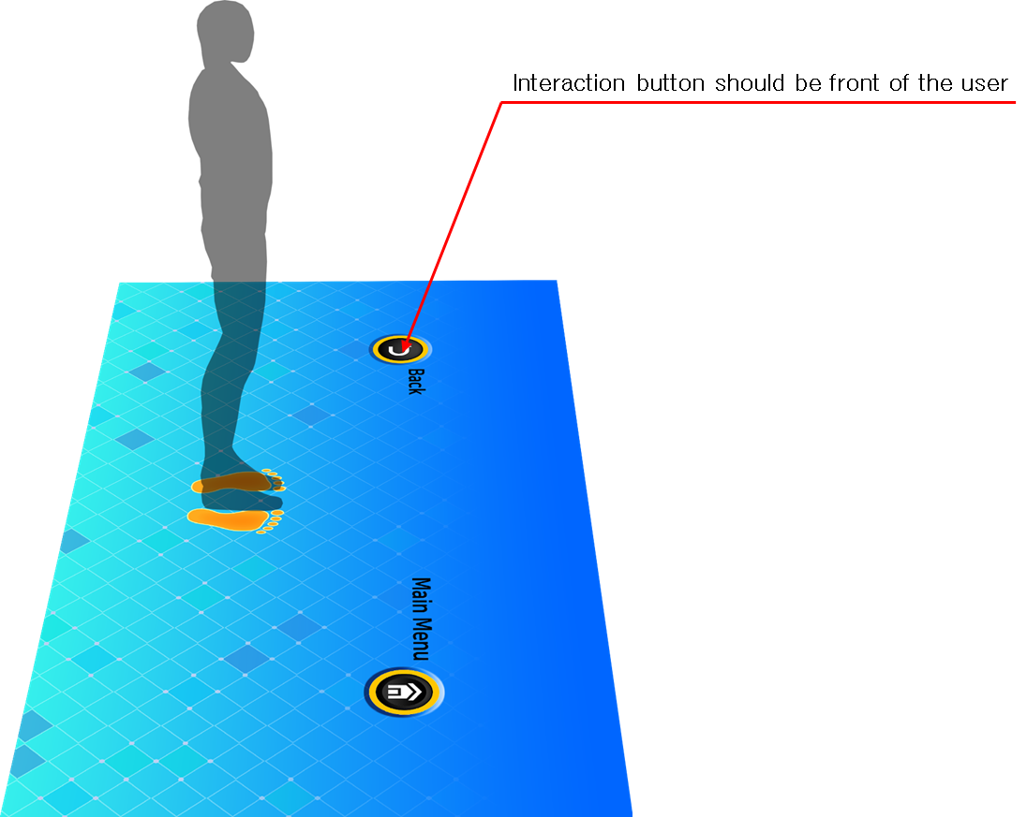
Figure 1. Conceptual diagram of optimization of display representation through placement of virtual objects.

Users use content by reacting to images being projected, and interaction in this process has a significant impact on users’ usability. When a user wants to input information into a specific virtual object in a projection image with the purpose of interaction, the user faces a very embarrassing situation if the user’s shadow causes the object to be invisible.
Therefore, it is necessary to review user scenarios of content and optimize display representation through the placement of virtual objects that fit the user interface, so that the user’s shadow does not interfere with controls for interaction.
That is, virtual objects should be placed on the front of the user to ensure visual recognition and that they are not obscured by shadows created by the projection.

  - Identify command for user input

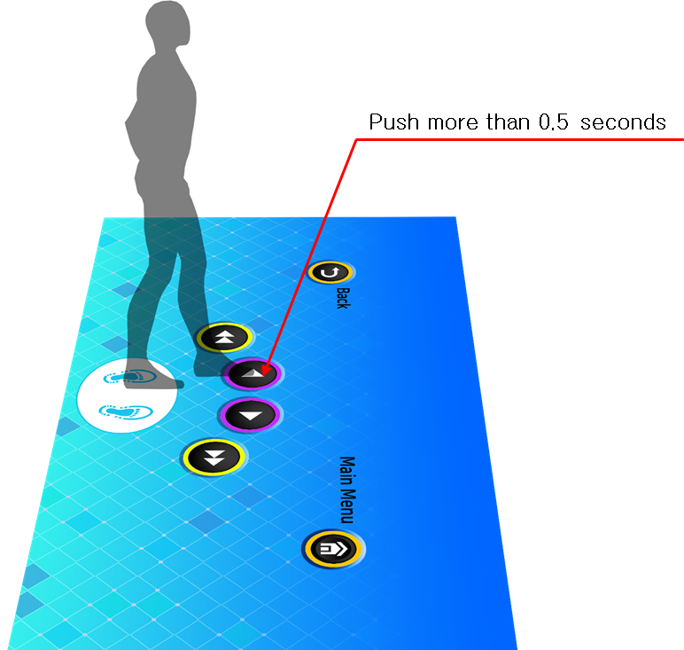
Figure 2. Conceptual diagram of the guidelines for user’s gesture

The user will generate continuous interaction within the already programmed area. Thus, it is highly likely that the pattern of user’s motion in a very wide area is far different from the intention of the person who designed the content. In such cases, if the content reacts immediately according to the user’s unintended behavior, it may be appropriate to the plan’s intention, but it becomes an input of commands that do not comply with the user’s intention, resulting in a serious error.
Therefore, content needs to identify and reflect users’ exact intentions. When a user is required to input any command for this process, it is necessary to be clearly communicated by allowing the action to be continued for a few seconds.
In other words, if a user wanted to input the command as an action, the user will be given enough time (more than 0.5 second) to meet the intention of the action, and too much time will be avoided in consideration of the convenience.

  - Optimize user display representation

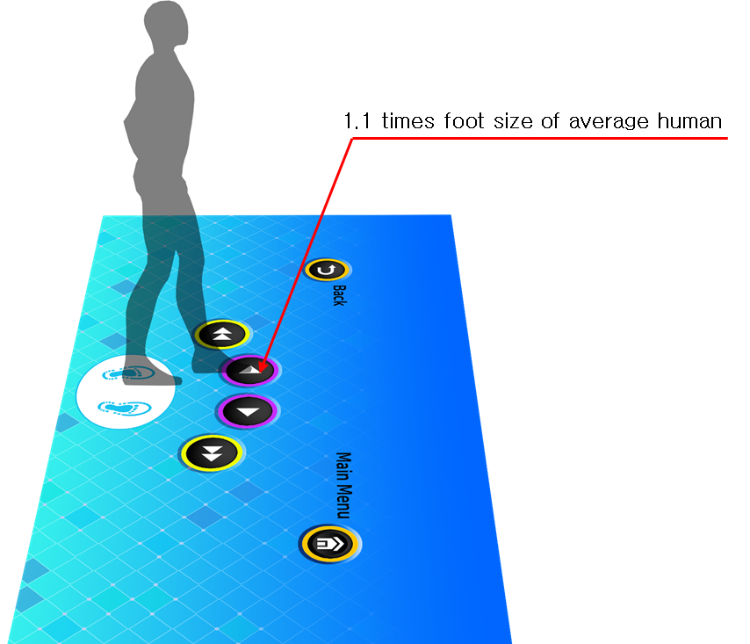
Figure 3. Conceptual diagram of user display representation optimization technology

In order for virtual images by projection to be augmented and interactions to occur through augmented images, areas that are responded by the user’s actions must be designated. The images implemented at this time serve to induce the user’s behavior, but also point to the range of recognizable sensors to respond to the actions of the actual user. Therefore, this part may dampen the user’s behavior and may act as a hindrance to the sense of immersion unless it has a proper error margin.
To avoid this error, the shape drawn on the floor that response with the part of the human body should be 1.1 times the size of the area desired to be inputted. The size of the area to be inputted at this time is based on the average size of the body in Korea’s 30s, which is announced by the Ministry of Health and Welfare every year.

- Application of interaction interface

- The size of the interface can be changed at will, but must comply with the provision of Figure 1.
- It is recommended that guidance be organized in accordance with the combination of basic operating recognition, or in accordance with the method of motion recognition, for example, for those not prescribed in this standard or insufficient in this standard.

