Project | Human Factor for Immersive Content Working Group  <http://sites.ieee.org/sagroups-3079/ >
Title | User Body Size Optimize System for Gesture Cognitive Interface
DCN | 3079-20-0033-00-0000
Date Submitted | July 7, 2020
Source(s) | Sangkwon Peter Jeong ceo@joyfun.kr (JoyFun Inc.,)  Dong Soo Choi soochoi@dau.ac.kr (Dong-A University)  HyeonWoo Nam hwnam@dongduk.ac.kr (Dongduk Women’s University)
Re:
Abstract | This document defines the architecture to identify and verify the user's status by monitoring his or her motion when the content creator is developing a 3D character-based motion following system for the purpose of learning or leisure.
Purpose | The purpose of this document is to provide an architecture that enables the content creator to check and analyze if the user is properly following or learning the basic motions of various activities such as dancing, rhythmical movement, yoga and so on using a 3D character. .
Notice | This document is offered as a basis for discussion and is not binding on the contributing individual(s) or organization(s). The material in this document is subject to change in form and content after further study. The contributor(s) reserve(s) the right to add, amend or withdraw material contained herein.
Release | The contributor grants a free, irrevocable license to the IEEE to incorporate material contained in this contribution, and any modifications thereof, in the creation of an IEEE Standards publication; to copyright in the IEEE’s name any IEEE Standards publication even though it may include portions of this contribution; and at the IEEE’s sole discretion to permit others to reproduce in whole or in part the resulting IEEE Standards publication. The contributor also acknowledges and accepts that IEEE 802.21 may make this contribution public.
Patent Policy | The contributor is familiar with IEEE patent policy, as stated in Section 6 of the IEEE-SA Standards Board bylaws <http://standards.ieee.org/guides/bylaws/sect6-7.html#6> and in Understanding Patent Issues During IEEE Standards Development http://standards.ieee.org/board/pat/faq.pdf

- Introducing
The motion of 3D character which generated by receiving skeleton information of a reference sample captured by an image camera or depth camera sensor is the basis for animation production. During the user can try learning to follow or follow this animation, the skeletal information extracted from the motion of user is compared and analyzed to judge that the motion of user exactly mimics that of the reference sample.
In this process, it is important to note that the judgement module should be set differently depending on the height of the user. Therefore, reference height is defined and user height optimization system presents for the motion recognition interface.

- The User Motion Judgement System Architecture

  - System Architecture
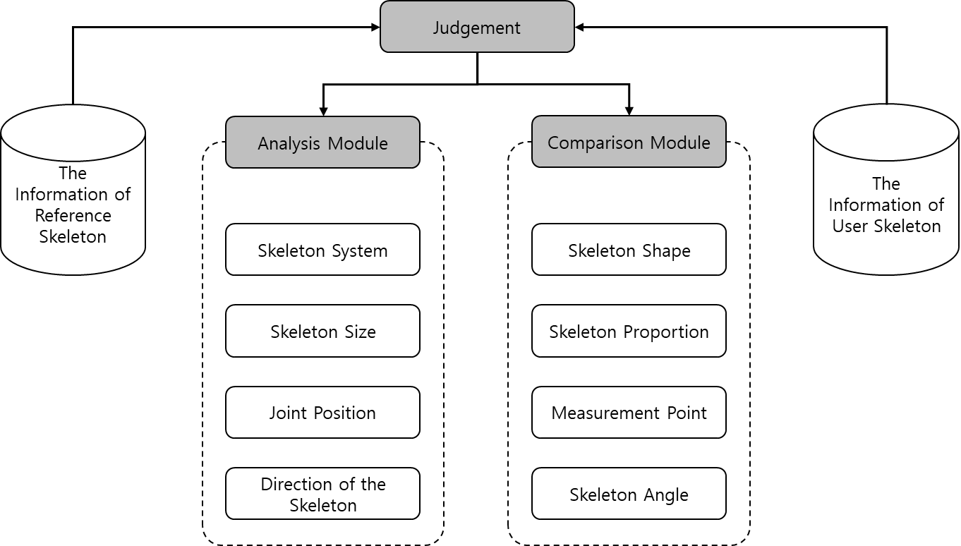
Figure 1. The scheme of the judgement system architecture

The judgement (including discrimination) system is composed of ‘analysis module’ and ‘comparison module’ as shown in Figure 1.

    - Analysis module

The analysis module judges the skeleton information such as the structure of skeleton, the size of skeleton, the position of joint and the direction of skeleton.

    - Comparison module
The comparison module compares the shape of skeleton, the proportion of skeleton, the measurement point and the skeleton angle, etc. as shown in Figure 2. based on the data judged by the analysis module.
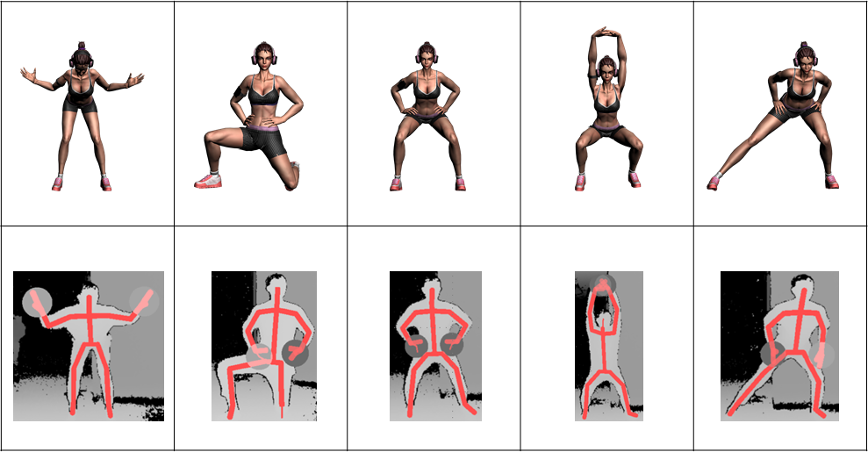
Figure 2. Comparison of user skeletal information with 3D characters

- User motion guide interface

The guide on the ‘floor output section’ displays images of body part that touch in the floor such as hand, feet and knees in order to compare user motion with reference sample in mixed reality-based judgement system as shown in Figure 3.

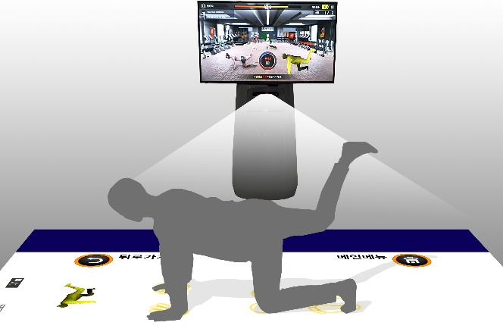 | 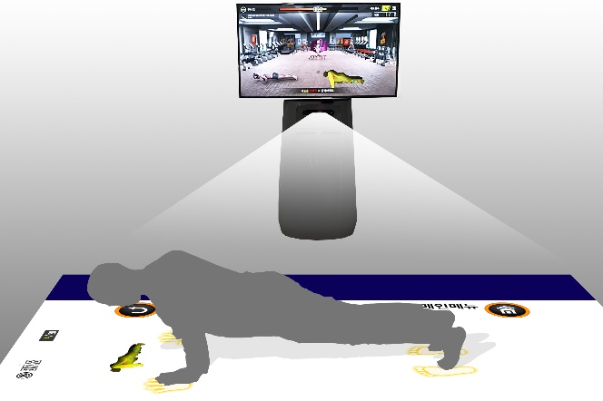
Figure 3. Examples of use

  - The optimization formula for user height

For the optimization guide according to the user’s height, the data for the distance between feet and the distance between foot and hand is required.

    - Distance between the feet

The distance between both feet according to the user’s height can be calculated proportionally based on the distance between the feet of 30cm when the average height of Korean men is 173.5cm.

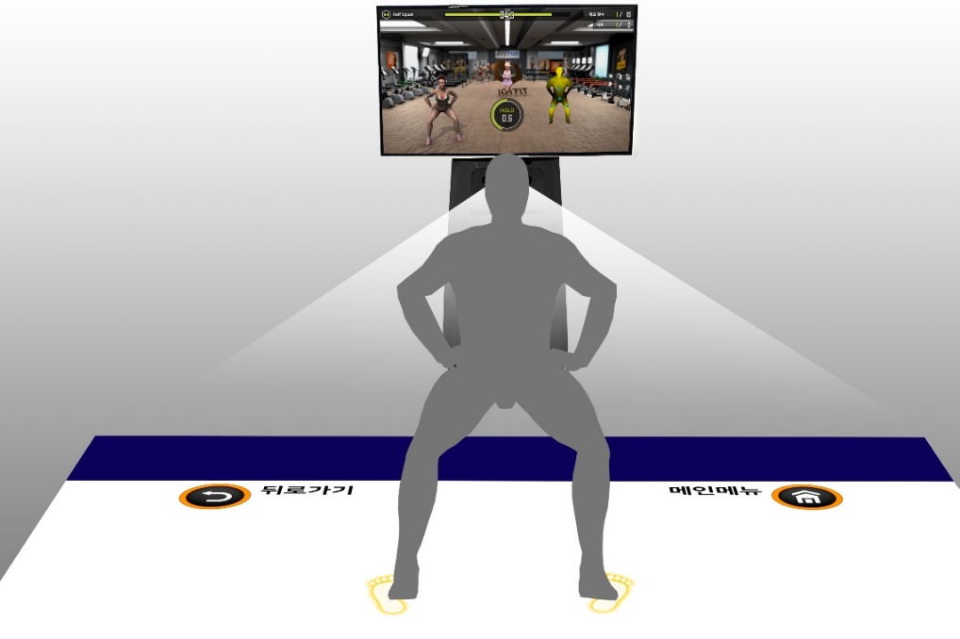
Figure 4. Half squat posture

In the half squat posture as shown in Figure 4, the distance between feet should be calibrated as shown in (Figure 5) according to the user’s height compared with standard sample.

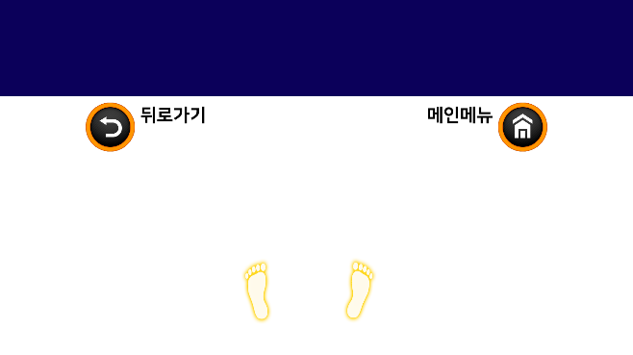
Figure 5. The difference in distance between feet of user who is 150cm tall (left) and is 180cm tall (right)

    - Distance between foot and hand

The distance between foot and hand according to the user’s height can be calculated proportionally based on the distance between the foot and hand of 121cm when the average height of Korean men is 173.5cm.

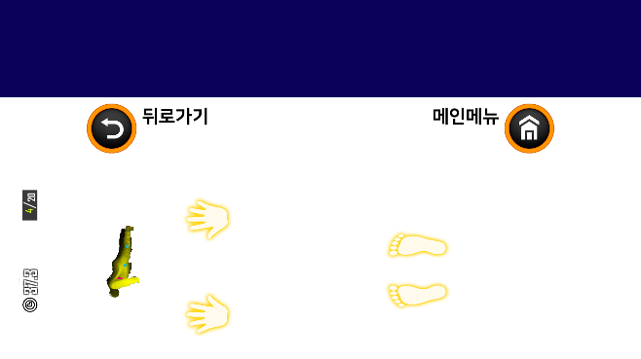 | 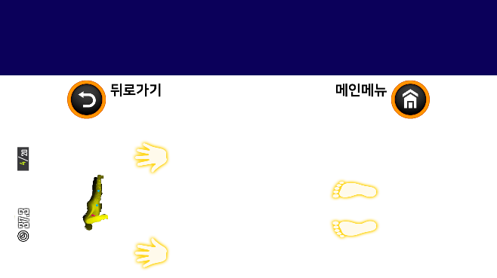
Figure 6. The difference in distance between foot and hand of user who is 150cm tall (left) and is 180cm tall (right)

As described above, the standard distance of the standard sample (the distance between feet and hands, etc.) should be defined, and the user interface should be optimized by the formula. The individual deviation will be ignored in this service.

Height | Distance between both feet |  | Distance foot and hand |  | Remark
(cm) | Distance(cm) | Ratio | Distance(cm) | Ratio
110 | 19.02 | 63.40% | 76.71 | 63.40%
115 | 19.88 | 66.28% | 80.20 | 66.28%
120 | 20.75 | 69.16% | 83.69 | 69.16%
125 | 21.61 | 72.05% | 87.18 | 72.05%
130 | 22.48 | 74.93% | 90.66 | 74.93%
135 | 23.34 | 77.81% | 94.15 | 77.81%
140 | 24.21 | 80.69% | 97.64 | 80.69%
145 | 25.07 | 83.57% | 101.12 | 83.57%
150 | 25.94 | 86.46% | 104.61 | 86.46%
155 | 26.80 | 89.34% | 108.10 | 89.34%
160 | 27.67 | 92.22% | 111.59 | 92.22%
165 | 28.53 | 95.10% | 115.07 | 95.10%
170 | 29.39 | 97.98% | 118.56 | 97.98%
173.5 | 30 | 100.00% | 121 | 100.00%
175 | 30.26 | 100.86% | 122.05 | 100.86%
180 | 31.12 | 103.75% | 125.53 | 103.75%
185 | 31.99 | 106.63% | 129.02 | 106.63%
190 | 32.85 | 109.51% | 132.51 | 109.51%
195 | 33.72 | 112.39% | 135.99 | 112.39%
200 | 34.58 | 115.27% | 139.48 | 115.27%

