Project | Human Factor for Immersive Content Working Group  <http://sites.ieee.org/sagroups-3079/ >
Title | User Display Interface of Gesture Correction by Motion Sensor
DCN | 3079-20-0032-00-0000
Date Submitted | July 7, 2020
Source(s) | Sangkwon Peter Jeong ceo@joyfun.kr (JoyFun Inc.,)  Dong Soo Choi soochoi@dau.ac.kr (Dong-A University)  HyeonWoo Nam hwnam@dongduk.ac.kr (Dongduk Women’s University)
Re:
Abstract | This document defines the architecture to identify and verify the user's status by monitoring his or her motion when the content creator is developing a 3D character-based motion following system for the purpose of learning or leisure.
Purpose | The purpose of this document is to provide an architecture that enables the content creator to check and analyze if the user is properly following or learning the basic motions of various activities such as dancing, rhythmical movement, yoga and so on using a 3D character.
Notice | This document is offered as a basis for discussion and is not binding on the contributing individual(s) or organization(s). The material in this document is subject to change in form and content after further study. The contributor(s) reserve(s) the right to add, amend or withdraw material contained herein.
Release | The contributor grants a free, irrevocable license to the IEEE to incorporate material contained in this contribution, and any modifications thereof, in the creation of an IEEE Standards publication; to copyright in the IEEE’s name any IEEE Standards publication even though it may include portions of this contribution; and at the IEEE’s sole discretion to permit others to reproduce in whole or in part the resulting IEEE Standards publication. The contributor also acknowledges and accepts that IEEE 802.21 may make this contribution public.
Patent Policy | The contributor is familiar with IEEE patent policy, as stated in Section 6 of the IEEE-SA Standards Board bylaws <http://standards.ieee.org/guides/bylaws/sect6-7.html#6> and in Understanding Patent Issues During IEEE Standards Development http://standards.ieee.org/board/pat/faq.pdf

- Introducing

An animation is produced using the motion of a three-dimensional character created by inputting skeleton information of a reference sample captured by an image camera or depth camera sensor.
Through these animations, users attempt to learn to imitate or imitate.
In this process, skeleton information about the user’s gesture is extracted, compared, and analyzed to judge that the user’s motion accurately mimics the behavior of the reference sample.
At this time, the user should be calibrated through the analyzed results, which is most efficient to express the directionality of each action.

- User behavior verification system architecture

  - System configuration
- 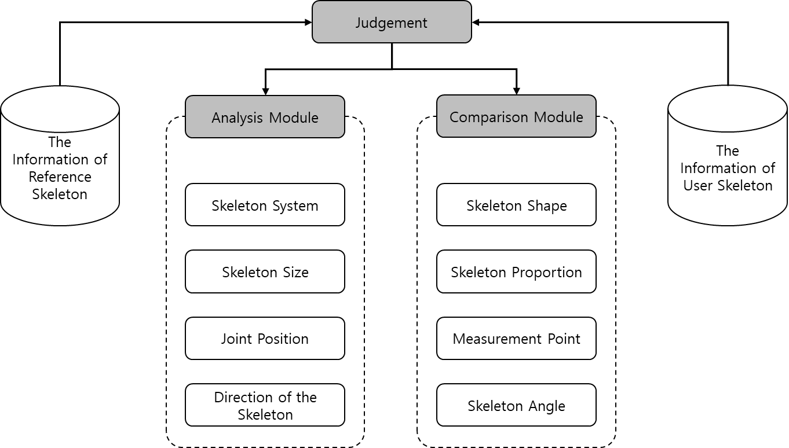
Figure 1. The judgement system architecture structure

The judgement system consists of ‘an analysis module’ and ‘a comparison module’ as shown in Figure 1.

    - Analysis module

The analytical module judges the information from skeletal information such as composition of skeleton, the size of skeleton, the position of joint and the direction of skeleton. Each item is analyzed through a comparison module with each confirmed information value.

    - Comparison module

The comparison module compares the data to be compared as shown in Figure 2. for the shape of skeleton, the proportion of skeleton, the measurement point, and the skeleton angle based on the data judged by the analysis module.
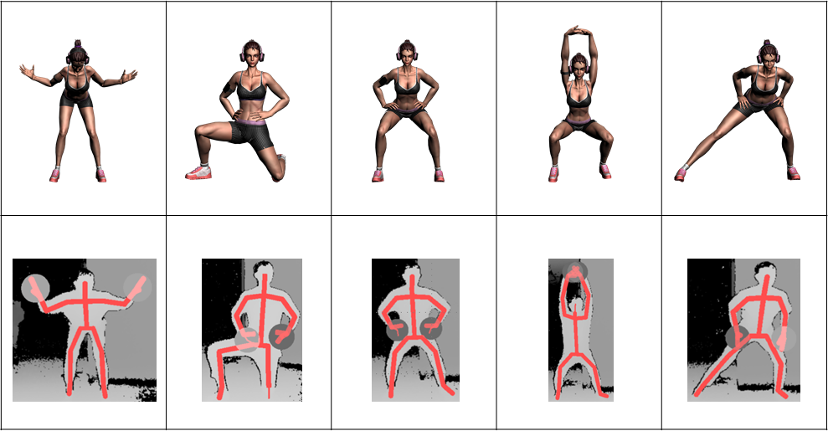
Figure 2. Comparison of user skeletal information with 3D characters

- Output processing section

‘The Output processing section’ provides a graphical of sound-type user interface for results processed by ‘the Input processing section’. This standard refers only to graphical user interfaces.

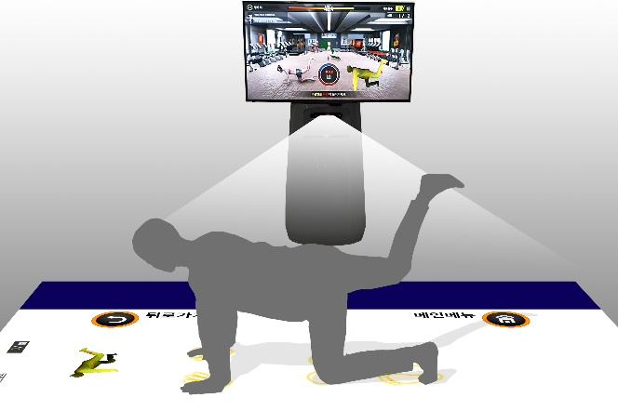 | 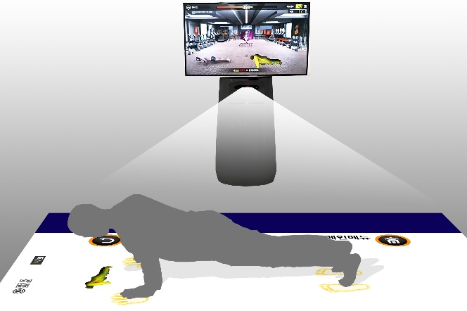

Figure 3. Examples of use
As shown in Figure 3. ‘Output processing section’ can be divided into ‘Screen output section’ using display panel and ‘Floor output section’ using projector.

  - Screen output section

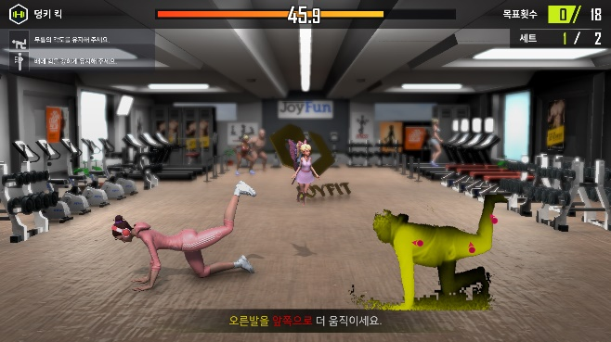 | 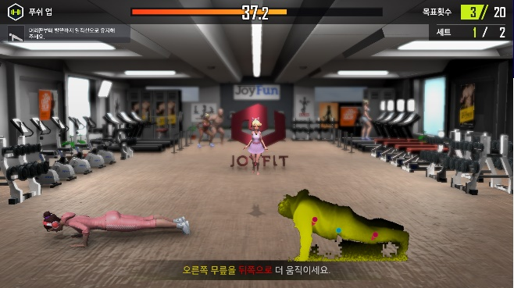

Figure 4. Example of a Screen output section

The screen output section is a device that outputs visual motion guide information to the user, as shown in Figure 4, and is displayed on the display panel of the mixed reality device.

  - Floor output section

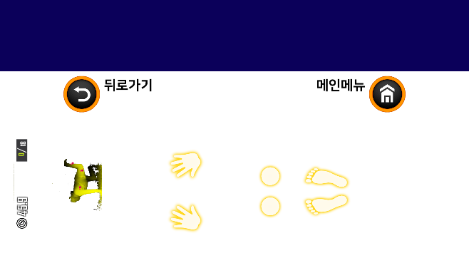 | 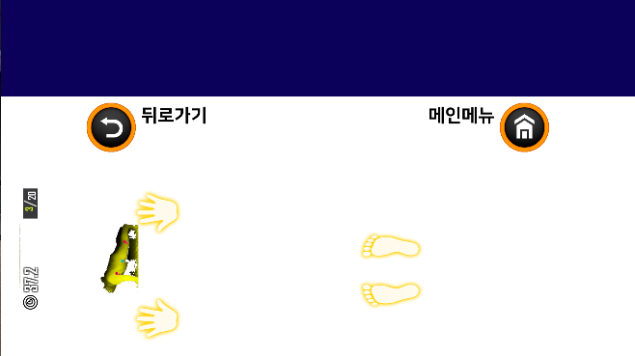

Figure 5. Example of Floor output section

The floor output section is a device that outputs spatial motion guide information that presents the position of the user’s feet, hands, etc., as shown in Figure 5, and is usually displayed on the floor through an image projector of a mixed-reality device.

- Posture correction information display interface

The right posture must be taken for postural correction. Therefore, the interface presents the information through displaying the direction on each body part which should be corrected to pose the right posture so that the user can intuitively correct their posture.

  - Screen output section correction information display interface

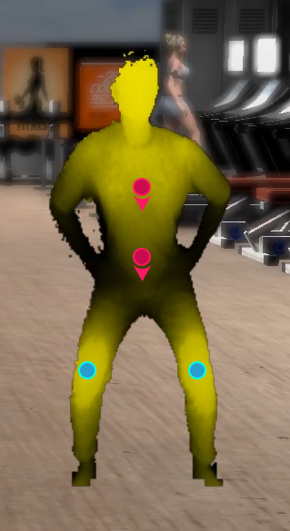 | 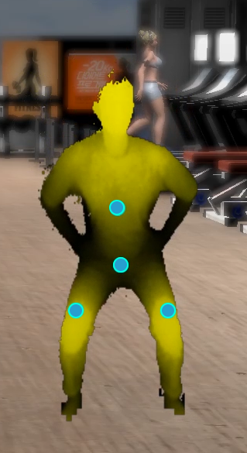

Figure 6. Example of half squat posture

The standing posture that can see the front, such as Figure 6, displays an outline or an image on the front screen output interface, and intuitively displays the direction to move by augmenting marks on each body part with arrow.
If each area is correctly positioned in the correct position, mark it in blue to indicate that it is well positioned in the calibration position.

  - Floor output section correction information display interface

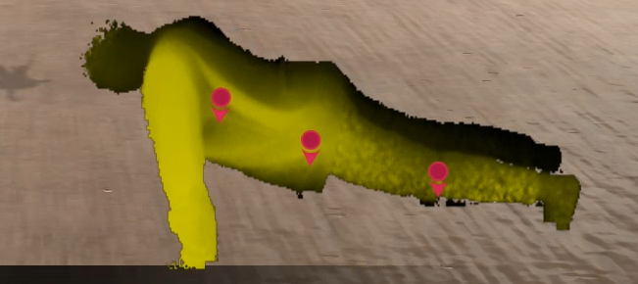 | 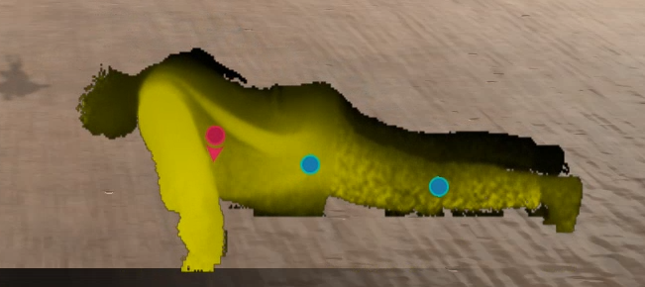

Figure 7. Example of a push-up posture correction

The posture that cannot see the front and should see the floor as shown in Figure 7. displays the user’s outline or an image on the floor output section, and intuitively displays the direction to move by augmenting marks on each body part with arrow.
If each area is correctly positioned in the correct position, mark it in blue to indicate that it is well positioned in the calibration position.

