Project | HMD based 3D Content Motion Sickness Reducing Technology  <http://sites.ieee.org/sagroups-3079/ >
Title | The review of the MTP latency sensing in complex VE
DCN | 3079-19-0035-00-0000
Date Submitted | October 6, 2019
Source(s) | Dong Soo Choi soochoi@dau.ac.kr (Dong-A University)  Sangkwon Peter Jeong ceo@joyfun.kr (JoyFun Inc.,)  Beom Ryeol Lee lbr@etri.re.kr (ETRI)
Re:
Abstract | This aim of this article is focused to quantify the role of VE scene content and resultant latency perception. Therefore, the visual scene was a pre-computed radiosity rendering of two interconnected rooms that include real-world object. We review the claim of this article which average JND should be less than 15ms for well-practiced participants learn to discriminate latency. We will analyze whether it is feasible in the industrial area.
Purpose | The purpose of this documents to review article that provide a claim for asserting that MTP latency should be less than 15ms regardless of the virtual condition from a single virtual object to more complex radiosity environment.
Notice | This document is offered as a basis for discussion and is not binding on the contributing individual(s) or organization(s). The material in this document is subject to change in form and content after further study. The contributor(s) reserve(s) the right to add, amend or withdraw material contained herein.
Release | The contributor grants a free, irrevocable license to the IEEE to incorporate material contained in this contribution, and any modifications thereof, in the creation of an IEEE Standards publication; to copyright in the IEEE’s name any IEEE Standards publication even though it may include portions of this contribution; and at the IEEE’s sole discretion to permit others to reproduce in whole or in part the resulting IEEE Standards publication. The contributor also acknowledges and accepts that IEEE 802.21 may make this contribution public.
Patent Policy | The contributor is familiar with IEEE patent policy, as stated in Section 6 of the IEEE-SA Standards Board bylaws <http://standards.ieee.org/guides/bylaws/sect6-7.html#6> and in Understanding Patent Issues During IEEE Standards Development http://standards.ieee.org/board/pat/faq.pdf

The review of the MTP latency sensing in complex VE

- Introduction

Bernard D. Adelstein et al. in NASA Ames Research Center insist that the Motion-to-Photon (MTP) Latency to be considered in VR sickness of HMD based VR contents is under the 17ms. And the authors of that group insist again in this article 『PERCEPTUAL SENSITIVITY TO HEAD TRACKING LATENCY IN VIRTUAL ENVIRONMENTS WITH VARING DEGREES OF SCENE COMPLEXITY』 the MTP latency should be under 15ms regardless of the given VE having a single virtual object or a complex real-world setting such as radiosity-rendered scene of two interconnected rooms.
Since the VE is becoming more and more complex like the real world, MTP latency in simple or complex VE is important and this article needs to be investigated.
Due to the article reported in 2004, we would like to exam whether there are any missed points or overlooked more important parameters. In addition, we should consider if the article is so perfect that there is no doubt or not.
We should discuss which experimental results are appropriate to accept reliably based on both articles.

- Main issues of this article

The experimental environment and VE conditions were different between article in 2003 and 2004. These results should be reviewed to determine which of the two experiments is more statistically significant and to ensure validity.
We are going to review the article reported in 2004 from a present point of view, with a focus on the results of data, methods and the reliability of the experiment itself.
Moreover, our aim is to certify the practical validity of the article by processing of verifying experiment for the potential issues through recent new arguments and experiment methods.
We might expect observers to be more sensitive to the visual consequences of latency when viewing a scene representing what could be a real-world space because there could be an inherent association with how the real world is perceived.
This study’s scene presented a much more complex VE than we had used previously, and included a much greater variety and number of contours, textures and depth planes.

- Objectives of Experiment
- To quantify the latency that a VE system can exhibit without being perceptible to the user.
- To quantify the role of VE scene content and Virtual Environment (VE) relative object motion on perceptual sensitivity to VE Latency
- To exam latency detection by presenting HMD with environments having differing levels of complexity ranging from simple geometrical objects to realistic immersing like a radiosity-rendered scene of two interconnected rooms
- To compare Latency discrimination with results from previous study
- To elucidate latency perception mechanism
- To guide VE designers in the development of latency countermeasures

- Theoretical background based on Psychophysics
- Psychophysics: An area of perceptual psychology that specific behavioral methods to study the relation between physical stimulus intensity and sensation reported by a human observer.
- Psychometric function: A specific application of the generalized linear model(GLM) to psychophysical data. The probability of response is related to a linear combination of predictors by means of a sigmoid link function (e.g. probit, logit, etc.)
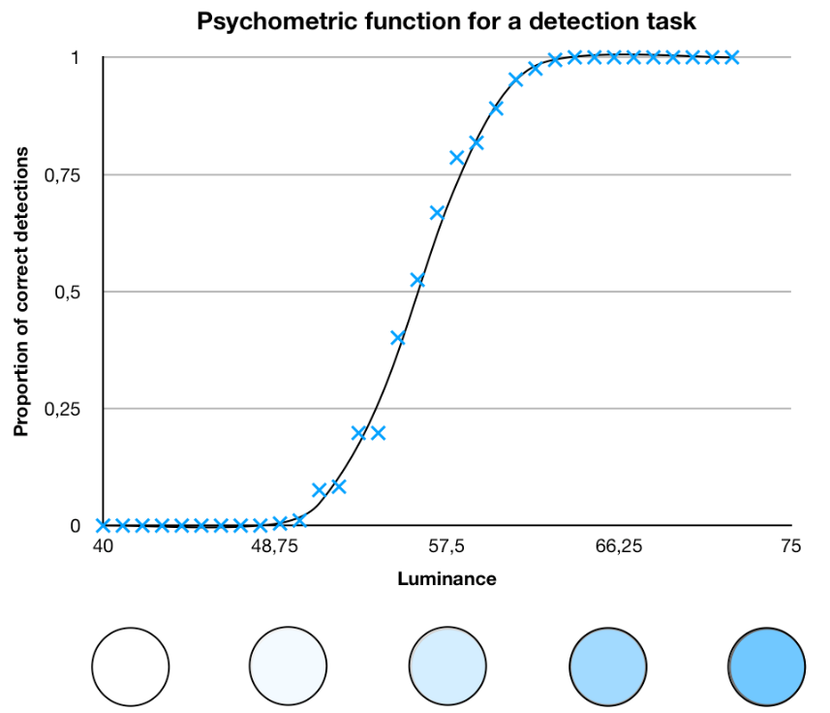
Figure 1. Simulated example of psychometric function (ref. Wikipedia)

- JND(Just Noticeable Difference): Difference threshold (DL) ins used interchangeably with JND. DL is defined the amount of change in a stimulus required to produce a just noticeable difference in sensation.
- The basic procedure for measuring thresholds: to present a stimulus to observers and asking them to report whether they perceive the stimulus. They are defined in a statistical manner because they are not deterministic.
- Measuring methods for psychophysical functions for the discrimination of latency: two-interval technique and two-alternative forced-choice (2AFC) technique.
- Two-interval: the reference stimulus (R) and the probe stimulus (P)
- 2AFC: The observers were forced to choose between whether the two viewed intervals were ‘different’ or the ‘same’.
- VE latency: the time lag between a user’s action in a VE and the system’s response to this action.
- The internal latency: The portion of the end-to-end interval ending at the top of the video frame when the first color channel activity is detected on the VGA input to the HMD. Internal latency excludes temporal component such as TFT-LCD in the V8. Internal latency has a magnitude resulting from the sum of processing and transport times along the single data path. Tabulated are the measured update rate and latency of each component as below
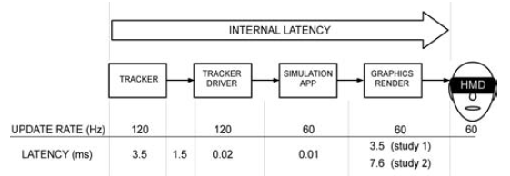
Figure 2. Internal VE latency

- Latin-square experimental design: n×n array filled with n different symbols
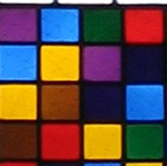
- ANOVA(Analysis of variance): A collection of statistical models and their associated variation among groups.
- Sign test: A statistical method to test for consistent differences between pairs of observations, such as the weight of subjects before and after treatment

- Experimental methods
- Participants – 10 (6M, 4F, ages 25~45)
  - All had participated in the previous study
  - All participants had normal or corrected to normal vision
  - All had no reported neuromotor impairment
  - All were naïve to the exact purpose of the experiment without 2 participants (author KM – participant #5, MH- participant #4)

- Apparatus
  - A single receiver: Polhemus FasTrak (motion sensing at 120 Hz)
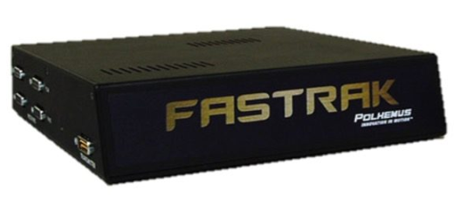
  - Virtual Research V8 HMD
- Resolution: All environments were displayed in stereo at VGA resolution (640×480 pixels)
- cf) Oculus Rift DK1: 640×480 = 8.44 arcmin/pixel,
Sony HMZ-T1: 1280×720 = 2.11 arcmin/pixel
- Resolution: 4.5 arcmin/pixel (FOV 48°H×36°V at 100% binocular overlap)
- Operated at a 60Hz (refresh frequency)
- TFT-LCD in the V8

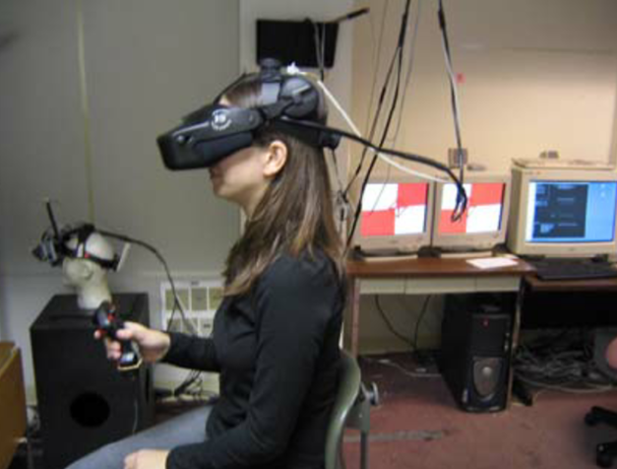
Figure 3. Experimental set-up

  - Software; application to interface to the FasTrak (a customized version of AuTrak by AuSIM, Inc.) and to model and render the experiment VE were written in Visual C++ under Windows 2000.
- All software ran on a Dell Precision 530 workstation equipped with dual 2.4 GHz Xeon Processors and an Nvidia 3D graphics card.
- Graphics card based on GeForce4 MX-440 GPU was used for simple VE(~ 100 polygon)
- Based on Nvidia GeForce FX-5900 GPU card was used for complex radiosity VE (~ 35,000polygons)

  - The internal latency:
- For the simple environments on the MX-440 GPU, the latency of ~8.5ms was maintained.
- For the complex environments on the FX-5900 GPU, the latency of ~12.5ms was maintained.
- GPU: MX-440 GPU baseline ~8.5 ms / FX-5900 GPU baseline ~12.5ms

  - Object; 3 simple and complex VE
- Synthetic VE with differing levels of graphical complexity for extending the generality of the results for participant sensitivity latency in VE
- 3 visual conditions within subjects according to a Latin-square experiment design
- A 2m diameter faceted sphere, a hollow octahedral frame and environment including both the sphere and octahedron
cf) only a single simple object such as a faceted sphere or a hollow-framed octahedron against an empty black background in previous study
- Pre-computed radiosity rendering of two interconnected rooms (4×4m each) with objects placed at various heights.
- The 2 rooms were connected by a wall with a large opening.
- The room was fixed at eye height, with the far wall (~6m) from the seated participant’s head yaw axis. (The room position was automatically adjusted for each participant’s eye height)

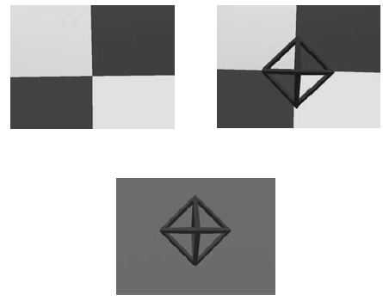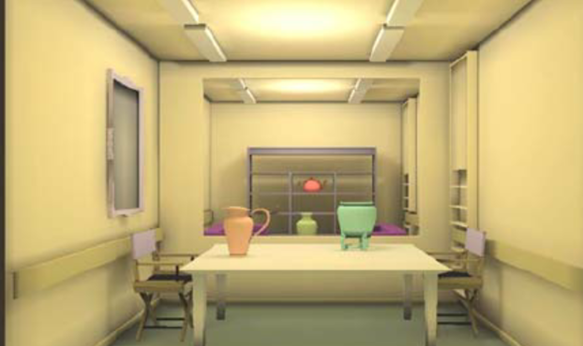
Figure 4. Experimental visual condition

- Procedure
The standard stimulus was based on the system’s 12.5ms minimum latency setting
  - The participants were instructed to yaw their head smoothly form side-to-side (with ~ 30°, -15° left to +15° right)
- Each visual scene would span the entire 48° horizontal FOV of the HMD, while still maintain the scene within view.
- If participants turned too far, the scene darkened by 58% to signal excessive rotation. (average rotation ranged between 20~30°)
- Subjects were paced side to side by computer-generated beep listening
- The interval between first and second beep establishes motion period
- Subject were paced by moving during the remaining time to complete two full back-and-forth cycles after listening to first two beep Moving as motion period
  - Latency conditions were presented in sequential pairs, one being a reference(R) and the other a probe level(P)
- Probe level= reference level + added latency
  - R and P presentation order was pair-wise randomized
  - Using 3 button hand controller both to signal their 2AFC response, participants advance the next stimulus pair.
  - We employed an adaptive staircase method (two-down, one-up (2D-1U), begin with a latency step size of 66.7ms).
- The procedure began with a latency step size of 66.7ms that was halves at each reversal until reaching a final step size of 8.3ms (resolution of this VE tracker)
- The procedure continued through 7 more reversals.
- A single scripted block comprised of three paired staircases.
  - For the complex radiosity environment, the reference stimulus was set to a stable internal latency of 13.5ms (> 12.5ms baseline) in order to ensure running at the VE system’s maximum 60Hz effective frame rate.
  - Participants were given an explanation of latency.
- Participants were instructed to report any apparent differences between stimulus pairs such as delay, visual lag, oscillation or visual instability of scene.
- Participants took rest breaks every 10~15 min.
- All participants were highly practiced approximately 19~24 hours each, sometimes spread over a few weeks in laboratory.

- Results
- The 2D-1U staircase has a theoretical setting level that corresponds to the 70.7% threshold, which is helpful for exploring the region of the underlying psychometric function between the 50% PSE and 75% JND.
- The JNDs and PSEs for 10 participants were respectively 9.1±1.6ms and 14.3±2.7ms(mean±standard error).
- The statistical significance of any differences between was investigated by ANOVA.
- The null hypothesis is typically rejected when the probability that a result occurring under it is less than 0.05.
- ANOVAs did not show statistically significant difference for JND and PSE from the 3 viewing condition
- The reduction seen in eight of the nine participants was significant by sign test but this significant pattern for JND and PSE was unchanged by removal of author KM’s data.

- The issues that need to be investigated

Consider the key issues identified in Part II, particularly those that should be considered form the current perspective.

Classification | Contents | Remarks
- Experimental Validity | Is the experiment an appropriate method to measure MTP Latency?
 | Are there any other experimental methods for measuring MTP Latency?
 | What is the theoretical background for the validity of this experiment?
- Progressiveness of Experimental Technology | Is there any difference in the sophistication between technical equipment at that time and current technology?
 | Are there any advances in experimental methods?
 | Have any of experimental methods been found to be advanced in this article?
- Reliability of Experimental Results | Is the number of samples appropriate?
 | Were factors besides experimental parameters properly controlled?
 | Is the method of experimental significant?
 | Is the results of the experiment reliable?

- Conclusions

We can draw the following conclusions based on the experimental results of reviewing this article.

- Although no detailed experimental data was shown, it was inferred that the average JND should be less than 15ms for well-practiced participants learn to discriminate latency.
- The experiment could not be performed elaborately due to the unsophisticated equipment added latency in addition to the inherent VE time lag.
- It was analyzed that the difference in the latency detection depending on whether it is a single virtual object or an FOV-filling background in VE was not statistically significant, but it is difficult to discuss reliability with just 10 participants.
- The equipment having 60 Hz update rate was used the same as previous study. This is an external factor that can cause errors in data. The newest equipment has performance above 120 Hz, thus reducing additional latency, therefore, more detailed experiments can be inducted.
- The radiosity-rendered scene depicting a meaningful real-world setting did not have a statistically significant impact.
- The current FOV of HMD is much wider. Therefore, it is possible to assume that the new HMD will be less affected by latency than the V8 HMD used in this article.
- Head motion and psychophysical tasks were performed without explicitly providing error-correcting feedback to participants.

