|  |  |
| --- | --- |
| Project | **HMD based 3D Content Motion Sickness Reducing Technology**  <<http://sites.ieee.org/sagroups-3079/> **>** |
| Title | **The Analysis of Head Tracking Latency in Psychophysics** |
| DCN | **3079-19-0034-00-0000** |
| Date Submitted | **October 4, 2019** |
| Source(s) | **Dong Soo Choi** [soochoi@dau.ac.kr](mailto:soochoi@dau.ac.kr) **(Dong-A University)**  **Sangkwon Peter Jeong** [ceo@joyfun.kr](mailto:ceo@joyfun.kr) **(JoyFun Inc.,)** |
| Re: |  |
| Abstract | In order to review the reference that inferred the claim that MTP Latency should be less than 17ms, we analyzed the experimental materials and methods and carefully examined what was overlooked for parameters during procedure such as the characteristics in subjects like gender and age, etc., apparatus specification, and data analysis. Furthermore, we look into what should be done if it will be verified through reliable procedure for industrial area. |
| Purpose | This document aims to review reference article that provide evidence for claiming that the MTP Latency should be less that 17ms, to examine the need for proof, and to estimate the results. |
| Notice | This document is offered as a basis for discussion and is not binding on the contributing individual(s) or organization(s). The material in this document is subject to change in form and content after further study. The contributor(s) reserve(s) the right to add, amend or withdraw material contained herein. |
| Release | The contributor grants a free, irrevocable license to the IEEE to incorporate material contained in this contribution, and any modifications thereof, in the creation of an IEEE Standards publication; to copyright in the IEEE’s name any IEEE Standards publication even though it may include portions of this contribution; and at the IEEE’s sole discretion to permit others to reproduce in whole or in part the resulting IEEE Standards publication. The contributor also acknowledges and accepts that IEEE 802.21 may make this contribution public. |
| Patent Policy | The contributor is familiar with IEEE patent policy, as stated in [Section 6 of the IEEE-SA Standards Board bylaws](http://standards.ieee.org/guides/opman/sect6.html#6.3) <[http://standards.ieee.org/guides/bylaws/sect6-7.html#6](http://127.0.0.1:4664/cache?event_id=757737&schema_id=1&s=5X0vID10lu_E6yrIkWkNd4Wz2H8&q=hancock)> and in *Understanding Patent Issues During IEEE Standards Development* <http://standards.ieee.org/board/pat/faq.pdf> |

**The Analysis of Head Tracking Latency in Psychophysics**

1. **Introduction**

Motion-to-Photon(MTP) latency should be less than 17ms has known as the reference in Virtual Environments(VE), since 『HEAD TRACKING LATENCY IN VIRTUAL ENVIRONMENTS: PSYCHOPHYSICS AND A MODEL』 has been reported by Bernard D. Adelstein et al., in NASA Ames Research Center.

Up to now, this reference is known to present the limit time of MTP latency, which is considered to be a very important cause among many reasons for preventing VR sickness caused by VR contents.

John D. Carmack II of Oculus insisted that MTP latency is less than 20ms to apply to the HMD product. However, there is no evidence for his claim.

Therefore, it is essential to review of Bernard et al.’s article in detail, which provides the data for experimental procedure.

Due to the article reported by Bernard et al. in 2003, we would like to exam whether there are any missed points or overlooked more important parameters. In addition, we should consider if the article is so perfect that there is no doubt or not.

1. **Main Issues of this article**

At the present time, we will investigate the results, methods and the reliability of the experiment itself in detail from this article which was reported in 2003.

Moreover, our aim is to certify the practical validity of the article by processing of verifying experiment for the potential issues through recent new arguments and experiment methods.

1. Objective of experiment

* Quantification of perceptual sensitivity to latency in Virtual Environment (VE)
* Elucidation of the mechanism by which latency is perceived
* Suggestion of guideline for development of countermeasures by VE designer and system engineers

1. Theoretical background

* Weber’s law: also called Weber-Fechner law, historically important psychological law quantifying the perception of change in a given stimulus. The law states that the change in a stimulus that will be just noticeable is a constant ratio of the original stimulus. It has been shown no to hold for extremes of stimulation.
* Method of Constant Stimuli: The threshold is determined by presenting the observer with a set of stimuli of which some are above the threshold and of which some are below the threshold but that the set of stimuli are presented in a random order. This technique prevents the observer from being able to predict what the next stimulus will be.
* Method of limits: In experiments, the ascending and descending methods are used alternately and the thresholds are averaged. In the ascending method of limits, some property of the stimulus starts out at a level so low that the stimulus could not be detected, then this level is gradually increased until the particular reports that they are aware of it. In the descending method of limits, this is reversed.
* JND(Just Noticeable Difference): The amount something must be changed in order for a difference to be noticeable, detectable at least half the time (50% is usually used for p in the comparison task).
* PSE(Point of Subjective Equality): At the point of subjective equality, the subject perceives the two stimuli to be the same.
* Probit: probability unit
* ANOVA(Analysis of variance): A collection of statistical models and their associated variation among groups.
* Three Pedestal Latency is setting at 33, 100, 200ms.[1]
* Image Slip: the virtual scene’s artifactual concomitant motion with the observer’s head resulting from time lag.
* FOV(Field Of View): the sense of restriction to what is visible by external virtual reality goggles. In other words, the range that can obtained when moving the sensor. It much correlated with 3D motion sickness. (depending on the products, they have FOV of 90 ~ 150°, e.g.; ~ 96° for Samsung Gear VR, ~ 100° for PlayStation VR, and ~110° for Oculus Rift and HTC VIVE)

1. Procedure

* Subject – 11 observers (M 9, F 2, age 20~29)
  + With the exception of one subject (author: Thomas G. Lee), all were naïve to the exact purpose of the experiment.
  + One subject had extensive experience in a previous latency study.
  + All had normal or corrected to normal vision.
  + All participants were highly practiced, having spent approximately 20~40 hours spread out over several weeks in the VE.
* Apparatus
  + Virtual Research V8 HMD (horizontal FOV 48°)
  + Resolution: 640×480



* + A single receiver: Polhemus FASTRACK (Head motion was tracked at 120 Hz)

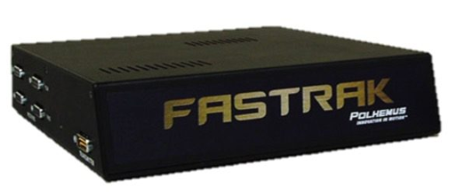

* To fix to a benchtop in laboratory at eye-height ~80 cm in front of the seated viewer’s head yaw axis.
  + Object; blue octahedral frame (apexes aligned vertically)

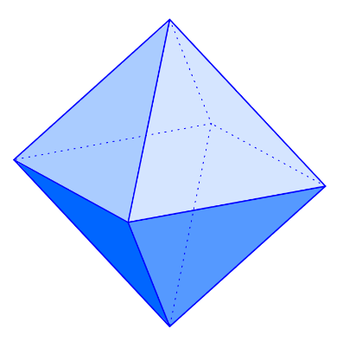

* The position of the virtual octahedron occupied a horizontal visual angle 6°.

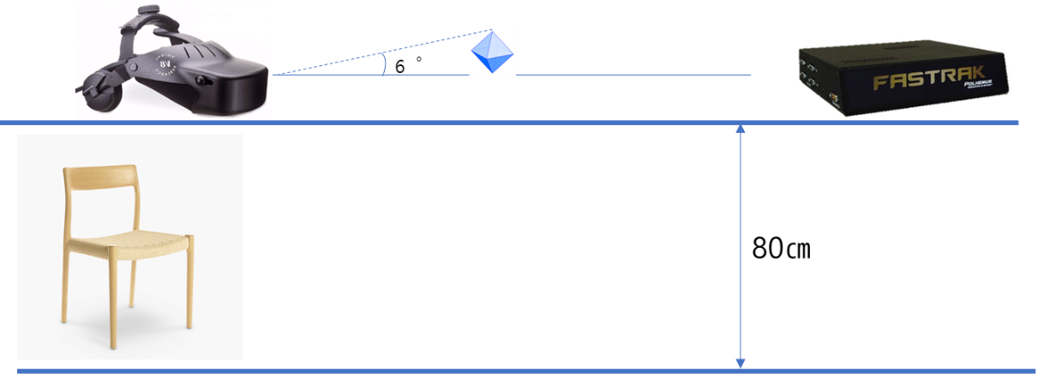

* + Software; VE software developed using Sense8's WTK API
  + The software ran on a 4-CPU dual-pipeline SGI Onyx computer with RE-2 graphics. (Reality Engine 2 – the original high-end graphics subsystem for the Onyx)
  + custom tracker driver and multi-processing shared-memory architecture (ensured a base latency: 33±5ms, 60 Hz update rate)
* Procedure
  + The subjects were instructed to yaw their head smoothly and sinusoidally from site-to-side (36°end-to-end; left -18° ~ right +18°)
* virtual octahedron remains fully visible within 36° while its motion spanned HMD’s entire 48°horizontal FOV
* Subjects were paced side to side by computer-generated beep listening
* The interval between first and second beep establishes motion period
* Subject were paced by moving during the remaining time to complete two full back-and-forth cycles after listening to first two beep Moving as motion period

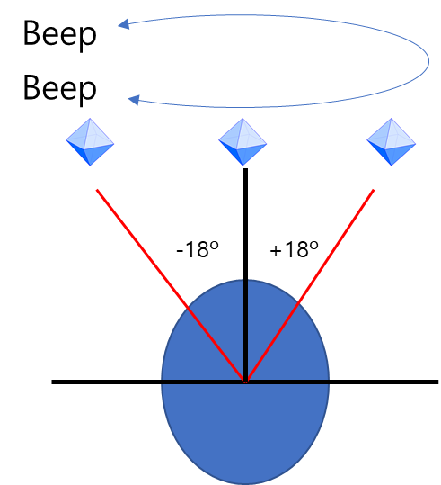

* + Latency conditions were presented in sequential pairs, one being a reference(R) and the other a probe level(P)
* Probe level= reference level + added latency
  + R and P presentation order was pair-wise randomized
  + Using 3 button hand controller, subjects advance from one condition to the next.
  + Subjects input their two-alternative forced-choice response as to whether the intervals were the ‘same’ or ‘different’
  + No instructions were given concerning features to be used in making this judgement so subjects were free to form their own criteria.
  + The judgements advanced according to a staircase algorithm (Method of Limits) with uniform 16.7ms increments.
  + The increment size was limited by the HMD’s and VE application’s 60 Hz update rate.
  + Sessions comprised a single scripted set of 18 staircases.
  + The staircase combines three ascending and three descending staircases for each of three (33, 100, 200ms) R levels. (6×3=18)
  + Descending staircase begins with a randomly selected latency of 117, 133, or 150msadded to R.
  + The process ends when the subject responds that the paired stimuli are the same.
  + Ascending staircase begins with between one and three (randomly selected) repetitions of zero added latency during which P and R matched and end when the subjects report the paired stimuli to be different.
  + Subjects complete 2~4 sessions per day, with never more than two hours VE exposure per day, including breaks between sessions and individual staircase runs.
* The reason for this procedure is presumed to reflect the concern about the occurrence of errors in the experimental results due to the sickness and insensitivity of experience.
  + For one-half of the study, subjects operated with a single 1 s beep interval (0.5 Hz yaw cycle) and in the other half, three beep intervals of 0.5, 1 and 2s were employed (1, 0.5, 0.25 Hz)



Figure 1. Model of Image Slip for Sinusoidal Head Motion

* In the Figure1, Input Motion was paced for 2s by sinusoidal head motion for -18~+18°. (at 0.5 Hz with base latency 33ms + additional 16.7ms delay increments)
* The delayed display image depending on the angular displacement is indicated by a dotted line.
* Image slip is represented by the difference between ‘Input Motion’ and ‘Delayed Display’.



Figure 2. The time difference between the input motion and the displayed consequence causes the image slip

* Because of inherent VE time lag and experimentally added latency, subjects input head motion results in delayed motion in the display.
* The time difference between the input motion and the displayed consequence causes the image slip.
* The magnitude of the slip grows as the number of added delay steps increases from 0 to 5.
* The aspect of the image slip depends on the frequency of the head motion.

1. Experimental Results

* For group comparison among the two experiments, the results showed statistically significant results for the 33 and 100ms latency pedestals, while the absence of a significant result for the 200ms.
* The absence of a significant JND interaction at 200ms can be discussed two causes.
* For 1 Hz pacing condition, the 200ms pedestal, incremental changes in image slip become less distinct from those at the lower pedestals.
* At a such long latencies, image slip exceeds 32° (2/3 of HMD horizontal FOV), making it difficult to view the target octahedron throughout the full extent of the motion.

1. **The issues that need to be investigated**

Consider the key issues identified in Part II, particularly those that should be considered form the current perspective.

|  |  |  |
| --- | --- | --- |
| Classification | Contents | Remarks |
| 1. Experimental Validity | Is the experiment an appropriate method to measure MTP Latency? |  |
| Are there any other experimental methods for measuring MTP Latency? |  |
| What is the theoretical background for the validity of this experiment? |  |
| 1. Progressiveness of Experimental Technology | Is there any difference in the sophistication between technical equipment at that time and current technology? |  |
| Are there any advances in experimental methods? |  |
| Have any of experimental methods been found to be advanced in this article? |  |
| 1. Reliability of Experimental Results | Is the number of samples appropriate? | The number of samples which is statistically valid is at least 30 |
| Were factors besides experimental parameters properly controlled? |  |
| Is the method of experimental significant? |  |
| Is the inference of the experiment reliable? |  |

1. **Conclusions**

We can draw the following conclusions based on the experimental results of reviewing this article.

1. The experiment could not be performed elaborately due to the unsophisticated equipment added latency in addition to the inherent VE time lag.
2. There should be at least 30 subjects in order to analyze a statistically normal distribution, however, since only 11 subjects participated, the statistically significant reliability is difficult to discuss.
3. There was no choice but to add an additional 16.7ms latency increments to the pedestal latency of 30, 100, and 200ms due to the equipment having 60 Hz update rate. This is an external factor that can cause errors in data. The newest equipment has performance above 120 Hz, thus reducing additional latency, therefore, more detailed experiments can be inducted.
4. The reason why blue octahedral frame was used when measuring image slip is omitted from this article. In this regard, it is also necessary to consider whether we can get different results if we use an alternative virtual image.
5. The current FOV of HMD is much wider than in 2003. Therefore, it is possible to assume that the new HMD will be less affected by latency than the V8 HMD used in this article.
6. We could find out that experiments about latency discrimination in VE. The subjects of the experiments varied from the normal to priority person. Nevertheless, there seems to be no significant difference in the experimental method itself. Therefore, we can consider modifying the actual equipment and virtual objects fitted into current technology while maintaining the experimental method.

1. Perceptual Sensitivity to Head Tracking Latency in Virtual Environments with Varying Degrees of Scene Complexity, Bernard D. Adelstein, 2004, P40