Project | HMD based 3D Content Motion Sickness Reducing Technology  <http://sites.ieee.org/sagroups-3079/ >
Title | Technical issues of 360º VR Scene on Web environment
DCN | 3079-18-0037-00-0002
Date Submitted | July 16, 2018
Source(s) | Kwan-Hee Yoo khyoo@chungbuk.ac.kr (Chungbuk National University)
Re:
Abstract | Since the 360º virtual reality (VR) can provide the experience of virtual reality for users in various web environments, there are still some technical issues related to the process of producing 360º VR scene. There are three categories of procedures for making possible the 360º VR scene on web environment. First issue is to take and produce 360º photos which are referred to the work of using camera to capture the real-world environment. Second issue is referred to mapping between capturing 360º photos and virtual environment and the third issue is manipulating and rendering of VR scene.
Purpose | This document deals with technical issues related to the process of producing 360º VR scene.
Notice | This document is offered as a basis for discussion and is not binding on the contributing individual(s) or organization(s). The material in this document is subject to change in form and content after further study. The contributor(s) reserve(s) the right to add, amend or withdraw material contained herein.
Release | The contributor grants a free, irrevocable license to the IEEE to incorporate material contained in this contribution, and any modifications thereof, in the creation of an IEEE Standards publication; to copyright in the IEEE’s name any IEEE Standards publication even though it may include portions of this contribution; and at the IEEE’s sole discretion to permit others to reproduce in whole or in part the resulting IEEE Standards publication. The contributor also acknowledges and accepts that IEEE 802.21 may make this contribution public.
Patent Policy | The contributor is familiar with IEEE patent policy, as stated in Section 6 of the IEEE-SA Standards Board bylaws <http://standards.ieee.org/guides/bylaws/sect6-7.html#6> and in Understanding Patent Issues During IEEE Standards Development http://standards.ieee.org/board/pat/faq.pdf

Technical issues of 360º VR Scenes on Web environment

IEEE 3079 Plenary Meeting (16-19, July, 2018, USA)
Chheang Vuthea and Kwan-Hee Yoo (Chungbuk National University)

- Introduction

Since the 360º virtual reality (VR) can provide the experience of virtual reality for users in various web environments, there are still some technical issues related to the process of producing 360º VR scene. There are three categories of procedures for making possible the 360º VR scene on web environment. First issue is to take and produce 360º photos which are referred to the work of using camera to capture the real-world environment. Second issue is referred to mapping between capturing 360º photos and virtual environment and the third issue is manipulating and rendering of VR scene.

- Applications of 360-degree VR Scene

-Virtual Tour
-Walking & Jogging
-Games
-Virtual Events
-Health

- Sickness in 360-degree Virtual Reality Scene

There are three types of VR sickness such as motion, simulator, and cyber sickness. These kinds of sickness are very similar that can be impacted to user while they are experiencing VR. However, they have very distinctive difference to cause the user.
Motion sickness is caused to user by the dislocation between the visual movement, and the vestibular system’s sense of movement. Motion sickness can be caused by motion that is felt but not seen, motion that is seen but not felt, and when both systems detect the motion but they are not corresponding. The simulator sickness is a subset of motion sickness that most of users experience after the use of simulator’s types. Most simulators cannot accurately produce the correct amount of movement to correspond the movement. Besides the motion and simulator sickness, cyber sickness is a third type of motion sickness. Cyber sickness is mostly caused by using a VR system while user’s body is stationary. Most of VR systems allow the user to walk in the virtual reality but the user in the real world is standing or sitting in a stationary position. And the limitation of space for experiencing VR system are caused the cyber sickness, because of movement seen by the user’s eyes in the virtual environment is not felt by the user’s body in the real world. Cyber sickness is occurred as a result of conflicts between three sensory systems such as visual, vestibular, and proprioceptive.
Cyber sickness is known as virtual reality sickness, that is like a visually induced motion sickness. There are several theories that described why the brain caused us the physical discomfort due to the cyber sickness. The poison theory – when the scene of motion doesn’t match to the scene of sight, the brain may be reacting as if it’s been poisoned. The sensory conflict theory – the mismatch in inputs from the scene can cause a negative physical reaction. And the postural instability theory – the critical behavior of human is to minimize movement that are related to the environment, so the result can be caused in a negative reaction. Furthermore, there are many factors that are contributed for cybersickness such as age, postural stability, ethnicity, flicker frequency, experience, gender, health, mental rotation ability, field dependence/independence, and motion sickness sensitivity.
The following technical factors are the causes of virtual reality motion sickness.
- Quality of images
The quality of image is one of the reasons that cause the sickness in virtual reality. It can be affected to human’s balance and control. The vestibule is renown for influencing control, balance, and posture. The posture and balance are influenced by simulation of sensory system such as hearing, vision, and touch. The interaction between the vestibule and other sensory systems sometimes doesn’t work perfectly with the virtual reality environment especially quality of images and the delay between image and head movement.
- Gaze Stabilization
The virtual reality system should consider about gaze stabilization that the eyes have to be stabilized to the object that is being viewed in VR. The positions of object which is viewed by user’s eyes can set in the way that users can look straight ahead, 45 degrees towards the right, 45 degrees towards the left, and others. That is, when the head moves in a particular direction, the vestibular system of human feels the movement.
- Vection
Vection is referred to a phenomenon that occurs when the user feels like his/her body while moving when no movement is taking place. There are two types of vection which are commonly occurred in VR system such as circular and linear vection. The circular vection occurs when camera rotation, the scene is moving around the observer. And, linear vection is occurred when the viewed point approaches from the observer during linear directional movements.
- Moving of user’s position
The positions of user are tracked while walking in virtual reality, however if the tracked positions are not simulated in real-time with the positioning in VR, that will be caused the problem for user.

- Refresh rate
The refresh rate of images to display on screen is often not high enough when virtual reality sickness occurs. Since the refresh rate is slower than the human’s brain processes, it causes a discomfort between the processing rate and the refresh rate. That is, if the refresh rate is too slow it causes more acute cybersickness symptoms.

- Screen
The resolution, luminosity, and contrasts should be adjusted to avoid the eye fatigue. Moreover, the resolution on animation also can cause the users to experience the phenomenon. Since the animations are poor, it causes many types of discord to what is expected and what is actually happening on the screen.

- Visual stress
The use of a stereoscopic screen can provoke the visual stress. Since a minimal change in the position of the helmet on the head can make a significant impact to the convergence of the eyes.

- The weight of helmet can also cause the physical symptoms. The lighter helmets can be used to avoid those kinds of problems.

- Temporal delay
The delay of head movements and corresponding content that will be appeared on the screen are also caused the conflict between visual and vestibular perception. Furthermore, network delay and data loading can be caused.

- Individual differences in susceptibility
Some of the factors in virtual reality sickness can be caused by individual differences in their susceptibility such as age, postural stability, flicker fusion frequency threshold, experience with the system, gender, health, mental rotation ability, field dependence/independence, and motion sickness sensitivity.

- Taking & Producing 360o photos

The work of taking 360º photos might be easy by using 360º camera devices such as Richo theta, Samsung Gear 360, Insta 360, and so on. However, since the user wants to use general camera device to capture the real-environment as 360º photo, it might be a bit difficult for them.
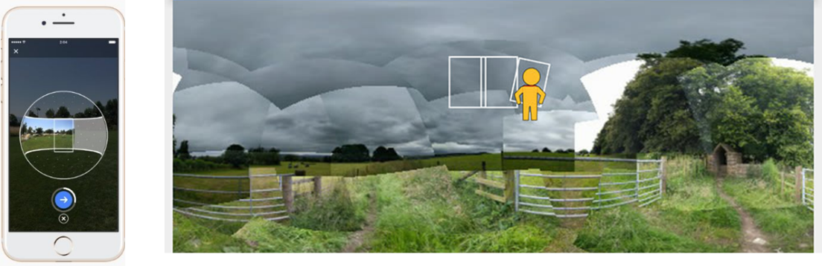
Figure 1 A 360º photo captures by using smart phone
Using smartphone for capturing photos is the convenience way for users, but capturing 360º photo is not quite the same with the taking normal photo. The photosphere can be constructed from surrounding photos that captured by smartphone as shown in Figure1. The application should guide the user with navigation points for capturing photo around him/her. Figure 2 describes the process of capturing photos with the target points. However, the combined photos have to be meshed and rendered to only one 360º photo. The process of stitching together is required a deep algorithm for high quality and correctly photos.
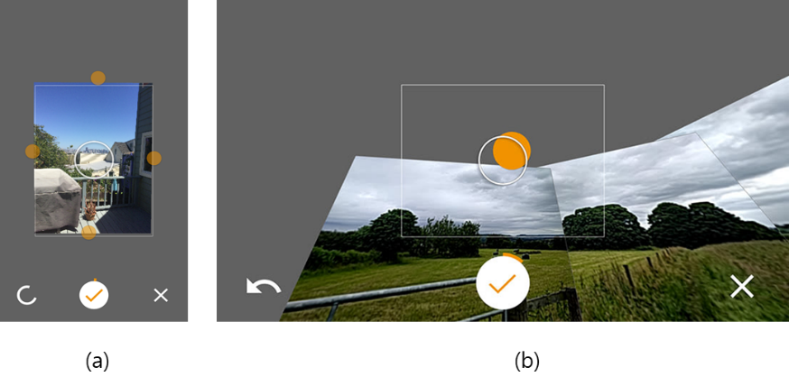
Figure 2 The points for guiding user to capture a 360º photo
For high-quality of photos, DSLR camera should be considered. Since DSLR camera is another choice for photo quality, it has been used to capture real-environment as 360-degree panoramic image. The process of capturing 360º photo with DSLR camera is required the equipment and technique for producing a high-quality 360º photo. The capturing requires making a panorama which covered 360 degrees horizontally and up to 180 degrees vertically. Furthermore, in order to create this panoramic image, we need to capture a series of overlapping images that can be stitched together by using third-party software.
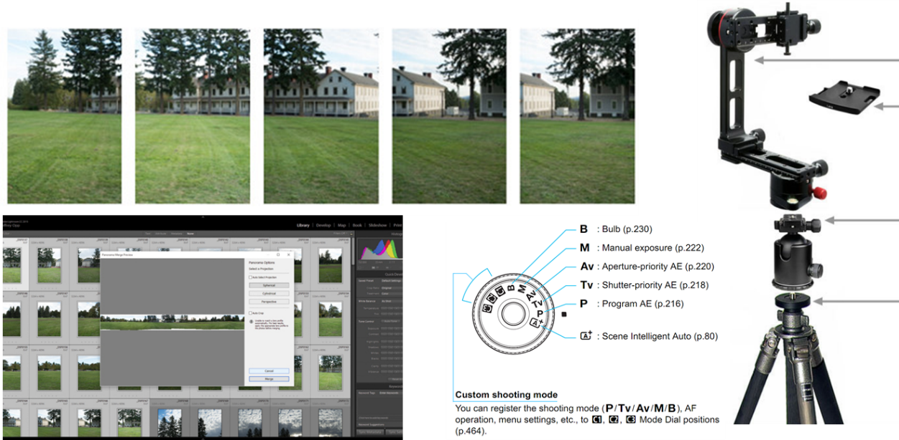
Figure 3 DSLR camera is used for capturing a high-quality 360ºphoto
Figure 3 shows the equipment which is used for capturing 360º photo by using DSLR camera. The capturing image should overlap the next by approximately 20% of a series images. The camera should stand vertically and shoot the photo around the horizontal axis. Moreover, there are still some issues on equipment setup and stitching those photos together for making 360º photo. Figure 4 (a) shows the blank spot while combing or stitching a series of capturing photo, and (b) shows the technique of equipment setup for DSLR camera to be used for capturing.
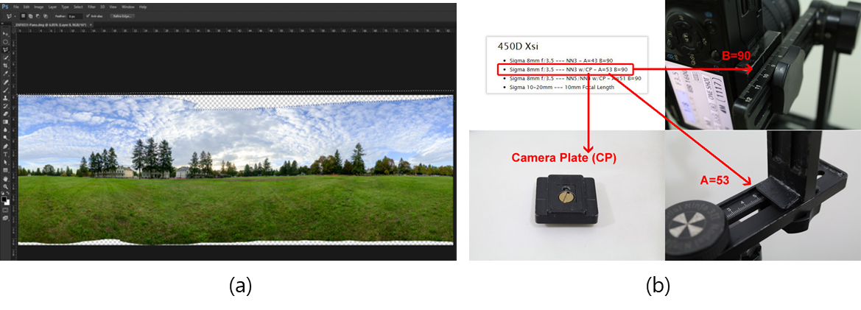
Figure 4 Blank spot and equipment setup of DSLR camera for capturing 360º photo
The issues of this category can be deal with the following criteria:
- Image quality of 360º photo which is captured by 360º camera or smartphone camera and the quality of image that is constructed by stitching into one large wide-angle image could be considered. The stitching algorithm is used to design and evaluate the quality of 360º image, better algorithms is the more better, accurate, and lightweight images.
- The photometric correction target errors which occur due to heterogeneous imaging hardware or environmental conditions among the capturing cameras.
- Parallax error can happen in spherical panorama image reproduction, when more than two images are combined or stitching together while producing the expanded viewing coverage of the image. The parallax error can be introduced when two sources of photographic images are acquired from an inconsistent viewpoint. Moreover, a parallax error that has slight difference in the viewing perspective would disallow multiple images to be combined correctly. That is, usually multiple images might be forced to compromise with certain levels of unwanted parallax error.
- Nadir angle generally known as the bottom side of the 360º photo, is difficult to be acquired correctly during the capturing and stitching process. It usually does not allow acquiring the nadir angle image due to the obstacle of the equipment that has blocked the viewing of nadir perspective.
- Dynamic range in 360º photo is referred to the capability of reproducing visual luminance from the real world. The shadow and highlight luminosity can be exceeded according to the recording capability of film negative or sensor in camera.

- Mapping 360o environment
After receiving 360º photos, the next process is about mapping those 360º photos to be mapped into virtual environment. The 360º virtual reality scene can be constructed by a cylindrical, spherical, or cubical panorama. Those environments are used to visualize the scene of 360º virtual reality based on their own specific features.
- Cylindrical Environment
The cylindrical environment offers only limited rotational freedom around the horizontal axis. Therefore, the user can turn around and see the views in a full circle which is the rotation around the vertical axis. By the way, the looking up and down is restricted. Figure 5 shows the cylindrical environment which is constructed by creating a cylinder and texture with the cylindrical panorama image.
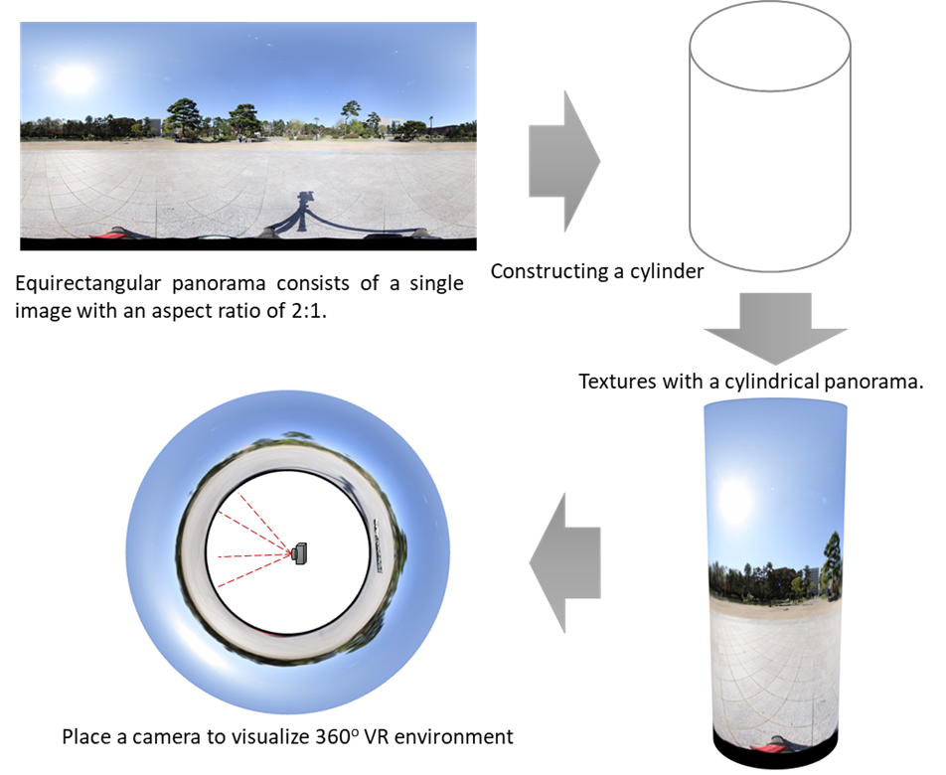
Figure 5 Cylindrical environment of 360º virtual reality
- Cubical Environment
Cubical environment of 360º virtual reality is constructed by six images for every face of a cube as shown in Figure 6. The cubic panorama is used to construct the cubical environment, and then place the user at its center. It also is known as skybox. In 2D layouts, the X-axis points to the right and the Y-axis points downs which means the top left is (0,0) and the bottom right will be the width and the height of the element at width and height.
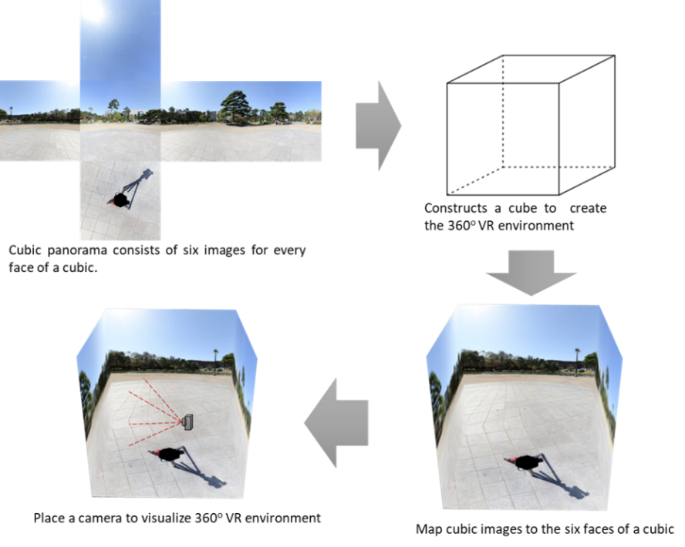
Figure 6 Cubical environment of 360º virtual reality
- Spherical Environment
Another process for visualizing 360º virtual reality is mapping with spherical environment. As 360º virtual reality can be constructed by the spherical environment, this kind of scene can provide the experience of virtual reality more immersive with every angle of views including top and bottom. The spherical environment constructs by creating a sphere and the user is located at its center. Furthermore, the equirectangular image is used to texture this environment.
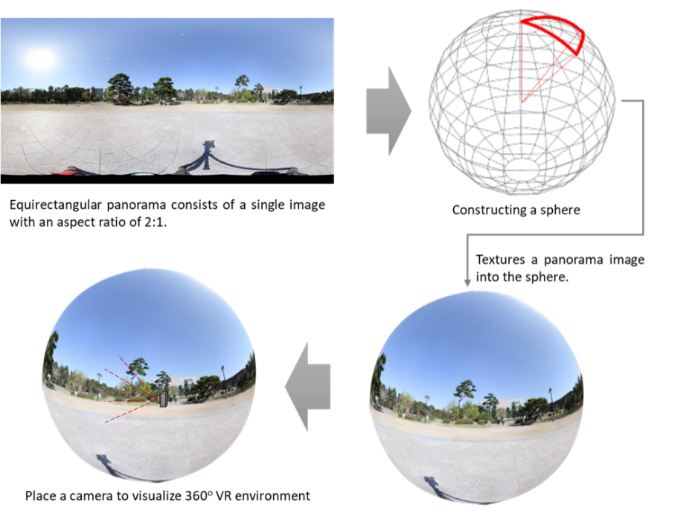
Figure 7 Spherical environment of 360º virtual reality

- Manipulating & Rendering
The last step of making 360º virtual reality scene are about manipulating and rendering the scene to web environment. The 360º photos and videos can be visualized to users by stereo vision technique. This includes the left and right viewpoint for displaying to each eyes of user. The key element for interaction to the virtual reality is to track the position of real world objects such as head tracking, side-by-side stereo rendering, spatial audio rendering, detecting user inputs (trigger), and so on. Those things should be considered in order to make user feel comfortable in virtual environment. Some cases, the stereo rendering is rendered without considering of user’s interpupillary distance (IPD) also cause the problems. Because the different distance of user’s IPD as shown in Figure 8, user can feel uncomfortable, motion sickness, and so on.
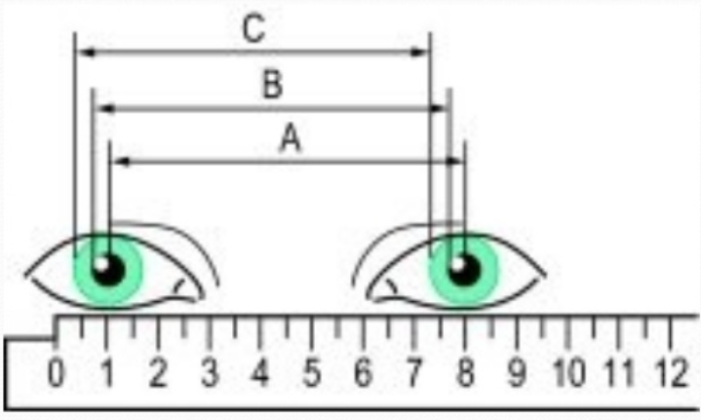
Figure 8 Inpterpupillary distance between two eyes
One of the hot technical issues in 360º virtual reality is delivering content of the scene at a high enough frame rate for accurate the user into feeling or believing that he/she is experiencing the virtual world. By using high-end VR headset, it requires the high processing and rendering capabilities of PC that is the hardware side. By the way, for software side, the target of frames per second (FPS) should be 90 FPS at all times. Most VR setup that generate the frame rate below 90 PFS, it may induce disorientation, nausea, and other negative user effect. To solve that, developer should consider this point and keep in mind that lower the frame rate is worse the effects.
In addition, health effects are still unknown for users. Many side effects are temporary cause to user such as motion sickness, but the long-term effects of VR are still unknown. The potential symptoms are seizures, loss of awareness, eye strain, eye or muscle twitching, involuntary movements, altered, blurred, or double vision or other visual abnormalities, dizziness, disorientation, impaired balance, impaired hand-eye coordination, excessive sweating, increased salivation, nausea, lightheadedness, discomfort or pain in the head or eyes, drowsiness, fatigue, and other symptoms similar to motion sickness. That is most of health and safety guidelines are suggested to take a rest at least a 10 to 15 minutes break for every 30 minute of use. Moreover, the VR developer should also consider the following criteria to avoid those kinds of effects to user.
- Avoiding quick acceleration or deceleration of camera movements, and using a constant velocity instead.
- Avoiding the use of depth of field or motion blur post processing because of not knowing where the eyes will focus.
- Avoiding sharp and/or unexpected camera rotations.
- Avoiding brightness changes (use low frequency textures or fog effects to create smooth lighting transitions).
- Intermittent disconnection of the network service, leading to false confidence in the currently presented information.
- Wearing an HMD device and being blind to potentially dangerous objects in the vicinity.
- Keep frame rate at least 90 FPS to avoid virtual reality sickness from wearing an HMD.
Besides that, another technical issue is referred to hardware capabilities. According to research and studies have shown that less than one percent of the 1.43 billion computers in the world meet the requirement of graphical capabilities for virtual reality. That means the VR headsets are required the high hardware capabilities such as CPU, graphic card, and so on. Not only computer, gaming console and smartphone are also required the high capabilities of hardware also.
Furthermore, the virtual reality is also a very bandwidth-intensive according to a research report released by Greenlight VR. Virtual reality is the most bandwidth-intensive technology in regard to streaming huge files without buffering and without imparting bandwidth.
Since 360º photos are used for visualizing the virtual reality, the photo size can cause the problem to load on web environment. That is, large photo might need times to load and visualize. It also can be caused by network problem, device specification, and graphic rendering. Therefore, tile based for mapping and rendering large size of image is the better idea to deal with this issue. This solution is simple, but not quite easy depending on environment mapping.
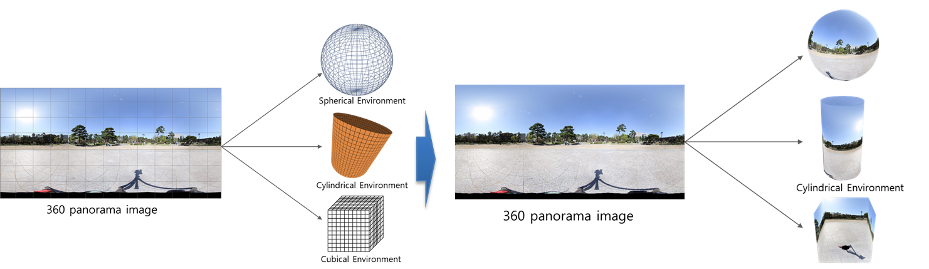
Figure 9 Tile based rendering for 360º VR environment
As shown in Figure 9 the 360º photo should be tiled to spherical environment, cylindrical, or cubical environment based on their aspect. Tile based might reduce the size of photo and loading time for visualizing 360º virtual reality on web environment. Figure 10 shows the process of tile based for VR environment mapping by splitting photo to specific pixels, then map them to the virtual reality environment, and render to web browser. In addition, the expectation size after using tile based mapping is described in table 1.

Table 1 Expectation size for 360º photo after using tile based mapping
Pixels | Resolution | Number of tiles | Size
88.6M | 13312x6656 | 26x13 | ~5M
22.2M | 6656x3328 | 13x7 | ~2M
5.5M | 3328x1664 | 7x4 | ~800K
1.4M | 1664x832 | 4x2 | ~300K
0.3M | 832x416 | 2x1 | ~90K

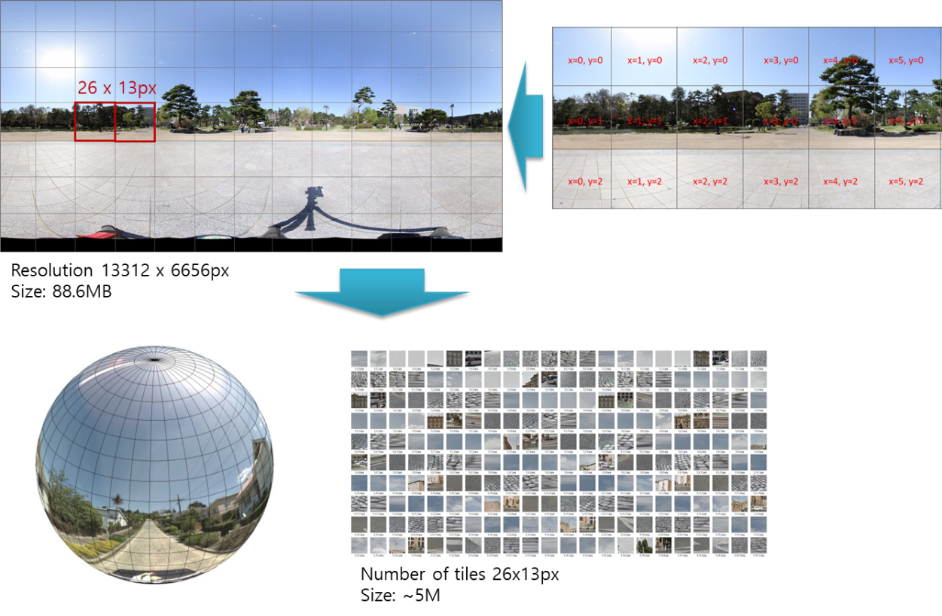
Figure 10 Tile based 360º VR environment mapping
- Walking routes of Multiple 360-degree VR Scenes
Moving from a 360-degree VR scene to another scene can be caused the sickness. That is, we need a design of walking routes for 360-degree VR for determining the nearest scenes. Figure 11 shows the map that can be design with the Voronoi diagram to calculate the space of 360-degree scene.
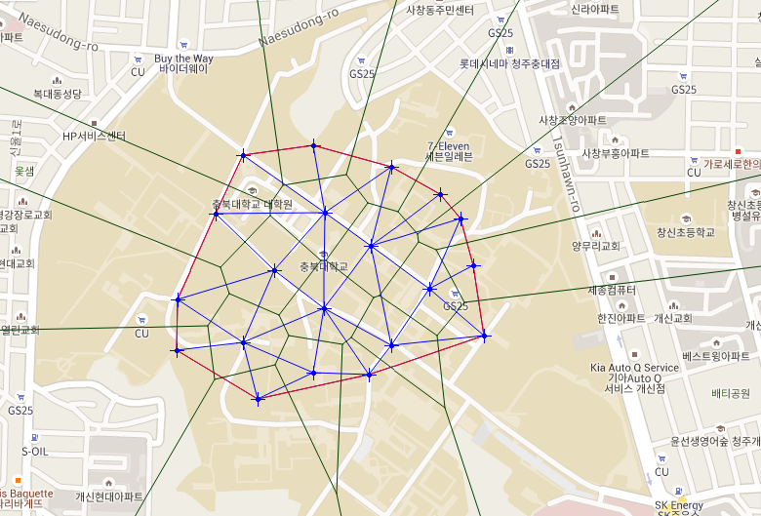
Figure 11 Walking routes of 360-degree VR

- Future Work
2D and 3D objects may be added into 360-degree VR scene. And the objects can be dynamically moved in the 360-degree VR scene. Methods to reduce VR sickness in the situation are needed.

