Project | HMD based VR Sickness Reducing Technology  <http://sites.ieee.org/sagroups-3079/ >
Title | Requirement specifications for design and implement VR content reducing VR sickness
DCN | 3079-18-0036-00-0002
Date Submitted | July 14, 2018
Source(s) | Beom-Ryeol Lee Lbr@etri.re.kr (ETRI)
Re:
Abstract | This document describes the user's point of view requirements and the system requirements and technical specifications required to produce VR content for VR sickness reduction. As a basis for implementing VR content without VR sickness, it also suggests a way to eliminate nausea, eye fatigue, and dizziness of users experiencing VR content. It also describes methods to ensure that users are comfortable with VR content for a long time.
Purpose | This document deals with the use requirements, user-driven scenarios and technical specifications for reducing VR sickness of VR content
Notice | This document has been prepared to assist the IEEE 802.21 Working Group. It is offered as a basis for discussion and is not binding on the contributing individual(s) or organization(s). The material in this document is subject to change in form and content after further study. The contributor(s) reserve(s) the right to add, amend or withdraw material contained herein.
Release | The contributor grants a free, irrevocable license to the IEEE to incorporate material contained in this contribution, and any modifications thereof, in the creation of an IEEE Standards publication; to copyright in the IEEE’s name any IEEE Standards publication even though it may include portions of this contribution; and at the IEEE’s sole discretion to permit others to reproduce in whole or in part the resulting IEEE Standards publication. The contributor also acknowledges and accepts that IEEE 802.21 may make this contribution public.
Patent Policy | The contributor is familiar with IEEE patent policy, as stated in Section 6 of the IEEE-SA Standards Board bylaws <http://standards.ieee.org/guides/bylaws/sect6-7.html#6> and in Understanding Patent Issues During IEEE Standards Development http://standards.ieee.org/board/pat/faq.pdf

Introduction

An important factor to boost VR industry is the designing and implementing VR content to reduce VR sickness.
When VR content are applied to reduce VR sickness, immersion of VR content can be reduced. Therefore applying reduction skills of VR sickness and controlling immersiveness of VR content are complementary to each other.
In order to design VR content for VR sickness reduction, three aspects should be considered. That is the view of content, HMD hardware, and human factors. In addition, three aspects of VR sickness should be applied in an integrated manner.
While users experience VR content, they may experience unintended nausea, eye fatigue, and dizziness. This presents a very serious problem from the perspective of users who enjoy VR content. VR content should also be able to reduce VR sickness without compromising VR content themes as it will cause VR sickness to be very severe for users to use VR content over time.
This document defines user requirements for the production of VR content to reduce VR sickness and describes the technical specifications of the system.

Overview

Purpose
This document contains user requirements and system specifications from the user's perspective of VR content to design and implement VR content to reduce VR sickness.

Scope
The scope contained in this document includes use-cases and scenarios for VR content creation for VR sickness reduction, and system requirements and technical specifications.
In uses-case 1 the topic is about VR sickness reduction for implementing VR content. It covers methods such as screen movement and change considerations, using head-motion for navigation, and setting the visual guides.
Use-case 2 deals with situations where VR content can be experienced for a long time more than a half hour without any burden on VR sickness. Even if VR sickness reduction method is applied, it needs to maintain sense of realism and immersion about VR content. While experiencing VR content, users should be able to maintain adequate immersion without VR sickness through proper VR sickness control. It should also be able to provide criteria for calculating VR sickness level for VR content.

Use Case

Use case for Content & SW

Classification of user
User | User’s role
Content designer | - Designing visual scene and stages for VR content
Content programmer | - Implementing rules and modules for VR content SW
Content player | - Playing VR content
Content evaluator | - Test VR content and evaluate the CSL of the VR content

Use Case Summary
Cases | Descriptions | Remarks
Use case 1 | VR contents should be able to reduce feeling of nausea, eye fatigue, and dizziness.  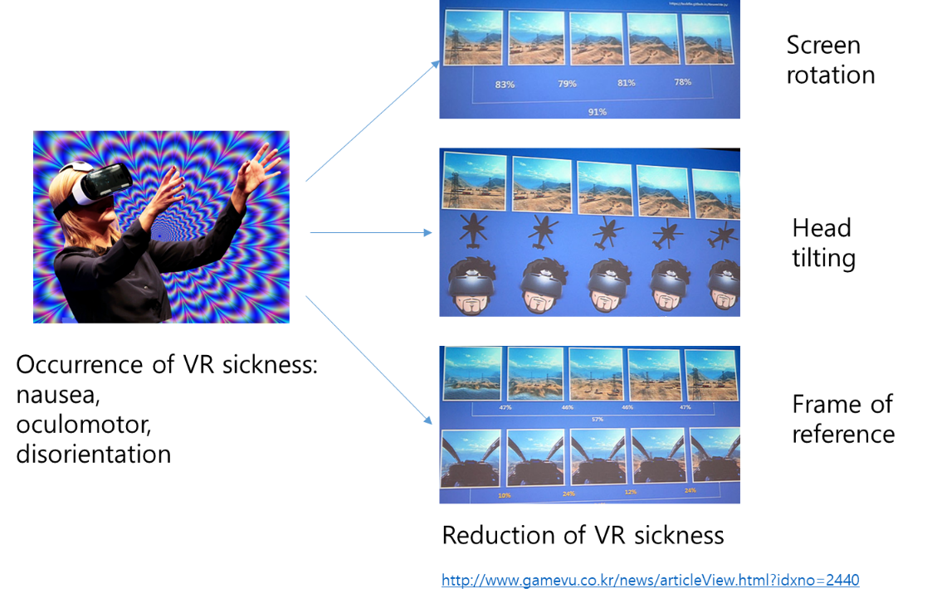  < VR sickness and its reduction for VR content>

Cases | Descriptions | Remarks
Use case 2 | VR contents needs to be experienced for a long time (30 minutes or more).  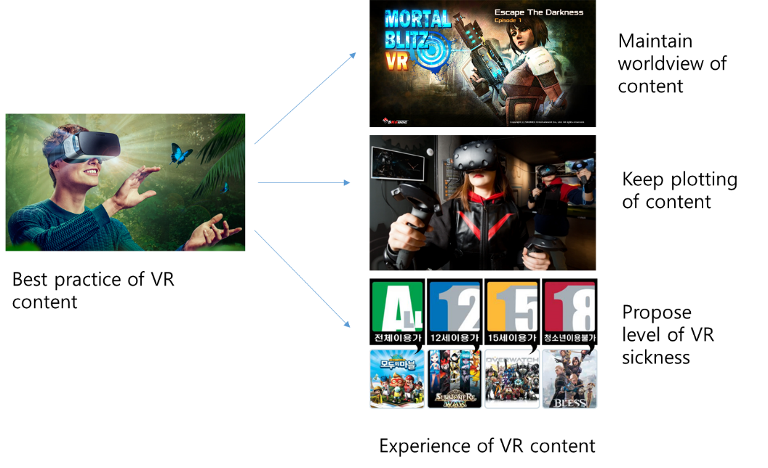  < Design VR content for VR sickness reduction>

Use case 1

Use case name
VR sickness and its reduction for VR content

Overview
VR content should be able to reduce feeling of nausea, eye fatigue, and dizziness. It should be able to control changes in the objects on the VR screen, provide user interaction to VR content to resolve sensory inconsistency, and use static coordinate system such as visual guide

Related actor
Content designer, Content programmer, content player

Pre-condition
-situation for experience of VR sickness on the VR content

Event Flow
-move to stage or scene occurring of VR sickness
-applying VR sickness reducing method
-restore new stage and scene reduced VR sickness

Post-condition
-controlled state of VR sickness level of VR content

Requirements

Functional Requirements
-reduce and control of VR sickness level of VR content

Non-functional Requirements
-none

Use case 2

Use case name
Design VR content for VR sickness reduction

Overview
Users should be able to run VR content for long enough. During the experience of VR content, users should be able to run VR content for long enough periods without any inconvenience, including nausea, eye fatigue, and dizziness.

Related actor
Content designer, Content programmer, Content player

Pre-condition
-stage and scene information of VR sickness

Event Flow
-evaluate VR sickness level on the stages of VR content
-maintain adequate VR sickness level for runnig VR content
-keep immersiveness level to VR content

Post-condition
-controlled state of VR sickness level of VR content

Requirements

Functional Requirements
-keep immersiveness of VR content after applying VR sickness reducing methods

Non-functional Requirements
-none

Scenario

Scenario 1 (apply VR sickness reducing skills for VR content)

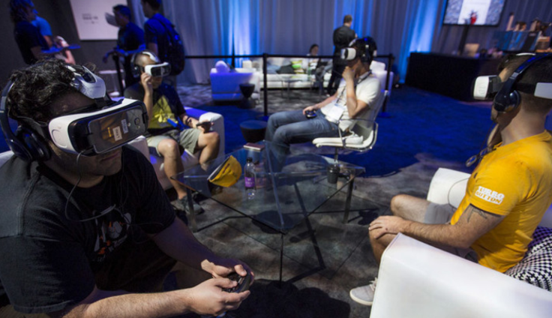
VR content developers will establish plans with stage designers for VR content to reduce VR sickness. VR designers apply optimal design rules to design VR content that can reduce VR sickness.

To reduce VR sickness, speed and acceleration of objects that make up a VR scenes can be defined first. It can also determine the speed and acceleration of virtual cameras to reduce VR sickness experienced by users. VR content designers are aware that VR sickness can be reduced by including objects like to nose shape of vehicles with fixed coordinate systems within VR scenes. One of the major causes of VR sickness is inconsistency in the sense of vision and vestibular organs. To address this problem, it is possible to reduce VR sickness by encouraging changes in VR content based on user interface with head tilting.

There are subjective and objective methods for reducing VR sickness that can be applied when creating VR content. It is an objective method to use image features of VR content. It is a subjective method to use responses from users who experience VR content. There is also an objective way to use biometric information of users to assess VR sickness. In order to use biometric information of users as a way to assess the VR sickness of VR content, real-time measurement of biometric information and real-time user responses need to be analyzed. This provides a more accurate measure of VR sickness.

Scenario 2 (design and implement of VR content for reducing VR sickness)

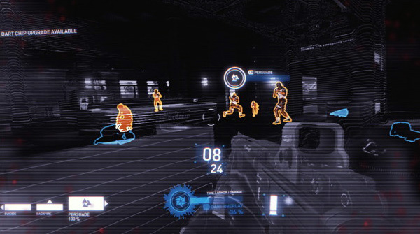
The biggest obstacle to the growth of the VR industry is VR sickness. VR sickness causes users to have difficulties in running VR content for a long time. Reducing VR sickness in the design and implementation of VR content can result in reduced user immersion of VR content. Reducing VR sickness is also important, but it should not undermine the original design intention of VR content. VR content should also be designed so that users experiencing VR content can experience VR content without any inconvenience by adjusting the cumulative VR sickness for those experiencing VR content throughout the stage of VR content.
VR content developers will be able to evaluate VR sickness by entire VR content and stage so that VR content can be presented to users. VR content developers need to apply methods to provide users with inconvenience of corresponding VR content while experiencing VR content. Users can adjust their driving environment so that they can experience VR content that is comfortable for them.

System requirements and its specifications

Overview
System requirements describe requirements and technical specifications in terms of content, HMD hardware, human factors, and environments.

<Summary of categories for technical requirements of the VR content system>
Content related issues | Hardware related issues
Virtual camera movement optimization  Scene complexity optimization  FOV adjustment  Sensory conflict synchronization  User interface placement  Optical flow  VR fidelity  Frame of reference | Latency minimization  Frame rate optimization  Stereoscopic 3D optimization  Resolution optimization  Display type  Flicker optimization
Human factor related issues | Environment related issues
Gender and age  Prior experience  Motion sickness susceptibility  Duration of VR experience  Controllability on VR sickness | Stitching optimization  Rig configuration  Sound configuration  Motion platform synchronization  Vertical synchronization  Clinical protocols

Development environments

Development environment
- Operation system : Windows 10 or later
- GPU: nVidia GTX 580 above
- Windows DirectX9 or DirectZ11

Development language
- C#
- VC++
- nVidia PhysX GPU
- Game Engine: Unity 3D or Unreal Engine

System requirements and specs for content

Virtual camera movement optimization

Needs
- Sudden camera movement during VR content production can dramatically change viewing angle of VR content, causing VR sickness among users.
- The human vestibular nervous system is sensitive to changes in movement (acceleration) and the rapid movement of the virtual camera in VR content should be minimized.

Requirement specification
- The acceleration movement of a virtual camera during the production of VR content ensures that it reduces the frequency as often as possible and is recommended to move at a constant rate of movement.
- VR interaction content limits the application of virtual camera movements that are different from the user's.

Evaluation methods
- Using virtual camera measurement software
- Measure speed and acceleration rates by interval within VR content

Remarks
- Viewing time can be reduced when camera movements are limited, since they affect entertainment.

Scene complexity optimization

Needs
- In case of high image complexity of VR content, users are forced to recognize large amounts of visual information, leading to VR sickness
- Complex backgrounds and numerous objects cause rendering computation loads for GPUs, which can reduce frame rates
- Reduces VR sickness during simple background and low contrast

Requirement specification
- When implementing VR content, the background complexity (texture and spatial frequency components) should be produced as low as possible.
- When producing VR content, distribution of objects within images is kept as low as possible.
- It is recommended to produce a low spatial frequency as well as rapid changes in background texture and object distribution over time

Evaluation methods
- Using image complexity measurement software
- Spatial frequency domain translation of images and calculation of generalized Gaussian distribution (position, scale, shape variables)

Remarks
- Not easy to reduce image complexity, such as background complexity and object distribution, while reflecting the VR content director's intention

FOV adjustment

Needs
- If the scale difference between the virtual camera angle (cFOV) and the display angle (dF OV) occurs, this may cause inconvenience due to motion, image distortion, and poor image quality.

Requirement specification
- Align the virtual camera angle (cFOV) to the fixed display angle(dFOV) as much as possible.

Evaluation methods
- Use measuring software to check for a match between cFOV and dFOV
- Check for match between cFOV and dFOV

Remarks
- Reducing the dFOV can reduce VR sickness but also reduce the immersion and visual context awareness of VR content

Sensory conflict synchronization

Needs
- Asynchronous behavior that does not coincide with the visual experience of VR content causes dizziness and discomfort to the user

Requirement specification
- It is recommended to produce VR content that synchronize visual experience of VR content and feeling effects.
- Interaction VR content inserts a predictable component.
- Use head motion information for navigation instead of i/o controllers

Evaluation methods
- Enable sensory mismatch measurement software
- Check synchronization between visual stimuli and perceived effects

Remarks
- Unable to fully synchronize VR content movement with user experience
- Repeated use of VR content results in reduced VR sickness and cumulative fatigues

User interface placement

Needs
- A user interface attached virtual camera can cause discomfort and nausea to follow user's gaze unnecessarily.

Requirement specification
- When using the user interface, it is recommended to place three-dimensional objects in a three-dimensional space.
- The movement of objects that make up a large part of the visual view is minimized to ensure the natural user movements.
- A head up display-type user interface needs to be implemented in line with the depth values of three-dimensional objects.
- When inserting subtitles into VR content, it is recommended to apply spherical distortion.

Evaluation methods
- Using user interface layout measurement software
- Check the user interface implemented on a three-dimensional space on the VR content

Remarks
- Frame of reference within VR content reduce VR sickness

Optical flow

Needs
- The optical flow can be used as an objective criterion for assessing VR sickness of VR content.
- The optical flow of VR content can be controlled as a measure to control VR sickness when creating VR content.

Requirement specification
- Optical flow can be used as an objective evaluation measure for VR sickness assessment.
- Optical flow can be used as a basis for controlling cumulative VR sickness during the experience of VR content.

Evaluation methods
- Use optical flow evaluation software

Remarks
- Confer to global visual flow, spatial velocity, and speed of VR content

VR fidelity

Needs
- VR fidelity can be utilized as a measure of similarity level between the virtual world and the real world for VR content being implemented.

Requirement specification
- It is recommended that VR content are implemented maintain the best VR fidelity.

Evaluation methods
- Use evaluation software for VR fidelity level
- Define and measure VR fidelity level

Remarks
- Confer to realism, and scene complexity

Frame of reference

Needs
- You can reduce VR sickness by adding objects that are always fixed in VR content screens.

Requirement specification
- It is recommended to fixed objects that are exposed consistently regardless of changes in images of VR content for stages with high VR sickness.
- Proper consideration is given to location of fixed objects and time of exposure due to changes in user’s VR sickness.

Evaluation methods
- Measure whether fixed objects are present, the size of fixed objects on the screen, the starting position of exposure, and the time of exposure

Remarks
- Confer to independent visual background(IVB), and scene content

System requirement and specs for HMD hardware

Latency minimization

Needs
- VR Latency impacts user immersion and inconvenience

Requirement specification
- VR Latency shall be kept as low as possible at 20 ms or less

Evaluation methods
- Using latency-measuring software or hardware
- Determine the specifications of the head tracking speed of a given VR HMD, measure the time taken to render the corresponding motion information reflected in the VR image, and calculate it by combining the head tracking speed.

Remarks
- The latency of a VR appliance needs to be minimized, but the delay in each phase is inevitable during the processing of the VR appliance

Frame rate optimization

Needs
- Low Frame Rate may cause users to have headaches, eye fatigue, and over-sensitive seizures as a result of flickering.

Requirement specification
- Frame rate in VR content must be synchronized to the refresh rate of VR HMD, and minimum frame rate is recommended at least 30 fps of images, 60 fps of graphics, and at least 90fps of interaction content.

Evaluation methods
- Using frame rate measurement software
- Measure with frame rate for VR content

Remarks
- High contrast VR content may have a flickering effect even though frame rate is high
- The frame rate of device refresh rate specification might be different for custom VR content creation

Stereoscopic 3D optimization

Needs
- The stereoscopic 3D image implementation is a method of setting up and displaying negative and positive disparity images for each incoming image on the left and right eyes. Therefore, beyond the optimum depth distance, visual fatigue can occur.
- When viewing stereoscopic 3D content in an HMD environment, a 3D content production technique is required to minimize fatigue as a geometric error causes fatigue in the eyes.

Requirement specification
- When producing HMD-based VR 3D image content, ensure that no geometry errors (ex. vertical, tilting, and scale inconsistencies, etc.) occur.
- When filming VR 3D images, the distance between cameras should be set at around 6.5cm, based on the distance between human pupils.
- The subtitles in VR 3D image content should be placed forward of the user rather than in the depth value applied in the image.
- It is recommended to refrain from making sudden changes in depth in the video as this results in eye fatigue.

Evaluation methods
- Using stereoscopic 3D geometry error measurement software
- The interval between the camera and the virtual camera is less than 6.5 cm, and the parameters of the two cameras are synchronized to minimize the geometry error.

Remarks
- Depth of VR S3D images is determined at the shooting phase and is more important than post production
- For VR S3D image optimization (quality of images), the post production is considered more important than the shooting phase as it is important to avoid stitching inconsistencies

Resolution optimization

Needs
- Resolution in the image of VR content affects the degree of user immersion and inconvenience
- Higher ppi(pixel per inch) enables sharper screen content

Requirement specification
- VR content should be kept at least 4K (3840 × 1920 or 3840 × 2048, UHD) based on the user's vision and hardware parameters of VR HMD.

Evaluation methods
- Using the resolution measurement software
- Measure VR content resolution

Remarks
- VR HMD requires a higher level of resolution than the TV and movie viewing environments because of the optical system (convex lens) between the user's eyes and the display.

Display type

Needs
- HMD is considered for displays for VR content in this document.

Requirement specification
- The display type of VR content should be HMD based.

Evaluation methods
- Check display type for HMD

Remarks
- VR content display environment: screen, CAVE, monitor, HMD
- Consider HMD VR on the simulators
- Consider PC-based and standalone type HMD

Flicker optimization

Needs
- Flicker in VR content display directly affects eyestrain but the cumulative effect can also increase VR sickness.

Requirement specification
- It is recommended to minimize the effect of flicker on VR screens due to graphic effects when producing VR content.

Evaluation methods
- Measure the brightness of the entire screen of VR content

Remarks
- Flicker may also occur that is associated with frame rate and vertical frequency synchronization.

System requirement and specs for human factor

Gender and age

Needs
- For evaluation of the level of VR sickness of VR content, male and female differences and age groups are considered.

Requirement specification
- Gender and age are reflected in MSSQ design and survey.

Evaluation methods
- Check MSSQ sheet

Remarks
- Subjects can consider their living areas, educational status, race, etc.
- The personal information of subjects can be managed for VR sickness response to the specific VR content

Prior experience

Needs
- Prior experience of subjects with VR content can have a significant impact on VR sickness assessment.

Requirement specification
- Consider whether VR content have prior experience and the degree of experience from MSSQ survey

Evaluation methods
- Check MSSQ sheet

Remarks
- Consider drinking and health condition before VR sickness evaluation.
- The personal information of subjects can be managed for VR sickness response to the specific VR content.

Motion sickness susceptibility

Needs
- The sensitivity of motion sickness of users can have a significant impact on VR sickness assessment.

Requirement specification
- Consider user's personal sensitivity of motion sickness in MSSQ survey.

Evaluation methods
- Check MSSQ sheet

Remarks
- The personal information of subjects can be managed for VR sickness response to the specific VR content.

Duration of VR experience

Needs
- Exposure to VR content experience by users can have a significant impact on VR sickness assessment.

Requirement specification
- Consider the strength of individual users ' endurance to VR content experience in MSSQ survey.

Evaluation methods
- Check MSSQ sheet

Remarks
- The personal information of subjects can be managed for VR sickness response to the specific VR content.

Controllability on VR sickness

Needs
- The degree of control that users have against VR sickness can have a significant impact on VR sickness assessment.

Requirement specification
- Consider personal VR sickness control level of VR content for MSSQ survey.

Evaluation methods
- Check MSSQ sheet

Remarks
- The personal information of subjects can be managed for VR sickness response to the specific VR content.

System requirement and specs for environments

Stitching optimization

Needs
- If VR shooting images are not stitching properly, distorted parts of images are exposed to the user's view, which reduces the user's sense of immersion.

Requirement specification
- Camera placement, lens distortion, and camera synchronization should be adjusted accordingly to minimize stitching errors during filming and post production of VR content.
- It is recommended to accurately fit camera synchronization because subjects move faster or are more important when filming in S3D.

Evaluation methods
- Using the stitching measurement tools
- Measure with frame rate for VR content

Remarks
- Technical limitations of stitching errors

Rig configuration

Needs
- No-parallax points mismatch between optical instruments due to the physical volume of the camera during rig configuration
- In the shooting 360 ° VR real content, physical limitations due to camera structure overcome through rig system design

Requirement specification
- When producing 360 ° VR content, the camera rig system shall be configured so that the gap between cameras is close to the no-parallax point.
- The error range of the no-parallax points should be set to a smaller range in the shooting near-view than in the shooting far-view
- It is recommended to place the camera overlapping at approximately 20 ° (15 % to 20 % of the shooting image) of the camera angle when forming a rig.
- It is recommended to use Genlock for VR imaging because synchronization between cameras is very important.

Evaluation methods
- Use of no-parallax points confirmable measurement software
- Check no-parallax points matching virtual cameras

Remarks
- For high-performance cameras, the volume makes it difficult to get the no-parallax points close to each other.
- For action cams, it's easy to configure no-parallax points in close proximity, but there is a decrease in quality compared to intermediate instruments.

Sound configuration

Needs
- VR content users experience less VR sickness if they change their sound configuration according to their direction of rotation

Requirement specification
- It is recommended that the 3d space sound be positioned in the direction of movement of the user's head.

Evaluation methods
- Use space orientation measurement software for sound
- Space sound configuration according to the scenario of VR content

Remarks
- When frame rate is reduced by overusing engine resources for space sound effect, optimizing frame rate first will help reduce VR sickness

Motion platform synchronization

Needs
- Asynchronous behavior between visual experience and actual movement provided by VR content for motion-platform riders causes users to feel dizzy and uncomfortable

Requirement specification
- For synchronization between physical movement and visual experience of motion platform boarding users, it is recommended that the transfer delay between VR input and VR motion output be less than 150ms.
- Filter motion data based on the precision manufacturing of hardware (communications, motors, apparatus parts, etc.) to minimize transfer delay time and maximize precision and the entertainment elements in the VR content.
- When constructing motion data for motion platforms, prioritize the axial direction that is not reactive to the human body.

Evaluation methods
- Using motion platform synchronization measurement software
- After recognizing and adjusting the behavior of the motion platform rider, measure the time it takes for the motion platform to feel to be delivered to the user by implementing software

Remarks
- When creating separate motion platforms and VR content, synchronization is difficult because movement values of VR content can not be communicated directly to the motion platform

Vertical Synchronization

Needs
- When the frame rate of the VR content is higher than on screen, vertical synchronization option is on when the VR content is running due to horizontal stripes, but VR content is set to off for frame rate gain.
- Setting vertical sync to on may cause slow the response speed due to input lag
- Continuous exposure to vertical synchronization trembling may cause eye fatigue, headaches, etc.

Requirement specification
- To optimize the drive of VR content, set vertical sync to off.

Evaluation methods
- Use vertical sync on/off measurement software
- Check vertical sync on/off

Remarks
- If the frame rate of the VR content is below the screen interlacing rate, it becomes meaningless

Clinical protocols

Needs
- To perform its own safety assessment when creating VR content, measuring subjective VR sickness levels should be preceded by measurement of the various groups of subjects (age/gender).
- Based on clinical data, consider appropriate level of judgment between subjective design intentions and objective production safety parameters for VR content

Requirement specification
- It is recommended that the clinical subjects are performed in four groups : the male and the female youth, the male and female middle aged.
- The number of clinical participants is calculated taking into account the elimination rate of 20 %.
- Perform a preliminary vulnerability assessment using motion sickness susceptibility questionnaire (MSSQ).
- The subjective level of VR sickness is recorded based on VR sickness symptoms in the simulation sickness questionnaire (SSQ).

Evaluation methods
- Based on the VR sickness symptoms of SSQ, the level of VR sickness experienced sustainably after watching the reference VR content is measured (Step 0-4)
- Measure objective indicators that reflect an individual's bio-signal and VR sickness sensitivity
- Collect both pre-SSQ and post-SSQ of clinical test and must be approved by the clinical participants in advance.

Remarks
- Designing a simple, standardized clinical protocol enables VR producers to easily assess the safety of their own content

Conclusions

This document defines the user requirements, user scenarios, and system specifications necessary to design and implement VR content for VR sickness reduction.

Measures to reduce VR sickness of VR content experienced by users have been discussed. Designers and developers of VR content can adjust the screen changes of VR content by adjusting the objects that make up it. User interfaces employ methods for resolving sensory inconsistencies. In addition, VR content were addressed to reduce VR sickness for users by establishing fixed coordinate systems like virtual nose on the VR scenes.

By applying VR content to reduce VR sickness, designers should not modify their planning intent for VR content. In particular, VR content should not be affected by fun elements or immersion due to methods to reduce VR sickness. We mentioned methods to ensure that VR sickness can be adjusted while maintaining adequate tension about the overall content of VR content. In addition, VR sickness estimation method for VR content is included.

This document describes the technical specifications of the system in terms of content, hardware and human factors.

