Project | HMD based 3D Content Motion Sickness Reducing Technology  <http://sites.ieee.org/sagroups-3079/ >
Title | Requirement specifications for design and implement VR content reducing cybersickness
DCN | 3079-18-0036-00-0002
Date Submitted | July 14, 2018
Source(s) | Beom-Ryeol Lee Lbr@etri.re.kr (ETRI)
Re:
Abstract | This document describes the user's point of view requirements and the system requirements and technical specifications required to produce VR content for cybersickness reduction. As a basis for implementing VR content without cybersickness, it also suggests a way to eliminate nausea, eye fatigue, and dizziness of users experiencing VR content. It also describes methods to ensure that users are comfortable with VR content for a long time.
Purpose | This document deals with the use requirements, user-driven scenarios and technical specifications for reducing cybersickness of VR content
Notice | This document has been prepared to assist the IEEE 802.21 Working Group. It is offered as a basis for discussion and is not binding on the contributing individual(s) or organization(s). The material in this document is subject to change in form and content after further study. The contributor(s) reserve(s) the right to add, amend or withdraw material contained herein.
Release | The contributor grants a free, irrevocable license to the IEEE to incorporate material contained in this contribution, and any modifications thereof, in the creation of an IEEE Standards publication; to copyright in the IEEE’s name any IEEE Standards publication even though it may include portions of this contribution; and at the IEEE’s sole discretion to permit others to reproduce in whole or in part the resulting IEEE Standards publication. The contributor also acknowledges and accepts that IEEE 802.21 may make this contribution public.
Patent Policy | The contributor is familiar with IEEE patent policy, as stated in Section 6 of the IEEE-SA Standards Board bylaws <http://standards.ieee.org/guides/bylaws/sect6-7.html#6> and in Understanding Patent Issues During IEEE Standards Development http://standards.ieee.org/board/pat/faq.pdf

Introduction

An important factor to boost VR industry is the designing and implementing VR content to reduce cybersickness.
When VR content are applied to reduce cybersickness, immersion of VR content can be reduced. Therefore applying reduction skills of VR sickness and controlling immersiveness of VR content are complementary to each other.
In order to design VR content for VR sickness reduction, three aspects should be considered. That is the view of content, HMD hardware, and human factors. In addition, three aspects of VR cybersikness should be applied in an integrated manner.
While users experience VR content, they may experience unintended nausea, eye fatigue, and dizziness. This presents a very serious problem from the perspective of users who enjoy VR content.VR content should also be able to reduce VR sickness without compromising VR content themes as it will cause cybersickness to be very severe for users to use VR content over time.
This document defines user requirements for the production of VR content to reduce VR sickness and describes the technical specifications of the system.

Overview

Purpose
This document contains user requirements and system specifications from the user's perspective of VR content to design and implement VR content to reduce cybersickness.

Scope
The scope contained in this document includes use-cases and scenarios for VR content creation for cybersickness reduction, and system requirements and technical specifications.
In uses-case 1 the topic is about cybersickness reduction for implementing VR content. It covers methods such as screen movement and change considerations, using head-motion for navigation, and setting the visual guides.
Use-case 2 deals with situations where VR content can be experienced for a long time more than a half hour without any burden on cybersickness. Even if cybersickness reduction method is applied, it needs to maintain sense of realism and immersion about VR content. While experiencing VR content, users should be able to maintain adequate immersion without VR sickness through proper VR sickness control. It should also be able to provide criteria for calculating cybersickness level for VR content.

Use Case

Use case for Content & SW

Classification of user
User | User’s role
Content designer | - Designing visual scene and stages for VR content
Content programmer | - Implementing rules and modules for VR content SW
Content player | - Playing VR content
Content evaluator | - Test VR content and evaluate the CSL of the VR content

Use Case Summary
Cases | Descriptions | Remarks
Use case 1 | VR contents should be able to reduce feeling of nausea, eye fatigue, and dizziness.  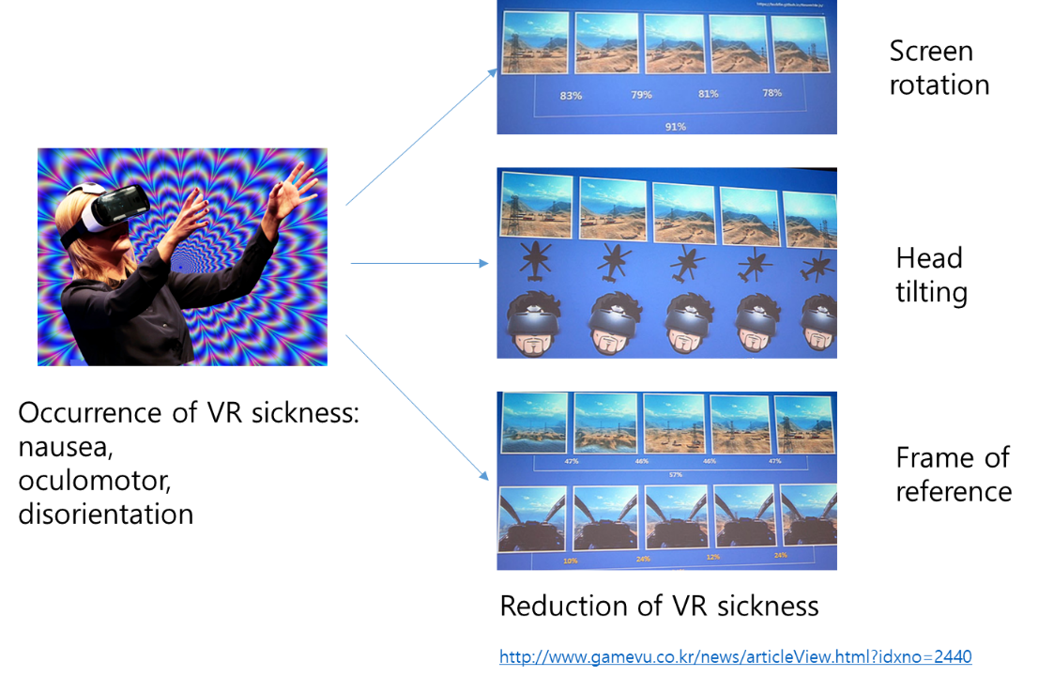  < VR sickness and its reduction for VR content>

Cases | Descriptions | Remarks
Use case 2 | VR contents needs to be experienced for a long time (30 minutes or more).  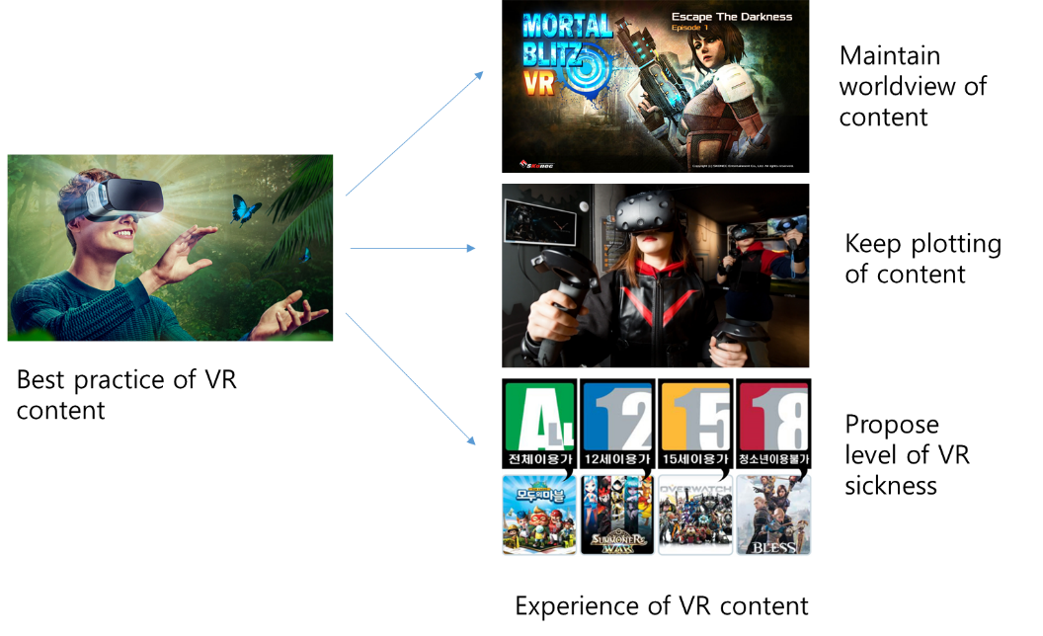  < Design VR content for VR sickness reduction>

Use case 1

Use case name
VR sickness and its reduction for VR content

Overview
VR content should be able to reduce feeling of nausea, eye fatigue, and dizziness. It should be able to control changes in the objects on the VR screen, provide user interaction to VR content to resolve sensory inconsistency, and use static coordinate system such as visual guide

Related actor
Content designer, Content programmer

Pre-condition
-situation for experience of cybersickness on the VR content

Event Flow
-move to stage or scene occurring of cybersickness
-applying cybersickness reducing method
-restore new stage and scene reduced cybersickness

Post-condition
-controlled state of cybersickness level of VR content

Requirements

Functional Requirements
-reduce and control of cybersickness level of VR content

Non-functional Requirements
-none

Use case 2

Use case name
Design VR content for VR sickness reduction

Overview
Users should be able to run VR content for long enough. During the experience of VR content, users should be able to run VR content for long enough periods without any inconvenience, including nausea, eye fatigue, and dizziness.

Related actor
Content designer, Content programmer, Content player

Pre-condition
-stage and scene information of cybersickness

Event Flow
-evaluate cybersickness level on the stages of VR content
-maintain adequate cybersickness level for runnig VR content
-keep immersiveness level to VR content

Post-condition
-controlled state of cybersickness level of VR content

Requirements

Functional Requirements
-keep immersiveness of VR content after applying cybersickness reducing methods

Non-functional Requirements
-none

Scenario

Scenario 1 (apply cybersickness reducing skills for VR content)

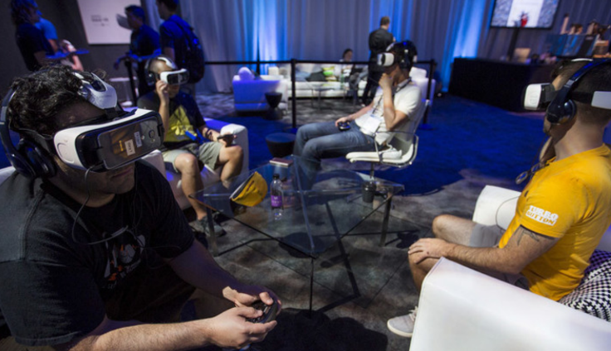
VR content developers will establish plans with stage designers for VR content to reduce VR sickness. VR designers apply optimal design rules to design VR content that can reduce VR sickness.

To reduce VR sickness, speed and acceleration of objects that make up a VR scenes can be defined first. It can also determine the speed and acceleration of virtual cameras to reduce VR sickness experienced by users. VR content designers are aware that VR sickness can be reduced by including objects like to nose shape of vehicles with fixed coordinate systems within VR scenes. One of the major causes of VR sickness is inconsistency in the sense of vision and vestibular organs. To address this problem, it is possible to reduce VR sickness by encouraging changes in VR content based on user interface with head tilting.

There are subjective and objective methods for reducing VR sickness that can be applied when creating VR content. It is an objective method to use image features of VR content. It is a subjective method to use responses from users who experience VR content. There is also an objective way to use biometric information of users to assess VR sickness. In order to use biometric information of users as a way to assess the cybersickness of VR content, real-time measurement of biometric information and real-time user responses need to be analyzed. This provides a more accurate measure of VR sickness.

Scenario 2 (design and implement of VR content for reducing cybersickness)

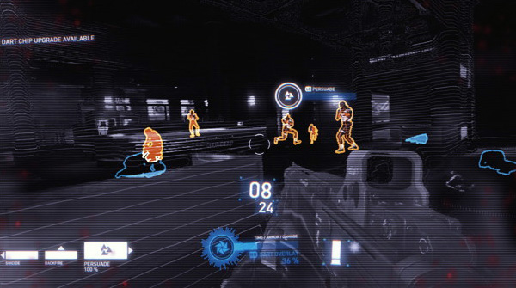
The biggest obstacle to the growth of the VR industry is VR sickness. VR sickness causes users to have difficulties in running VR content for a long time. Reducing VR sickness in the design and implementation of VR content can result in reduced user immersion of VR content. Reducing VR sickness is also important, but it should not undermine the original design intention of VR content. VR content should also be designed so that users experiencing VR content can experience VR content without any inconvenience by adjusting the cumulative VR sickness for those experiencing VR content throughout the stage of VR content.
VR content developers will be able to evaluate VR sickness by entire VR content and stage so that VR content can be presented to users. VR content developers need to apply methods to provide users with inconvenience of corresponding VR content while experiencing VR content. Users can adjust their driving environment so that they can experience VR content that is comfortable for them.

System requirements and its specifications

Overview
System requirements describe requirements and technical specifications in terms of content, HMD hardware, and human factors.

Development environments

development environment
- Operation system : Windows 10
- GPU: nVIdia GTX 580 above
- Windows DirectX9 or DirectZ11

development language
- C#
- VC++
- nVidia PhysX GPU

System requirement and specs for content

Virtual camera movement optimization

Stitching optimization

FOV adjustment

UI placement

Sound configuration

Steroscopic 3D optimization

Scene complexity optimization

Optical flow

VR fidelity

Frame of reference

System requirement and specs for HMD hardware

Latnecy minimization

frame rate optimization

Rig configuration

Sensory conflict synchronization

Resolution optimization

Vertical Synchronization

display type

Flicker optimization

System requirement and specs for human factors

Gender and age

Prior experience

Motion sickness susceptibility

Duration of VR experience

Controllability on cybersickness

System requirement and specs for environments

Clinical protocols

Motion platform synchronization

Conclusions

This document defines the user requirements, user scenarios, and system specifications necessary to design and implement VR content for VR sickness reduction.

Measures to reduce VR sickness of VR content experienced by users have been discussed. Designers and developers of VR content can adjust the screen changes of VR content by adjusting the objects that make up it. User interfaces employ methods for resolving sensory inconsistencies. In addition, VR content were addressed to reduce VR sickness for users by establishing fixed coordinate systems like virtual nose on the VR scenes.

By applying VR content to reduce VR sickness, designers should not modify their planning intent for VR content. In particular, VR content should not be affected by fun elements or immersion due to methods to reduce VR sickness. We mentioned methods to ensure that VR sickness can be adjusted while maintaining adequate tension about the overall content of VR content. In addition, VR sickness estimation method for VR content is included.

This document describes the technical specifications of the system in terms of content, hardware and human factors.

