Project | HMD based 3D Content Motion Sickness Reducing Technology  <http://sites.ieee.org/sagroups-3079/ >
Title | Technical issues of 360º VR Scene on Web environment
DCN | 3079-18-0024-00-0003
Date Submitted | April 22, 2018
Source(s) | Kwan-Hee Yoo (khyoo@chungbuk.ac.kr)
Re: | IEEE 3079 Session #5 in ToKyo, Japan
Abstract | This document describes the use cases and technical requirements to be considered with HMD based VR Services.
Purpose | Working Group Discussion and Acceptance
Notice | This document has been prepared to assist the IEEE 3079 Working Group. It is offered as a basis for discussion and is not binding on the contributing individual(s) or organization(s). The material in this document is subject to change in form and content after further study. The contributor(s) reserve(s) the right to add, amend or withdraw material contained herein.
Release | The contributor grants a free, irrevocable license to the IEEE to incorporate material contained in this contribution, and any modifications thereof, in the creation of an IEEE Standards publication; to copyright in the IEEE’s name any IEEE Standards publication even though it may include portions of this contribution; and at the IEEE’s sole discretion to permit others to reproduce in whole or in part the resulting IEEE Standards publication. The contributor also acknowledges and accepts that IEEE 3079 may make this contribution public.
Patent Policy | The contributor is familiar with IEEE patent policy, as stated in Section 6 of the IEEE-SA Standards Board bylaws <http://standards.ieee.org/guides/bylaws/sect6-7.html#6> and in Understanding Patent Issues During IEEE Standards Development http://standards.ieee.org/board/pat/faq.pdf

Introduction

Since the 360o virtual reality (VR) can provide the experience of virtual reality for users in various web environments, there are still some technical issues related to the process of producing 360o VR scene. There are three categories of procedures for making possible the 360o VR scene on web environment. First issue is to take and produce 360o photos which are referred to the work of using camera to capture the real-world environment. Second issue is referred to mapping between capturing 360o photos and virtual environment and the third issue is manipulating and rendering of VR scene.

Taking & Producing 360o photos

The work of taking 360o photos might be easy by using 360o camera devices such as Richo theta, Samsung Gear 360, Insta 360, and so on. However, since the user wants to use general camera device to capture the real-environment as 360o photo, it might be a bit difficult for them.
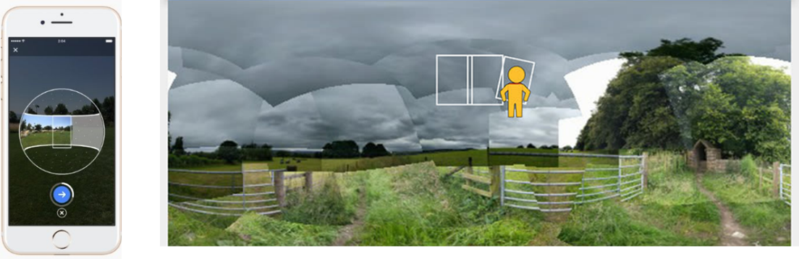
Figure 1 A 360o photo captures by using smart phone
Using smartphone for capturing photos is the convenience way for users, but capturing 360o photo is not quite the same with the taking normal photo. The photosphere can be constructed from surrounding photos that captured by smartphone as shown in Figure1. The application should guide the user with navigation points for capturing photo around him/her. Figure 2 describes the process of capturing photos with the target points. However, the combined photos have to be meshed and rendered to only one 360o photo. The process of stitching together is required a deep algorithm for high quality and correctly photos.
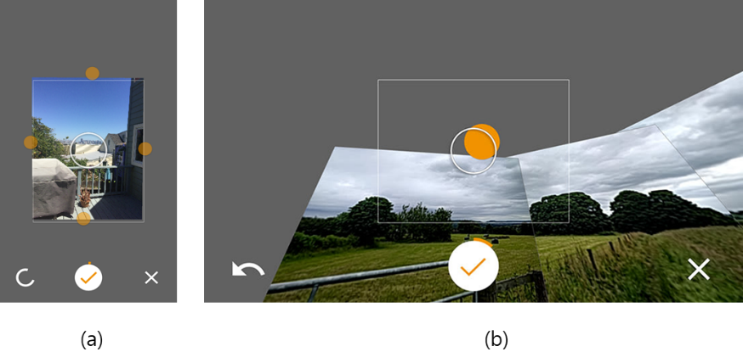
Figure 2 The points for guiding user to capture a 360o photo
For high-quality of photos, DSLR camera should be considered. Since DSLR camera is another choice for photo quality, it has been used to capture real-environment as 360-degree panoramic image. The process of capturing 360o photo with DSLR camera is required the equipment and technique for producing a high-quality 360o photo. The capturing requires making a panorama which covered 360 degrees horizontally and up to 180 degrees vertically. Furthermore, in order to create this panoramic image, we need to capture a series of overlapping images that can be stitched together by using third-party software.
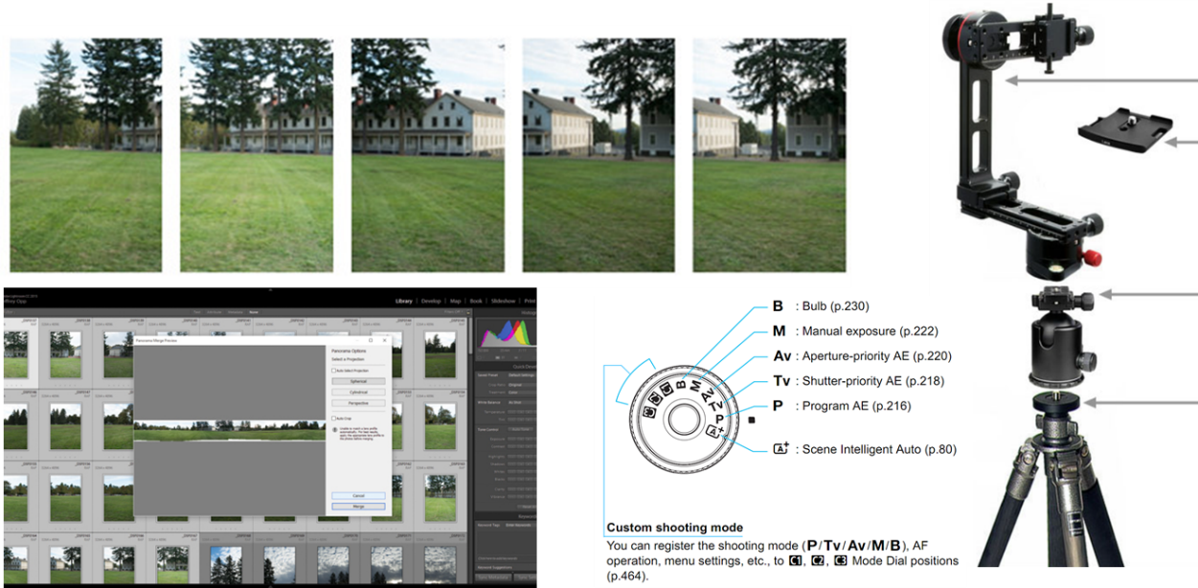
Figure 3 DSLR camera is used for capturing a high-quality 360ophoto
Figure 3 shows the equipment which is used for capturing 360o photo by using DSLR camera. The capturing image should overlap the next by approximately 20% of a series images. The camera should stand vertically and shoot the photo around the horizontal axis. Moreover, there are still some issues on equipment setup and stitching those photos together for making 360o photo. Figure 4 (a) shows the blank spot while combing or stitching a series of capturing photo, and (b) shows the technique of equipment setup for DSLR camera to be used for capturing.
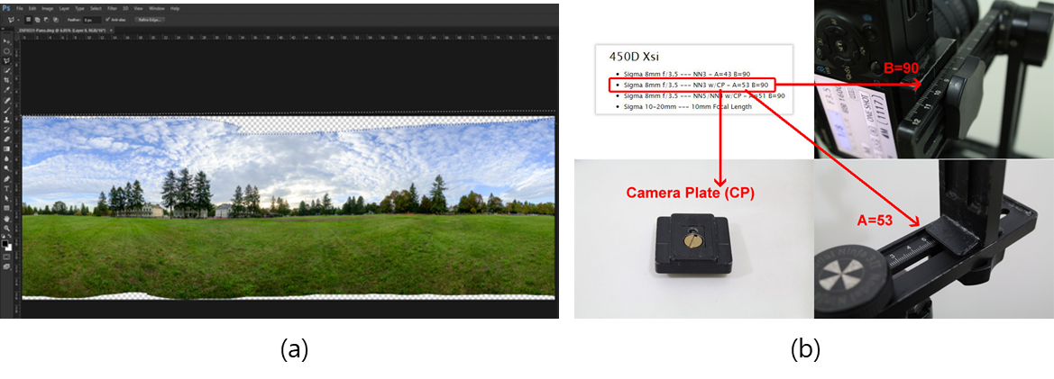
Figure 4 Blank spot and equipment setup of DSLR camera for capturing 360o photo
The issues of this category can be deal with the following criteria:
- Image quality of 360º photo which is captured by 360º camera or smartphone camera and the quality of image that is constructed by stitching into one large wide-angle image could be considered. The stitching algorithm is used to design and evaluate the quality of 360º image, better algorithms is the more better, accurate, and lightweight images.
- The photometric correction target errors which occur due to heterogeneous imaging hardware or environmental conditions among the capturing cameras.
- Parallax error can happen in spherical panorama image reproduction, when more than two images are combined or stitching together while producing the expanded viewing coverage of the image. The parallax error can be introduced when two sources of photographic images are acquired from an inconsistent viewpoint. Moreover, a parallax error that has slight difference in the viewing perspective would disallow multiple images to be combined correctly. That is, usually multiple images might be forced to compromise with certain levels of unwanted parallax error.
- Nadir angle generally known as the bottom side of the 360º photo, is difficult to be acquired correctly during the capturing and stitching process. It usually does not allow acquiring the nadir angle image due to the obstacle of the equipment that has blocked the viewing of nadir perspective.
- Dynamic range in 360º photo is referred to the capability of reproducing visual luminance from the real world. The shadow and highlight luminosity can be exceeded according to the recording capability of film negative or sensor in camera.

Mapping 360º environment

After receiving 360o photos, the next process is about mapping those 360o photos to be mapped into virtual environment. The 360o virtual reality scene can be constructed by a cylindrical, spherical, or cubical panorama. Those environments are used to visualize the scene of 360o virtual reality based on their own specific features.

3.1 Cylindrical Environment

The cylindrical environment offers only limited rotational freedom around the horizontal axis. Therefore, the user can turn around and see the views in a full circle which is the rotation around the vertical axis. By the way, the looking up and down is restricted. Figure 5 shows the cylindrical environment which is constructed by creating a cylinder and texture with the cylindrical panorama image.
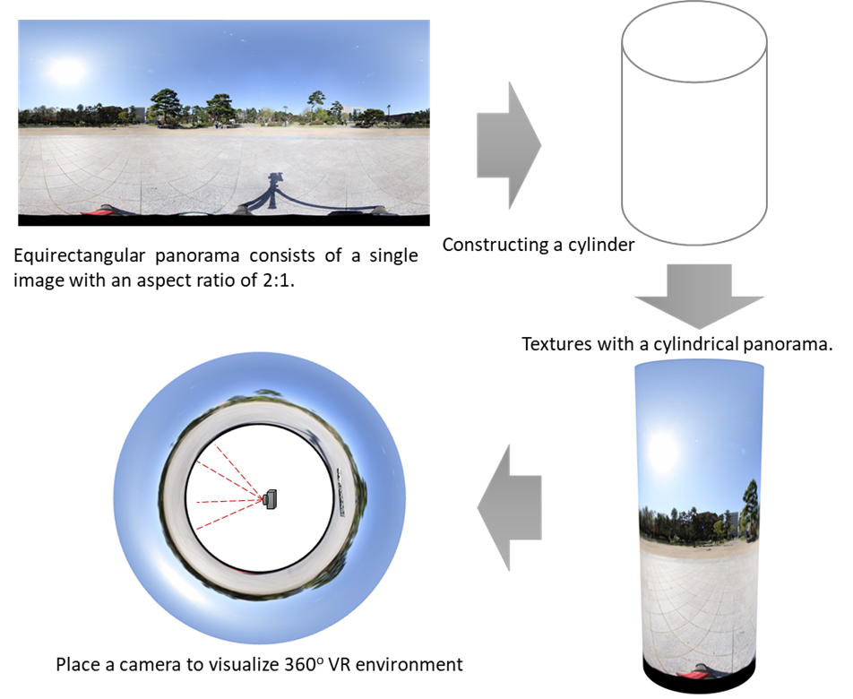
Figure 5 Cylindrical environment of 360o virtual reality

3.2 Cubical Environment

Cubical environment of 360o virtual reality is constructed by six images for every face of a cube as shown in Figure 6. The cubic panorama is used to construct the cubical environment, and then place the user at its center. It also is known as skybox. In 2D layouts, the X-axis points to the right and the Y-axis points downs which means the top left is (0,0) and the bottom right will be the width and the height of the element at width and height.
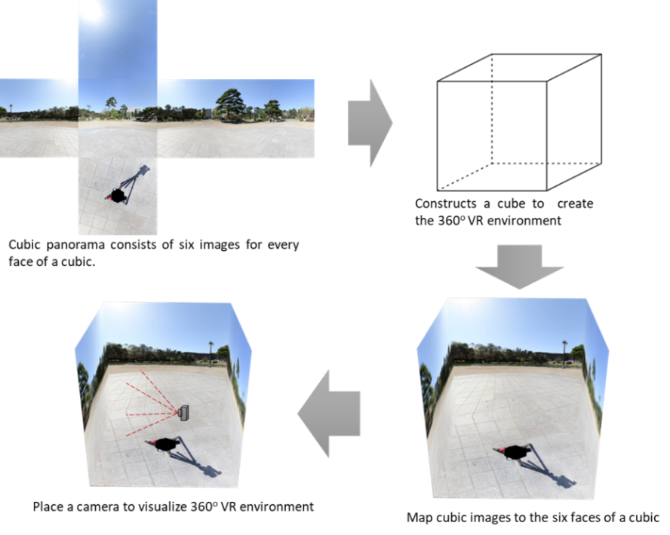
Figure 6 Cubical environment of 360o virtual reality

3.3 Spherical Environment

Another process for visualizing 360o virtual reality is mapping with spherical environment. As 360o virtual reality can be constructed by the spherical environment, this kind of scene can provide the experience of virtual reality more immersive with every angle of views including top and bottom. The spherical environment constructs by creating a sphere and the user is located at its center. Furthermore, the equirectangular image is used to texture this environment.
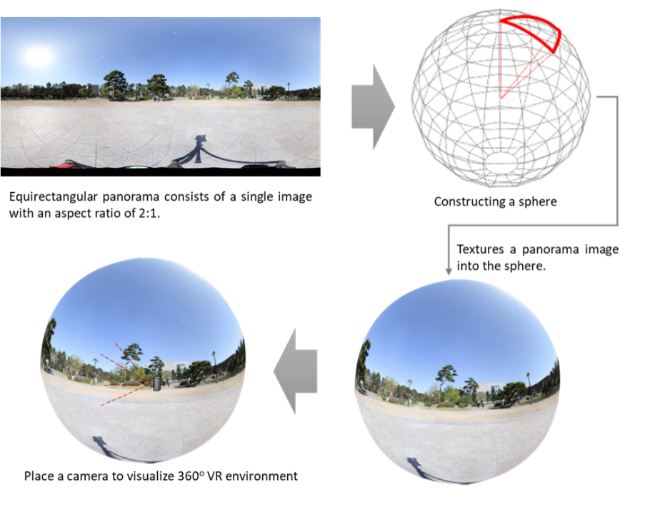
Figure 7 Spherical environment of 360o virtual reality

Manipulating & Rendering

The last step of making 360o virtual reality scene are about manipulating and rendering the scene to web environment. The 360o photos and videos can be visualized to users by stereo vision technique. This includes the left and right viewpoint for displaying to each eyes of user. The key element for interaction to the virtual reality is to track the position of real world objects such as head tracking, side-by-side stereo rendering, spatial audio rendering, detecting user inputs (trigger), and so on. Those things should be considered in order to make user feel comfortable in virtual environment. Some cases, the stereo rendering is rendered without considering of user’s interpupillary distance (IPD) also cause the problems. Because the different distance of user’s IPD as shown in Figure 8, user can feel uncomfortable, motion sickness, and so on.
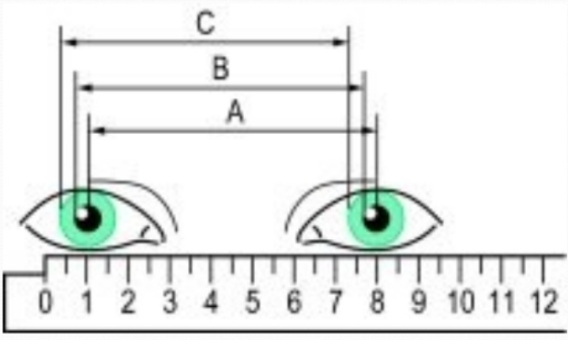
Figure 8 Inpterpupillary distance between two eyes
One of the hot technical issues in 360o virtual reality is delivering content of the scene at a high enough frame rate for accurate the user into feeling or believing that he/she is experiencing the virtual world. By using high-end VR headset, it requires the high processing and rendering capabilities of PC that is the hardware side. By the way, for software side, the target of frame per second (FPS) should be 90 FPS at all times. Most VR setup that generate the frame rate below 90 PFS, it may induce disorientation, nausea, and other negative user effect. To solve that, developer should consider this point and keep in mind that lower the frame rate is worse the effects.
In addition, health effects are still unknown for users. Many side effects are temporary cause to user such as motion sickness, but the long-term effects of VR are still unknown. The potential symptoms are seizures, loss of awareness, eye strain, eye or muscle twitching, involuntary movements, altered, blurred, or double vision or other visual abnormalities, dizziness, disorientation, impaired balance, impaired hand-eye coordination, excessive sweating, increased salivation, nausea, lightheadedness, discomfort or pain in the head or eyes, drowsiness, fatigue, and other symptoms similar to motion sickness. That is most of health and safety guidelines are suggested to take a rest at least a 10 to 15 minutes break for every 30 minute of use. Moreover, the VR developer should also consider the following criteria to avoid those kinds of effects to user.
- Avoiding quick acceleration or deceleration of camera movements, and using a constant velocity instead.
- Avoiding the use of depth of field or motion blur post processing because of not knowing where the eyes will focus.
- Avoiding sharp and/or unexpected camera rotations.
- Avoiding brightness changes (use low frequency textures or fog effects to create smooth lighting transitions).
- Intermittent disconnection of the network service, leading to false confidence in the currently presented information.
- Wearing an HMD device and being blind to potentially dangerous objects in the vicinity.
- Keep frame rate at least 90 FPS to avoid virtual reality sickness from wearing an HMD.
Besides that, another technical issue is referred to hardware capabilities. According that research and studies have been shown that less than one percent of the 1.43 billion computers in the world meet the requirement of graphical capabilities for virtual reality. That means the VR headsets are required the high hardware capabilities such as CPU, graphic card, and so on. Not only computer, gaming console and smartphone are also required the high capabilities of hardware also.
Furthermore, the virtual reality is also a very bandwidth-intensive according to a research report released by Greenlight VR. Virtual reality is the most bandwidth-intensive technology in regard to streaming huge files without buffering and without imparting bandwidth.
Since 360o photos are used for visualizing the virtual reality, the photo size can cause the problem to load on web environment. That is, large photo might need times to load and visualize. It also can be caused by network problem, device specification, and graphic rendering. Therefore, tile based for mapping and rendering large size of image is the better idea to deal with this issue. This solution is simple, but not quite easy depending on environment mapping.
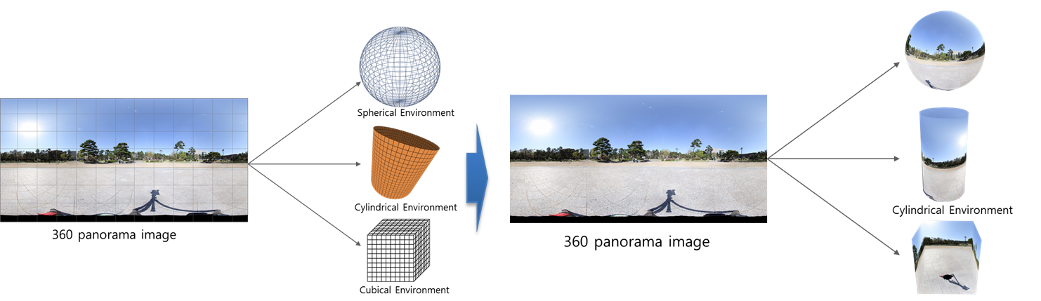
Figure 9 Tile based rendering for 360o VR environment
As shown in Figure 9 the 360o photo should be tiled to spherical environment, cylindrical, or cubical environment based on their aspect. Tile based might reduce the size of photo and loading time for visualizing 360o virtual reality on web environment. Figure 10 shows the process of tile based for VR environment mapping by splitting photo to specific pixels, then map them to the virtual reality environment, and render to web browser. In addition, the expectation size after using tile based mapping is described in table 1.
Table 1 Expectation size for 360o photo after using tile based mapping
Pixels | Resolution | Number of tiles | Size
88.6M | 13312x6656 | 26x13 | ~5M
22.2M | 6656x3328 | 13x7 | ~2M
5.5M | 3328x1664 | 7x4 | ~800K
1.4M | 1664x832 | 4x2 | ~300K
0.3M | 832x416 | 2x1 | ~90K

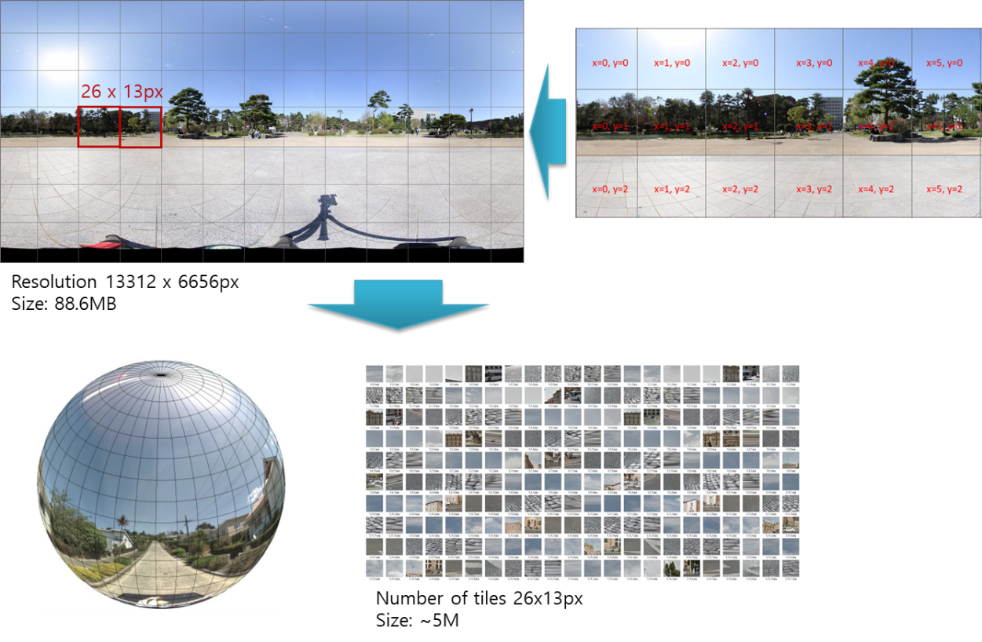
Figure 10 Tile based 360o VR environment mapping

