|  |  |
| --- | --- |
| Project | **HMD based 3D Content Motion Sickness Reducing Technology**  <<http://sites.ieee.org/sagroups-3079/> **>** |
| Title | **Use Cases to Measure the Motion-to-Photon Latency** |
| DCN | **3079-18-0000-00-0000** |
| Date Submitted | **April 17, 2018** |
| Source(s) | **Suk-Ju, Kang** [**sjkang@sogang.ac.kr**](mailto:sjkang@sogang.ac.kr) **(Sogang University)** |
| Re: |  |
| Abstract | Latency is one of the biggest reasons for the motion sickness felt by users when wearing an head-mounted display (HMD) system. Therefore, a measurement system is required to accurately measure and analyze the latency to reduce these problems. We consider the photo sensor-based latency measurement system for HMDs. |
| Purpose | This document is to quantitatively measure the motion-to-photon latency so that the users of HMD-based virtual reality content have a good experience and motion sickness is minimized. |
| Notice | This document has been prepared to assist the IEEE P3079 Working Group. It is offered as a basis for discussion and is not binding on the contributing individual(s) or organization(s). The material in this document is subject to change in form and content after further study. The contributor(s) reserve(s) the right to add, amend or withdraw material contained herein. |
| Release | The contributor grants a free, irrevocable license to the IEEE to incorporate material contained in this contribution, and any modifications thereof, in the creation of an IEEE Standards publication; to copyright in the IEEE’s name any IEEE Standards publication even though it may include portions of this contribution; and at the IEEE’s sole discretion to permit others to reproduce in whole or in part the resulting IEEE Standards publication. The contributor also acknowledges and accepts that IEEE P3079 may make this contribution public. |
| Patent Policy | The contributor is familiar with IEEE patent policy, as stated in [Section 6 of the IEEE-SA Standards Board bylaws](http://standards.ieee.org/guides/opman/sect6.html#6.3) <[http://standards.ieee.org/guides/bylaws/sect6-7.html#6](http://127.0.0.1:4664/cache?event_id=757737&schema_id=1&s=5X0vID10lu_E6yrIkWkNd4Wz2H8&q=hancock)> and in *Understanding Patent Issues During IEEE Standards Development* <http://standards.ieee.org/board/pat/faq.pdf> |

# Introduction

* Movies and game contents using virtual reality (VR) have taken a center stage because they provide greater immersion and realism. Thus, the VR market is expected to expand rapidly. Especially, the VR environment using a head-mounted display (HMD) is currently in the spotlight as a new growth market because of its reasonable price and accessibility, compared with any other VR equipment. However, HMD devices may have several problems, such as a screen-door effect caused by the low spatial resolution, a frame rate drop caused by the low computing performance, and a blurring artifact caused by the low temporal resolution.
* Among the problems, the motion-to-photon latency is the most significant one because it results in motion sickness and dizziness caused by the inconsistency of human perception. Specifically, it refers to the difference between the starting time point of the head motion for a new orientation and the time point when generating an image on the display of an HMD system.
* Figure 1 shows the overall process and motion-to-photon latency of the image rendering in an HMD system. First, the physical head movement occurs, and the head position is measured using an inertial measurement unit (IMU) sensor. Then, an HMD device transmits the measurement data to a PC via a USB connection. The PC generates the changed image in the virtual space based on the measured physical position using the graphics processing unit (GPU). Eventually, a new image is outputted to the display of the HMD system. In this case, each module has a latency, and the total summation of the latencies in the whole process is called the motion-to-photon latency.

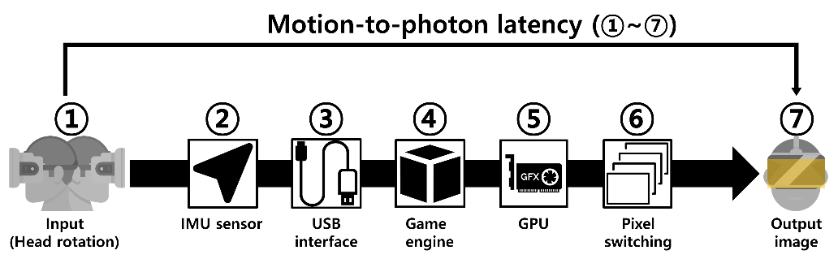

Figure 1. Overall process and motion-to-photon latency of the image rendering.

* Reducing the latency requires an accurate measurement system that can consider the human physical movement.

# Overview

## Purpose

This document is to quantitatively measure the motion-to-photon latency so that the users of HMD-based virtual reality content have a good experience and motion sickness is minimized.

## Scope

We describe the measurement system considers the physical head movement. Specifically, it consists of a head position model-based rotary platform, pixel luminance change detector, and signal analysis and calculation modules. Using these modules, the system can measure the latency, which is the time difference between the physical movement for a user and the luminance change of an output image.

# Use Case

## Use case for Measuring the Motion-to-Photon Latency

### Classification of user

|  |  |
| --- | --- |
| **User** | **User’s role** |
| Player | * Playing VR content * Subject for the sickness testing |
| Device designer | * Design HW system with the target latency available |
| Content designer | * Designing visual scene and stages with best practice for considering the motion-to-photon latency and sickness |
| Content programmer | * Implementing rules and modules for considering computational time and rendering consumption of the content SW |
| System operator | * Operating and clinical test system with standard latency measurement system |
| Sickness evaluator | * Analyzing subjective and objective component for predicting sickness with standard measured latency time |

### Use Case Summary

|  |  |  |
| --- | --- | --- |
| Cases | Descriptions | Remarks |
| Use case 1 | The motion-to-photon latency for the commercial HMD was measured.   < Figure 2. Prototype of the motion-to-photon latency measurement system: (a) a head position model-based rotary platform, (b) a pixel luminance change detector, and (c) an oscilloscope and an amplifier. > | Measuring the latency |

|  |  |  |
| --- | --- | --- |
| Cases | Descriptions | Remarks |
| Use case 2 | This latency was evaluated by changing the graphic rendering workload for the HMD system.   < Figure 3. (a) A model with a high number of polygons used in the experiment and (b) textures of the model. > | Different workloads |

#### User environmental variables

|  |  |
| --- | --- |
| **User interface** | **Environmental variables for VR content** |
| User(player) | * Head movement (yaw-pitch-roll & translation) * Personal physical endurance |
| Content | * Different rendering amount depends on the content SW |
| Display Device | * All-in-one type(stand-alone type) * PC-based * Smartphone-based |
| Play Environment | * Sit-down * Stand * Working attractions * Treadmills |
| Motion Platform | * Hang-on * Riding-on * Lay-down |
| Getting data | * Measured time depends on the conditions (movement, velocity, workload) |
| Reference design | * None (Required the standard) |

### Use case 1

#### Use case name

Measuring the latency

#### Overview

The motion-to-photon latency for the commercial HMD was measured.

#### Related actor

Player, Device designer, System operator, Sickness evaluator

#### Pre-condition

-Preparing VR content for testing

-Preparing VR HW system for testing

-Defining the motion scenario with various movement, velocity, acceleration.

#### Event Flow

-measured by rotating in the yaw and pitch directions

-repeating the experiment until getting the statistically reliable data

-comparing the pulse generated by the encoder with high resolution, which was used for the physical movement and the pulse generated by changing the luminance of the display in the photo-sensor.

-Avg. and Std. analysis of the measured data

#### Post-condition

-store the motion-to-photon latency

#### Requirements

##### Functional Requirements

-require measurement system and signal processing

##### Non-functional Requirements

-consider the testing environments

### Use case 2

#### Use case name

Different Workload

#### Overview

This latency was evaluated by changing the graphic rendering workload for the HMD system.

#### Related actor

Player, Content designer, Content programmer, System operator, Sickness evaluator

#### Pre-condition

-Preparing VR content for testing

-Preparing VR HW system for testing

-Setting the quality measurement metric

-Defining the motion scenario with various workload complexity

#### Event Flow

-measuring the motion-to-photon latency according to the change in the image rendering workload

-changing the vertex in the content SW which is a data structure in computer graphics that describes certain attributes such as the position of a point in 2D or 3D space, at multiple points on a surface

#### Post-condition

- store the motion-to-photon latency

- analyze the correlation between the latency and the workload.

#### Requirements

##### Functional Requirements

- require measurement system and signal processing

##### Non-functional Requirements

-consider the testing environments

# Scenario

## Scenario 1 (System Implementation & Measurement Performance)

Figure 4 shows an implementation of the photosensor-based latency measurement system. The rotary platform was designed to make a movement, as shown in Figure 4a, and the detector was placed on this platform to measure the luminance change, as shown in Figure 4b. The oscilloscope and the amplifiers, shown in Figure 4c, were used to calculate and analyze the output signals of each part.

Specifically, the Oculus Rift DK2 hardware, which is one of the most popular VR systems, was used as the target HMD. A rotary DC motor (RE40, Maxon, Sachseln, Switzerland) was used to rotate the platform, and a controller (EPOS2 50/5, Maxon, Sachseln, Switzerland) was used to handle the platform. In addition, incremental-type encoders (EIL580, Baumer, Southington, USA) were used to generate pulses based on the movement of the HMD. Its maximum output frequency was 300 kHz and its resolution was 5000 steps/turn (0.018°/step). A photosensor (SM05PD2B, Thorlabs, Newton, USA) was used to measure the luminance change, and its spectral range was from 200 nm to 1000 nm. The PC-based oscilloscope was a PicoScope 4824 oscilloscope (Pico technology, St Neots, UK).

For rendering the virtual space and analyzing the signals, a PC with an Intel i7-6700k 4.4-GHz CPU and an NVIDIA GeForce GTX 1080 GPU was used. In addition, the time-warp technique was not used for generating VR patterns used to measure the actual motion-to-photon latency of the HMD.

Figure 5 shows the performance of the measurement system along the user’s head movement.

|  |
| --- |
|  |

**Figure 4.** Prototype of the photo sensor-based latency measurement system: (**a**) a head position model-based rotary platform, (**b**) a pixel luminance change detector, and (**c**) an oscilloscope and an amplifier.

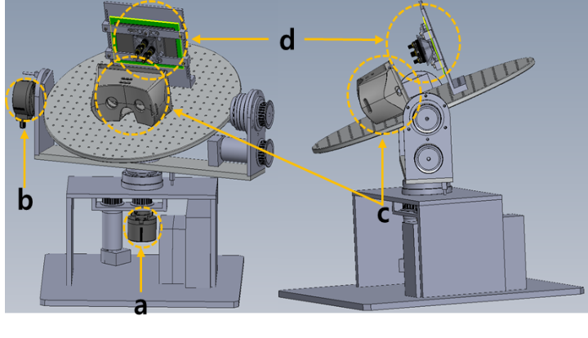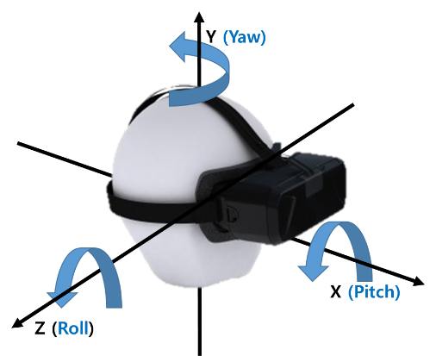

**Figure 5.** Overall architecture of the photo sensor-based latency measurement system: (a) a yaw-direction encoder, (b) a pitch-direction encoder, (c) a HMD system, and (d) a plate holding the display of the HMD system. It performed along the user’s head movement.

# Conclusion

# This document is to quantitatively measure the motion-to-photon latency so that the users of HMD-based virtual reality content have a good experience and motion sickness is minimized.

# Two different cases for the latency measurement were performed using the latency measurement system. First, the motion-to-photon latency for the commercial HMD was measured. Second, this latency was evaluated by changing the graphic rendering workload for the HMD system.

# The system, which uses high-accuracy DC motors and encoders with high resolution, could replicate the head movement, and it is possible to measure the rotation angles of the platform in real time. In addition, the luminance change in the display could be detected using a photo sensor.