Project | HMD based 3D Content Motion Sickness Reducing Technology  <http://sites.ieee.org/sagroups-3079/ >
Title | Use cases of SW & Content for evaluation of CSL
DCN | 3079-18-0020-01-0002
Date Submitted | June 27, 2018
Source(s) | Beom-Ryeol Lee lbr@etri.re.kr (ETRI)
Re:
Abstract | HMD-based VR content users are interested in the stability of VR content because of VR sickness that occurs differently depending on the characteristics of the user who experiences VR content. We consider the application of the user's viewpoint to present the level of VR sickness to the user of the VR content and adjust it according to the sensitivity of the VR sickness of the user through the objective and subjective evaluation method for assessing the VR sickness
Purpose | This document deals with the user-oriented system environment configuration and user-driven scenarios for evaluating VR sickness levels
Notice | This document has been prepared to assist the IEEE 802.21 Working Group. It is offered as a basis for discussion and is not binding on the contributing individual(s) or organization(s). The material in this document is subject to change in form and content after further study. The contributor(s) reserve(s) the right to add, amend or withdraw material contained herein.
Release | The contributor grants a free, irrevocable license to the IEEE to incorporate material contained in this contribution, and any modifications thereof, in the creation of an IEEE Standards publication; to copyright in the IEEE’s name any IEEE Standards publication even though it may include portions of this contribution; and at the IEEE’s sole discretion to permit others to reproduce in whole or in part the resulting IEEE Standards publication. The contributor also acknowledges and accepts that IEEE 802.21 may make this contribution public.
Patent Policy | The contributor is familiar with IEEE patent policy, as stated in Section 6 of the IEEE-SA Standards Board bylaws <http://standards.ieee.org/guides/bylaws/sect6-7.html#6> and in Understanding Patent Issues During IEEE Standards Development http://standards.ieee.org/board/pat/faq.pdf

Introduction

VR content allows the user to experience a safe and immersive indirect experience in the virtual world that transcends time and space in the real world.
However, VR sickness or cybersickness, which VR users commonly experience, has many obstacles in growing the VR industry.
Therefore, it is necessary to develop a technique for reducing VR sickness and an evaluation and control technology for VR sickness according to a user's VR sickness adaptability.
In this document, we describe a software platform for analyzing and predicting the levels of VR sickness from the user 's point of view about VR sickness that can occur when experiencing user VR content, and describe a user - based experience scenarios.

Overview

Purpose
This document deals with the user-oriented system environment configuration and user-driven scenarios for evaluating cybersickness levels(CSL)

Scope
We describe the range of the platform for presentation to the user, the execution examples of the user’s view, and the experience scenarios of the VR content by evaluating the cybersickness levels corresponding to the intensity of the VR sickness experienced by the user executing the VR content.

Use Case

Use case for Content & SW

Classification of user
User | User’s role
Player | - Playing VR content  - Subject for CSL testing
Content designer | - Designing visual scene and stages with best practice for controlling CSL
Content programmer | - Implementing rules and modules for VR content SW
System operator | - Operating and clinical test system
CSL evaluator | - Analyzing subjective and objective component for predicting CSL
CSL data manager | - Managing CSL data

Use Case Summary
Cases | Descriptions | Remarks
Use case 1 | Evaluating CSL using bio-signal and SSQ  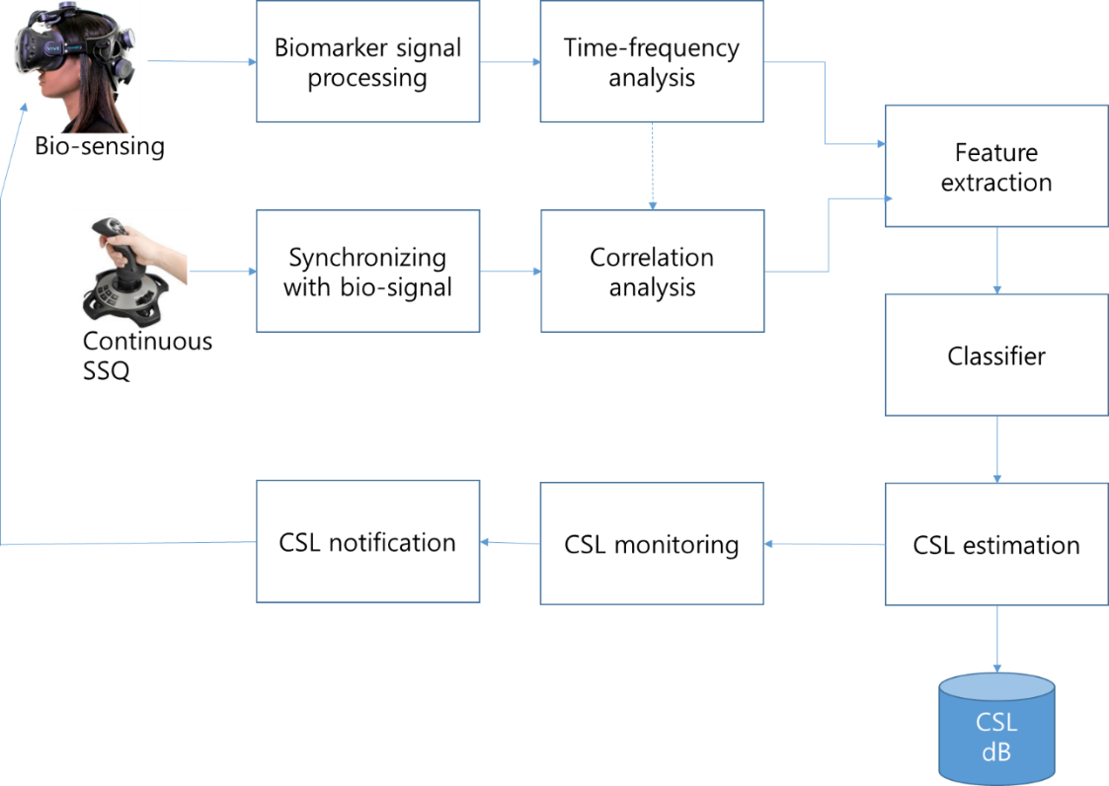  < System block diagram for CSL evaluation>

Cases | Descriptions | Remarks
Use case 2 | Clinical trials for getting the characteristic data of CSL for VR content users  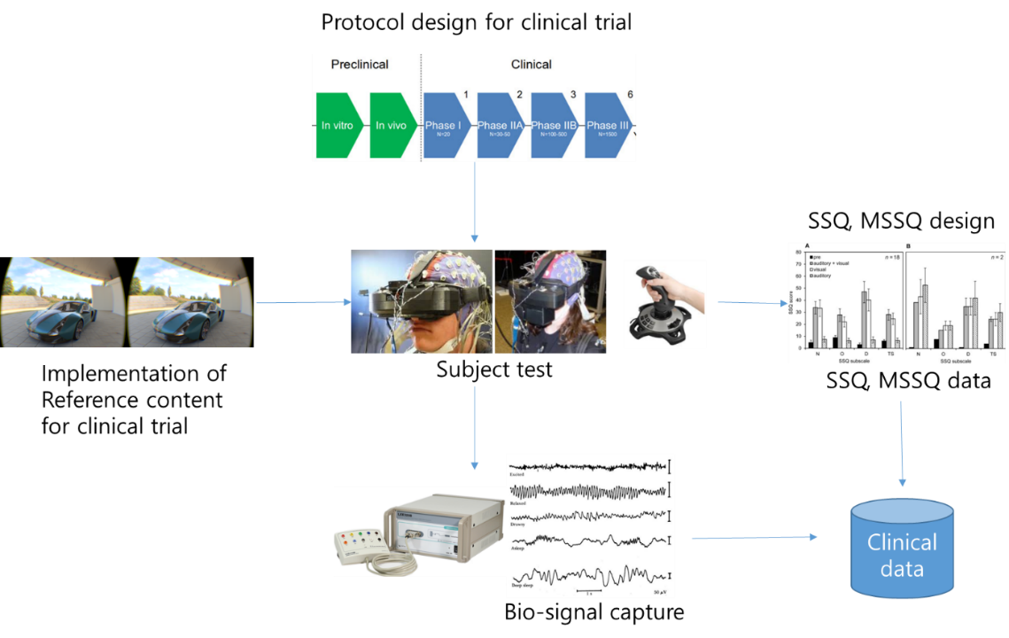  < Design tools of clinical trial for CSL estimation>

Cases | Descriptions | Remarks
Use case 3 | Cloud based clinical trial method for evaluating CSL  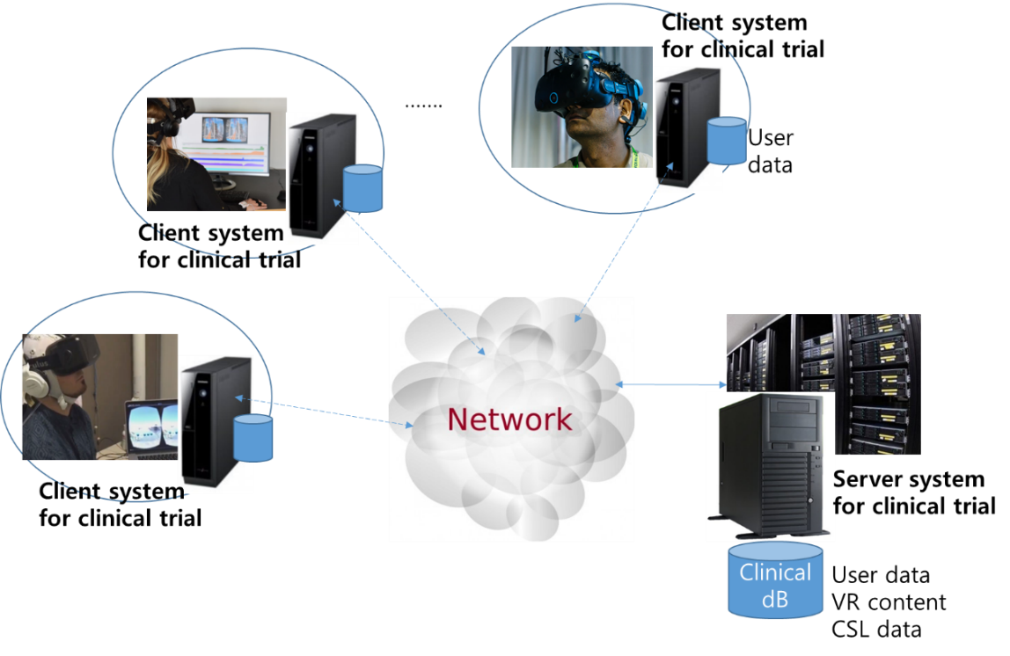  < Configuration of cloud based clinical trials>

User environmental variables
User interface | Environmental variables for VR content
User(player) | - Sit-down  - Stand  - Walk and run
Content | - 1st personal view / 3rd personal view /Flying view  - Independent visual background or visual guide  - Adjusting FOV(Field of View)  - Play with walking/Play on riding  - Watching mode/broadcasting mode  - Interaction mode/navigation mode  - Single-user/Multi-user
Display Device | - All-in-one type(stand-alone type)  - PC-based  - Smartphone-based
Play Environment | - Sit-down  - Stand  - Working attractions  - Treadmills
Motion Platform | - Hang-on  - Riding-on  - Lay-down
Getting sickness data | - Biomarking  - Continuous SSQ(Simulator Sickness Questionnaire) with joystick or Pre/post SSQ
Clinical test boundary | - Stand-alone(local)  - Cloud(network)
Management system configuration | - Stand-alone(local)  - Client-Server(network)  - Streaming  - Downloading
Estimation of CSL | - Analysis  - Evaluation  - Prediction  - Notice
Reference design | - MSSQ(Motion Sickness Susceptibility Questionnaire  - Test content  - Clinical protocol

Use case 1

Use case name
Evaluating CSL

Overview
While the user is experiencing the VR content, the user is allowed to evaluate the VR sickness level using the bio-signal and the SSQ.

Related actor
Player, System operator, CSL evaluator, CSL data manager

Pre-condition
-Prepare VR content for testing
-setting biomarker and bio-signal measurement equipment
-on-line SSQ
-defining the number of CSL

Event Flow
-acquire bio-signal from measuring equipment
-getting SSQ data during the VR content play
-synchronizing bio-signal with SSQ
-time-frequency analysis and correlation analysis
-frequency selection and feature extraction
-classify extracted feature data using the deep learning method, etc
-leveling CS, monitoring
-notification of CSL

Post-condition
-store CSL data for the VR content and user
-notify CSL

Requirements

Functional Requirements
-support process and methodology for evaluation of CSL

Non-functional Requirements
-Biomarker : EEG(Electroencephalogram), ECG(Electrocardiogram), PPG(Photoplethysmograph), GSR(Galvanic skin response)

Use case 2

Use case name
Clinical trials

Overview
While the user is experiencing the VR content, the user is allowed to evaluate the VR sickness level using the bio-signal and the SSQ.

Related actor
System operator, player, Content designer, Content programmer

Pre-condition
-implement reference VR content
-design protocol for clinical trials
-design SSQ/MSSQ

Event Flow
-playing reference VR content
-acquiring bio-signal and on-line SSQ data
- synchronizing bio-signal and SSQ data

Post-condition
-store bio-signal and on-line SSQ/MSSQ

Requirements

Functional Requirements
-support clinical trials

Non-functional Requirements
-Biomarker : EEG, ECG, PPG, GSR

Use case 3

Use case name
Cloud based clinical trials

Overview
We will conduct cloud-based clinical trials to ensure that the number of clinical trial patients will be sufficient when conducting clinical trials to reduce VR sickness.

Related actor
Player, System operator, CSL data manager

Pre-condition
-setting for client clinical trial environment
-setting for server clinical trial environment
-downloading user’s CSL data from server

Event Flow
-Initialize client/server dB
-execute client system, start clinical trials and estimating CSL for VR content
-uploading CSL data and user’s data from client to server system
-CSL data mining to server system for clinical trials

Post-condition
-managing CSL data
-analysing CSL data

Requirements

Functional Requirements
-supporting cloud based clinical trials

Non-functional Requirements
-supporting subjects more than 100

Scenario

Scenario 1 (FPS VR game in the walking attraction with CSL estimation)

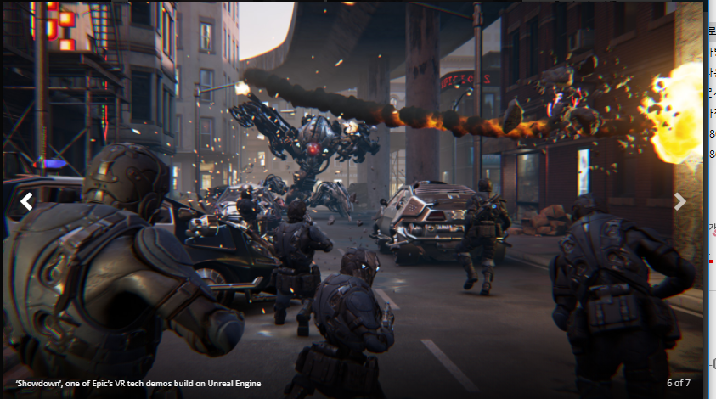
Users of VR content participate in the battle simulation game between the multiple users while wearing personal protective clothing with haptic feedback function in the personal space in the attraction space for the gun shooting game wearing the HMD.

The user can walk while moving through the VR game. When the gamer reaches the boundaries of the designated game space, he / she will see a warning sound and a visual warning effect as an indication of the boundary. You can also move the game stage using a jeep. You can ride on the elevator to move to a higher floor. When you are shot, haptic feedback on the shooting is delivered through your protective clothing.

Particularly, when moving the game stage or moving from left to right in a state of sudden head tracking or left to right in a state of severe change of the screen, the user feels severe dizziness and nausea. At this time, by presenting the nausea according to the severity of the change, the nausea can be reduced by allowing the gamer to predict the nausea in advance.
Also, when moving to a higher place, the motion feeling of the height difference becomes serious due to the virtual feeling At this time, it is possible to experience the effect of reducing the motion picture by adjusting the viewing angle of the screen or presenting the visual guide. The variation of the VR sickness of each game stage experienced by the user is stored and stored as the personalized information of the user. Cumulative changes of the user's VR sickness are comprehensively determined to determine the sickness of the VR content. Update personalized VR sickness information about changes in the user's rehabilitation of VR sickness.

Scenario 2 (Roller Coaster VR game on the Motion Platform with CSL estimation)

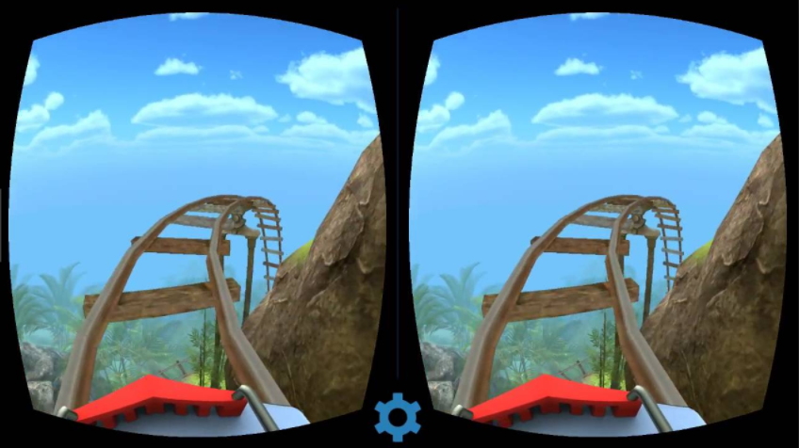
VR content users will experience content that implements a roller coaster. The motion platform is implemented based on the 6-DOF degrees of freedom. The user experiences VR content in the watching mode while the HMD is mounted and the pre-configured contents are loaded on the motion platform without any additional navigation input of user.
When riding a roller coaster in the real world or playing VR content with HMD, the user has an similar experience to motion sickness symptoms. The user experiences a sudden height change in the VR content. The VR user will experience severe VR sickness due to sudden changes in height and severe accelerating speed. On a very fast curve travel content, the user experiences very severe VR sickness. Information about the user's VR sickness effect is stored in the image of the content experiencing VR sickness. At this point, the user can be provided with a visual guide to reduce the VR sickness or alleviate the VR sickness symptoms in the whole contents by reflecting the appropriate constant velocity motion to the image and moderately adjusted image in the sudden fluctuation of the image.

Conclusions

This document describes procedures and methods for evaluating the VR sickness phenomenon that a VR content user experiences when playing VR content. Thus, the VR sickness level for the VR content is determined so that the user can select the VR content and activate the VR market.

To evaluate the VR sickness of the content, the objective data, the bio signal, and the subjective data, SSQ/MSSQ, are used. By performing time-frequency analysis and feature extraction of such user biometric data, prediction of VR sickness is performed and the level of VR sickness is determined.

Clinical trials of VR sickness are performed to clarify the correlation between the symptoms of VR sickness and the VR sickness of the content. In order to increase the reliability of the clinical trial results, it is appropriate to introduce a cloud clinical trial method in order to construct an analysis environment for the result data of more than 100 participants.

