Project | HMD based 3D Content Motion Sickness Reducing Technology  <http://sites.ieee.org/sagroups-3079/ >
Title | Terminologies of Cybersickness
DCN | 3-18-0008-00-0002
Date Submitted | Jan 25, 2018
Source(s) | Beom-Ryeol Lee lbr@etri.re.kr (ETRI)
Re: | WG Meeting, Seoul, Korea
Abstract | Definition of terminologies for cybersickness reducing technology of HMD based virtual reality.
Purpose | By establishing a clear concept of VR sickness-related technology, we avoid the conceptual confusion between researchers and define basic terms for clear communication.
Notice | This document has been prepared to assist the IEEE P3333.3 Working Group. It is offered as a basis for discussion and is not binding on the contributing individual(s) or organization(s). The material in this document is subject to change in form and content after further study. The contributor(s) reserve(s) the right to add, amend or withdraw material contained herein.
Release | The contributor grants a free, irrevocable license to the IEEE to incorporate material contained in this contribution, and any modifications thereof, in the creation of an IEEE Standards publication; to copyright in the IEEE’s name any IEEE Standards publication even though it may include portions of this contribution; and at the IEEE’s sole discretion to permit others to reproduce in whole or in part the resulting IEEE Standards publication. The contributor also acknowledges and accepts that IEEE P3333.3 may make this contribution public.
Patent Policy | The contributor is familiar with IEEE patent policy, as stated in Section 6 of the IEEE-SA Standards Board bylaws <http://standards.ieee.org/guides/bylaws/sect6-7.html#6> and in Understanding Patent Issues During IEEE Standards Development http://standards.ieee.org/board/pat/faq.pdf

TERminlology OF Cybersickness

Contents
VR Cybersickness 4
1. Motion Sickness 4
2. Simulator Sickness 4
3. Virtual Reality Sickness 6
4. Cybersickness 6
5. Visually Induced Motion Sickness(VIMS) 7
6. Vection 8
7. Simulator Sickness Questionnaire(SSQ) 9
8. Motion Sickness Susceptibility Questionnaire(MSSQ) 10
9. Human Factor 10
10. Sensory Conflict theory 10
11. Postural Instability 11
12. Vestibulo-Ocular Reflex(VOR) 12
13. Best Practice 13
14. Foveated Rendering 13
15. Time warping Rendering 14
16. Galbanic Vestibula Stimulation(GVS) 15
17. Electroencephalography(EEG) 16
18. Electrocardiography(ECG) 16
19. PhotoPlethysmography(PPG) 17
20. Galvanic Skin Response(GSR) 17
21. Biomarker 17
22. Subjective Vertical 18
Virtual Reality 19
23. Virtual Reality(VR) 19
24. Immersive Virtual Reality(Immersive VR) 19
25. Augmented Reality, AR 20
26. Mixed Reality, MR 20
27. Substitutional Reality(SR) 23
28. Merged Reality 23
29. Shared Reality 23
30. eXtended Reality(XR) 24
31. Virtual Retinal Display(VRD), Retinal Scan Display(RSD) 25
32. Head Mounted Display, HMD 26
33. Smart Glasses 27
34. Gesture Recognition 28
35. Positional Tracking 28
36. Eye Tracking 30
37. 3DOF, three Degrees Of Freedom 30
38. 6DOF, six Degrees Of Freedom 31
39. Motion Capture System(MCS) 31
40. Object Tracking, Video Tracking 33
41. Tangible User Interface(TUI ) 33
42. Natural User Interface( NUI) 34
43. Haptic Interface 35
44. Zero UI , Zero Screen 36
45. Extensible 3D(X3D) 36
46. Augmented Reality Markup Language(ARML) 37
Display Technology 37
47. Panoramic Imaging System 37
48. Stereoscopic 3D(S3D) 38
49. Multiview Image 38
50. Viewing Angle 38
51. Field of View, Field of Vision(FOV ) 39
52. Binocular Parallax(Disparity) 40

VR Cybersickness
- Motion Sickness
Motion sickness is a condition in which a disagreement exists between visually perceived movement and the vestibular system's sense of movement. Depending on the cause, it can also be referred to as seasickness, car sickness, simulation sickness or airsickness. Dizziness, fatigue and nausea are the most common symptoms of motion sickness. If the motion causing nausea is not resolved, the sufferer will usually vomit. Vomiting often will not relieve the feeling of weakness and nausea, which means the person might continue to vomit until the cause of the nausea is treated.
Motion sickness can be divided into three categories: 1)Motion sickness caused by motion that is felt but not seen 2)Motion sickness caused by motion that is seen but not felt 3)Motion sickness caused when both systems detect motion but they do not correspond.
https://en.wikipedia.org/wiki/Motion_sickness
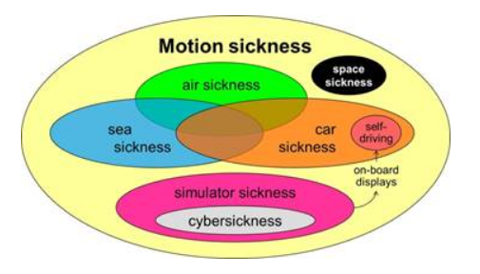http://www.jeltebos.info/perception_sickness.htm

- Simulator Sickness
Simulator sickness is a form of motion sickness linked to interaction with a simulated environment. It can be caused, for example, by discrepancies between the simulated motion in a simulator and the user's perception or expectation of motion. The phenomenon is often observed in users training with flight simulators and is also associated with video gaming.
The symptoms of simulator sickness include lethargy, nausea, vomiting, sweating, headaches, uneasiness, drowsiness, disorientation and ocular motor disturbances. Individuals are affected by simulator sickness to varying degrees and may experience different symptoms. Like virtual reality sickness, simulator sickness differs from motion sickness in that only visually perceived movement is required to cause its symptoms, although some simulators do include a moving cockpit. Differences between control input to reaction, between simulator movement and vehicle movement, and between tracking motion on screens as opposed to real life all contribute to simulator sickness. Another causal factor is an individual’s postural instability in dealing with perceived and actual simulator movement.
http://whatis.techtarget.com/definition/simulator-sickness

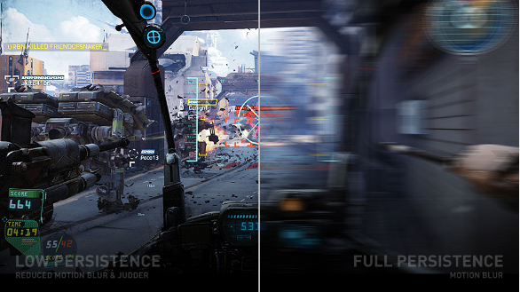
https://www.gamasutra.com/blogs/BenLewisEvans/20140404/214732/Simulation_Sickness_and_VR__What_is_it_and_what_can_developers_and_players_do_to_reduce_it.php

- Virtual Reality Sickness
Virtual reality sickness occurs when exposure to a virtual environment causes symptoms that are similar to motion sickness symptoms. The most common symptoms are general discomfort, headache, stomach awareness, nausea, vomiting, pallor, sweating, fatigue, drowsiness, disorientation, and apathy. Other symptoms include postural instability and retching. Virtual reality sickness is different from motion sickness in that it can be caused by the visually-induced perception of self-motion; real self-motion is not needed. It is also different from simulator sickness; non-virtual reality simulator sickness tends to be characterized by oculomotor disturbances, whereas virtual reality sickness tends to be characterized by disorientation.
https://en.wikipedia.org/wiki/Virtual_reality_sickness

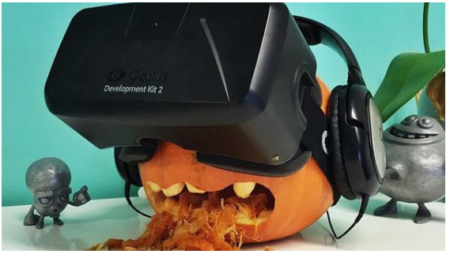
https://medium.com/research-vr-reports/vr-sickness-why-and-how-review-4309a54a509f

- Cybersickness
Cybersickness is similar to motion sickness and typically occurs during or after immersion in a virtual environment. Cybersickness is believed to occur primarily as a result of conflicts between three sensory systems: visual, vestibular and proprioceptive. Accordingly, the eyes perceive a movement that is out of sync by a few milliseconds with what is perceived by the vestibular system, whereas the remainder of the body remains almost motionless (Stanney, Kennedy, & Kingdon, 2002). Cybersickness can also be caused by factors related to the use of virtual reality equipment (e.g. heaviness of the helmet, closeness of screen to the eyes). Lawson, Graeber, Mead and Muth (2002) note the added possibility that these side effects are also connected to Sopite Syndrome (fatigue due to the movements).
According to Kennedy, Lane, Berbaum and Lilienthal (1993), the temporary side effects associated to cybersickness can be divided into three classes of symptoms related to the sensory conflicts and to the use of virtual reality equipment: (1) visual symptoms (eyestrains, blurred vision, headaches), (2) disorientation (vertigo, imbalance) and (3) nausea (vomiting, dizziness). Visual symptoms typically occur as a result of closeness of the screen and are limited primarily to the use of a virtual helmet. The nausea and disorientation experienced are temporary, comparable to reading in a moving vehicle and are caused primarily as a result of sensory conflict.
http://w3.uqo.ca/cyberpsy/en/cyberma_en.htm#def

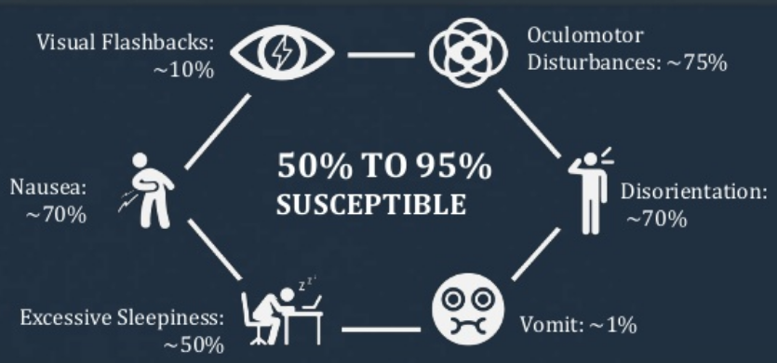
https://www.slideshare.net/AugmentedWorldExpo/dr-brent-winslow-design-interactive-design-guidelines-for-preventing-vr-sickness
http://designinteractive.net/cybersickness/

- Visually Induced Motion Sickness(VIMS)
VIMS is a sensation very similar to traditional motion sickness (MS), with the difference being that physical movement is usually limited or absent during VIMS (see Keshavarz et al., 2014a, for an overview). Typically, VIMS has been used as an umbrella term to describe MS-like symptoms that are strongly driven by visual stimulation in the absence of physical movement. Depending on the equipment and the laboratory setting, VIMS has been further segmented into different subcategories. For instance, VIMS in virtual environments has been labeled as cybersickness (e.g., McCauley and Sharkey, 1992), VIMS during video games has been labeled as gaming sickness (e.g., Merhi et al., 2007), and VIMS in driving or flight simulators has been labeled as simulator sickness (e.g., Brooks et al., 2010). Note, however, that modern simulators can also provide non-visual cues that might induce sickness, such as physical movement. Thus, simulator sickness and cybersickness can include aspects from both VIMS and traditional MS that cannot always be clearly assigned to one of the two.
https://www.ncbi.nlm.nih.gov/pmc/articles/PMC4403286/

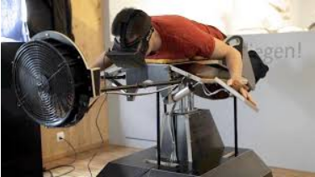
https://www.linkedin.com/pulse/how-do-you-design-your-vr-game-around-motion-sickness-alex-riviere

- Vection
Vection describes the sensation of illusory self-motion in the absence of physical movement through space (Fischer and Kornmüller, 1930; Dichgans and Brandt, 1973; see also Palmisano et al., 2015, for a discussion of terminology). Vection is a well-known phenomenon and first scientific reports of vection can be traced back to the late nineteenth century (e.g., Mach, 1875; Wood, 1895). A typical real-life example of vection is the train illusion, whereby seeing the movement of a neighboring train creates the illusion that one’s own stationary train is moving. Vection can also readily occur in virtual environments, movie theaters, or simulators (see Hettinger et al., 2014, for an overview).
https://www.ncbi.nlm.nih.gov/pmc/articles/PMC4403286/
https://en.wikipedia.org/wiki/Illusions_of_self-motion

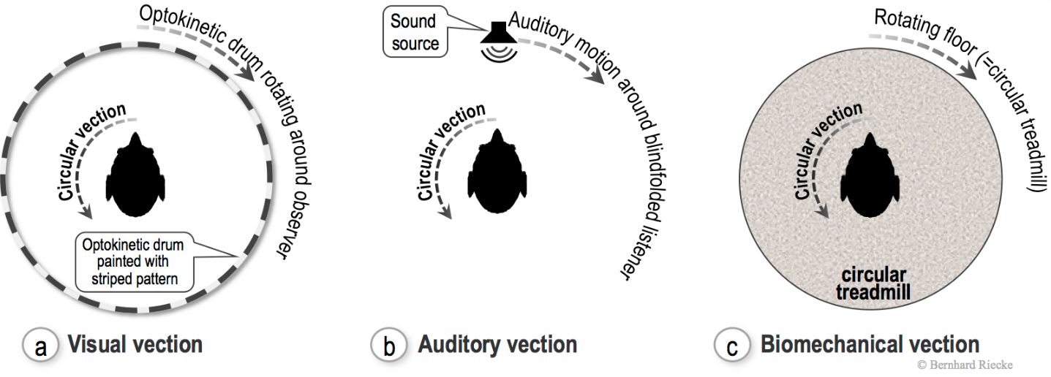
http://ispace.iat.sfu.ca/project/vection/

- Simulator Sickness Questionnaire(SSQ)
Simulator Sickness Questionnaire was developed by Kennedy and his colleagues in 1993 (Kennedy et al., 1993). They used over 1000 sets of previous data and through some analysis, they came up with a list of 27 symptoms which are commonly experienced by users of virtual reality systems. Each item is rated with the scale from none, slight, moderate to severe. Through some calculations, four representative scores can be found. Nausea-related subscore (N), Oculomotor-related subscore (O), Disorientation-related subscore (D) are the scores for the symptoms for the specific aspects. Total Score (TS) is the score representing the overall severity of cybersickness experienced by the users of virtual reality systems. Simulator Sickness Questionnaire is a widely applied measurement tool in research studying simulator sickness and cybersickness.
http://w3.uqo.ca/cyberpsy/docs/qaires/ssq/SSQ_va.pdf

- Motion Sickness Susceptibility Questionnaire(MSSQ)
Motion sickness susceptibility questionnaires, sometimes called motion history questionnaires, are useful instruments in the prediction of motion sickness due to a variety of provocative environments. A number of ad-hoc questionnaires have been reported in the literature but, apart from the Pensacola Motion History Questionnaire, few have the research pedigree of the Reason and Brand Motion Sickness Susceptibility Questionnaire (MSSQ)
https://www.sciencedirect.com/science/article/pii/S0361923098000914
http://downloads.bbc.co.uk/scotland/tv/trustme/motion_sickness_susceptibility_questionnaire.pdf

- Human Factor
Human factors also known as comfort design, functional design, and systems, is the practice of designing products, systems, or processes to take proper account of the interaction between them and the people who use them.
The field has seen some contributions from numerous disciplines, such as psychology, engineering, biomechanics, industrial design, physiology, and anthropometry. In essence, it is the study of designing equipment, devices and processes that fit the human body and its cognitive abilities. The two terms "human factors" and "ergonomics" are essentially synonymous.
The International Ergonomics Association defines ergonomics or human factors as follows:
Ergonomics (or human factors) is the scientific discipline concerned with the understanding of interactions among humans and other elements of a system, and the profession that applies theory, principles, data and methods to design to optimize human well-being and overall system performance.
https://en.wikipedia.org/wiki/Human_factors_and_ergonomics

- Sensory Conflict theory
The theory of sensory conflict remains the most prevalent explanation for the appearance symptoms caused by displacement. This theory holds that the orientation of the human body in a three-dimensional space requires a minimum of four points of entry of sensory information into the central nervous system: (1) the otoliths organs offer information concerning linear acceleration, velocity and incline; (2) the information on angular acceleration is provided by the semi-circular canals; (3) the visual system provides information concerning the body's orientation with respect to the visual scene; (4) the systems of touch, and of kinaesthetic pressure, provide information with respect to the limbs and the body's position. When the environment is altered in a way so as to produce a misalignment or discord between the sensory systems of the body that are already in place, symptoms of cybersickness can appear (Harm, 2002). This theory is generally adequate but it fails to properly explain (in enough detail) certain particular situations, for example, when the user experiences sensory conflict but fails to experience symptoms of cybersickness. In addition, this theory makes it difficult to describe the possibility of quantifying the conflict or of explicating its underlying mechanisms. Nor does it include the occurrence of sensory-motor conflict or of adaptation without conflict in its explanation.
http://w3.uqo.ca/cyberpsy/en/cyberma_en.htm

- Postural Instability
Postural stability is the ability to maintain balance using the muscles in your ankles, knees, and hips in response to movement. Postural stability decreases with fatigue, particularly in the knees and hips.
Visually induced motion sickness is preceded by changes in postural activity that are limited to persons who will later become motion sick. Postural instability has preceded motion sickness in studies using widely differing types of visual motion, including linear oscillations along the line of sight (e.g., Bonnet, Faugloire, Riley, Bardy, & Stoffregen, 2006; Stoffregen & Smart, 1998), angular oscillations around the line of sight (Stoffregen et al., 2000), and multiaxis motions that occur in console video games (Stoffregen et al., 2008 [this issue]). This effect confirms a prediction of the postural instability theory of motion sickness (Riccio & Stoffregen, 1991).
https://pdfs.semanticscholar.org/cadc/8ff3ca3e1b6708e1257c1beb141771b00c49.pdf

- Vestibulo-Ocular Reflex(VOR)
The vestibulo-ocular reflex (VOR) is a reflex, where activation of the vestibular system causes eye movement. This reflex functions to stabilize images on the retinas (in yoked vision) during head movement by producing eye movements in the direction opposite to head movement, thus preserving the image on the center of the visual field(s).For example, when the head moves to the right, the eyes move to the left, and vice versa. Since slight head movement is present all the time, the VOR is very important for stabilizing vision: patients whose VOR is impaired find it difficult to read using print, because they cannot stabilize the eyes during small head tremors, and also because damage to the VOR can cause vestibular nystagmus.
https://en.wikipedia.org/wiki/Vestibulo%E2%80%93ocular_reflex
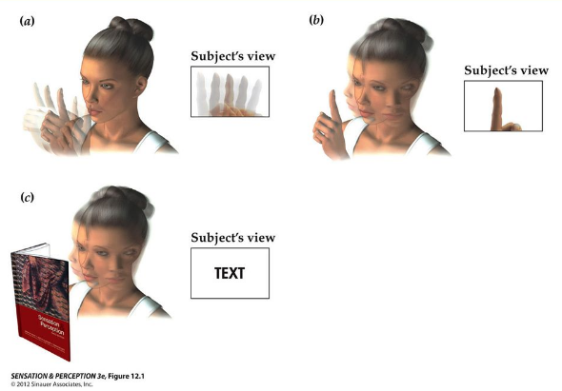 http://slideplayer.com/slide/7411968/

- Best Practice
Best practive contains some tips about how to make the best possible VR experiences for your users. We’ll make some specific recommendations about how to make comfortable experiences; however, VR is a young medium and all developers are responsible for ensuring that their content conforms to all standards and industry best practices for safety and comfort and to keep abreast of scientific research and industry standards.
https://developer.oculus.com/design/latest/concepts/book-bp/

- Foveated Rendering
Foveated rendering is an upcoming graphics rendering technique which uses an eye tracker integrated with a virtual reality headset to reduce the rendering workload by greatly reducing the image quality in the peripheral vision (outside of the zone gazed by the fovea). https://en.wikipedia.org/wiki/Foveated_rendering
Foveated Rendering uses the Gaze Prioritized Graphics feature, which displays the user's peripheral view area with a relatively low-resolution graphic while simultaneously displaying the area of ​​the screen that the user is staring at in high resolution. This feature makes real-time virtual experience more realistic by tracking your eyes very quickly and accurately for the interaction of the user's eye movements with the content in the HMD. These graphical optimizations enable a highly detailed and realistic virtual environment with much less bandwidth on CPU and GPU.
Foveated rendering, developed by NVIDIA with the German SMI (SensoMotoric Instruments), is a technology that increases virtual reality immersion and reduces rendering loads.
The visible range of human eyes is about 120 degrees left and right. At the end of the line of sight there is a blurred peripheral vision. There is a blurred area that can not be recognized properly in addition to the place to gaze. Poverty Rendering is a technique that realistically reproduces this human vision to reduce the virtual reality rendering load.
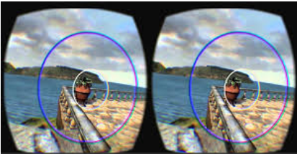
https://www.youtube.com/watch?v=Qq09BTmjzRs

- Time warping Rendering
Timewarp / Time warping also known as Reprojection is a technique in VR that warps the rendered image before sending it to the display to correct for the head movement occurred after the rendering. Timewarp can reduce latency and increase or maintain frame rate. Additionally, it can reduce judder caused missed frames (when frames take too long to render). This process takes the already rendered image, modify it with freshly collected positional information from your HMD's sensors, then display it to your screen. Utilizing depth maps (Z Buffers) already present in the engine, Timewarp requires very little computation.
https://xinreality.com/wiki/Timewarp
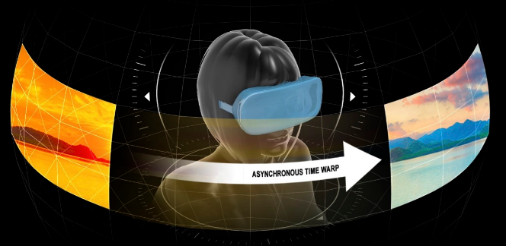
https://www.anandtech.com/show/9043/amds-liquidvr-announced-amd-gets-expanded-vr-headset-functionality

- Galbanic Vestibula Stimulation(GVS)
Galvanic vestibular stimulation is the process of sending specific electric messages to a nerve in the ear that maintains balance. There are two main groups of receptors in the vestibular system: the three semi-circular canals, and the two otolith organs (the utricle and the saccule). This technology has been investigated for both military and commercial purposes. The technology is being applied in Atsugi, Japan, the Mayo Clinicin the US, and a number of other research institutions around the world. It is being investigated for a variety of applications, including biomedical, pilot training, and entertainment.
https://en.wikipedia.org/wiki/Galvanic_vestibular_stimulation
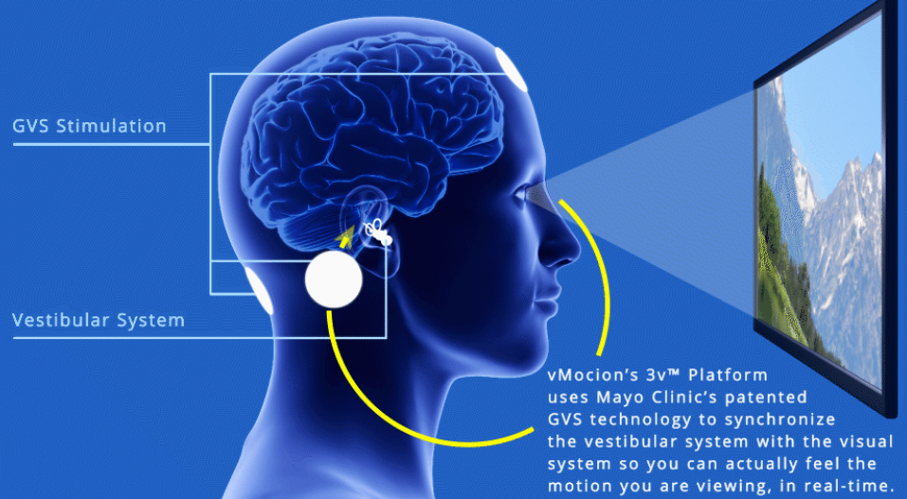
https://www.vmocion.com/technology.html

- Electroencephalography(EEG)
An electroencephalogram (EEG) is a test used to evaluate the electrical activity in the brain. Brain cells communicate with each other through electrical impulses. An EEG can be used to help detect potential problems associated with this activity.
An EEG tracks and records brain wave patterns. Small flat metal discs called electrodes are attached to the scalp with wires. The electrodes analyze the electrical impulses in the brain and send signals to a computer that records the results.
The electrical impulses in an EEG recording look like wavy lines with peaks and valleys. These lines allow doctors to quickly assess whether there are abnormal patterns. Any irregularities may be a sign of seizures or other brain disorders.
https://www.healthline.com/health/eeg

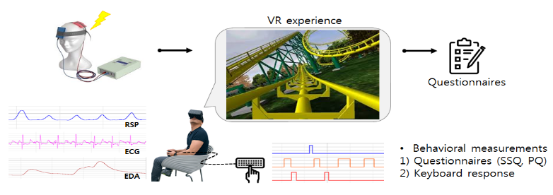
http://www.brainbehavior.net/bbs/board.php?bo_table=sub3_1

- Electrocardiography(ECG)
Electrocardiography (ECG) is the process of recording the electrical activity of the heart over a period of time using electrodes placed on the skin. These electrodes detect the tiny electrical changes on the skin that arise from the heart muscle's electrophysiologic pattern of depolarizing and repolarizing during each heartbeat. It is a very commonly performed cardiology test.
https://en.wikipedia.org/wiki/Electrocardiography#Electrocardiographs

- PhotoPlethysmography(PPG)
Photoplethysmography (PPG) is an optical measurement technique that can be used to detect blood volume changes in the microvascular bed of tissue (Challoner 1979). It has widespread clinical application, with the technology utilized in commercially available medical devices, for example in pulse oximeters, vascular diagnostics and digital beat-to-beat blood pressure measurement systems.
http://iopscience.iop.org/article/10.1088/0967-3334/28/3/R01/meta

- Galvanic Skin Response(GSR)
One of the most sensitive markers of emotional arousal is galvanic skin response (GSR), also referred to as skin conductance (SC) or electro-dermal activity (EDA). EDA modulates the amount of sweat secretion from sweat glands. The amount of sweat glands varies across the human body, being highest in hand and foot regions (200–600 sweat glands per cm2).
https://imotions.com/blog/gsr/

- Biomarker
A biomarker, or biological marker, generally refers to a measurable indicator of some biological state or condition. The term is also occasionally used to refer to a substance whose detection indicates the presence of a living organism.
Biomarkers are often measured and evaluated to examine normal biological processes, pathogenic processes, or pharmacologic responses to a therapeutic intervention. Biomarkers are used in many scientific fields.
https://en.wikipedia.org/wiki/Biomarker

- Subjective Vertical
The subjective vertical can be subdivided into several components. The subjective visual vertical (SVV) is determined by having subjects adjust a visible luminus line in complete darkness to what they consider to be upright, earth vertical. The "haptic" vertical (HV) is assessed by manipulation of a rod to the earth-vertical position with both eyes, while the subject's eyes are closed. Haptic means derived from sense of touch. The subjective postural vertical (SPV) is the position of the head or body with respect to true vertical.(Sharpe, 2003)
https://www.dizziness-and-balance.com/testing/subjective_vertical.htm

Virtual Reality
- Virtual Reality(VR)
A technology that makes virtual spaces and objects according to the imagination of human beings virtual and enables users to indirectly experience situations that they can not experience directly in the real world through the use of human five senses including sight, hearing and touch.
It is useful in many industries including games, education, defense, medical care, etc., because people can experience various situations that are difficult to experience in the real world. In 1968, Ivan Sutherland, the founder of computer graphics, first used the term 'virtual reality' while developing his first head mounted display(HMD).

- Immersive Virtual Reality(Immersive VR)
Virtual Reality (VR) to increase the sense of immersion in the user to feel realistic sense of the surrounding environment.
The user feels vivid realism through sensory elements such as visual, auditory, and tactile senses. For example, when driving a car using a head mounted display(HMD), the effect of running on an actual road can be obtained through realistic driving noise, engine sound, and vibration of the road surface.
Refer: https://news.samsung.com/kr

- Augmented Reality, AR
A technology that adds virtual information to the actual screen.
Augmented Reality (AR) is not only convenient but also satisfactory in terms of emotional aspects, so it can be applied in various fields such as broadcasting, games, education, entertainment, and fashion. Using AR technology, you can show the national flag or player information of a player who appears in the sporting event, preview the makeup when buying cosmetics, and buy clothes by virtue of it. In the mobile field, it is used in the field of location-based services (LBS). When the street is lit by a smart phone, information such as a coffee shop or a pharmacy is displayed on the screen. The AR concept was embodied in 1997 by Ronald Azuma.

- Mixed Reality, MR
A mixture of the real world and the virtual world.
Mixed reality includes augmented reality(AR) that adds virtual information based on reality and augmented virtuality(AV) that adds real information to a virtual environment. In other words, mixed reality provides users with a rich experience by providing a smart environment in which the reality and the virtual are connected naturally rather than the complete virtual world (virtual reality). It is used in various fields such as broadcasting station virtual studio for weather forecasts and news delivery, map information based on images taken from smart phone or smart glasses (smart glass), virtual training of aircraft, mirrors that can be put on clothes imaginatively do. Mixed reality (MR) was embodied in 1994 by Paul Milgram.

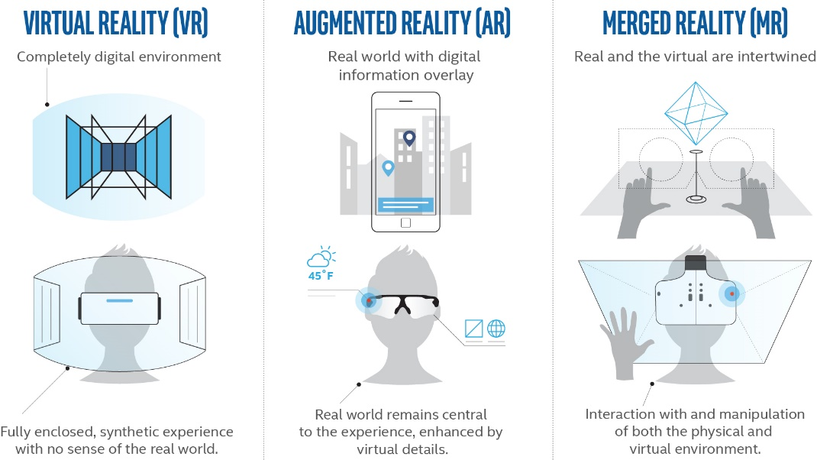
Refer: appliedart.com
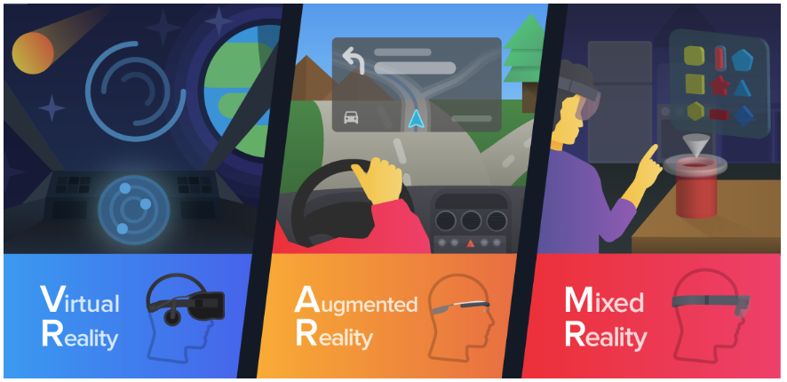
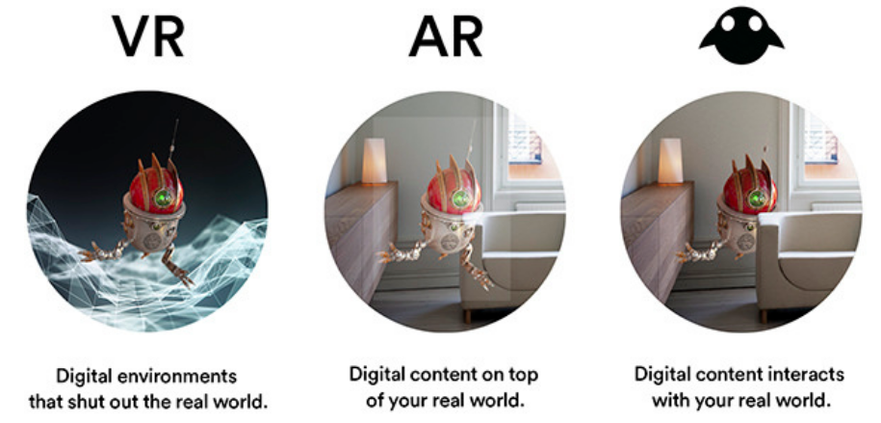
Refer : https://brunch.co.kr/@rrblog/23

- Substitutional Reality(SR)
The head mount display (HMD) to be worn by the participant shows the scene sequence of live scenes from the camera captured at the height of one's eyes and the past scenes previously recorded at the same location. By using a panorama video camera capable of recording all directions to capture the images from the past, the participant can look around for the scenes of the past freely just as he/she can for the live scene. In addition, the pre-recorded audio from the past is played through the headphone while the participant is experiencing the past scenes.
Under such conditions, it is impossible for the participant to distinguish between the live scenes and the scenes from the past. That is, the subjective reality experience itself is continuous, and the participant can be shown the live scenes and the past scenes that are switched flexibly. This mechanism to substitute the "reality" with one prepared beforehand without noticing the reality gap is called the Substitutional Reality (SR) technology.
http://www.riken.jp/en/outreach/ip/23946/

- Merged Reality
Intel CEO Brian Krzanich advocates Intel CEO Forum IDF2016 (Oct. 17, 2016, San Francisco, USA): "Project Alloy", an all-in-one VR solution for next generation sensing and digital technology, Disclosed and presented
https://medium.com/@bkrunner/merged-reality-the-best-of-all-worlds-f6d1480b855d

- Shared Reality
Drew Gottieb engineer, who works intern at Google, unveiled the 'Shared Reality' project where users of desktop VR terminals and users of mixed reality terminals run the same app and share the same images in real time. Both virtual reality and augmented reality are supported In the case of a desktop VR terminal that can be used only when it is wired to a mobile VR terminal, which is a simple accessory level of a current smart phone, a hybrid reality terminal supporting augmented reality function while improving the disadvantages of each terminal, This is a project that suggests the need to evolve into the future.
Gottieb Engineer's Shared Reality project is a form that HTC Vive and HTC Vive users can manipulate objects in virtual reality by linking with HTC Vive and Microsoft HoloLens.
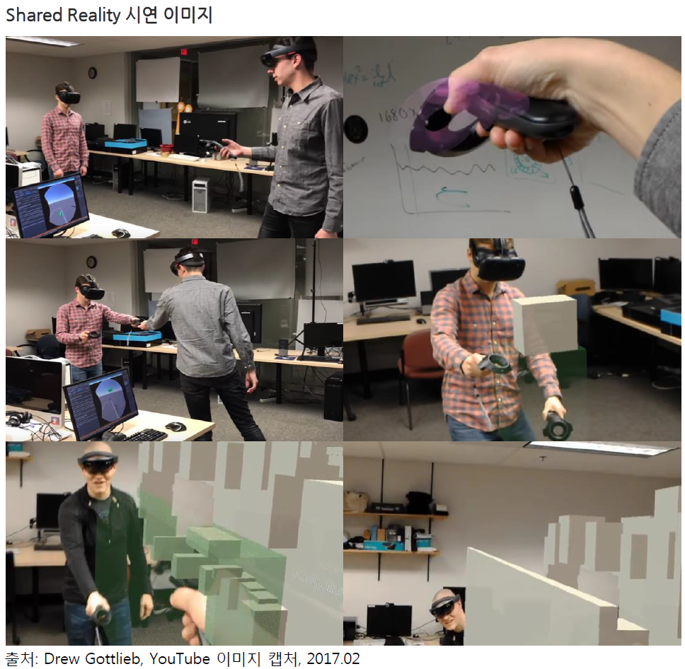
Refer: DIGIECO Report, Trends Briefing, Shared Reality where AR and VR end users share the same app, 2017.02.08.

- eXtended Reality(XR)
Qualcomm's XR (Extended Reality) strategy shows that the SnapDragon 835, which was recently released as a significant part of the chipset, includes VR SDK with 6DOF that can be used to track XR application programs and to save developers' (Development kit on software).
The ultimate goal of Qualcomm's development of XR is to enable its partners to commercialize their products with minimal R & D investment. To this end, we have partnerships with XR supply chain partners such as Goertek, Thundercomm, OmniVision, and Ximmerse.
Based on this, Qualcomm has released a smartphone and a separate device that can run more than 20 XR products using the SnapDragon 800 series platform, and more than 20 products are under development.
Refer : http://www.realitydome.com/what-is-extended-reality-xr/
https://www.youtube.com/watch?time_continue=120&v=0d_liG40ypM

- Virtual Retinal Display(VRD), Retinal Scan Display(RSD)
A display system that converts a video signal to an optical signal and projects the beam directly to the retina of the eye.
While the television raster scan display method scans the electron beam on the screen, the virtual retinal display (VRD) projects the beam directly onto the retina of the human eye.
The virtual retina display (VRD) is applied to a head wearable display (HMD) for an augmented reality (AR) that displays virtual information on an actual screen. As a typical example, a glass-shaped google glass is equipped with a prism projector to provide AR information to the user's eyes.
The Retina Display is a display with a resolution that exceeds the number of pixels per inch that can be distinguished by the human eye's retina. It displays the resolvable resolution in terms of the number of pixels per inch of the human eye, or more than 477 pixels per inch for a mobile phone.
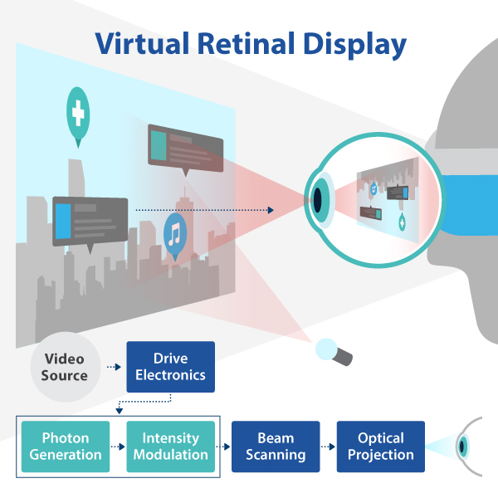
https://en.wikipedia.org/wiki/Virtual_retinal_display

- Head Mounted Display, HMD
A display of the form worn on the head. When an HMD device is placed on the head, a small display is placed in close proximity to both eyes to project a three-dimensional (3D) image using the parallax. A gyro sensor that tracks the movement of a user, and a rendering function that creates an image according to a motion can realize a virtual reality (VR) or an augmented reality (AR) in a 3D space. The first HMD was made by Professor Ivan Sutherland, the founder of Computer Graphics in 1968.
HMD is used not only in games, but also in a variety of fields such as industrial, space development, nuclear reactors, military and medical institutions.
HMD devices include desktop HMDs connected to PCs such as smart card-mounted HMDs such as Google cardboard and GearVR, Oculus Rift, and HTC VIVE, game consoles such as Sony PSVR Connection type HMD.
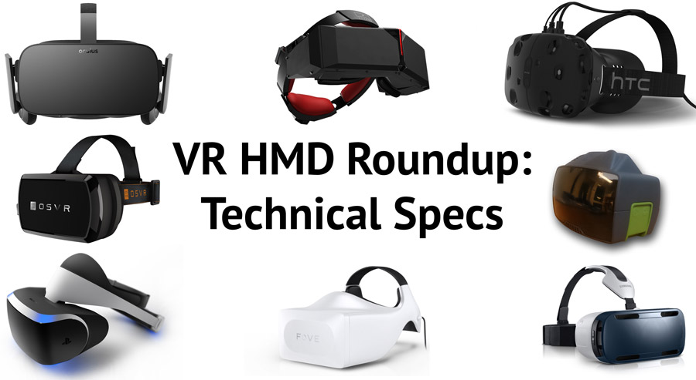
Refer : https://uploadvr.com/vr-hmd-specs/
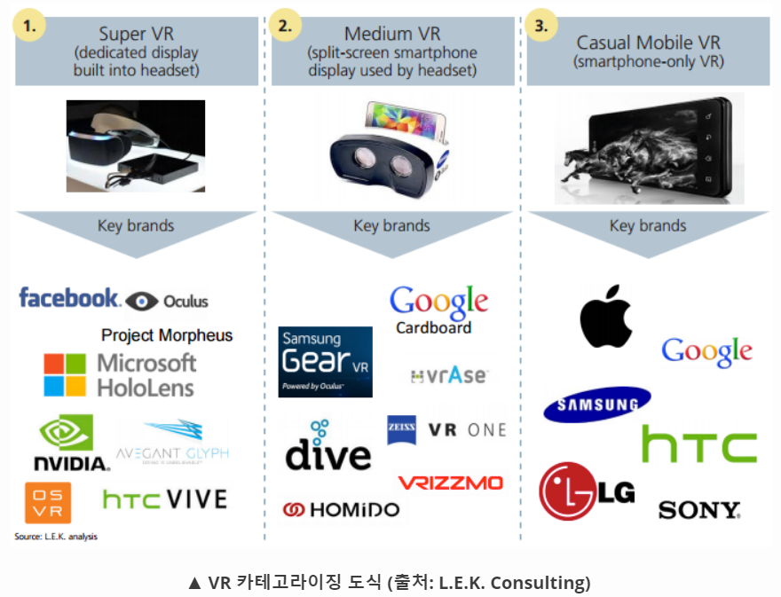
https://www.lek.com/insights/spotlight-media-entertainment-virtual-reality

- Smart Glasses
Glasses that show the user's desired information in real time. It is possible to connect to the internet, and it is equipped with a microphone or a camera to provide the information that the user wants. For example, if you look at the sky, the weather forecast shows you the appointment schedule with your friends when you look at the wall. The user can also listen to music through the glasses, stop the phone when he or she calls it, and make video calls.
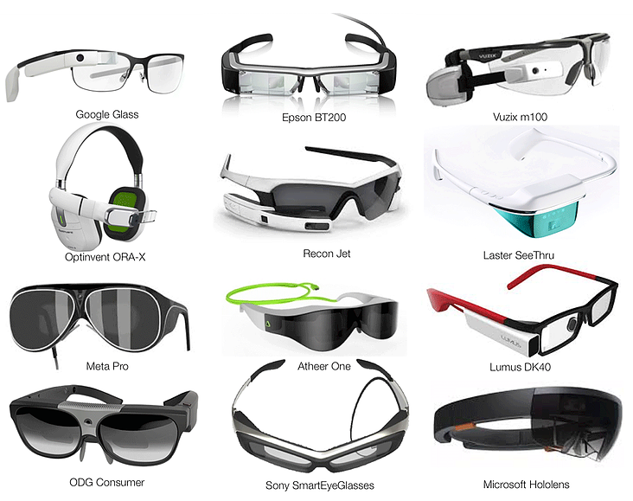
http://www.augmentedreality.org/smart-glasses-report

- Gesture Recognition
Computer interaction that perceives a human hand as a computer.
The computer recognizes the hand gestures and displays them on the computer screen in real time. It is used for entertainment programs and educational programs that produce handwritten word processors, games, and multimedia effects. It is also used to interact with the 3D penetration environment and includes finger pointing, face tracking, eye motion, and lip reading.

- Positional Tracking
A technique for tracking the movement (position, orientation) of an object.
Six Degrees of Freedom (6DOF: Horizontal, Vertical, Depth, Pitch, Yaw, Roll) of user's head wear display (HMD), controller and peripheral devices are measured in virtual reality (VR) It is used for tracking.
For example, when a user wearing an HMD moves up and down, right and left, forward and backward in a virtual space, and performs an operation such as catching an object with his / her arms extended, the position (position) of the HMD and the user's hand is measured and reflected in the VR content .
Therefore, the actual motion of the user in the real space can be synchronized with the virtual space as it is, so that a high immersion feeling and a vivid reality can be conveyed.
The location tracking function can be used for outside-in tracking to track HMD users, such as a camera, separately installed outside the camera (eg, camera), and an inside-out inside-out tracking method.
Oculus Rift, Playstation VR, and other VR devices use an outside-in method.
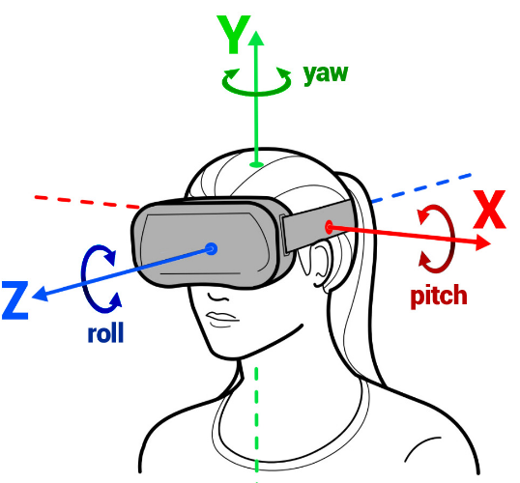
http://blog.dsky.co/tag/head-tracking/

- Eye Tracking
Eye tracking is a technique to track the position of the eye by sensing the movement of the pupil. Three methods are used: video analysis method, contact lens method, and sensor attachment method.
The video analysis method detects motion of the pupil through analysis of real-time camera images and calculates the direction of the eye based on the fixed position reflected on the cornea.
The contact lens method uses the reflected light of the built-in contact lens of the mirror or the magnetic field of the contact lens of the coil, which is less convenient and more accurate.
The sensor attachment method uses the electric field according to the movement of the eye by attaching the sensor around the eye, and it is possible to detect the motion of the eye even when the eye is closed (sleeping, etc.).
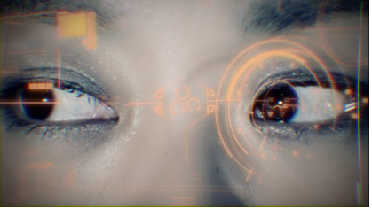
http://www.etcentric.org/startup-demos-new-eye-tracking-virtual-reality-hmd-at-ces/

- 3DOF, three Degrees Of Freedom
Three rotational elements of moving objects in three - dimensional space.
Means the roll (roll, x axis), pitch (y axis), yaw (y axis), and yaw (z axis) rotation operations on X, Y and Z axes.
Virtual reality (VR) is also referred to as 3DOF + if the 3DOF includes constrained translational motion (up, down, left, right, and back) as well as when the user is seated.

- 6DOF, six Degrees Of Freedom
Six Operating Elements of a Moving Object in Three Dimensional Space.
6DOF can be used to rotate (roll, x axis), pitch (y axis), yaw (z axis) rotation movements and forward / back, left / right ), And up and down translation operations.
It is used to measure the position and direction of objects in robotics, virtual reality, and so on.

- Motion Capture System(MCS)
It is a device that measures the position and orientation of motion of object in 3-D space and records it as information that can be used by computer.
The information obtained through the motion capture system is called motion capture data. The obtained data can be variously used in digital contents (animation, movie, game, etc.), medicine (motion analysis, rehabilitation, etc.) . Motion capture systems are optical, mechanical, magnetic, etc., depending on how data is extracted.
A marker-free motion capture system is a technique that allows real-time motion capture of free-wearing actors without markers or sensors attached to the body, allowing actors to act without optic, magnetic, or acoustic markers. There is little restriction on the operation, and there is a natural characteristic. Currently, a method of capturing human body motion through the process of three-dimensional position restoration and motion structuring by separately detecting each part of the body by a motion restoration method or a blob analysis by the silhouette analysis of the human body is being studied.
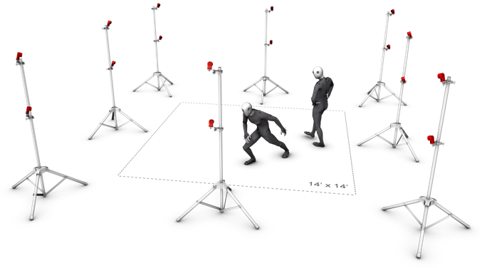
http://optitrack.com/products/flex-13/indepth.html

- Object Tracking, Video Tracking
It is a computer vision technology for finding the position change of a specific object such as a person, an animal, or a car in a video shot by a camera.
Finding objects in images or images is an object detection technique. Object tracking tracks changes in objects using similarity between feature information such as size, color, shape, and contour of objects in a series of image frames.
Object tracking technology is used in various fields such as real time video security, video call, traffic control, and augmented reality.

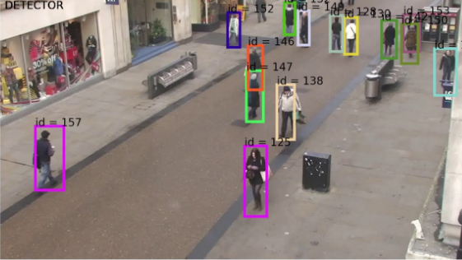
https://www.youtube.com/watch?v=tMuX5TP6uqA

- Tangible User Interface(TUI )
It is an interface technology that manipulates digital information through the act of touching, feeling, holding and moving objects.
It was originally proposed by Tangible Media Group at MIT Media Lab, which applied the senses and movements that people have developed in real life to the interface for a long time. We connect digital information of virtual space with actual objects without walls between real space and computer space and control digital information by using these real objects.
For example, when a user pulls out a picture from a computer and puts it on a desk, another person drags it again and puts it in his computer.
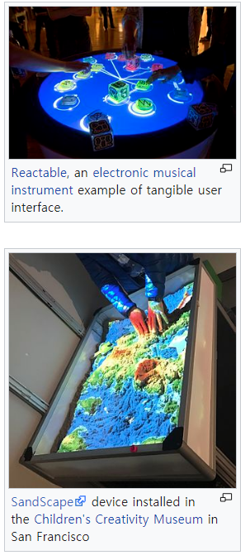
https://en.wikipedia.org/wiki/Tangible_user_interface

- Natural User Interface( NUI)
A user interface (UI) that recognizes the natural movement of the user and provides information to and from each other. The UI is an interface that interacts between the user and the device, and is moving toward a NUI that uses a keyboard or a mouse initially and then uses a graphical user interface (GUI) to utilize its own body such as multi-touch, haptic, and 3D motion recognition.
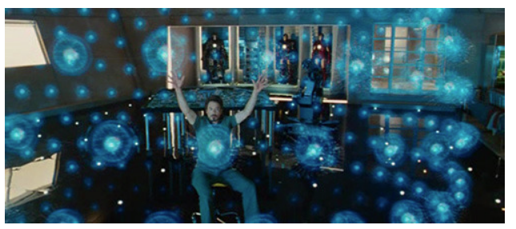
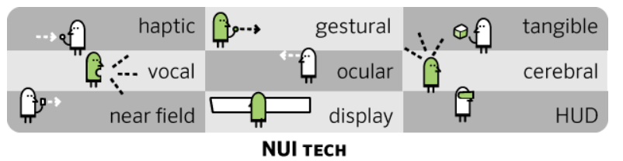
http://story.pxd.co.kr/731

- Haptic Interface
An access device for transmitting tactile information to a user.
Unlike vision and hearing, there is no systematic and standardized way of expressing information about skin sensation. However, the delivery speed of stimulus through skin is about 20 milliseconds (ms), which is five times faster than the visual acuity. It is considered as the essential communication channel for the recognition and expression of information when it is the largest organization of the body organs in 2 square meters (m2) and becomes a environment where humans and computers are closely connected in the future, such as a wearable computer.

- Zero UI , Zero Screen
Zero UI (User Interface) is a technology that minimizes the current screen-based user interface by naturally recognizing user's requirements in the user's living environment and providing necessary services. Zero UI can be realized through the judgment of the status of smart machines, voice recognition of the user, and natural gesture recognition of the user.

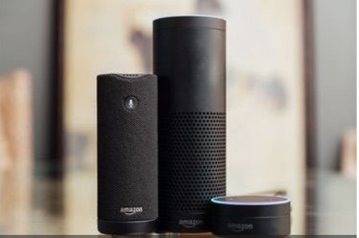
http://refreshstudio.tistory.com/114
http://www.techforum.co.kr/bbs/board.php?bo_table=trend&wr_id=1866
http://www.zdnet.co.kr/column/column_view.asp?artice_id=20170116160851

- Extensible 3D(X3D)
XML-based Virtual Reality Modeling Language (VRML) is a universal and open Web3D virtual environment authoring language that provides a dynamic and interactive real-time virtual environment via the Internet as a next generation language.
It is an improvement on Virtual Reality Modeling Language (VRML), which is compatible with VRML contents and can be used to make efficient 3D animation player. Streaming or rendering extensions and integration with web browsers via extensibility creation language (XML), integration with other applications, and 3D support for MPEG-4.
At the European web conference in 1994, Tim Berners-Lee claimed that the need for three-dimensional web standards was the beginning of VRML, and Sony, SGI, and SDSC proposed VRML 2.0. It is changed to VRML 97, and the alternative to adapt to XML based on this is X3D. In 2002, ISO standardized VRML 2002 by integrating X3D and VRML97.

- Augmented Reality Markup Language(ARML)
A programming language for implementing augmented reality (AR) on a terminal device and on the Web.
ARML is based on Google's Keyhole Markup Language (KML), and consists of ECMAscript and so on to connect extensibility creation language (XML) for displaying virtual objects and virtual object properties. It is developed by Augmented Reality (AR) mobile browser vendor, Wikitude, and promotes ARML standardization in the Open Geospatial Consortium (OGC).

Display Technology
- Panoramic Imaging System
360 degree viewing system that can watch all directions.
In addition to panoramic views of well-known sightseeing spots, it can be used for mapping and obstacle avoidance in cleaning robots and unmanned aerial vehicles, real-time introduction of famous sightseeing spots, hotels, and real estate for sale to customers via the Internet. . Stitching, which is one of the methods of obtaining omni-directional images, is often used in photographs by obtaining different images with two or more cameras and then gently connecting them with software, while a reflection-refracting omnidirectional lens Based system has the advantage of being able to run in real time by displaying images collected by specially designed mirrors in software.

- Stereoscopic 3D(S3D)
Stereo, which means two, and scopic, which is the meaning of seeing. By using the visual difference of both eyes, a pair of 2D images with binocular parallax are presented to both eyes of viewers to perceive a three dimensional depth sense It is a stereoscopic imaging technology that makes it possible.

- Multiview Image
It is a 3D image that geometrically corrects images taken by one or more cameras and provides various viewpoints in various directions through spatial synthesis.
Representative examples of multi-view images are used in various fields such as space / aerial photographing, computer vision, image processing, and computer graphics, as well as broadcasting as panoramic images.
In the second multi-view display, the interval between viewpoints is smaller than the pupil size, so that a plurality of viewpoint images are simultaneously projected on one eye so that a plurality of viewpoint images are projected in one pupil. In addition to the binocular disparity, the focus of the eye adjusts to the correct depth.
Professor Takaki Y. Takaki of the Japan Agricultural University in Japan projected multiple back-to-back panels in 2010, which resulted in 256 seconds of overlapping points.

- Viewing Angle
The maximum side angle at which a normal screen can be seen on the display device.
Unlike a cathode-ray tube, a liquid crystal display has characteristics in which the brightness or contrast ratio varies greatly depending on the viewing angle. The angle at which the contrast ratio is maintained over a certain value is expressed by a viewing angle. The horizontal viewing angle of 160 ° means that the screen can be viewed with normal brightness when the front is 0 ° and the left and right sides are 80 °.

- Field of View, Field of Vision(FOV )
Angles indicate the range of horizontal, vertical, or diagonal directions over which the camera can hold an image through the lens.
A standard lens with a focal length of 50 mm is 46 degrees, a 28 mm wide angle is 74 degrees, and a 135 mm telephoto lens is 20 degrees.
When the screen size is not common, such as a television screen or a 16: 9 screen, the horizontal viewing angle in the horizontal direction (horizontal screen angle) and the vertical viewing angle in the vertical direction (vertical screen angle) are displayed separately.
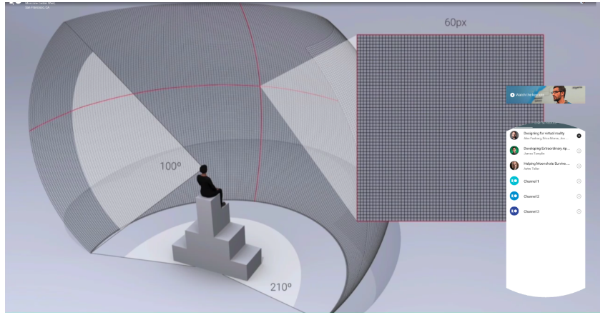
https://wonkykim.wordpress.com/2015/05/29/가상현실을-위한-화각과-픽셀/
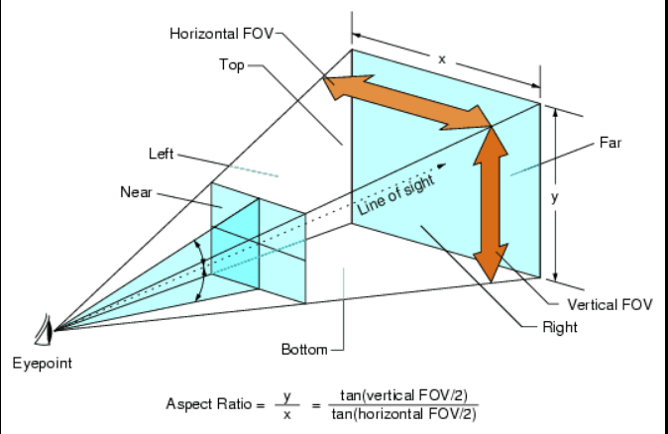
https://pcgamingwiki.com/wiki/Glossary:Field_of_view_(FOV)

- Binocular Parallax(Disparity)
Difference between left and right eye images in 3D images.
Our eyes are about 65 millimeters (mm) apart in the horizontal direction, and the binocular parallax caused by this becomes the most important factor of the three-dimensional feeling. 3D TV is a television system in which a person feels stereoscopic effect due to binocular parallax, and stereoscopic images are implemented using the stereoscopic images.

