Project | HMD based 3D Content Motion Sickness Reducing Technology  <http://sites.ieee.org/sagroups-3079/ >
Title | Use cases and Network Requirements
DCN | 3-18-0005-00-0003
Date Submitted | January 26, 2018
Source(s) | Dongil Dillon Seo dillon@volercreative.com (VoleRCreative),  Sangkwon Peter Jeong ceo@joyfun.kr (JoyFun Inc.)
Re: | IEEE 3079 Session #4 in Gyeonggi-do, Korea
Abstract | This document describes the use cases and technical requirements to be considered with HMD based VR Services.
Purpose | Working Group Discussion and Acceptance
Notice | This document has been prepared to assist the IEEE 3079 Working Group. It is offered as a basis for discussion and is not binding on the contributing individual(s) or organization(s). The material in this document is subject to change in form and content after further study. The contributor(s) reserve(s) the right to add, amend or withdraw material contained herein.
Release | The contributor grants a free, irrevocable license to the IEEE to incorporate material contained in this contribution, and any modifications thereof, in the creation of an IEEE Standards publication; to copyright in the IEEE’s name any IEEE Standards publication even though it may include portions of this contribution; and at the IEEE’s sole discretion to permit others to reproduce in whole or in part the resulting IEEE Standards publication. The contributor also acknowledges and accepts that IEEE 3079 may make this contribution public.
Patent Policy | The contributor is familiar with IEEE patent policy, as stated in Section 6 of the IEEE-SA Standards Board bylaws <http://standards.ieee.org/guides/bylaws/sect6-7.html#6> and in Understanding Patent Issues During IEEE Standards Development http://standards.ieee.org/board/pat/faq.pdf

Defining the User Environment for VR HMD

General User Environment

- The HMD discussed in this document is limited to the HMD used for the 'VR service'
- High performance HMDs can be used at home or in public places
- Both high performance HMDs and terminal units guarantee to work at the pedestrian speed level
- High performance HMDs can be connected to the sensor network with peripheral(s) recognizing the user's actions
- 'Low performance' HMDs are 'ubiquitous HMD', and ubiquitous HMDs are HMDs using smartphones or similar performance device
- The smartphone-based HMD is not a high-performance HMD
- HMDs using smart phones do not require a separate terminal
- High performance HMDs and smartphone based HMDs can use wired or wireless controllers
- The entire section of data communication while using a HMD provides modules, software and solutions for security and power savings
- All VR applications should meet the QoS / QoE requirements
- High-performance HMD provides immersive user experience with stereoscopic 3D video and 7.1 channel audio (The image quality should support more than 4K in stereoscopic 3D)

Requirements for providing good VR service to users using HMD

Requirements | Details
pixels/degree | - 40 pix/deg  - No HMD is capable of displaying 40pix/deg today
video resolution | - 3 times 4K(3840x1920) vertical resolution = 11,520 x 6,480
framerate | - 90 fps  - A 90fps framerate offers a latency low enough to prevent nausea
3D Audio | - Support of scene-based and/or environmental audio  - 360 surround sound, object-based audio, Ambisonics
motion-to-photon latency &  motion-to-audio latency | - How much time there is between the user interacts and an image / audio  - Maximum 20ms
Ref.) Technicolor, Oct. 2016 (m39532, MPEG 116th Meeting)
VR HMD(Virtual Reality Head Mounted Display) display two separate but identical images for left and right eye respectively in order to create stereoscopic image. Also, it uses a pair of fish eye lenses to maximize the field of view so that the user does not see the display edges and believes that he is seeing the virtual world with his own eyes, not through a display. This usage of fish eye lenses distorts the images displayed on the screen life Figure 1 and enlarges field of view, we are only perceiving 45% of the actual screen resolution. This is the reason why the VR HMD manufacturers are suggesting to use 4K UHD display to provide the visual fidelity we are commonly seeing from most popular TV sets, which is 1080p FHD display.
4K UHD resolution offers 3840 x 2160 pixels. It means that an image requires 1G size and the VR content service which requires 90 FPS would require 18 Gbps data transfer rate.

Equation: resolution × 24bit (color) × frame rate = data capacity

Even if the video data is compressed and transmitted, a minimum of 1 Gbps should be guaranteed. In order to prevent the user from feeling dizzy, it is recommended not to perform compression transmission accompanied by loss of data.
The minimum transmission rate at which the user may not feel uncomfortable is about 10 Gbps.

Use Case

Cases | Descriptions | Remarks
1 | Remote multi-party interactive content service connected to a wired server | Wired Network
2 | Content service provided by server via mobile network outside | Mobile Network
3 | Content service provided by server via Wi-Fi network inside | Wireless Network
4 | Stand-alone content service responding to motion through sensor network | Sensor Network
5 | Content service where HMD and terminal (client) are connected via local network | Local Network
6 | Switching between heterogenous networks while using content service via wireless network | Network Handover
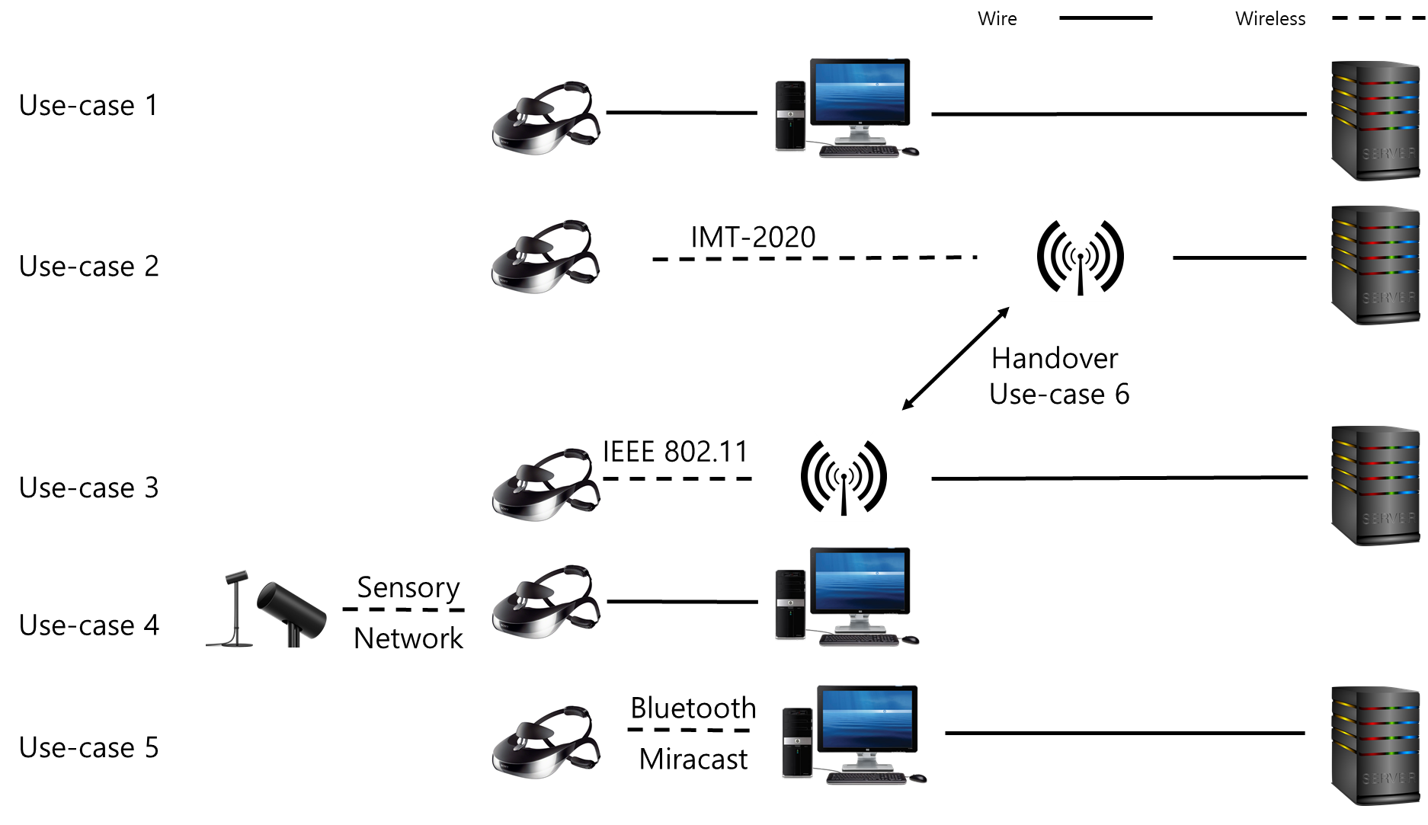

Use Case 1 (Wired Network)

Pre-condition

It is directly connected to a terminal such as PC or console gaming device via wired network to enable multi-party communication between remote (including near) users, and it uses and controls high-performance HMD for VR service. The high-performance HMD is equipped with all kinds of media content, processing unit and control management module that the user desires.

Application

The user wears a high-performance HMD connected to a terminal (PC, console, set top, etc.) with the embedded communication function and uses various content services such as playing a game and watching a movie. The behavior of the user wearing the HMD should be communicated to the remote user. The data transfer rate is at least 20 Gbps, the latency is less than 5 ms, the jitter is less than 5ms, and the PER is less than 10⁻².

Environment

High-performance HMDs are used at home. At home, there are no interferers or fewer than four. Interferers have various Quality of Service (QoS) requirements. The transmission (both desired signal and interference) may be LOS or NLOS. The D2D (Device-to-Device) connection distance between the high-performance HMD and the terminal with the communication function embedded is less than 5 m.

Communication Condition

D2D link is either blocked (eg NLOS) or no significant interference from other users (eg other wearables, access points, etc.) occurs.

Case

- All users use motion-responsive content (eg social content using networks such as games and movies) using the HMD and controllers connected to the terminal for VR service.
- Users can be in the same space or separate spaces in a far distance.
- A user experience is provided in the way that one user responds to another user.
- All users respond relatively to each other's actions.

Conditions | Requirements | Remarks
Distance between users | Unlimited
Video Quality | Stereoscopic 3D 4K | HDMI 2.0
HMD Movement | Neck Roll | 0.17 (s/60deg)
 | Neck Pitch | 0.14 (s/60deg)
 | Neck Yaw | 0.13 (s/60deg)
User Motion Recognition | Use Controllers | Wired/Wireless
Device Mobility | None
Response Time | Real time

Use Case 2 (Mobile Communication)

Pre-condition

User is connected to the server providing a VR service through wireless Internet with a HMD while travelling at a hight speed. In order to connect to the wireless Internet, the HMD is equipped with a high-speed communication module or a smart phone capable of high-speed mobile communication.

Application

The user connects the data communication to the service with the HMD connected to the high-speed mobile communication network, plays the game, watches the movie, does shopping, or uses the interactive content service connected with other users. The behavior of the user wearing the HMD should be communicated to the VR service server. The data transfer rate is at least 10 Gbps, the latency is less than 5 ms, the jitter is less than 5 ms, and the PER is less than 10⁻².

Environment

There is no limit to the usage distance of the HMD. Interferers (humans and/or objects) have various data communication QoS requirements. The transmission (both desired signal and interference) is NLOS. The connection distance between the HMD and the mobile repeater is less than 50 m.

Communication Condition

The mobile communication link is blocked or does not cause serious interference from other users (e.g., other wearables, access points, etc.).

Case

- The user uses the communication module of the HMD to use the content or service in the remote server through the mobile communication repeater.

Conditions | Requirements | Remarks
Video Quality | Sterescopic 3D 4K | HDMI 2.0
HMD Movement | Neck Roll | 0.17 (s/60deg)
 | Neck Pitch | 0.14 (s/60deg)
 | Neck Yaw | 0.13 (s/60deg)
User Motion Recognition | Use Controllers | Wired/Wireless
Device Mobility | Unlimited
Response Time | Real Time

Use Case 3 (Wireless Ethernet Telecommunication)

Pre-condition

The user is using a HMD to connect to a server providing a VR service through wireless Internet indoors. In order to wirelessly connect to an indoor access point (AP), the HMD is equipped with a high-speed Ethernet module.

Application

The user connects the data communication to the service with the HMD connected to the high-speed AP, plays the game, watches the movie, does shopping or plays the interactive content service connected with other users. The behavior of the user wearing the HMD should be communicated to the VR service server. The data transfer rate is at least 10 Gbps, the latency is less than 5 ms, the jitter is less than 5 ms, and the PER is less than 10⁻².

Environment

The usage range of the HMD is within the communication range of the AP. Interferers (humans and/or objects) have various data communication QoS requirements. The transmission (both desired signal and interference) is NLOS. The connection distance between the HMD and the AP is determined by the performance of the AP.

Communication Condition

The AP's link is blocked or does not cause significant interference from other users (eg other wearables, access points, etc.).

Case

- The user uses the Ethernet communication module of the HMD to use content or service on the remote server through the indoor AP.

Conditions | Requirements | Remarks
Video Quality | Stereoscopic 3D 4K | HDMI 2.0
HMD Movement | Neck Roll | 0.17 (s/60deg)
 | Neck Pitch | 0.14 (s/60deg)
 | Neck Yaw | 0.13 (s/60deg)
User Motion Recognition | User Controllers | Wired/Wireless
Device Mobility | Pedestrian walking speed | Less than 4 km/hr
Response Time | Real Time

Use Case 4 (Sensor Network)

Pre-condition

It is directly connected to a terminal such as a PC or a console game device, and can use and control a high-performance HMD (HMD) for VR service. The high-performance HMD is equipped with all kinds of media content, processing unit and control management module that the user desires. The high-performance HMD is equipped with a sensor or sensors for sensing and analyzing all of the user movements. The sensor and the HMD or the sensor and the terminal (HMD connected to D2D) are connected to the sensor network.

Application

The user wears a high-performance HMD connected to a terminal (PC, console, set-top box, etc.) and plays an action-responsive game. The behavior of the user wearing the HMD must be delivered to the terminal by the sensor (s) that sense and interpret all of the user's actions. The data transfer rate of the sensor network is at least 20 Mbps, the latency is less than 10 ms, and the jitter is less than 10 ms.

Environment

High-performance HMDs are used anywhere. There are many interferers and various QoS (Quality of Service) requirements. All transmissions (both desired signal and interference) are NLOS. The D2D connection distance between the high-performance HMD and the terminal embedded with the communication function is less than 5 m.

Communication Condition

D2D link is blocked (eg NLOS) and no significant interference from other users (eg other wearables, access points, etc.) occurs. The device may stop or move at pedestrian speed during use.

Case

- All users play motion-responsive content (eg social content such as games and movies connected to networks) using the HMD and the controller connected to the terminal for VR service.
- Users can be in the same space or separated by a long distance.
- A user is responding to another user’s response.
- All users respond relatively to each other's actions.

Conditions |  | Requirements | Remarks
Distance between the HMD and the Sensor |  | Less than 5 m | Depends on the Local Area Network module performance
Video Quality |  | Stereoscopic 3D 4K | HDMI 2.0
HMD Movement |  | Neck Roll | 0.17 (s/60deg)
 |  | Neck Pitch | 0.14 (s/60deg)
 |  | Neck Yaw | 0.13 (s/60deg)
Sensor Network | Distance | 10 m
 | Speed | Maximum 50 Mbps | Bluetooth 5.0
User Motion Recognition |  | Use Controller | Wired/Wireless
Device Mobility |  | None
Response Time |  | Real time

Use Case 5 (Local Area Network)

Pre-condition

A high-performance HMD is wirelessly connected to a terminal such as a PC or a console game device by a local area high speed communication module. The high-performance HMD is equipped with all kinds of media content, processing unit and control management module that the user desires.

Application

The user wears a high-performance HMD connected wirelessly with a terminal (PC, console, set-top box, etc.) to play an motion-responsive game. The terminal can recognize all the behavior information of the user wearing the HMD and reflect the operation. The data transfer rate by the short-range wireless network is at least 20 Mbps, the latency is within 5 ms, and the jitter is within 10 ms.

Environment

High-performance HMDs are used anywhere. There are many interferers and they have various QoS requirements. All transmissions (both desired signal and interference) are NLOS. The connection distance between the high-performance HMD and the terminal depends on the connection performance of the local area communication module.

Communication Condition

D2D link is blocked (eg NLOS) and no significant interference from other users (eg other wearables, access points, etc.) occurs. The device may stop or move at pedestrian speed during use.

Case

- All users play motion-responsive content (eg social content such as games and movies connected to network) using the HMD and the controller connected to the terminal for VR service.
- Users can be in the same space or separated by a long distance.
- A user is responding to another user’s response.
- All users respond relatively to each other's actions.

Conditions |  | Requirements | Remakrs
Distance between the HMD and the Terminal |  | Less than 5 m | Depends on the Local Area Network module performance
Video Quality |  | Stereoscopic 3D 4K | HDMI 2.0
HMD Movement |  | Neck Roll | 0.17 (s/60deg)
 |  | Neck Pitch | 0.14 (s/60deg)
 |  | Neck Yaw | 0.13 (s/60deg)
Local Area Network | Distance | 0.1m~10m | DLNA / Miracast
 | Speed | Maximum 5GHz | DLNA / Miracast
User Motion Recognition |  | Use controller | Wired/Wireless
Device Mobility |  | Pedestrian speed | Less than 4 km/hr
Response Time |  | Real time

Use Case 6 (Network Handover)

Pre-condition

A user is connected to a server with VR service via wireless Internet using the HMD while he is travelling. The HMD is equipped with both high speed communication and Ethernet modules to connect to wireless Internet or a smart phone with various communication capabilities.

Application

The user connects the data communication to the service with the HMD connected to the high-speed mobile communication network, plays the game, watches the movie, does shopping, or plays the interactive content service connected with other users. The user may be connected to another mobile communication network while moving, or may be 'seamlessly connected' to the Ethernet communication network. The behavior of the user wearing the HMD should be communicated to the VR service server. The data transfer rate is at least 10 Gbps, the latency is less than 5 ms, the jitter is less than 5 ms, and the PER is less than 10⁻².

Environment

There is no limit to the usage distance of the HMD. Interferers (humans and/or objects) have various data communication QoS requirements. The transmission (both desired signal and interference) is NLOS. The connection distance between the HMD and the mobile repeater is less than 50 m, and the distance to the AP is less than 10 m. However, this distance depends on the performance of the mobile communication module and the wireless Ethernet.

Communication Condition

The mobile communication link is blocked or does not cause serious interference from other users (e.g., other wearables, access points, etc.).

Case

- The user uses the wireless Ethernet module of the HMD to use the content or service on the remote server through the AP.
- When the user's HMD is not properly connected to the wireless Ethernet, it uses the communication module, the content or service in the remote server is played through the mobile communication repeater using the communication module.
- The QoS / QoE requirements for the application are met.

Conditions | Requirements | Remarks
Video Quality | Stereoscopic 3D 4K | HDMI 2.0
HMD Movement | Neck Roll | 0.17 (s/60deg)
 | Neck Pitch | 0.14 (s/60deg)
 | Neck Yaw | 0.13 (s/60deg)
User Motion Recognition | Use controller | Wired/Wireless
Device Mobility | Unlimited
Response Time | Real time

Scenario

Case 1 (Wired)

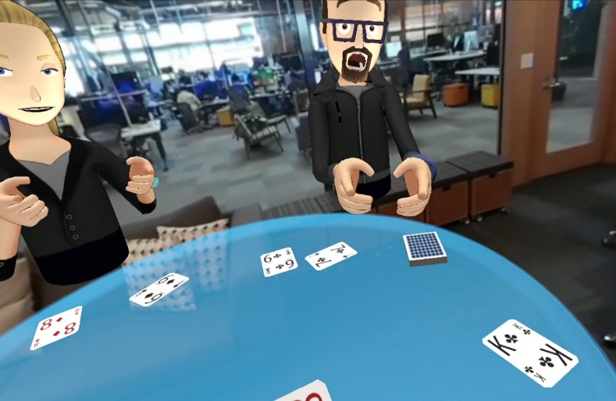
User A is wearing a wired HMD at home in California, USA and playing poker with his friends - user B, C, and D in VR. User B lives in Boston, USA, User C lives in Moscow, Russia, and User D lives in Tokyo, Japan, and they love to play poker together.

In order to create a VR environment that gives a good user experience without experiencing motion sickness, it requires a high resolution and big size 360-degree images and takes less than a 20 ms response time to all moving images. Therefore, it is necessary that the network speed of 10 Gbps or more is required for the HMD to recognize the action of the user, transmit it to the PC, and then the PC transmits the action information to the counterpart via the network and displays the reaction in real time.

Case 2 (Mobile Network)

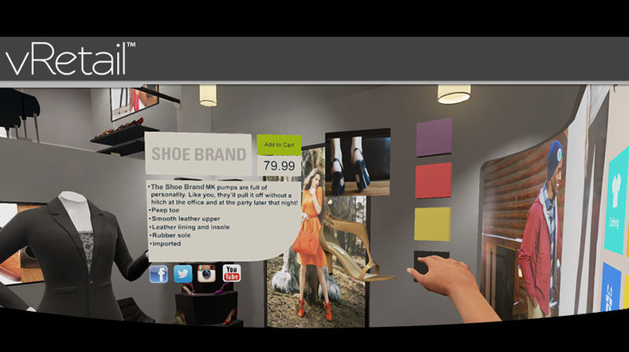
While User E rides the bus to the meeting place to meet his friend, she is watching the clothes she saw at the department store yesterday and doing VR shopping to make the purchase. VR is more realistic than online shopping malls because it gives the user the feeling that she is actually seeing things. Especially, the ability to unfold and view the clothes in three dimensions provides very important information when she selects the clothes.
At this moment, in order to express the detailed texture and the pattern of the clothes, it certainly requires a high resolution and big size images and also the response time to the change of images needs to be less than 20 ms to reflect the action in real time without feeling motion sick. Therefore, in order for the HMD to recognize the user's actions, send them to the PC, and then the PC needs to transmit the action information to the other party through the network in real time, the wireless network speed of 10 Gbps or more is required

Case 3 (Wireless Ethernet Telecommunication)

User F is from London, UK, user G is Bundang, Korea and user H is from Rio, Brazil. They all want to attend the meeting I. However, the user G urgently needs to deal with an important work from his company at the same time the meeting is scheduled but cannot miss the meeting either. To solve this dilemma, user G uses a VR HMD connected to the wireless Ethernet telecommunication to attend the meeting virtually while working on the company work. This was all possible because of the HMD mobility and the high-performance wireless Ethernet communication was possible.

Case 4 (Sensor Network)
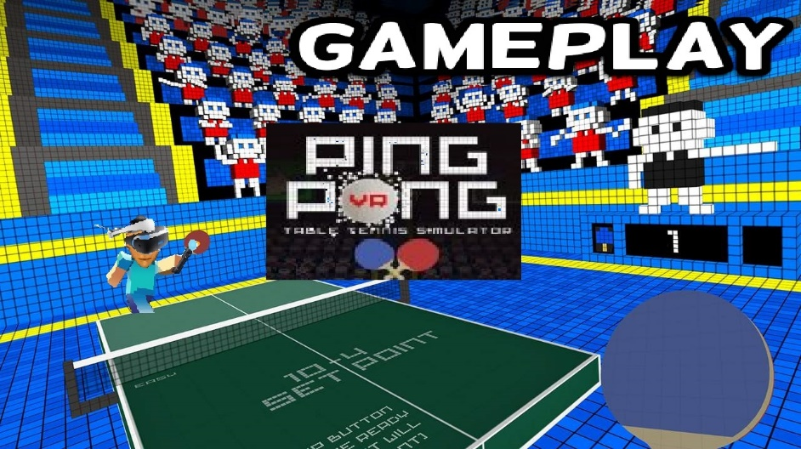
Table tennis is a very fast-paced game. User J likes to play table tennis in VR with user K, a girlfriend. In order for the user J and K to play games in VR, they must recognize the user's actions around the sensor and transmit the recognized information to the PC through the sensor network. Then, the PC computes the reaction information and transmits it back to the user's HMD display through the sensor network. The network delay time generated in this process should be almost none and it should work in real time.

Case 5 (Local Area Network)
User L is wearing a HMD at home in Busan, Korea and is dating with user M, his girlfriend, while looking at the Eiffel Tower in Paris' Marsei Square all in VR. User L's HMD is not a high-performance HMD, so it cannot render images in real time. However, the terminal he uses is capable of processing the image information very fast via the wired network. Since the QoS can be satisfying as long as the local area network speed for transmitting video, sound, and motion recognition information is fast enough, the user L is using the HMD which supports DLNA or Miracast to enjoy this happy date with user M.

Case 6 (Handover)

The HMD of the VR service user N is a smartphone-mounted HMD having both a high-speed mobile network module and a wireless Ethernet network module. User N is watching a movie using HMD in the bus. The bus route has a lot of Wi-Fi sections, but some sections do not have Wi-Fi. The user N uses his smartphone network setting to connect the wireless Ethernet network first and then connect to the mobile network. In other words, his HMD connects to Wi-Fi when it is available and connects to the mobile network when it is not available. In such situation, heterogeneous network handover occurs between the Wi-Fi and the wireless mobile network. During this network handover, the performance change may happen between the high-speed network and the low-speed network. This performance difference may prevent the data to be transferred reliably and may create a very uncomfortable situation, such as a nausea. In particular, when a heterogeneous network handover occurs in which network performance is significantly different, the data cliff phenomenon as shown in Figure 1 occurs.
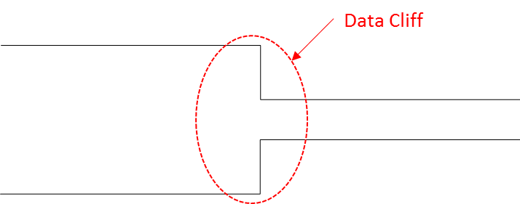
(Figure 1: Occurrence of data cliff between the heterogeneous networks)

In the process of transmitting the image file constructed as shown in Figure 2, there is a high possibility that the 'Movie Header' file containing the configuration information of the entire file is lost when the data cliff occurs. If the 'Movie Header' is lost, it is impossible to restore the whole image file even if another file is transferred.

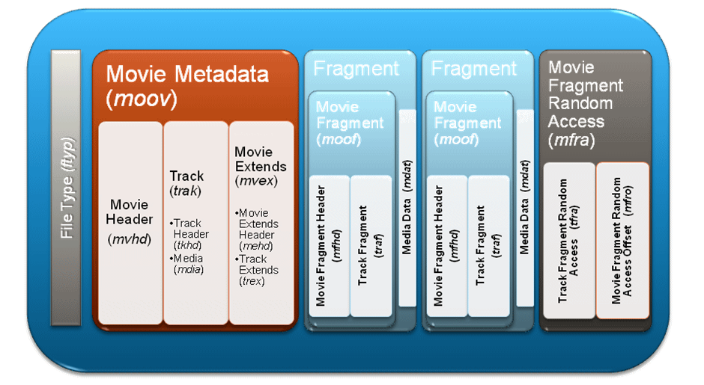
(Figure 2: Structure of movie file)

If the data cliff situation as described above occurs, the user cannot expect a good user experience, and may fail to receive the video service itself.

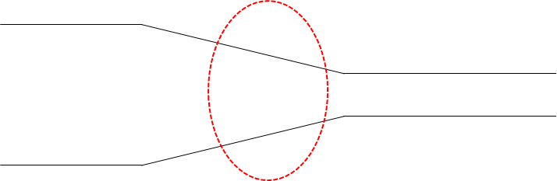
(Figure 3: Continuous Network Handover between heterogenous networks avoiding data cliff)

If the data cliff can be managed in the handover interval as shown in Figure 3, the user experience may not significantly improve but it will improve some and prevents the data transfer failure.

