Project | HMD based 3D Content Motion Sickness Reducing Technology  <http://sites.ieee.org/sagroups-3079/ >>
Title | Technical Trends of VR Standard
DCN | 3-17-0067-00-1000
Date Submitted | October 30, 2017
Source(s) | Sangkwon Peter Jeong ceo@joyfun.kr (JoyFun Inc.,)  Dongil Dillon Seo dillon@volercreative.com (VoleRCreative)  GookHwan Lee ghlee@joyfun.kr (JoyFun Inc.,)
Re: | Session #03, Beijing, China
Abstract | We will review the development status of OpenXR and WebVR standards conducted by Khronos Group and W3C respectively.
Purpose | Prior to establishing the IEEE P3079 standards, we will examine the current trends in the establishment of VR-related standards from various international standards organizations and reference will be made to the IEEE P3079 standards
Notice | This document has been prepared to assist the IEEE 3079 Working Group. It is offered as a basis for discussion and is not binding on the contributing individual(s) or organization(s). The material in this document is subject to change in form and content after further study. The contributor(s) reserve(s) the right to add, amend or withdraw material contained herein.
Release | The contributor grants a free, irrevocable license to the IEEE to incorporate material contained in this contribution, and any modifications thereof, in the creation of an IEEE Standards publication; to copyright in the IEEE’s name any IEEE Standards publication even though it may include portions of this contribution; and at the IEEE’s sole discretion to permit others to reproduce in whole or in part the resulting IEEE Standards publication. The contributor also acknowledges and accepts that IEEE 3079 may make this contribution public.
Patent Policy | The contributor is familiar with IEEE patent policy, as stated in Section 6 of the IEEE-SA Standards Board bylaws <http://standards.ieee.org/guides/bylaws/sect6-7.html#6> and in Understanding Patent Issues During IEEE Standards Development http://standards.ieee.org/board/pat/faq.pdf

- Khronos Group (Open XR)
  - Concept: The OpenXR™ working group – previously known as the Khronos VR Initiative - is creating an open and royalty-free standard for VR and AR applications and devices.
  - Issue:
Without a cross-platform standard, VR applications, games and engines must port to each vendors’ APIs.
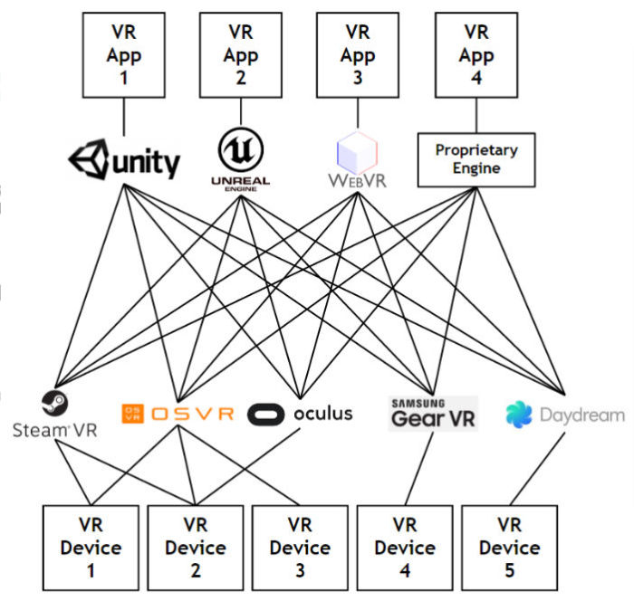
(Figure 1) Before Open XR (VR Market Fragmentation)
  - Solution:
The cross-platform VR standard eliminates industry fragmentation by enabling applications to be written once to run on any VR system, and to access VR devices integrated into those VR systems to be used by applications.
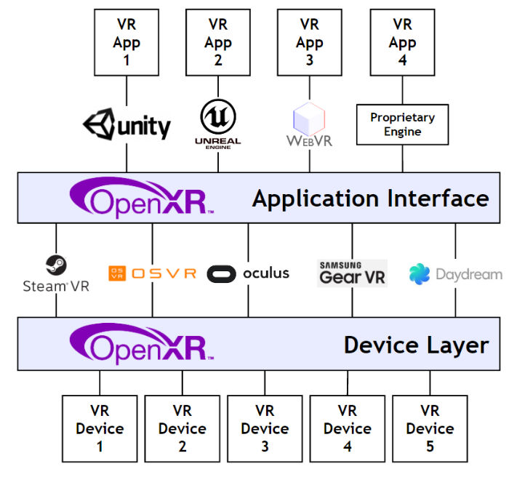
(Figure 2) After OpenXR (Wide interoperability of VR apps and devices)
  - OpenXR Architecture
OpenXR defines two levels of API interfaces that a VR platform’s runtime can use to access the OpenXR ecosystem.
Apps and engines use standardized interfaces to interrogate and drive devices. Devices can self-integrate to a standardized driver interface.
Standardized hardware/software interfaces reduce fragmentation while leaving implementation details open to encourage industry innovation.
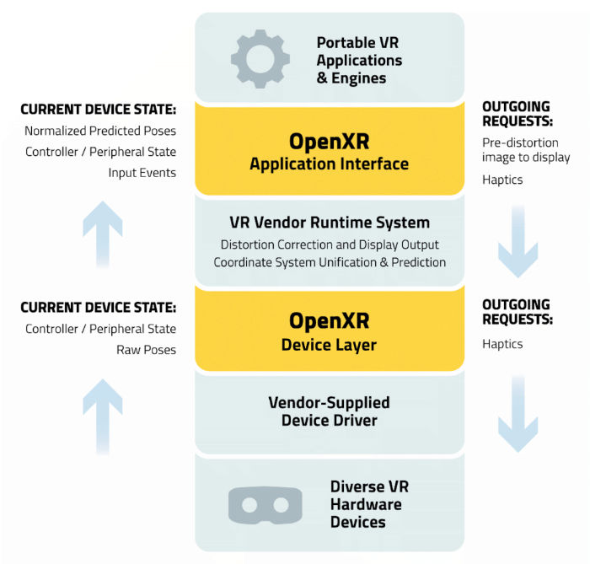
(Figure 3) Note that the design of the OpenXR specification is in progress, and so while the above diagrams represents the design goals of the group - final details may change

- W3C (WebVR)
  - Overview: A JavaScript API that provides a fully immersive 3D experience in a browser using VR headsets and VR-enabled devices (such as Daydream headsets and pixel phones) from WebVR users.
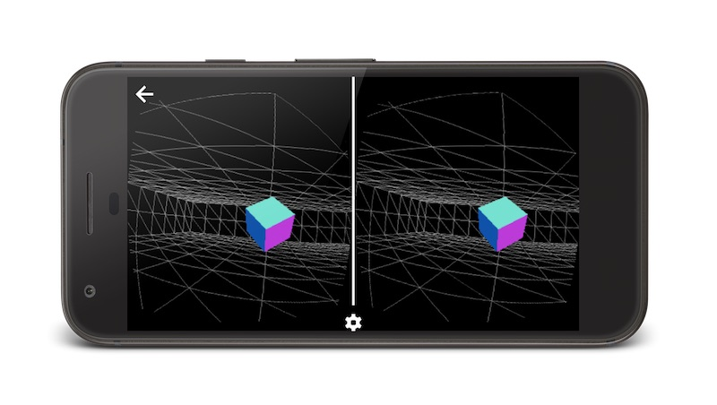
(Figure 4) WebVR Sample figure

  - Support and Availability: The WebVR API is available in the following browsers
      - Chrome Beta (M56+) via Original Trial
      - Firefox Nightly
      - Samsung Internet Browser for Gear VR (Note: Supports previous versions of the current WebVR specification.)
If the browser does not support WebVR or uses an older version of the API, you can replace it with a WebVR polyfill. However, because VRs are very performance sensitive and because polyfills are typically relatively costly to perform, you may need to consider whether you use polyfills for users that do not natively support WebVR.
  - WebVR Considerations: When building the WebVR experience, remember the followings
- WebVR content should be provided via HTTPS. Otherwise, the browser displays a warning to the user
- For more information, see Using HTTPS on the server.
- Chrome currently only supports native WebVR on Android. You must use a Daydream headset with a Pixel phone.
- WebVR polyfills may not always match one-to-one with the default implementation of the specification. To use a polyfill, you need to verify both on your VR-enabled device and on your non-VR device.
- You must click the VR controller button before you can use it in your code. In your code, you should implement it in such a way that it usually prompts the user to press a controller button when starting the VR experience.
- You need to enable Gamepad pose information when running locally on Chrome 56. If you do not enable the Gamepad Extensions runtime flag on Chrome 56, your gamepad information will not include pose (or location) information when running on localhost. If you are running Origin Trial, you can enable Gamepad Extensions using the WebVR API.

