Project | HMD based 3D Content Motion Sickness Reducing Technology  <http://sites.ieee.org/sagroups-3079/ >>
Title | P 3079 development Timeline
DCN | 3079-17-0000-00-0000
Date Submitted | October 23, 2017
Source(s) | Sangkwon Peter Jeong ceo@joyfun.kr (JoyFun Inc.,)  Dongil Dillon Seo dillon@volercreative.com (VoleRCreative)  GookHwan Lee ghlee@joyfun.kr (JoyFun Inc.,)
Re: | Session #03, Beijing, China
Abstract | We are going to set a schedule for developing the IEEE P3079 standards.
Purpose | We want to determine the schedule for developing the IEEE 3079 standards.
Notice | This document has been prepared to assist the IEEE 3079 Working Group. It is offered as a basis for discussion and is not binding on the contributing individual(s) or organization(s). The material in this document is subject to change in form and content after further study. The contributor(s) reserve(s) the right to add, amend or withdraw material contained herein.
Release | The contributor grants a free, irrevocable license to the IEEE to incorporate material contained in this contribution, and any modifications thereof, in the creation of an IEEE Standards publication; to copyright in the IEEE’s name any IEEE Standards publication even though it may include portions of this contribution; and at the IEEE’s sole discretion to permit others to reproduce in whole or in part the resulting IEEE Standards publication. The contributor also acknowledges and accepts that IEEE 3079 may make this contribution public.
Patent Policy | The contributor is familiar with IEEE patent policy, as stated in Section 6 of the IEEE-SA Standards Board bylaws <http://standards.ieee.org/guides/bylaws/sect6-7.html#6> and in Understanding Patent Issues During IEEE Standards Development http://standards.ieee.org/board/pat/faq.pdf

- Last Version
- PAR approved: 12/2016
- Draft 1.0: 07/2019
- Draft 2.0: 10/2019
- Letter ballot: 07/2018 – 07/2019
- WG approval: 10/2019
- Sponsor ballot: 10/2019 – 07/2020
- Sponsor approval: 08/2020
- RevCom approval: 11/2020

- New Propose
- PAR approved: 12/2016
- Working Group 1st Letter Ballot: 06/2019 (20 days)
- Before July meeting
- Working Group 2nd Letter Ballot: 09/2019 (20 days)
- Before October meeting
- Open Sponsor Ballot Invitation: 10/2019 (30 days)
- Start Sponsor Ballot: 11/2019 (30 days)
- Start Recirculation 1st Ballot: 02/2020 (10 days)
- Start Recirculation 2nd Ballot: 05/2020 (10 days)
- Submit to RevCom: 07/2020
- Publishing: 01/2021Z

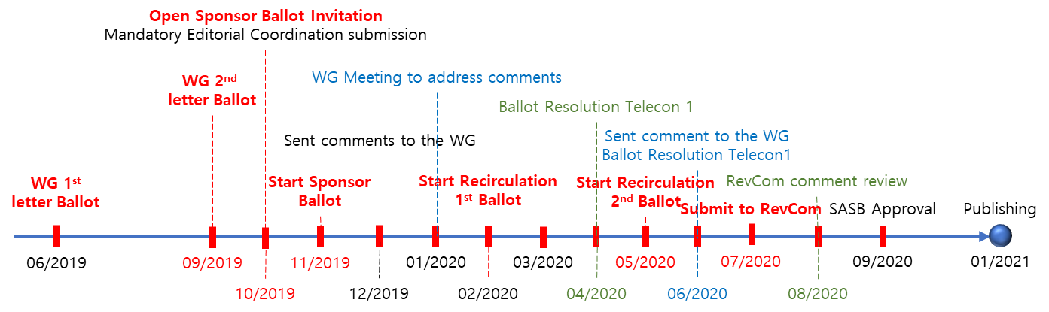
(Figure 1) Development Timeline

