Project | HMD based 3D Content Motion Sickness Reducing Technology  <http://sites.ieee.org/sagroups-3333-3/ >
Title | Bandwidth and Latency Requirements for Virtual Reality
DCN | 3-17-0057-00-0000
Date Submitted | July 24, 2017
Source(s) | Eun-Seok Ryu esryu@gachon.ac.kr (Gachon University)  Sangkwon Peter Jeong ceo@joyfun.kr (JoyFun Inc.)  Dongil Dillon Seo dillon@volercreative.com (VoleRCreative)
Re: | Session #2, NY, USA
Abstract | Determining bandwidth and latency requirements for Virtual Reality using the LAB data.
Purpose | Provide specific network requirements for VR service and reflect these technical requirements to IEEE P3333.3 standards.
Notice | This document has been prepared to assist the IEEE P3333.3 Working Group. It is offered as a basis for discussion and is not binding on the contributing individual(s) or organization(s). The material in this document is subject to change in form and content after further study. The contributor(s) reserve(s) the right to add, amend or withdraw material contained herein.
Release | The contributor grants a free, irrevocable license to the IEEE to incorporate material contained in this contribution, and any modifications thereof, in the creation of an IEEE Standards publication; to copyright in the IEEE’s name any IEEE Standards publication even though it may include portions of this contribution; and at the IEEE’s sole discretion to permit others to reproduce in whole or in part the resulting IEEE Standards publication. The contributor also acknowledges and accepts that IEEE P3333.3 may make this contribution public.
Patent Policy | The contributor is familiar with IEEE patent policy, as stated in Section 6 of the IEEE-SA Standards Board bylaws <http://standards.ieee.org/guides/bylaws/sect6-7.html#6> and in Understanding Patent Issues During IEEE Standards Development http://standards.ieee.org/board/pat/faq.pdf

1. VR HMD Characteristics
VR HMD (Virtual Reality Head Mounted Display) display two separate but identical images for left and right eye respectively in order to create stereoscopic image. Also, it uses a pair of fish eye lenses to maximize the field of view so that the user does not see the display edges and believes that he is seeing the virtual world with his own eyes, not through a display. This usage of fish eye lenses distorts the images displayed on the screen life Figure 1 and enlarges field of view, we are only perceiving 45% of the actual screen resolution. This is the reason why the VR HMD manufacturers are suggesting to use 4K UHD display to provide the visual fidelity we are commonly seeing from most popular TV sets, which is 1080p FHD display.

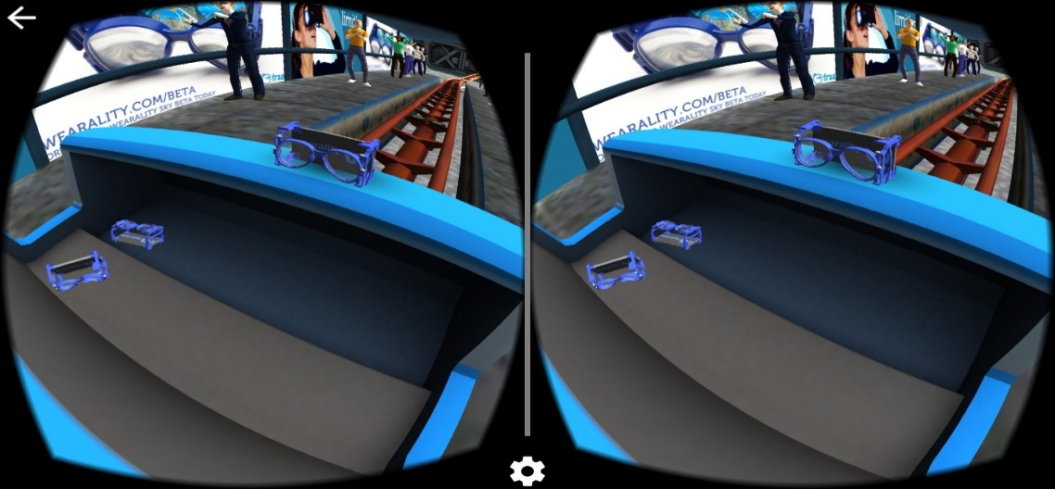
Figure 1. Stereoscopic image for VR HMD

4K UHD resolution offers 3840 x 2160 pixels. It means that an image requires 1G size and the VR content service which requires 90 FPS would require 18 Gbps data transfer rate.
Equation: resolution × 24bit (color) × frame rate = data capacity

Even if the movie clip data is compressed, 1 Gbps data transfer rate needs to be guaranteed.

Table 1. IMT-2020 vs WLAN vs IMT-Advanced
 | IMT-Advanced | WLAN(802.11ac) | IMT-2020
Peak data rate | 1 Gbps | 7Gbps | 20 Gbps
User experienced data rate | 10 Mbps  (urban/suburban) | 300Mpbs  (urban/suburban) | 100 Mbps (urban/suburban), 1Gbps (hotspots)
Mobility | 350 Km/h | N/A | 500 Km/h
Area traffic capacity | 0.1 Mbps/ m2 | N/A | 10 Mbps/ m2

Refer to Table 1, minimal data transfer rate for VR service would require at least IMT-Advanced wireless network; and 802.11ac or above WLAN or IMT-2020 wireless network will be necessary to create smooth VR service environment.
However, only IMT-2020 specifications are available and its technological implementation standards are not yet ready whereas VR already has commercial services ready. Hence, we are currently facing a situation where content is ready to be served but the network infrastructure is not ready to accommodate the needs. Therefore, it would be great if IEEE 802 can examine the industry requirements and provide standards for a secured and stable wireless network infrastructure that the industry can use to provide VR content services.
Especially, IEEE 802.21 is working on network handover issues and it would be worthwhile to examine different cases where VR service may leverage its standards on network handover.

2. Video Coding Standard for VR and Its Bandwidth Requirements
2.1. Quality requirements for VR to reduce nausea
There have been joint collaborations between ISO/IEC SC29 MPEG (Moving Picture Experts Group) and ITU-T VCEG (Video Coding Experts Group) to compress raw video sequences efficiently. For example, AVC (Advanced Video Coding), HEVC (High Efficiency Video Coding) were standardized in 2001 and 2013, respectively, and FVT (Future Video Coding) are under standardizing by the Joint Video Exploration Team (JVET) of MPEG and VCEG now. Because ISO/IEC SC29 MPEG standard covers the system and the file format area, MPEG-I actively standardizes the immersive media technology for 360 video VR service as well.

In 116th MPEG meeting (Oct. 2016), Technicolor, Qualcomm, Harmonic, and TNO announced the quality requirements for VR [1], which indicated 12K video with 90 frames per second are desirable to reduce the user nausea. The document addresses the visible viewport is about 12~14% of the total environment. Thus, if the resolution of target HMD is a 4K, the desirable resolution for 360 video VR service is 3 times of 4K resolution (11520x6480). Table 2 addresses that the VR video with 12K resolution, 90 fps, and 20ms delays reduces VR users’ nausea.

Table 2. Quality Requirements for VR Presented in MPEG 116th Meeting
Requirement | Details
Pixels/degree | - 40 pix/deg  - No HMD is capable of displaying 40pix/degree today
Video Resolution | - 3 times 4K(3840x1920) vertical resolution = 11520x6480
Framerate | - 90 fps  - 90fps framerate offers a latency low enough to prevent nausea
Stitching Errors | - Delivery and rendering processes shall not introduce additional stitching errors
3D Audio | - Support of scene-based and/or environmental audio  - 360 surround sound, object-based audio, Ambisonics
Motion-to-photon latency &  motion-to-audio latency | - How much time there is between the user interacts and an image / audio  - Maximum 20 ms
Foreground & Parallax | - Objects in the foreground shall be far enough to prevent nausea  - If objects are too close it is likely they can become an important cause of  nausea  - Interactive parallax with background shall be present for such objects

Thus, we measured the bandwidth requirement to meet the quality requirements. Experiments were conducted with the common test condition (CTC) defined in JVET.
The picture coding structure RA (Random Access) and LDB (Low-delay B), and QP (Quantization parameter) 22, 27, 32, and 37 were used. Test sequence were prepared by cropping and merging JVET’s 8K (5760x3240) test sequences (Gaslamp, Harbor, KiteFlite, Trolley) because there are no 12K test sequences defined in JVET yet.
For the pilot tests, the video standard reference software HM (ver. 16.6) encoded first 10 frames of the sequence because of its complexity (3 hours per 1 test set, total 8 sets.)
Experimental results in Table 3 shows maximum 360 Mbps are needed for 12K 90fps VR service.

Table 3. Measured Bandwidth Requirement for 12K VR under the CTC of JVET
Coding Structure | Quantization Parameter | 12K Bitrate  (@90fps)
RA | 37 | 60 Mbps
 | 32 | 107 Mbps
 | 27 | 191 Mbps
 | 22 | 353 Mbps
LDB | 37 | 58 Mbps
 | 32 | 106 Mbps
 | 27 | 192 Mbps
 | 22 | 357 Mbps
※ HM: HEVC test Model (reference software of the H.265 Standard)

2.2. Bandwidth requirements with viewport-based adaptive tile streaming
Due to the high bandwidth requirement for VR streaming service, there have been some researches to reduce the bandwidth using viewport-based adaptive tile streaming.
Figure 2 shows the conceptual sequences of the technology to reduce bandwidth: (1) HMD signals the viewport information of user to a VR server, (2) VR server extracts and transmits the tiles including the viewport area, (3) Corresponding tiles are decoded and rendered.
To simulate the bandwidth savings with the independent tile decoding, MCTS (Motion-Constrained Tile Set) method to prevent PU (Prediction Unit) referencing over tiles were implemented by Gachon University.
The maximum number of viewport tiles is four while the minimum number of it is one when the resolution of each tile is around 4K. Table 4 shows the bandwidth savings with the two cases: (1) four tiles streaming and (2) only one tile streaming. The results indicate that maximum 165 Mbps bandwidth is still required even the bandwidth saving technologies are applied for the VR service.
This experiment did not use the projection technologies using partial down-sampling such as CMP (Cube-Map Projection). Thus, further studies are needed to investigate the bandwidth saving and the efficient VR video streaming.

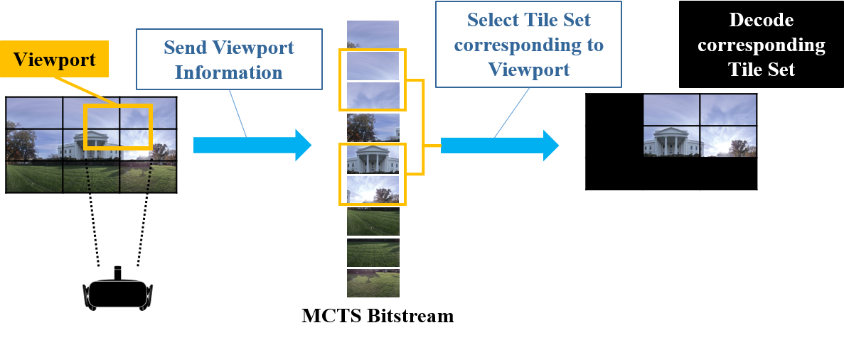
Figure 2. Viewport-based Adaptive Tile Streaming

Table 4. Bandwidth Requirements for Viewport Tile Streaming
Coding Structure | Quantization Parameter | Original Bitrate  (9 Tiles/@90fps) | Proposed Bitrate  (4 Tiles/@90fps) | Proposed Bitrate  (1 Tiles/@90fps)
RA | 37 | 60 Mbps | 28 Mbps(-53%) | 7 Mbps(-88%)
 | 32 | 107 Mbps | 50 Mbps(-53%) | 12 Mbps(-88%)
 | 27 | 191 Mbps | 88 Mbps(-53%) | 22 Mbps(-88%)
 | 22 | 353 Mbps | 162 Mbps(-54%) | 40 Mbps(-88%)
LDB | 37 | 58 Mbps | 28 Mbps(-51%) | 7 Mbps(-87%)
 | 32 | 106 Mbps | 50 Mbps(-52%) | 12 Mbps(-88%)
 | 27 | 192 Mbps | 90 Mbps(-53%) | 22 Mbps(-88%)
 | 22 | 357 Mbps | 165 Mbps(-53%) | 41 Mbps(-88%)

References
- ISO/IEC JTC1/SC29/WG11 MPEG 116/m39532, “Quality Requirements for VR”, Oct. 2016.

