Project | HMD based 3D Content Motion Sickness Reducing Technology  <http://sites.ieee.org/sagroups-3333-3/ >
Title | Display Specifications of VR HMDs
DCN | 3-17-0050-00-0004
Date Submitted | July 20, 2017
Source(s) | Dongil Dillon Seo dillon@volercreative.com (VoleRCreative)  Suk-Ju Kang sjkang@sogang.ac.kr (Sogang University)  Sangkwon Peter Jeong ceo@joyfun.kr (JoyFun Inc.)
Re: | Session PM1, NY, USA
Abstract | Understand the current display type, resolution and its pixel structure used in currently most popular commercial VR HMDs and discuss how its specification is related to the motion sickness caused by the VR experience.
Purpose | Understand the current VR HMD display specifications and discuss any possible correlation between the display specifications and the motion sickness caused by the VR service.
Notice | This document has been prepared to assist the IEEE P3333.3 Working Group. It is offered as a basis for discussion and is not binding on the contributing individual(s) or organization(s). The material in this document is subject to change in form and content after further study. The contributor(s) reserve(s) the right to add, amend or withdraw material contained herein.
Release | The contributor grants a free, irrevocable license to the IEEE to incorporate material contained in this contribution, and any modifications thereof, in the creation of an IEEE Standards publication; to copyright in the IEEE’s name any IEEE Standards publication even though it may include portions of this contribution; and at the IEEE’s sole discretion to permit others to reproduce in whole or in part the resulting IEEE Standards publication. The contributor also acknowledges and accepts that IEEE P3333.3 may make this contribution public.
Patent Policy | The contributor is familiar with IEEE patent policy, as stated in Section 6 of the IEEE-SA Standards Board bylaws <http://standards.ieee.org/guides/bylaws/sect6-7.html#6> and in Understanding Patent Issues During IEEE Standards Development http://standards.ieee.org/board/pat/faq.pdf

<Most Popular Commercial VR HMDs in the market and their specifications>
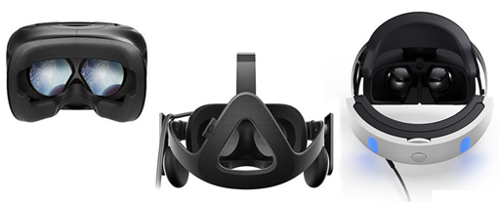
Figure 1. HTC Vive, Oculus Rift and Sony PS VR (From left to right)

Since the acquisition of Oculus by Facebook in 2014, virtual reality has been receiving a lot of industrial attention. In almost any large consumer electronic shows and IT conferences, the presence of virtual reality tech demos was very strong. Especially in 2016, Facebook Oculus, HTC and Sony have released their commercial version of VR HMD and opened an era of affordable consumer VR experience. However, due to the lack of industrial standards, each company has created their own versions of VR HMD with various specifications and this is causing the manufacturing price of VR HMD to rise as the sales of the hardware is still at its early stage. Hence, it would be worthwhile to examine the current specifications of each commercial VR HMD, especially on the display, to enhance the understanding of current status and discuss what would be needed to standardize the hardware specification.
 | HTC Vive | Oculus Rift | PlayStation VR
Type | Dual low-persistence  Samsung AMOLED  (Diamond PenTile  subpixel matrix) | Dual low-persistence  Samsung AMOLED  (Diamond PenTile  subpixel matrix) | Low-persistence  AMOLED  (RGB subpixel matrix)
Size | 91.9 mm × 2, 447 ppi | 90 mm × 2, 456 ppi | 5.7-inch
Resolution | 1200 × 1080  (per eye) | 1200 × 1080  (per eye) | 960 × 1080  (per eye)
Refresh Rate | 90Hz | 90Hz | 90Hz, 120Hz
Table 1. Display Specifications of VR HMDs
The table 1 shows the information provided by the manufacturers themselves and the understanding of Samsung OLED display technology. In order to produce an immersive visual experience in VR, four elements – display resolution, display quality, optics and field of view – are required and it would be important to understand why the current VR HMDs have chosen the current display types and resolution.
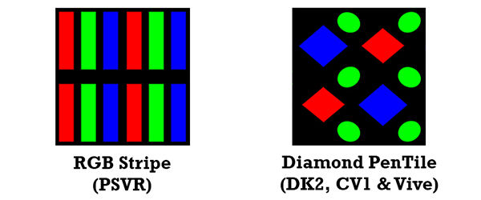
Figure 2. Subpixel matrix of OLED display used in VR HMDs
Looking at the table 1, both Oculus Rift and HTC Vive are using the Samsung Display manufactured OLED display and its resolution specification is superior to the display resolution specification of Sony PS VR. However, the display quality difference received by the user using the VR service between the three devices is minimal and this is due to the subpixel matrix. Figure 2 demonstrates how the subpixel matrix of the OLED screen used in PS VR and Oculus Rift & HTC Vive. Normally, it is very difficult to distinguish the subpixel matrix of the AMOLED displays used in the devices like smartphones as the user views from a distance, but a VR HMD screen is magnified with a set of fisheye lenses and it is placed only inches from the viewer’s eyes so the subpixel matrix is much more visible. This is where the Sony PS VR has an advantage as the black area that divides the subpixels is much smaller. Its 1080p screen’s RGB stripe matrix is superior to the PenTile matrix. In a square of four pixels as shown in Figure 2, Sony PS VR screen has more subpixels with even number of each color (red, green and blue) where Samsung PenTile screen has fewer subpixels and more number of green colors. This allows the quality of perceived resolution of PS VR screen when looking at it closely is close to that of the Rift and Vive. The PenTile display used in the Rift and Vive looks grainier when looking at a close distance and produces more pronounced screen-door effect – the grid of the gap between pixels and gradients look worse. PenTile matrix in AMOLED, however, has a price advantage as it costs less to achieve the desired resolution and extends the life cycle of the panel.

<Discussion Points>
- Does resolution have any relation to the motion sickness caused by the use of VR HMD?
  - Is resolution alone a factor causing the motion sickness? If so, why?
  - Is locomotion with higher resolution helps ease the motion sickness problem? If so, why?
- What is the optimal refresh rate of the screen to minimize the motion sickness?
  - Is 90 Hz the defecto standards? If so, why?

