Project | HMD based 3D Content Motion Sickness Reducing Technology  <http://sites.ieee.org/sagroups-3333-3/ >
Title | Lens Specifications of VR HMDs
DCN | 3-17-0049-00-0006
Date Submitted | July 20, 2017
Source(s) | Dongil Dillon Seo dillon@volercreative.com (VoleRCreative)  Sangkwon Peter Jeong ceo@joyfun.kr (JoyFun Inc.)
Re: | Session #2, NY, USA
Abstract | Understand the current lens types used in currently most popular commercial VR HMDs and the advantages and the disadvantages and discuss how its specification is related to the motion sickness caused by the VR experience.
Purpose | Understand the current VR HMD lens specifications and discuss any possible correlation between the lens specifications and the motion sickness caused by the VR service.
Notice | This document has been prepared to assist the IEEE P3333.3 Working Group. It is offered as a basis for discussion and is not binding on the contributing individual(s) or organization(s). The material in this document is subject to change in form and content after further study. The contributor(s) reserve(s) the right to add, amend or withdraw material contained herein.
Release | The contributor grants a free, irrevocable license to the IEEE to incorporate material contained in this contribution, and any modifications thereof, in the creation of an IEEE Standards publication; to copyright in the IEEE’s name any IEEE Standards publication even though it may include portions of this contribution; and at the IEEE’s sole discretion to permit others to reproduce in whole or in part the resulting IEEE Standards publication. The contributor also acknowledges and accepts that IEEE P3333.3 may make this contribution public.
Patent Policy | The contributor is familiar with IEEE patent policy, as stated in Section 6 of the IEEE-SA Standards Board bylaws <http://standards.ieee.org/guides/bylaws/sect6-7.html#6> and in Understanding Patent Issues During IEEE Standards Development http://standards.ieee.org/board/pat/faq.pdf

In order to deliver an immersive VR experience, large field of view and image clarity are important factors to consider and one of the hardware components used in VR HMDs that determines these factors is the optics. Two important attributes to consider for the lenses are the followings:
- A short focal length to magnify the displays for the best possible field of view
- As compact and light as possible to minimize the impact on the ergonomics and design
Table 1 below shows the lens type and its adjustment used by three most popular commercial VR HMDs in the market.
 | HTC Vive | Oculus Rift | PlayStation VR
Lens Type | Fresnel | Hybrid Fresnel | Standard
Lens Adjustment | IPD (60.8-74.6 mm),  lens-to-eye distance  ("eye-relief" adjustment) | IPD (58-72 mm),  lens-to-eye distance  (adjustable with optional glasses spacer) | Software IPD,  lens-to-eye distance
Table 1. Lens Specification for VR HMDs

The magnification and the screen-door effect are inversely proportional. The higher magnification increases the size of the display pixels and it makes the visibility of subpixel matrix more visible. Hence, this problem needs to be addressed when image clarity is needed.

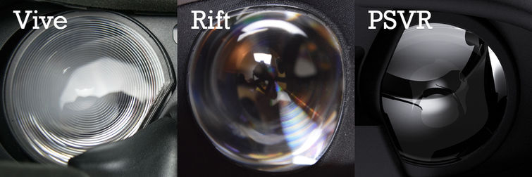
Figure 1. Optics used in various VR HMDs
To solve this dilemma, Oculus Rift and HTC Vive are using Fresnel lenses. This lens type segments a standard curved lens into small curved sections so when viewed from the front, it looks like there are circular concentric ridges on the surface of the lens – please see HTC Vive lens shown in Figure 1. The YouTube video provided by VR Lens Lab will be helpful to understand how lenses for virtual reality headsets work. Fresnel lenses also produce optical diffusion and it helps to minimize the screen-door effect. Oculus Rift is using a set of hybrid Fresnel lenses with very fine ridges combined with a regular convex lens. This is the reason why the ridges are not very visible as shown in Figure 1 and it offers better quality of image with less screen-door effect than HTC Vive. The Rift’s hybrid lenses also have a larger viewing spot where the image quality is at its best and more consistent focus across their visual field. This allows the users to position the HMD in front of their eyes more easily.

The Vive’s Fresnel lenses are more traditional so it achieves wider field of view than the Rift. Their coarser ridges produce higher contract VR environments when users look for them but their viewing spot is smaller so it is less forgiving about the headset adjustment. Their coarser ridges also make the screen-door effect more visible than the Rift. Image comparison between the Rift and the Vive is well demonstrated in the linked YouTube video.

Unfortunately, finding a perfect solution that solves every known problem in VR is not possible at the moment. Fresnel lenses have some clear advantages over regular lenses, but also have some clear disadvantages. The two major issues with Fresnel lenses are
- Reduced contrast and
- Fresnel glare
Fresnel glare is much more noticeable in high contrast situations where bright objects exhibit very noticeable light flare artifacts around them. On darker backgrounds, the glare can be quite distracting and it is problematic to both the Rift and the Vive.

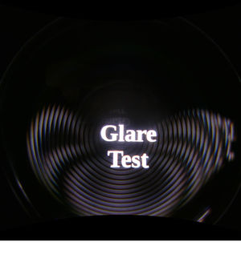
Fresnel Glare in HTC Vive | Fresnel Glare in Oculus Rift
Sony PS VR, however, is not using the Fresnel lenses. Perhaps, Sony is hoping that its superior screen technology with better subpixel matrix can help to produce better image quality than the Rift and the Vive. However, the current PS4 is significantly less powerful than the PCs needed for the Rift and the Vive so the more aliasing and less detailed graphics quality are inevitable to achieve the 90 FPS required for comfortable VR experience. This may set back the image quality of the VR service.

<Discussion Points>
- Does image quality have any relation to the motion sickness caused by the use of VR HMD?
  - Do problems caused by the use of Fresnel lenses have any relations to the motions sickness? If so, why?
  - Are there any different types of lenses that solve the problems mentioned in the article?

