IEEE P3004.9™/D2
Draft Recommended Practice for Transformer Protection in Industrial and Commercial Power Systems
Sponsor
Technical Books Coordination Committee
of the
IEEE <Society Name> Society
Approved <XX Month 20XX>
IEEE-SA Standards Board

Copyright © <current year> by the Institute of Electrical and Electronics Engineers, Inc.
Three Park Avenue
New York, New York 10016-5997, USA
All rights reserved.
This document is an unapproved draft of a proposed IEEE Standard. As such, this document is subject to change. USE AT YOUR OWN RISK! Because this is an unapproved draft, this document must not be utilized for any conformance/compliance purposes. Permission is hereby granted for IEEE Standards Committee participants to reproduce this document for purposes of international standardization consideration. Prior to adoption of this document, in whole or in part, by another standards development organization, permission must first be obtained from the IEEE Standards Activities Department (stds.ipr@ieee.org). Other entities seeking permission to reproduce this document, in whole or in part, must also obtain permission from the IEEE Standards Activities Department.
IEEE Standards Activities Department
445 Hoes Lane
Piscataway, NJ 08854, USA

Abstract: <Select this text and type or paste Abstract—contents of the Scope may be used>
Keywords: <Select this text and type or paste keywords>

•
IEEE Standards documents are developed within the IEEE Societies and the Standards Coordinating Committees of the IEEE Standards Association (IEEE-SA) Standards Board. The IEEE develops its standards through a consensus development process, approved by the American National Standards Institute, which brings together volunteers representing varied viewpoints and interests to achieve the final product. Volunteers are not necessarily members of the Institute and serve without compensation. While the IEEE administers the process and establishes rules to promote fairness in the consensus development process, the IEEE does not independently evaluate, test, or verify the accuracy of any of the information or the soundness of any judgments contained in its standards.
Use of an IEEE Standard is wholly voluntary. The IEEE disclaims liability for any personal injury, property or other damage, of any nature whatsoever, whether special, indirect, consequential, or compensatory, directly or indirectly resulting from the publication, use of, or reliance upon this, or any other IEEE Standard document.
The IEEE does not warrant or represent the accuracy or content of the material contained herein, and expressly disclaims any express or implied warranty, including any implied warranty of merchantability or fitness for a specific purpose, or that the use of the material contained herein is free from patent infringement. IEEE Standards documents are supplied “AS IS.”
The existence of an IEEE Standard does not imply that there are no other ways to produce, test, measure, purchase, market, or provide other goods and services related to the scope of the IEEE Standard. Furthermore, the viewpoint expressed at the time a standard is approved and issued is subject to change brought about through developments in the state of the art and comments received from users of the standard. Every IEEE Standard is subjected to review at least every five years for revision or reaffirmation, or every ten years for stabilization. When a document is more than five years old and has not been reaffirmed, or more than ten years old and has not been stabilized, it is reasonable to conclude that its contents, although still of some value, do not wholly reflect the present state of the art. Users are cautioned to check to determine that they have the latest edition of any IEEE Standard.
In publishing and making this document available, the IEEE is not suggesting or rendering professional or other services for, or on behalf of, any person or entity. Nor is the IEEE undertaking to perform any duty owed by any other person or entity to another. Any person utilizing this, and any other IEEE Standards document, should rely upon his or her independent judgment in the exercise of reasonable care in any given circumstances or, as appropriate, seek the advice of a competent professional in determining the appropriateness of a given IEEE standard.
Interpretations: Occasionally questions might arise regarding the meaning of portions of standards as these relate to specific applications. When the need for interpretations is brought to the attention of IEEE, the Institute will initiate action to prepare appropriate responses. Since IEEE Standards represent a consensus of concerned interests, it is important to ensure that any interpretation has also received the concurrence of a balance of interests. For this reason, IEEE and the members of its societies and Standards Coordinating Committees are not able to provide an instant response to interpretation requests except in those cases where the matter has previously received formal consideration. A statement, written or oral, that is not processed in accordance with the IEEE-SA Standards Board Operations Manual shall not be considered the official position of IEEE or any of its committees and shall not be considered to be, nor be relied upon as, a formal interpretation of the IEEE. At lectures, symposia, seminars, or educational courses, an individual presenting information on IEEE standards shall make it clear that his or her views should be considered the personal views of that individual rather than the formal position, explanation, or interpretation of the IEEE.
Comments for revision of IEEE Standards are welcome from any interested party, regardless of membership affiliation with IEEE. Suggestions for changes in documents should be in the form of a proposed change of text, together with appropriate supporting comments. Recommendations to change the status of a stabilized standard should include a rationale as to why a revision or withdrawal is required. Comments and recommendations on standards, and requests for interpretations should be addressed to:
Secretary, IEEE-SA Standards Board
445 Hoes Lane
Piscataway, NJ 08854
USA
Authorization to photocopy portions of any individual standard for internal or personal use is granted by The Institute of Electrical and Electronics Engineers, Inc., provided that the appropriate fee is paid to Copyright Clearance Center. To arrange for payment of licensing fee, please contact Copyright Clearance Center, Customer Service, 222 Rosewood Drive, Danvers, MA 01923 USA; +1 978 750 8400. Permission to photocopy portions of any individual standard for educational classroom use can also be obtained through the Copyright Clearance Center.

Introduction
This introduction is not part of IEEE P3004.9/D1, Draft Recommended Practice for Transformer Protection in Industrial and Commercial Power Systems.
<Select this text and type or paste introduction text>
Notice to users
Laws and regulations
Users of these documents should consult all applicable laws and regulations. Compliance with the provisions of this standard does not imply compliance to any applicable regulatory requirements. Implementers of the standard are responsible for observing or referring to the applicable regulatory requirements. IEEE does not, by the publication of its standards, intend to urge action that is not in compliance with applicable laws, and these documents may not be construed as doing so.
Copyrights
This document is copyrighted by the IEEE. It is made available for a wide variety of both public and private uses. These include both use, by reference, in laws and regulations, and use in private self-regulation, standardization, and the promotion of engineering practices and methods. By making this document available for use and adoption by public authorities and private users, the IEEE does not waive any rights in copyright to this document.
Updating of IEEE documents
Users of IEEE standards should be aware that these documents may be superseded at any time by the issuance of new editions or may be amended from time to time through the issuance of amendments, corrigenda, or errata. An official IEEE document at any point in time consists of the current edition of the document together with any amendments, corrigenda, or errata then in effect. In order to determine whether a given document is the current edition and whether it has been amended through the issuance of amendments, corrigenda, or errata, visit the IEEE Standards Association web site at http://ieeexplore.ieee.org/xpl/standards.jsp, or contact the IEEE at the address listed previously.
For more information about the IEEE Standards Association or the IEEE standards development process, visit the IEEE-SA web site at http://standards.ieee.org.
Errata
Errata, if any, for this and all other standards can be accessed at the following URL:
http://standards.ieee.org/reading/ieee/updates/errata/index.html. Users are encouraged to check this URL for errata periodically.
Interpretations
Current interpretations can be accessed at the following URL: http://standards.ieee.org/reading/ieee/interp/
index.html.
Patents
[If the IEEE has not received letters of assurance prior to the time of publication, the following notice shall appear:]
Attention is called to the possibility that implementation of this recommended practice might require use of subject matter covered by patent rights. By publication of this recommended practice, no position is taken with respect to the existence or validity of any patent rights in connection therewith. The IEEE is not responsible for identifying Essential Patent Claims for which a license may be required, for conducting inquiries into the legal validity or scope of Patents Claims or determining whether any licensing terms or conditions provided in connection with submission of a Letter of Assurance, if any, or in any licensing agreements are reasonable or non-discriminatory. Users of this recommended practice are expressly advised that determination of the validity of any patent rights, and the risk of infringement of such rights, is entirely their own responsibility. Further information may be obtained from the IEEE Standards Association.
[The following notice shall appear when the IEEE receives assurance from a known patent holder or patent applicant prior to the time of publication that a license will be made available to all applicants either without compensation or under reasonable rates, terms, and conditions that are demonstrably free of any unfair discrimination.]
Attention is called to the possibility that implementation of this recommended practice might require use of subject matter covered by patent rights. By publication of this recommended practice, no position is taken with respect to the existence or validity of any patent rights in connection therewith. A patent holder or patent applicant has filed a statement of assurance that it will grant licenses under these rights without compensation or under reasonable rates, with reasonable terms and conditions that are demonstrably free of any unfair discrimination to applicants desiring to obtain such licenses. Other Essential Patent Claims might exist for which a statement of assurance has not been received. The IEEE is not responsible for identifying Essential Patent Claims for which a license might be required, for conducting inquiries into the legal validity or scope of Patents Claims, or determining whether any licensing terms or conditions provided in connection with submission of a Letter of Assurance, if any, or in any licensing agreements are reasonable or non-discriminatory. Users of this recommended practice are expressly advised that determination of the validity of any patent rights, and the risk of infringement of such rights, is entirely their own responsibility. Further information may be obtained from the IEEE Standards Association.
Participants
At the time this draft recommended practice was submitted to the IEEE-SA Standards Board for approval, the Protection & Coordination Working Group had the following membership:
Rasheek Rifaat, Chair
<Vice-chair Name>, Vice Chair

Participant1
Participant2
Participant3
Participant4
Participant5
Participant6
Participant7
Participant8
Participant9

The following members of the <individual/entity> balloting committee voted on this recommended practice. Balloters might have voted for approval, disapproval, or abstention.

(to be supplied by IEEE)

Balloter1
Balloter2
Balloter3
Balloter4
Balloter5
Balloter6
Balloter7
Balloter8
Balloter9

When the IEEE-SA Standards Board approved this recommended practice on <XX Month 20XX>, it had the following membership:
(to be supplied by IEEE)
<Name>, Chair
<Name>, Vice Chair
<Name>, Past President
<Name>, Secretary

SBMember1
SBMember2
SBMember3
SBMember4
SBMember5
SBMember6
SBMember7
SBMember8
SBMember9

*Member Emeritus

Also included are the following nonvoting IEEE-SA Standards Board liaisons:
<Name>, TAB Representative
<Name>, NIST Representative
<Name>, NRC Representative

<Name>
IEEE Standards Program Manager, Document Development

<Name>
IEEE Standards Program Manager, Technical Program Development

Contents
<After draft body is complete, select this text and click Insert Special->Add (Table of) Contents>

Draft Recommended Practice for Transformer Protection in Industrial and Commercial Power Systems
IMPORTANT NOTICE: This standard is not intended to ensure safety, security, health, or environmental protection in all circumstances. Implementers of the standard are responsible for determining appropriate safety, security, environmental, and health practices or regulatory requirements.
This IEEE document is made available for use subject to important notices and legal disclaimers.
These notices and disclaimers appear in all publications containing this document and might
be found under the heading “Important Notice” or “Important Notices and Disclaimers
Concerning IEEE Documents.” Also, these can be obtained on request from IEEE or viewed at http://standards.ieee.org/IPR/disclaimers.html.
- Overview
Increased use of electric power in industrial plants has led to the use of larger and more expensive primary and secondary substation transformers. This work provides guidelines for properly protecting these transformers.
- Normative references--UPDATE
The following referenced documents are indispensable for the applying this document (i.e., these must be understood and used, so each referenced document is cited in text and its relationship to this document is explained). For dated references, only the edition cited applies. For undated references, the latest edition of the referenced document (including any amendments or corrigenda) applies.
ANSI C37.91-2008, ANSI Guide for Protective Relay Applications to Power Transformers.
ANSI C57.92-2000, ANSI Guide for Loading Mineral-Oil-Immersed Power Transformers Up to and Including 100 MVA with 55 °C or 65 °C Winding Rise.
IEEE Std 141-1993 (Reaff 1999), IEEE Recommended Practice for Electric Power Distribution for Industrial Plants.
IEEE Std 493-2007, IEEE Recommended Practice for the Design of Reliable Industrial and Commercial Power Systems.
IEEE Std C57.12.00-2010, IEEE Standard General Requirements for Liquid-Immersed Distribution, Power, and Regulating Transformers.
IEEE Std C57.91-1995, IEEE Guide for Loading Mineral-Oil-Immersed Power Transformers.
IEEE Std C57.96-1999, IEEE Guide for Loading Dry-Type Distribution and Power Transformers.
IEEE Std C57.109-1993, IEEE Guide for Liquid-Immersed Transformer Through-Fault-Current Duration.
NFPA 70-2011, National Electrical Code® (NEC®).
- Transformer Protection
Primary substation transformers normally range in size between 1,000 kVA and 12,000 kVA, with a secondary voltage between 2,400 V and 13,800 V. Secondary substation transformers normally range in size between 300 kVA and 2,500 kVA, with secondary voltages of 208 V, 240 V, and 480 V. Larger and smaller transformers might also be protected by the devices discussed in this work.
Industrial transformers, unlike utility transformers, frequently have neutral grounding resistors to limit ground current during faults; the allowed fault current is in the range of 200–400 A range on medium-voltage systems.
  - Need for protection
Transformer failure results in loss of service. However, prompt fault clearing, in addition to lessening the damage and cost of repairs, usually minimizes system disturbance, diminishes the magnitude of the service outage, and makes the outage duration shorter. Usually, prompt fault clearing prevents catastrophic damage. Proper protection is important for transformers of all sizes, even though transformers are among the simplest and most reliable components in the plant electrical system.
Previous studies (see Table 1) indicate that all transformers had a failure rate of 62 per 10,000 transformer years; that transformers rated 300 kVA to 10,000 kVA had a failure rate of 59 per 10,000 transformer years; and that transformers rated greater than 10,000 kVA had a failure rate 153 per 10,000 transformer years. These statistics might be taken incorrectly, implying that little or no transformer protection is required.
The need for transformer protection is indicated when the average forced hours of downtime per transformer year is considered. The large value of 356 h average out-of-service time per transformer failure challenges the system-design engineer to protect the transformer and minimize any damage that could occur.
- — Reliability of power transformers (1979 survey)
Equipment subclass | Failure rate  (failures for  unit-year) | Average repair  time  (hours per failure) | Average  replacement time  (hours per failure)
All liquid filled | 0.0062 | 356.1 | 85.1
Liquid filled  300–10 000 kVA | 0.0059.4 | 297 | 79.3
Liquid filled  >10 000 kVA | 0.0153 | 1178.5ª | 192.0ª
Dry  300–10 000 kVA | ª | ª | ª
ª Small sample size; less than eight failures.
The failure of a transformer can be caused by any of a number of internal or external conditions that make the unit incapable of performing its proper function electrically or mechanically. Transformer failures might be grouped by the initiating cause, as follows:
- Winding breakdown is the most frequent cause of transformer failure. Reasons for this type of failure include insulation deterioration or defects in manufacturing, overheating, mechanical stress, vibration, and voltage surges.
- Terminal boards and no-load tap changers. Failures are attributed to improper assembly, damage during transportation, excessive vibration, or inadequate design.
- Bushing failures. Causes include vandalism, contamination, aging, cracking, and animal damage.
- Load-tap-changer failures. Causes include mechanism malfunction, contact problems, insulating liquid contamination, vibration, improper assembly, and excessive stresses within the unit. Load-tap-changing units are applied on utility systems rather than on industrial systems.
- Miscellaneous failures. Causes include core insulation breakdown, bushing current transformer (CT) failure, liquid leakage because of poor welds or tank damage, shipping damage, and foreign materials left within the tank.
Failure of other equipment within the transformer protective device zone of protection could cause the loss of the transformer to the system. This failure includes any equipment (cables, bus ducts, switches, instrument transformers, surge arresters, neutral grounding devices) between the next upstream protective device and the next downstream device.
  - Objectives in transformer protection
Protection is combining system design, physical layout, and protective devices:
- Meet the requirements of the application economically
- Protect the electrical system from the effects of a transformer failure
- Protect the transformer from disturbances occurring on the electrical system
- Protect the transformer from incipient malfunction within the transformer
- Protect the transformer from physical conditions in the environment that might affect reliable performance
  - Types of transformers
Under the broad category of transformers, two types are used widely in industrial and commercial power systems: liquid and dry. Liquid transformers are constructed to have the essential elements, the core and coils of the transformer, contained in the liquid-filled enclosure. This liquid serves as an insulating medium and as a heat-transfer medium. Dry transformers are constructed with the core and coils surrounded by an atmosphere, which might be the surrounding air, free to circulate through the transformer enclosure. Dry coils can be conventional (with exposed, insulated conductors) or encapsulated (with the coils completely vacuum cast in an epoxy resin).
An alternative to free circulation of outside air through the dry transformer is a sealed enclosure in which a gas or vapor is contained. In either case, this surrounding medium acts as a heat-transfer medium and as an insulating medium. It is important, with both liquid and dry transformers, to monitor the quality and function of the surrounding media to avoid damage to the core and coil structures. Systems to preserve or protect the medium within the transformer enclosure are presented in section 3.4.
  - Preservation systems
    - Dry preservation systems
Dry preservation systems are used to ensure an adequate supply of clean ventilating medium (air) at an acceptable ambient temperature. Contamination of the insulating ducts within the transformer can lead to reduced insulation strength and severe overheating. The protection method most used in commercial applications consists of a temperature-indicating device with probes installed in the transformer winding ducts and contacts to signal dangerously high temperatures by visual and audible alarm. Figure 1 illustrates this feature.
The following types of dry systems are common:
- Open ventilated
- Filtered ventilated
- Totally enclosed, nonventilated
- Sealed air- or gas-filled
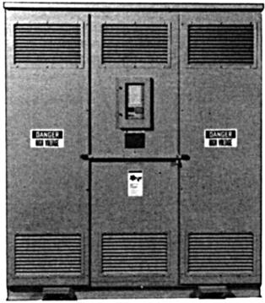 Replacement photo---http://www.relectric.com/Transformers/Custom-Transformers
- — Tamper-proof, fan-cooled, dry ventilated, outdoor transformer with microprocessor temperature-control system
    - Liquid preservation systems
Liquid preservation systems safeguard the amount of liquid and to prevent contamination by the surrounding atmosphere that might introduce moisture and oxygen, leading to reduced insulation strength and to sludge formation in cooling ducts.
The importance of maintaining the purity of insulating oil is critical at high voltages because of increased electrical stress on the insulating oil.
The sealed tank system is used almost to the total exclusion of other types in industrial and commercial applications. The following types of systems are common:
- Sealed tank
- Positive-pressure inert gas
- Gas-oil seal
- Conservator tank
Historically, liquid preservation systems have been called oil-cooled systems, even though the medium was askarel or a substitute for askarel. Many transformer manufacturers now also offer options for vegetable based and other bio-friendly cooling fluids (for environmental reasons).
      - Sealed tank
The sealed-tank design is most common and is standard on most substation transformers. As the name implies, the transformer tank is sealed to isolate it from the outside atmosphere.
A gas space equal to about one-tenth of the liquid volume is maintained at the top of the tank to allow for thermal expansion. This space might be purged of air and filled with nitrogen.
A pressure-vacuum gauge and bleeder device might be furnished on the tank to allow the internal pressure or vacuum to be monitored and any excessive static pressure buildup to be relieved, to avoid damage to the enclosure and operation of the pressure-relief device. This system is the simplest and most maintenance-free of all of the preservation systems.
      - Positive-pressure inert gas
The positive-pressure inert gas design shown in Figure 2 is similar to the sealed-tank design with the addition of a gas (usually nitrogen) pressurizing the assembly. This assembly provides a slight positive pressure in the gas supply line to prevent air from entering the transformer during operating mode or temperature changes. Transformers with primary windings rated 69 kV and more, and rated 7,500 kVA and more, typically are equipped with this device.
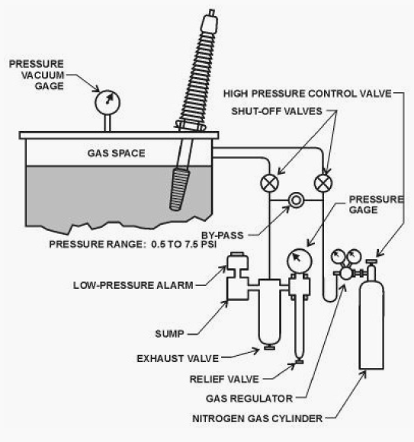
© 2013 EEP - Electrical Engineering Portal
sales@electrical-engineering-portal.com

- — Positive-pressure inert-gas assembly, often used on sealed tank transformers rated 7500 kVA and more and 69 kV and more primary voltage
      - Gas-oil seal
The gas-oil seal design incorporates a captive gas space that isolates a second auxiliary oil tank from the main transformer oil, as shown in Figure 3. The auxiliary oil tank is open to the atmosphere and provides room for thermal expansion of the main transformer oil volume.
The main tank oil expands or contracts because of changes in temperature, causing the level of the oil in the auxiliary tank to rise or lower as the captive volume of gas is forced out of or allowed to reenter the main tank. The pressure of the auxiliary tank oil on the contained gas maintains a positive pressure in the gas space, preventing atmospheric vapors from entering the main tank.
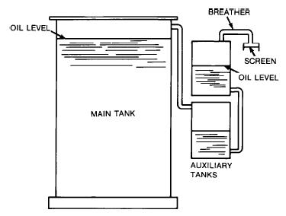
- — Gas-oil seal system of oil preservation
      - Conservator tank
The conservator tank design shown in Figure 4 does not have a gas space above the oil in the main tank. It includes a second oil tank above the main tank cover with a gas space adequate to absorb the thermal expansion of the main tank oil volume. The second tank is connected to the main tank by an oil-filled tube or pipe.
A large diameter stand pipe extends at an angle from the cover and is closed above the liquid level by a frangible diaphragm that ruptures for rapid gas evolution and releases pressure to prevent damage to the enclosure.
Because the conservator construction allows gradual liquid contamination, it has become obsolete.
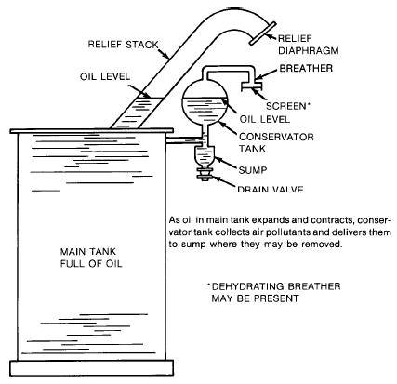
- — Conservator tank oil-preservation system
  - Protective devices for liquid preservation systems
    - Liquid-level gauge
The liquid-level gauge, shown in Figure 5 and Figure 6, measures the level of insulating liquid within the tank with respect to a predetermined level, usually indicated at 25 °C temperature. An excessively low level could indicate the loss of insulating liquid. Such a loss could lead to internal flashovers and overheating if not corrected. Periodic observation is performed to check that the liquid level is within acceptable limits. Usually, alarm contacts for low liquid level are available as a standard option. Alarm contacts should be specified for unattended operation to save transformers from a loss-of-insulation failure. The alarm contact is set to close before an unsafe condition actually occurs. The alarm contacts should be connected through a communications link to an attendant.
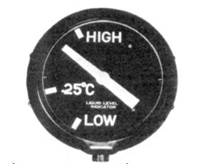 http://www.qualitrolcorp.com/uploadedImages/Siteroot/Products/QUALITROL_032_042_045_and_AKM_44712_34725_COMBINED.jpg
- — Liquid-level indicator depicting level of liquid with respect to a predetermined level, usually 25 °C
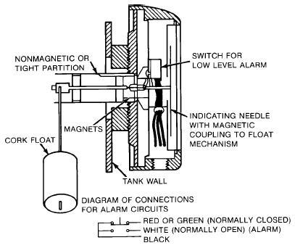
- — Liquid-level-indicating needle, driven by a magnetic coupling to the float mechanism
    - Pressure-vacuum gauge
The pressure-vacuum gauge in Figure 7 indicates the difference between the transformer internal gas pressure and atmospheric pressure. It is used on transformers with sealed-tank oil preservation systems. Both the pressure-vacuum gauge and the sealed-tank oil preservation system are standard on most small and medium power transformers.
The pressure in the gas space is related to the thermal expansion of the insulating liquid and varies with load and ambient temperature changes. Large positive or negative pressures could indicate an abnormal condition, such as a gas leak, particularly if the transformer has been observed to remain within normal pressure limits for some time or if the pressure-vacuum gauge has remained at the zero mark for a long period. The pressure vacuum gauge equipped with limit alarms is used to detect excessive vacuum or positive pressure that could cause tank rupture or deformation. The need for pressure-limit alarms is less urgent when the transformer is equipped with a pressure relief device.
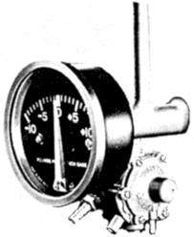
- — Pressure vacuum gauge indicates internal gas pressure relative to atmospheric pressure (with bleeder valve to equalize pressure manually)
    - Pressure-vacuum bleeder valve
Transformers are designed to operate over a range of 100°, generally from –30 °C to +70 °C. Should temperatures exceed these limits, the pressure-vacuum bleeder valve adjusts automatically to prevent any gauge pressure or vacuum in excess of 35 kPa. This valve also prevents operation of the pressure-relief device in response to slowly increasing pressure caused by severe overload heating or extreme ambient temperatures. Also incorporated in the pressure vacuum bleeder valve is a hose burr and a manually operated valve for purging and checking for leaks by attaching the transformer to an external source of gas pressure. The pressure vacuum bleeder valve is usually mounted with the pressure-vacuum gauge as shown in Figure 7.
    - Pressure-relief device
A pressure-relief device is a standard accessory on all liquid-insulated substation transformers, except on small oil-insulated secondary substation units, where it can be optional. This device, shown in Figure 8, relieves both minor and serious internal pressures. When the internal pressure exceeds the tripping pressure (70 kPa, ±7 kPa gauge), the device snaps open, allowing the excess gas or fluid to be released. Upon operation, a pin (standard), alarm contact (optional), or semaphore signal (optional) is actuated to indicate operation. The device resets automatically, is self-sealing, and requires little or no maintenance or adjustment.
This pressure-relief device is mounted on top of the transformer cover and usually has a visual indicator. The indicator should be reset manually to prepare for subsequent operation.
This device can provide remote warning when equipped with an alarm contact and with a self-sealing relay. Any operation of the pressure-relief device that was not preceded by high-temperature loading indicates possible trouble in the windings.
The major function of the pressure-relief device is to prevent rupture or damage to the transformer tank because of excess pressure in the tank. Excess pressure is developed because of high peak loading, long-time overloads, or internal arc-producing faults.
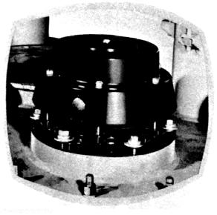
- — Pressure-relief device limits internal pressure to prevent tank rupture under internal fault conditions
    - Mechanical detection of faults
Two methods of detecting transformer faults other than by electric measurements exist:
- Accumulation of gases because of slow decomposition of the transformer insulation or oil. Also, these relays can detect heating because of high-resistance joints or because of high eddy currents between laminations.
- Increases in tank oil or gas pressures caused by internal transformer faults.
Relays that use these methods are valuable supplements to differential or other forms of protective relaying; particularly for grounding transformers and transformers with complicated circuits that are not well suited to differential protection. Two examples are regulating transformers and phase-shifting transformers. These mechanical relays might be more sensitive for certain internal faults than relays that depend upon electrical quantities. Therefore, gas accumulator and oil and gas pressure relays can be valuable in minimizing transformer damage because of internal faults.
      - Gas-accumulator relay
A gas-accumulator relay, commonly known as the Buchholz relay, applies only to transformers equipped with conservator tanks and with no gas space inside the transformer tank.
The relay is placed in the pipe from the main tank to the conservator tank and traps any gas that might rise through the oil. It operates for small faults by accumulating the gas over time, and for large faults that force the oil through the relay at a high velocity. This device detects a small volume of gas and accordingly can detect low-energy arcs. The accumulator portion of the relay is used frequently for alarming only. It might detect gas that is not the result of a fault, but rather produced by oil gassing during a sudden pressure reduction. This relay can detect heating because of high-resistance joints and high eddy currents between laminations.
      - Gas-detector relay
The gas-detector relay shown in Figure 9 is a special device used to detect and indicate an accumulation of gas from a transformer with a conservator tank, either conventional or sealed. Often the relay detects gas production from minor arcing before extensive damage occurs to the windings or core. This relay can detect heating because of high-resistance joints and high eddy current between laminations. These incipient winding faults and hot spots in the core normally generate small amounts of gas that are channeled to the top of the special domed cover. From there, gas bubbles enter the accumulation chamber of the relay through a pipe.
Essentially, the gas detector relay is a magnetic liquid-level gage with a float operating in an oil-filled chamber. The relay is mounted on the transformer cover with a pipe connection from the highest point of the cover to the float chamber. A second pipe connection from the float chamber is carried to an eye-level location on the tank wall. This connection is used for removing gas samples for analysis. The relay is equipped with a dial marked in cubic centimeters and a snap-action switch set to give an alarm when a specific amount of gas has been collected. Gas accumulation is indicated on the gage in cubic centimeters. An accumulation of gas of 100 cm³ to 200 cm³, for example, lowers a float and operates an alarm switch to indicate that an investigation is necessary. This gas can then be withdrawn for analysis and recording.
The rate of gas accumulation is a clue to the magnitude of the fault. If the chamber continues to fill quickly, with resultant operation of the relay, potential danger might justify removing the transformer from service.
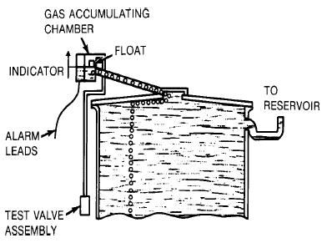
- — Gas-detector relay accumulates gases from top air space of transformer (used only on conservator tank units)
      - Static-pressure relay
The static-pressure relay can be used on all types of oil-immersed transformers. These relays are mounted on the tank wall under oil and respond to the static or total pressure. These relays have been superseded by the sudden-pressure relay, but many are in service on older transformers. However, because of susceptibility to operation for temperature changes or external faults, the majority of the static-pressure relays that are in service are connected for alarming only.
      - Sudden-pressure relays
Normally, sudden-pressure relays are used to isolate the transformer from the electrical system and to limit transformer damage when the transformer internal pressure rises abruptly. The rapid pressure rise occurs because an internal fault vaporizes the insulating liquid. Internal faults, such as internal shorted turns, ground faults, or winding-to-winding faults, can cause total transformer destruction. The gas bubble formed in the insulating liquid creates a pressure wave that activates the relay promptly.

The oil version of the sudden-pressure relay, shown in Figure 10, uses the insulating liquid to transmit the pressure wave to the relay bellows. Inside the bellows, special oil transmits the pressure wave to a piston that actuates a set of switch contacts. This type of relay is mounted on the transformer tank below oil level. (See 3.5.5.4.1.)
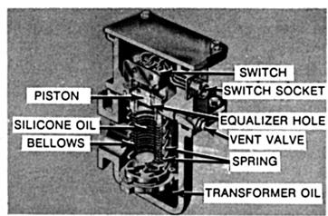
- — Sudden oil-pressure-rise relay mounted on transformer tank below normal oil level
Another type of sudden-pressure relay uses gas pressure. Figure 11 shows that the inert gas above the insulating liquid transmits the pressure wave to the relay bellows. Expansion of the bellows actuates a set of switch contacts. This type of relay is mounted on the transformer tank above oil level. (See 3.5.5.4.2.)
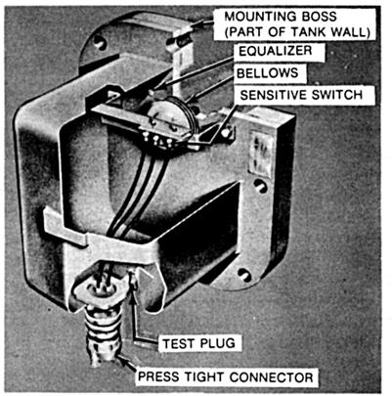
- —Sudden gas-pressure relay mounted on transformer tank above normal oil level
Both types of relays have a pressure-equalizing opening to prevent operation of the relay on gradual rises in internal pressure because of changes in loading or ambient conditions.
Both types of sudden-pressure relays are sensitive to the rate of rise in the internal pressure. The time for the relay switch to operate is approximately 4 cycles for high rates of pressure rise (172 kPa/s of oil pressure rise; 34.5 kPa/s of air pressure rise). These relays are insensitive to mechanical shock and vibration, to through faults, and to magnetizing inrush current.
The use of sudden-pressure relays increases as the size and value of the transformer increases. Most transformers 5,000 kVA and greater, are equipped with this type of device. This relay provides valuable protection at low cost.
        - Sudden oil-pressure relay
The sudden oil-pressure relay is applicable to all oil-immersed transformers and is mounted on the transformer tank wall below the minimum liquid level. Transformer oil fills the lower chamber of the relay housing within which a spring backed bellows is located. The bellows is completely filled with silicone oil and additional silicone oil in the upper chamber is connected to the oil in the bellows by two small equalizer holes.
A piston rests on the silicone oil in the bellows, but extends up into the upper chamber. It is separated from a switch by an air gap. Should an internal fault develop, the rapid rise in oil pressure or pressure pulse is transmitted to the silicone oil by the transformer oil and the bellows. This increased pressure then acts against the piston, which closes the air gap and operates the switch.
For small rises in oil pressure because of changes in loading or ambient temperature, for example, the increased pressure is also transmitted to the silicone oil. However, instead of operating the piston, this pressure is gradually relieved by oil that escapes from the bellows into the upper chamber by the equalizer holes. The bellows then contract slightly. The pressure bias on the relay is thus relieved by this differential feature. Relay sensitivity and response to a fault is thus independent of transformer-operating pressure.
This relay has proven sufficiently free from false operations to be connected for tripping in most applications. It is important that the relay be mounted in strict accordance with the manufacturer specifications. A scheme providing a shunt path around the 63X auxiliary-relay coil is preferred to prevent its operation because of surges. See Figure 12.
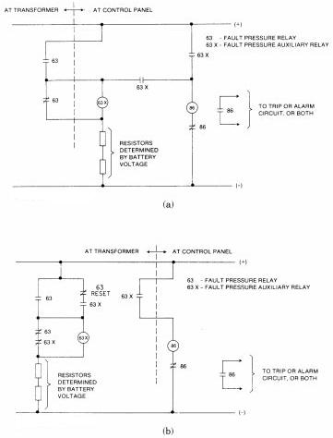
- — Fault pressure relay schemes (a) Auxiliary relay at control panel (b) Auxiliary relay at transformer with manual reset
        - Sudden gas-pressure relay
The sudden gas-pressure relay is applicable to all gas-cushioned oil-immersed transformers and is mounted in the region of the gas space. It consists of a pressure-actuated switch, housed in a hermetically sealed case and isolated from the transformer gas space except for a pressure-equalizing orifice.
The relay operates on the difference between the pressure in the gas space of the transformer and the pressure inside the relay. An equalizing orifice tends to equalize these two pressures for slow changes in pressure because of loading and ambient temperature change. However, a more rapid rise in pressure in the gas space of the transformer because of a fault results in operation of the relay. High-energy arcs evolve a large quantity of gas, which operates the relay in a short time. The operating time is longer for low-energy arcs.
This relay has proven sufficiently free from false operations to be connected for tripping in most applications. It is important that the relay be mounted in strict accordance with the manufacturer specifications.
        - Sudden gas/oil-pressure relay
A more recent design of the relays described in 3.5.5.4.1 and 3.5.5.4.2 is the sudden gas/oil-pressure relay, which utilizes two chambers, two control bellows, and a single sensing bellows. All three bellows have a common interconnecting silicone-oil passage with an orifice, and an ambient-temperature-compensating assembly is inserted at the entrance to one of the two control bellows. An increase in transformer pressure causes a contraction of the sensing bellows, which forces a portion of the silicone oil from that bellows into the two control bellows and expands these bellows.
An orifice limits the flow of oil into one control bellows to a fixed rate, while there is essentially no restriction to flow into the second control bellows. The two control bellows expand at a uniform rate for gradual rate of rise in pressure; but during high rates of transformer pressure rise, the orifice causes a slower rate of expansion in one bellows relative to the other. The dissimilar expansion rate between the two control bellows causes a mechanical linkage to actuate the snap action switch, which initiates the proper tripping.
      - Dissolved fault-gases detection device
The dissolved fault-gases detection device can be used for continuous monitoring of hydrogen. The instrument shown in Figure 13 is a special device (developed in 1975) used to detect fault gases dissolved in transformer mineral oil and to continually monitor their evolution. Thermal and electrical stresses break the insulation materials down, and gases are generated. These gases dissolve in oil. The materials involved and the severity of the fault determine the gases produced. The rate of production of these gases is dependent on the temperature of the fault and is indicative of the magnitude of the fault. These faults are normally not detected until these develop into larger and more damaging ones.
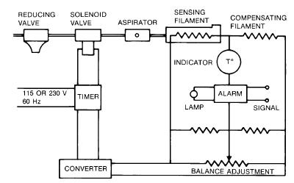
- — Combustible gas relay, which periodically samples gas in transformer to detect any minor internal fault before it can develop into a serious fault
The transformer incipient fault monitor measures the dissolved fault gases that are characteristic of the breakdown of the solid and liquid insulation materials. Hydrogen and other combustible gases diffusing through a permeable membrane are oxidized on a platinum gas-permeable electrode; oxygen from the ambient air is electrochemically reduced on a second electrode. The ionic contact between the two electrodes is provided by a gelled highly concentrated sulfuric acid electrolyte. The electric signal generated by this fuel cell is directly proportional to the total combustible gas concentration and is sent to a conditioning electric circuit. The resulting output signal is temperature compensated.
This device is easily retrofitted on existing transformers in the field or installed on transformers at the time of manufacture or repair. The sensor is installed on a valve on the transformer, and the electronics control is mounted on the transformer or on an adjacent structure. A digital display on the electronics control enclosure indicates the concentration of fault gases. Alarm levels are programmable and warn personnel when diagnostic or remedial actions are needed. The device can be connected to a data acquisition system to detect a deviation from a base and to monitor the rate of change.
This type of device is used on critical transformers; it reduces unplanned outages, provides for more predictable and reliable maintenance, and creates a safer work environment.
Gas-analysis equipment can be used to test the composition of gases in the transformers. By analyzing the percentage of unusual or decomposed gases in the transformer, a determination can be made about whether the transformer has a low-level fault and, if so, what type of fault had occurred.
  - Thermal detection of abnormalities
    - Causes of transformer overheating
Transformers can overheat because of the following:
- High ambient temperature
- Failure of cooling system
- External fault not cleared promptly
- Overload
- Abnormal system conditions, such as low frequency, high voltage, non-sinusoidal load current, or phase-voltage unbalance
    - Undesirable results of overheating
The consequences of overheating include the following:
- Overheating shortens the life of the transformer insulation in proportion to the duration of the high temperature and in proportion to the degree of the high temperature.
- Severe over-temperature might result in an immediate insulation failure.
- Severe over-temperature might cause the transformer coolant to heat above its flash temperature and result in fire.
    - Liquid temperature indicator (top oil)
The liquid temperature indicator shown in Figure 14 measures the temperature of the insulating liquid at the top of the transformer. Because the hottest liquid is less dense and rises to the top of the tank, the temperature of the liquid at the top partially reflects the temperature of the transformer windings and is related to the loading of the transformer.
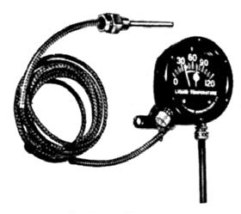
- — Liquid temperature indicator, the most common transformer temperature-sensing device
The thermometer reading is related to transformer loading only insofar as that loading affects the liquid temperature rise over ambient. Transformer liquid has a much longer time constant than the winding itself and responds slowly to changes in loading losses that directly affect winding temperature. Thus, the thermometer temperature warning varies between too conservative or too pessimistic, depending on the rate and direction of the change in loading. A high reading could indicate an overload condition.
The liquid temperature indicator is normally furnished as a standard accessory on power transformers. It is equipped with a temperature-indicating pointer and a drag pointer that shows the highest temperature reached since it was last reset.
The liquid temperature indicator can be equipped with one to three adjustable contacts that operate at preset temperatures. The single contact can be used for alarm. When forced air cooling is employed, the first contact initiates the first stage of fans. The second contact either initiates a second stage of fans, if furnished, or an alarm. The third contact, if furnished, is temperature-sensing device used for the final alarm or to initiate load reduction on the transformer. The indicated temperatures would change for different temperature insulation system designs.
Because the top-oil temperature might be considerably lower than the hot-spot temperature of the winding, especially shortly after a sudden load increase, the top-oil thermometer is not suitable for effective protection of the winding against overloads. However, where the transformer loss-of-life policy permits, tripping on top-oil temperature might be satisfactory. This approach has the added advantage of directly monitoring the oil temperature to ensure that it does not reach the flash temperature.
Similar devices are available for responding to air or gas temperatures in dry transformers. For unattended substations, these devices can be connected to central annunciators.
    - Thermal relays
Thermal relays, diagrammatically shown in Figure 15, are used to give a more direct indication of winding temperatures of either liquid or dry transformers. A CT is mounted on one of the three phases of the transformer bushing. It supplies current to the thermometer bulb heater coil, which contributes the proper heat to closely simulate the transformer hot-spot temperature.
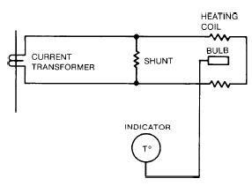
- — Thermal (or winding temperature) relay, which uses a heating element to duplicate effects of current in transformer
Monitoring of more than one phase is desirable if a reason exists to expect an unbalance in the three-phase loading.
The temperature indicator is a bourdon gauge connected through a capillary tube to the thermometer bulb. The fluid in the bulb expands or contracts proportionally to the temperature changes and is transmitted through the tube to the gauge. Coupled to the shaft of the gauge indicator are cams that operate individual switches at preset levels of indicated transformer temperature.
Thermal relays are most common on transformers rated 10,000 kVA and more. But these can be used on all sizes of substation transformers.
    - Hot-spot temperature thermometers
Hot-spot temperature equipment shown in Figure 16 is similar to the thermal relay equipment on a transformer because it indicates the hottest-spot temperature of the transformer. While the thermal relay works with fluid expansion and a bourdon gauge, the hot-spot temperature equipment works electrically using a Wheatstone bridge method.
In other words, it measures the resistance of a resistance temperature detector (RTD) that is responsive to transformer temperature changes and increases with higher temperature. Because this device can be used with more than one detector coil location, temperatures of several locations within the transformer can be checked. The location of the hottest spot within a transformer is predictable from the design parameters. A common practice is to measure or to simulate this hot-spot temperature and to base control action accordingly. The desired control action depends on the user philosophy, on the amount of transformer life the user is willing to lose for the sake of maintaining service, and the priorities the user places on other aspects of the problem. Transformer top-oil temperature can be used, with or without hot-spot temperature, to establish the desired control action.
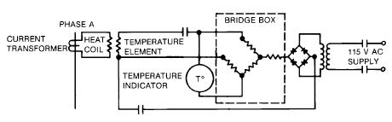
- — Hot-spot temperature indicator using the Wheatstone-bridge method to determine transformer temperature
A common method of simulating the hot-spot temperature is with a thermal relay responsive to both top-oil temperature and to the direct heating effect of load current. In these relays, the thermostatic element is immersed in the transformer top oil. An electric heating element is supplied with a current proportional to the winding current so that the responsive element tracks the temperature that the hot spot of the winding attains during operation. If this tracking is exact, the relay would operate at the same time that the winding reaches the set temperature. Because insulation deterioration is also a function of the duration of the high temperature, additional means are generally used to delay tripping action for some period.
One common method is to design the relay with a time constant longer than the time constant of the winding. Thus, the relay does not operate until some time after the set temperature has been attained by the winding. No standards have been established for this measuring technique, nor is information generally available to make an accurate calculation of the complete performance of such a relay. These relays can have one or more contacts that close at successively higher temperatures. With multiple contacts, the lowest level is commonly used to start fans or pumps for forced cooling, and the second level to initiate an alarm. The third step might be used for an additional alarm or to trip load breakers or to de-energize the transformer.
Another type of temperature relay is the replica relay. This relay measures the phase current in the transformer and applies this current to heater units inside the relay. Characteristics of these heaters approximate the thermal capability of the protected transformer. In the application of a replica relay, it is desirable to know the time constants of the iron, the coolant, and the winding. In addition, the relay should be installed in an ambient temperature approximately the same as the transformer ambient temperature and should not be ambient temperature compensated.
    - Forced-air cooling
Another means of protecting against overloads is to increase the transformer capacity by auxiliary cooling as shown in Figure 17. Forced-air-cooling equipment is used to increase the capacity of a transformer by 15% to 33% of base rating, depending upon transformer size and design. Refer to IEEE Std 141-1993. Dual cooling by a second stage of forced-air fans or a forced-oil system gives a second increase in capacity applicable to three phase transformers rated 12,000 kVA and more.
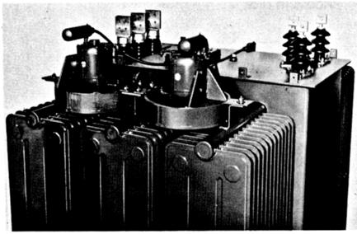
- — Forced-air fans, normally controlled automatically from a top oil temperature or winding temperature relay
Forced air cooling can be added later to increase the transformer capacity to take care of increased loads, provided that the transformer was ordered to have provisions for future fan cooling.
Auxiliary cooling of the insulating liquid helps keep the temperature of the windings and other components below the design temperature limits. Usually, operation of the cooling equipment is automatically initiated by the top oil temperature indicator or the thermal relay, after a predetermined temperature is reached.
    - Fuses or overcurrent relays
Other forms of transformer protection, such as fuses or overcurrent relays, provide some degree of thermal protection to the transformer. Application of these is discussed in 3.8.1.
    - Overexcitation protection
Overexcitation can be a concern on direct-connected generator unit transformers. Excessive excitation current leads directly to overheating of core and unlaminated metal parts of a transformer. Such overheating in turn causes damage to adjacent insulation and leads to ultimate failure. IEEE Std C57.12.00-2010 requires that transformers shall be capable of operating continuously at 10% greater than rated secondary voltage at no load without exceeding the limiting temperature rise. The requirement applies for any tap at rated frequency.
Direct-connected generator transformers are subjected to a wide range of frequency during the acceleration and deceleration of the turbine. Under these conditions the ratio of the actual generator terminal voltage to the actual frequency shall not exceed 1.1 times the ratio of transformer rated voltage to the rated frequency on a sustained basis:
(generator terminal voltage) / (actual frequency) ≤ 1.1 × (transformer rated voltage) / (rated frequency)
Generator manufacturers now recommend an overexcitation protection system as part of the generator excitation system. This system can also be used to protect the transformer against overexcitation. These systems might alarm for an overexcitation condition; and, if the condition persists, decrease the generator excitation or trip the generator and field breakers, or both. The generator and transformer manufacturers should be asked to provide their recommendation for overexcitation protection.
Overexcitation relays (i.e., V/Hz) can be used on transformers located either at or remote from generating stations. These are available with a definite time delay or an inverse-time overexcitation characteristic and might be connected for trip or alarm.
    - Nonlinear loads
Nonlinear electrical loads can cause severe overheating even when the transformer is operating below rated capacity. This overheating might cause failure of both the winding and the neutral conductor. Electronic equipment such as computers, printers, uninterruptible power supply (UPS) systems, variable-speed motor drives, and other rectified systems are nonlinear loads. Arc furnace and rectifier transformers also provide power to nonlinear loads.
For nonlinear loads, the load current is not proportional to the instantaneous voltage. This situation creates harmonic distortion on the system. Even when the input voltage is sinusoidal, the nonlinear load makes the input voltage nonsinusoidal. Harmonics are integral multiples of the fundamental frequency. For a 60 Hz system, the second harmonic is 120 Hz, the third harmonic is 180 Hz, the fifth is 300 Hz, etc. When incoming ac is rectified to dc, the load current is switched on for part of a cycle. This switching produces harmonics that extend into the radio frequency range. Nonlinear loads were formerly a small proportion of the total load and had little effect on system design and equipment, but this is no longer true.
The nonlinear load causes transformer overheating in three ways:
- Hysteresis. Hysteresis causes excessive heating in the steel laminations of the iron core because of the higher frequency harmonics. These harmonics produce greater magnetizing losses (or hysteresis) than normal 60 Hz losses because the magnetic reversals because of harmonics are more rapid than are the fundamental 60 Hz reversals.
- Eddy currents. Heating is produced when the high-frequency harmonic magnetic fields induce currents to flow through the steel laminations. This event occurs when the high-frequency harmonic magnetic field cuts through the steel laminations. These currents (called eddy currents) flow through the resistance of the steel and generate I²R heating losses. These losses are also greater than normal 60 Hz losses because of the higher frequencies.
- Skin effect. Heating is also produced in the winding conductors because of skin effect. Skin effect causes the higher frequency harmonic currents to flow on the outer portion of the conductor and thus reduce the effective cross-sectional area of the conductor. This reaction causes an increase in resistance, which results in more conductor heating than for the same 60 Hz current.
Overheating of neutral conductors from nonlinear loads is because of the following:
- Zero-sequence and odd-order harmonics. Zero-sequence and odd-order harmonics are additive in the neutral and can be as high as three times the 60 Hz magnitude. Odd-order harmonics are odd multiples of the fundamental (third, fifth, seventh, ninth, eleventh). Zero-sequence harmonics are all the odd multiples of the third harmonic (third, ninth, fifteenth).
- Skin effect. Skin effect causes the higher frequency harmonic currents to flow on the outer portion of the conductor and thus reduce the effective cross-sectional area of the conductor. This reaction causes an increase in resistance, which results in more conductor heating than for the same 60 Hz current.
Failures of transformers because of nonlinear loads can be prevented by derating the transformer. In some cases the neutral conductor might need to be larger (twice the size of the phase conductor rating) to prevent its failure. True root-mean-square (rms) meters, relays, and circuit breaker tripping devices that can sense not needed harmonics should be selected.
Transformers that have a K-factor rating can be used with nonlinear loads within their rating. The K factor is a numerical value that takes into account both the magnitude and the frequency of the components of a current waveform. It is equivalent to the sum of the squares of the harmonic current multiplied by the square of the harmonic order of the current. True rms current meters should be used to determine the per-unit value of each harmonic.
K factor = I_{h}²h²
Where
I² is the per-unit rated rms load current at harmonics h
h is the harmonic order
The K-factor rating indicates the amount of harmonic content the transformer can handle while remaining within its operating temperature limits.
  - Transformer primary protective device
A fault on the electrical system at the point of connection to the transformer can arise from failure of the transformer (internal fault) and from abnormal conditions on the circuit connected to the transformer secondary, such as a short circuit (a “through fault”). The predominant means of clearing such faults is a current-interrupting device on the primary side of the transformer, such as fuses, a circuit breaker, or a circuit switcher. Whatever the choice, the primary-side protective device should have an interrupting rating adequate for the maximum short-circuit current that can occur on the primary side of the transformer.
If a circuit switcher is used, it should be relayed so that it is called upon only to clear lower current internal or secondary faults that are within its interrupting capability. Instantaneous relays used to protect transformer feeders and high-voltage windings are set greater than the maximum asymmetrical through-fault current on the transformer secondary. The operating current of the primary protective device should be less than the short-circuit current of the transformer as limited by the combination of system and transformer impedance. This recommendation is true for a fuse or a time-overcurrent relay. The point of operation should not be so low, however, to cause circuit interruption because of the inrush excitation current of the transformer or normal current transients in the secondary circuits. Of course, any devices operating to protect the transformer by detecting abnormal conditions within the transformer and removing it from the system also operate to protect the system; but these devices are subordinate to the primary protection of the transformer.
  - Protecting the transformer from electrical disturbances
Transformer failures arising from abusive operating conditions are caused by the following:
- Continuous overloading
- Short circuits
- Ground faults
- Transient overvoltages
    - Overload protection
An overload causes a rise in the temperature of the various transformer components. If the final temperature is greater than the design temperature limit, deterioration of the insulation system occurs and causes a reduction in the useful life of the transformer. The insulation might be weakened so that a moderate overvoltage might cause insulation breakdown before expiration of expected service life. Transformers have certain overload capabilities that vary with ambient temperature, preloading, and overload duration. These capabilities are defined in ANSI C57.92-2000 and IEEE Std C57.96-1999. When the temperature rise of a winding is increased, the insulation deteriorates more rapidly, and the life expectancy of the transformer is shortened.
Protection against overloads consists of both load limitation and overload detection. Loading on the transformers can be limited by designing a system where the transformer capacity is greater than the total, assumed diversified, connected load. This method of providing overload protection is expensive because load growth and changes in operating procedures would quite often eliminate the extra capacity needed to achieve this protection. Common engineering practice is to size the transformer at about 125% of the present load to allow for system growth and change in the diversity of loads. The specification of a lower-than-ANSI temperature rise also permits an overload capability.
Load limitation by disconnecting part of the load can be done automatically or manually. Automatic load shedding schemes, because of cost, are restricted to larger units. However, manual operation is often preferred because it gives greater flexibility in selecting the expendable loads.
In some instances, load growth can be accommodated by specifying cooling fans or providing for future fan cooling.
The major method of load limitation that can be properly applied to a transformer is one that responds to transformer temperature. By monitoring the temperature of the transformer, overload conditions can be detected. A number of monitoring devices that mount on the transformer are available as standard or optional accessories. These devices are normally used for alarm or to initiate secondary protective device operation. These include the devices described in 3.8.1.1 and 3.8.1.2.
      - Overcurrent relays
Transformer overload protection can be provided by relays. IEEE 3004.2 describes overcurrent protective-relay construction characteristics and ranges. These relays are applied in conjunction with CTs and a circuit breaker or circuit switcher sized for the maximum continuous and interrupting duty requirements of the application. A typical application is shown in Figure 18.
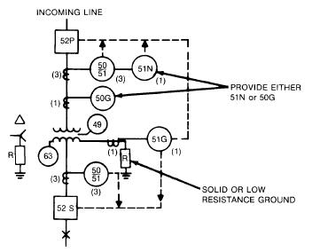
- — Overcurrent relays, frequently used to provide transformer protection in combination with primary circuit breaker or circuit switcher
Overcurrent relays are selected to provide a range of settings greater than the permitted overloads and instantaneous settings when possible within the transformer through-fault current withstand rating. The characteristics should be selected to coordinate with upstream and downstream protective devices.
The settings of the overcurrent relays should meet the requirements of applicable standards and codes and meet the needs of the power system. The requirements in the National Electrical Code® (NEC®) (NFPA 70-2011) represent upper limits that should be met when selecting overcurrent devices. These requirements, however, are not guidelines for the design of a system providing maximum protection for transformers. For example, setting a transformer primary or secondary overcurrent protective device at 2.5 times rated current could allow that transformer to be damaged without the protective device operating.
      - Fuses, circuit breakers, and fused switches
The best protection for the transformer is provided by circuit breakers or fuses on both the primary side and secondary side of the transformer when these are set or selected to operate at minimum values. Common practice is for the secondary-side circuit breaker or fuses to protect the transformer for loading in excess of 125% of maximum rating.
Using a circuit breaker on the primary of each transformer is expensive, especially for small capacity and less expensive transformers. An economical compromise is where one circuit breaker is installed to feed two to six relatively small transformers. Each transformer has its own secondary circuit breaker and, in most cases, a primary disconnect. Overcurrent protection should satisfy the requirements prescribed by the NEC.
The major disadvantage of this system is that all of the transformers are de-energized by the opening of the primary circuit breaker. Moreover, the rating or setting of a primary circuit breaker selected to accommodate the total loading requirements of all of the transformers would typically be so large that only a small degree of secondary-fault protection, and almost no backup protection, would be provided for each individual transformer.
By using fused switches on the primary of each transformer, short-circuit protection can be provided for the transformer and additional selectivity provided for the system. Using fused switches and time-delay dual-element fuses for the secondary of each transformer allows close sizing (typically 125% of secondary full-load current) and gives excellent overload and short-circuit protection for 600 V or less applications.
    - Short-circuit current protection
In addition to thermal damage from prolonged overloads, transformers are also adversely affected by internal and external short-circuit conditions that can result in internal electromagnetic forces, temperature rise, and arc-energy release.
Ground faults occurring in the substation transformer secondary and between the transformer secondary and main secondary protective device cannot be isolated by the main secondary protective device, which is located on the load side of the ground fault. These ground faults, when limited by a neutral grounding resistor, might not be seen by either the transformer primary fuses or transformer differential relays. These can be isolated only by a primary circuit breaker or other protective device tripped by either a ground relay in the grounding resistor circuit or a ground differential relay. A ground differential relay can consist of a simple overcurrent relay, connected to a neutral ground CT and the residual circuit of the transformer line CTs fed through a ratio matching auxiliary CT. Because this scheme is subject to error on through faults because of unequal CT saturation, a relay with phase restraint might be used instead of a simple overcurrent relay.
Secondary-side short circuits (through faults) can subject the transformer to short-circuit current magnitudes limited only by the sum of transformer and supply-system impedance. Hence, transformers with unusually low impedance might experience extremely high short-circuit currents and incur mechanical damage. Prolonged flow of a short-circuit current of lesser magnitude can also inflict thermal damage.
Protection of the transformer for both internal and external faults should be as rapid as possible to keep damage to a minimum. However, protection speed might be reduced by selective-coordination system design and operating procedure limitations.
Several mechanical sensing devices are available that provide varying degrees of short-circuit protection. These devices sense two different aspects of a short circuit. The first group of devices senses the formation of gases consequent to a fault and are used to detect internal faults. The second group senses the magnitude or the direction of the short-circuit current, or both, directly.
The gas-sensing devices include pressure-relief devices, rapid pressure rise relays, gas detector relays, and combustible-gas relays. The current-sensing devices include fuses, overcurrent relays, differential relays, and network protectors.
      - Gas-sensing devices
Low-magnitude faults in the transformer cause gases to be formed by the decomposition of insulation exposed to high temperature at the fault. Detection of the presence of these gases can allow the transformer to be taken out of service before extensive damage occurs. In some cases, gas can be detected a long time before the unit fails.
High-magnitude fault currents are usually first sensed by other detectors, but the gas-sensing device responds with modest time delay. These devices are described in detail in Section 3.5.
      - Current-sensing devices
Fuses, overcurrent relays, and differential relays should be selected to provide the maximum degree of protection to the transformer. These protective devices should operate in response to a fault before the magnitude and duration of the overcurrent exceed the short-time loading limits recommended by the transformer manufacturer. In the absence of specific information applicable to an individual transformer, protective devices should be selected in accordance with applicable guidelines for the maximum permissible transformer short-time loading limits. Curves illustrating these limits for liquid-immersed transformers are discussed in 3.8.2.2.1. In addition, ratings or settings of the protective devices should be selected in accordance with pertinent provisions of Chapter 4 of NEC Article 450.
        - Transformer through-fault capability

Through-fault failures were a major industry concern during the 1970s and 1980s when the industry experienced an unusually large number of through-fault failures because of design deficiencies. As a result, the IEEE Transformer Committee developed guidelines (C57.12.00-2000) for the duration and frequency of transformer through-faults. The multiples of normal current in Fig. 19 through Fig. 22 are based on the self-cooled rating of the transformer being 1.0 pu base current. These curves should be used when developing time-overcurrent settings in protective relays.
Through-fault effects on transformer failure are mitigated at medium-voltage industrial installations because most through-faults are line-to-ground faults. In addition, fault current is limited to the range of 200–400 A through grounding resistors in the transformer neutral.
Overcurrent protective devices such as fuses and relays have well-defined operating characteristics that relate fault-current magnitude to operating time. The characteristic curves for these devices should be coordinated with comparable curves, applicable to transformers, which reflect their through-fault withstand capability. Such curves for Category I, Category II, Category III, and Category IV liquid-immersed transformers (as described in IEEE Std C57.12.00-2010) are presented in this subclause as through-fault protection curves.
The through-fault protection curve values are based on winding-current relationships for a three-phase secondary fault and might be used directly for delta-delta- and wye-wye-connected transformers. For delta-wye-connected transformers, the through-fault protection curve values should be reduced to 58% of the values shown to provide appropriate protection for a secondary-side single phase-to-neutral fault.
Damage to transformers from through faults is the result of thermal and mechanical effects. The latter have gained increased recognition as a major cause of transformer failure. Although the temperature rise associated with high-magnitude through faults is typically acceptable, the mechanical effects are intolerable if such faults are permitted to occur with any regularity. This possibility results from the cumulative nature of some of the mechanical effects, particularly insulation compression, insulation wear, and friction-induced displacement. The damage that occurs as a result of these cumulative effects is, therefore, a function of not only the magnitude and duration of through faults, but also the total number of such faults.
The through-fault protection curves presented in IEEE Std C57.12.00-2010 take into consideration the fact that transformer damage is cumulative, and the number of through faults to which a transformer can be exposed is inherently different for different applications. For example, transformers with secondary-side conductors enclosed in conduit or isolated in some other fashion, such as transformers typically found in industrial, commercial, and institutional power systems, experience an extremely low incidence of through faults. In contrast, transformers with overhead secondary-side lines, such as transformers found in utility distribution substations, have a relatively high incidence of through faults. Also, the use of reclosers or automatic reclosing circuit breakers can subject the transformer to repeated current surges from each fault. Thus, for a given transformer in these two different applications, a different through-fault protection curve should apply, depending on the type of application.
For applications in which faults occur infrequently, the through-fault protection curve should reflect primarily thermal damage considerations because cumulative mechanical-damage effects of through faults would not be a problem. For applications in which faults occur frequently, the through-fault protection curve reflects the fact that the transformer is subjected to both thermal and cumulative-mechanical damage effects of through faults.
In using the through-fault protection curves to select the time-current characteristics (TCCs) of protective devices, the protection engineer should take into account not only the inherent level of through-fault incidence, but also the location of each protective device and its role in providing transformer protection. For substation transformers with secondary-side overhead lines, the secondary-side feeder protective equipment is the first line of defense against through faults; therefore, its TCCs should be selected by reference to the frequent-fault-incidence protection curve. More specifically, the TCCs of feeder protective devices should be below and to the left of the appropriate frequent-fault-incidence protection curve.
Secondary-side main protective devices (if applicable) and primary-side protective devices typically operate to protect against through faults in the rare event of a fault between the transformer and the feeder protective devices, or in the equally rare event that a feeder protective device fails to operate or operates too slowly because of an incorrect (i.e., higher) rating or setting. The TCCs of these devices, therefore, should be selected by reference to the infrequent-fault-incidence protection curve. In addition, these TCCs should be selected to achieve the desired coordination among the various protective devices.
In contrast, transformers with protected secondary conductors (cable, bus duct, switchgear) experience an extremely low incidence of through faults. Hence the feeder protective devices can be selected by reference to the infrequent-fault-incidence protection curve. The secondary-side main protective device (if applicable) and the primary-side protective device should also be selected by reference to the infrequent-fault-incidence protection curve. Again, these TCCs should also be selected to achieve the desired coordination among the various protective devices.
For Category I transformers (i.e., 5-500 kVA single-phase, 15-500 kVA three-phase), a single through-fault protection curve applies (see Figure 19). This curve can be used for selecting protective device TCCs for all applications, regardless of the anticipated level of fault incidence.
For Category II transformers (i.e., 501-1,667 kVA single-phase, 501-5,000 kVA three-phase), and Category III transformers (i.e., 1,668-10,000 kVA single-phase, 500-30,000 kVA three phase), two through-fault protection curves apply (see Figure 20 and Figure 21, respectively). The left-hand curve in both figures reflects both thermal and mechanical damage considerations and can be used for selecting feeder protective device TCCs for frequent-fault-incidence applications. The right-hand curve in both figures reflects primarily thermal damage considerations and can be used for selecting feeder protective device TCCs for infrequent-fault-incidence applications. Also, these curves can be used for selecting secondary-side main protective device (if applicable) and primary-side protective device TCCs for all applications, regardless of the anticipated level of fault incidence.
The smaller Category III transformers through-fault standards are defined by two sets of curves―one for frequent faults and one for infrequent faults. This was done because of the use of this size of transformer for utility distribution substation applications, which subjects these transformers to frequent through-faults and multiple automatic reclosing attempts. See Figure 23.
For Category IV transformers (i.e., greater than 10,000 kVA single-phase, greater than 30,000 kVA three phase), a single through-fault protection curve applies (see Figure 22). This curve reflects both thermal and mechanical damage considerations and can be used for selecting protective device TCCs for all applications, regardless of the anticipated level of fault incidence.
The aforementioned delineation of infrequent- versus frequent-fault-incidence applications for Category II and Category III transformers can be related to the zone or location of the fault. The requirements for Category III (5–30 MVA) and Category IV (above 30 MVA) transformers are shown in Fig. 21 and Fig. 22.

Because overload protection is a function of the secondary-side protection, the primary-side protective device characteristic curve can cross the through-fault protection curve at lower current levels. (Refer to transformer loading guides IEEE Std C57.91-1995 and ANSI C57.92-2000.) Efforts should be made to have the primary-side protective device characteristic curve intersect the through-fault protection curve at as low a current as possible in order to maximize the degree of backup protection for the secondary-side devices.
For additional discussion see Appendix A of ANSI C37.91- 2008. Similar information and through-fault protection curves can be found in IEEE Std C57.109-1993, and in IEEE Std C57.12.00-2010. The following discussion is based on these two standards.

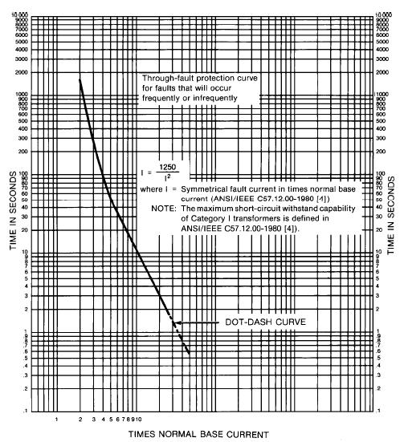
- —Through-fault protection curve for liquid-immersed Category I transformers (5–500 kVA single-phase, 15–500 kVA three-phase)
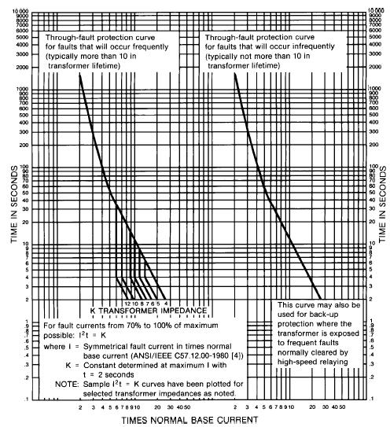
- — Through-fault protection curves for liquid-immersed Category II transformers (501–1,667 kVA single-phase, 501–5,000 kVA three-phase)
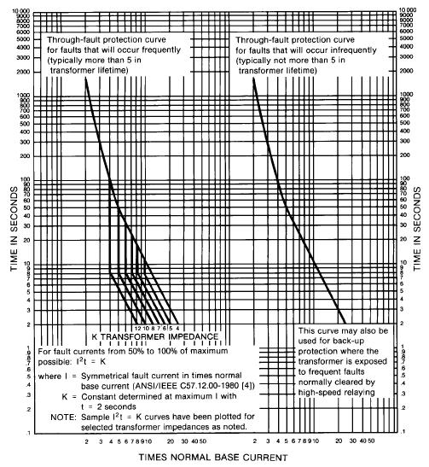
- — Through-fault protection curves for liquid-immersed Category III transformers (1,668–10,000 kVA single-phase, 5,001–30,000 kVA three-phase)
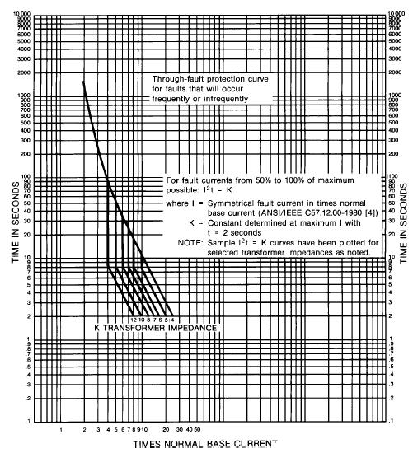
- — Through-fault protection curve for liquid-immersed Category IV transformers (greater than 10,000 kVA single-phase, greater than 30,000 kVA three-phase)
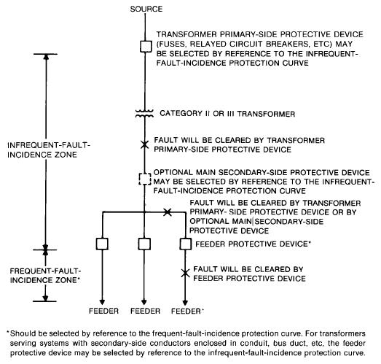
- — Infrequent- and frequent-fault-incidence zones for liquid-immersed Category II and Category III transformers
        - Fuses
Fuses utilized on the transformer primary are relatively simple and inexpensive one-time devices that provide short-circuit protection for the transformer. Fuses are normally applied in combination with interrupter switches capable of interrupting full-load current. By using fused switches on the primary where possible, short-circuit protection can be provided for the transformer, and a high degree of system selectivity can also be provided.
Fuse selection considerations include having:
- An interrupting capacity equal to or higher than the system fault capacity at the point of application.
- A continuous-current capability greater than the maximum continuous load under various operating modes
- TCCs that pass, without fuse operation, the magnetizing and load-inrush currents that occur simultaneously following a momentary interruption, but interrupt before the transformer withstand point is reached
Fuses so selected can provide protection for secondary faults between the transformer and the secondary-side overcurrent protective device and provide backup protection for the latter.
The magnitude and duration of magnetizing inrush currents vary between different designs of transformers. Inrush currents of 8 or 12 times normal full-load current for 0.1 s are commonly used in coordination studies.
Overload protection can be provided when fuses are used by utilizing a contact on the transformer temperature indicator to shed nonessential load or trip the transformer secondary-side overcurrent protective device.
When the possibility of backfeed exists, the switch, the fuse access door, and the transformer secondary main overcurrent protective device should be interlocked to ensure the fuse is deenergized before being serviced.
Relay-protected systems can provide low-level overcurrent protection. Relay protection systems and fused interrupter switches can provide protection against single-phase operation when an appropriate open-phase detector is used to initiate opening of a circuit breaker or interrupter switch if an open-phase condition should occur.
        - Overcurrent relay protection
Overcurrent relays can be used to clear the transformer from the faulted bus or line before the transformer is damaged. On some small transformers, overcurrent relays can protect also for internal transformer faults. On larger transformers, overcurrent relays might be used to provide backup for differential or pressure relays.
          - Time-overcurrent relays
Time-overcurrent relays applied on the primary side of a transformer provide protection for transformer faults in the winding, and provide backup protection for the transformer for secondary-side faults. These provide limited protection for internal transformer faults because sensitive settings and fast operation are usually not possible. Insensitive settings result because the pickup value of phase-overcurrent relays must be high enough to take advantage of the overload capabilities of the transformer and be capable of withstanding energizing inrush currents. Fast operation is not possible because these must coordinate with load-side protection. Settings of phase-overcurrent relays on transformers involve a compromise between the requirements of operation and protection.
Using only time-overcurrent protection can result in extensive damage to the transformer from an internal fault. If only overcurrent protection is applied to the high-voltage delta side of a delta-wye-grounded transformer, it can have a problem providing sensitive fault protection for the transformer. For low-voltage (wye-side) line-to-ground faults, the high-side line current is only 58% of the low-voltage per-unit fault current. When the wye is grounded through a resistor, the high-side fault current might be less than the maximum transformer load current. Differential protection (3.8.2.2.4) solves this problem.
The time setting should coordinate with relays on downstream equipment. However, transformers are mechanically and thermally limited in their ability to withstand short-circuit current for finite periods. For proper backup protection, the relays should operate before the transformer is damaged by an external fault. (Refer to the transformer through-fault current duration limits.)
When overcurrent relays are also applied on the secondary side of the transformer, these relays are the principal protection for transformer secondary-side faults. However, overcurrent relays applied on the secondary side of the transformer do not provide protection for the transformer winding faults, unless the transformer is backfed.
When setting transformer overcurrent relays, the short-time overload capability of the transformer in question should not be violated. (See IEEE Std C57.91-1995 and ANSI C57.92-2000 for allowable short-time durations, which might be different from the durations in the through-fault current duration curves.) The manufacturer should be consulted for the capability of a specific transformer.
          - Instantaneous overcurrent relays
Phase instantaneous overcurrent relays provide short-circuit protection to the transformers in addition to overload protection. When used on the primary side, these usually coordinate with secondary protective devices. Fast clearing of severe internal faults can be obtained. The setting of an instantaneous relay is selected on its application with respect to secondary protective devices and circuit arrangements. Such relays are normally set to pick up at a value higher than the maximum asymmetrical through-fault current. This value is usually the fault current through the transformer for a low-side three-phase fault. For instantaneous units subject to transient overreach, a pickup setting of 175% of the calculated maximum low-side three-phase symmetrical fault current generally provides sufficient margin to avoid false tripping for a low-side bus fault, while still providing protection for severe internal faults. (Variations in pickup settings of 125% to 200% are common.) For instantaneous units with negligible transient overreach, a lesser margin can be used. The settings in either case shall also be greater than the transformer inrush current to prevent nuisance tripping. In some cases, instantaneous trip relays cannot be used because the necessary settings are greater than the available fault currents. In these cases, a harmonic restraint instantaneous relay might be considered to provide the desired protection.
          - Tertiary winding overcurrent relays
The tertiary winding of an autotransformer, or three-winding transformer, is usually of much smaller kVA rating than the main windings. Therefore, fuses or overcurrent relays set to protect the main windings offer almost no protection to such tertiaries. During external system ground faults, these tertiary windings might carry very heavy currents.
The method selected for protecting the tertiary generally depends on whether the tertiary is used to carry load. If the tertiary does not carry load, protection can be provided by a single overcurrent relay connected to a CT on the tertiary winding. This relay senses system grounds and also phase faults in the tertiary or in its leads.
If the tertiary is used to carry load, partial protection can be provided by a single overcurrent relay supplied by three CTs, one in each winding of the tertiary and connected in parallel to the relay. This connection provides zero-sequence protection, but does not protect for positive- and negative-sequence overload current. The relay operates for system ground faults, but does not operate for phase faults in the tertiary or its leads. This relay needs to be set to coordinate with other system relays.
        - Differential relays
          - Phase differential relays
Differential protection compares the sum of currents entering the protected zone to the sum of currents leaving the protected zone; these sums should be equal. If more than a certain amount or percentage of current enters than leaves the protected zone, a fault is indicated in the protected zone; and the relay operates to isolate the faulted zone. Typically, differential protection is applied to transformers at 5 MVA and larger.
Transformer differential relays operate on a percentage ratio of input current to through current; this percentage is called the slope of the relay. A relay with 25% slope operates when the difference between the incoming and outgoing currents is greater than 25% of the through current and higher than the relay minimum pickup.
The fault-detection sensitivity of differential relays is determined by a combination of relay setting and circuit parameters. For most high-speed transformer differential relays, the relay pickup is about 30% of the tap setting. Depending on the setting, sensitivity is about 25% to 50% of full-load current. For delta-wye-connected transformers that supply low-resistance grounded systems, phase differential relays should be supplemented with secondary ground differential relays (Device 87TG), as shown in Figure 24, to provide additional sensitivity to secondary ground faults. For delta-zigzag transformers multiple ground sources might be present and the second ground should be protected similarly. For more details on application of Device 87TG, refer to IEEE 3004.6 on ground-fault protection.
The protection for a single-phase transformer is shown in Figure 25, although most transformer differential relay applications would apply to three-phase transformers of 5 MVA and larger.
In Figure 25, two restraining windings and one operating coil are shown. The CT ratios are selected to produce essentially equal secondary currents so that, under a no-fault condition, the CT secondary current entering one restraining circuit continues through the other restraining circuit, with no differential current to pass through the operating circuit. Because of ratio mismatches in CTs and relay tap settings, some current might always exist in the operating circuit under a no-fault condition.
When a fault is internal to the differential relay zone, definite quantities of current flow into the operating circuit. The relay then responds to this differential current based on the ratio of the operating current to the restraining currents. The relay operates to trip when this ratio exceeds the slope setting and is greater than the relay minimum sensitivity. (Ratio settings of 15%, 25%, 30%, or 40% are usually available.)
The three-phase connection shown in Figure 26 illustrates a typical application for protection of a three-phase transformer. The transformer is connected wye-delta: this configuration is selected generally to provide an ungrounded secondary connection while permitting the primary wye neutral to be grounded solidly. Other configurations would be reversed, and the grounded wye would be the secondary connection. Delta-wye and wye-delta connections produces a phase shift between current entering the primary and current leaving the secondary. For this reason, the CTs on the wye side have their secondaries connected in delta, and the CTs on the delta side have their secondaries connected in wye. Some solid state and digital relays can accomplish this compensation internally. Zigzag transformers produce anywhere from 0–360 degree phase shifts for which relays or with external CT configuration must compensate.
Several considerations are involved in applying differential relays:
a) The system should be designed so that the relays can operate a transformer primary circuit breaker. If a remote circuit breaker is to be operated, a remote trip system should be used (a pilot wire, a high-speed grounding switch). Often the utility controls the remote circuit breaker and might not allow tripping. Operation of a user-owned local primary circuit breaker presents no problem.
b) CTs associated with each winding often have different ratios, ratings, and excitation characteristics when subjected to heavy loads and short circuits. Multi-ratio CTs and relay taps can be selected to compensate for ratio differences. A less preferable but acceptable method is to use auxiliary transformers.
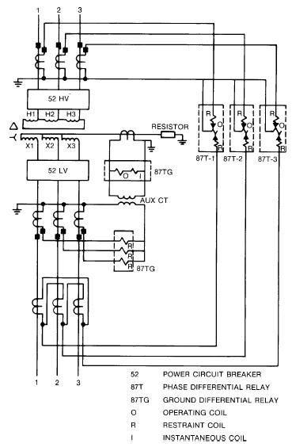
- — Transformer phase and ground differential relay CT and current-coil connections
c) Transformer taps can be operated changing the effective turns ratio. By selecting the ratio and taps for midrange, the maximum unbalance will be equivalent to half the transformer tap range.
d) CTs of the same make and type are recommended to minimize error current because of the different CT characteristics.
e) Magnetizing inrush current appears as an internal fault to the differential relays. The relays should be desensitized to the inrush current, but these should be sensitive to short circuits within the protection zone during the same period. This goal can be accomplished using relays with harmonic restraint. The magnetizing current inrush has a large harmonic component, which is not present in short-circuit currents. This feature permits harmonic-restraint relays to distinguish between faults and inrush.
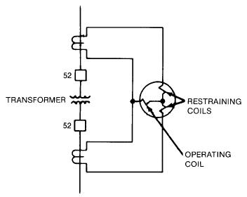
- — Percentage differential relays, which provide increased sensitivity while minimizing false operation as a result of CT mismatch errors for heavy through faults
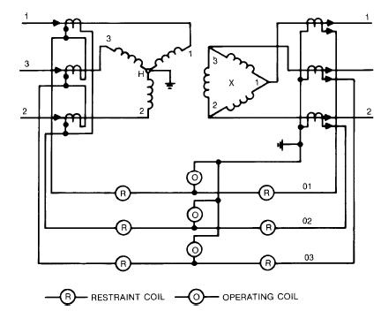
- — Typical schematic connections for percentage differential protection of a wye-delta transformer
f) Transformer connections often introduce a phase shift between high- and low-voltage currents. With electromechanical relays proper CT connections compensate for this shift. For a delta-primary, wye-secondary transformer, CTs are normally wye connected in the primary and delta connected in the secondary. Zigzag phase shifts can be anywhere between 0-360 degrees.
Many solid state and digital relays can internally compensate for phase shift so all CTs in wye is becoming common.
g) Heavy currents for faults outside the zone of protection can cause an unbalance between the CTs. Percentage differential relays shown in Figure 25, which operate when the difference is greater than a definite percentage of the phase current, are designed to overcome this problem. Percentage differential relays also help in solving the tap-changing problem and the CT ratio balance problem. Percentage slopes vary by manufacturer, but are generally available from 15% to 60%. A slope of 15% is normally used for standard transformers, 25% for load tap-changing transformers, and 40% to 60% for special applications. Guidelines are provided in IEEE 3004.2 on selecting the slope. Harmonic-restraint percentage differential relays are recommended for transformers rated 5 MVA and larger.
Unlike the differential relays applied to protect high-voltage buses or large motors, the transformer differential relay application has both harmonics and phase shift to consider. Although all transformer differential relays do not include harmonic filters, the use of harmonic filters is beneficial and faster acting, and these permit more sensitive pickups.
h) A delta-wye, or wye-delta, or zigzag transformer with the neutral grounded is a source (i.e., generator) of zero-sequence (or ground) fault current. A ground fault on the wye or zigzag side of the transformer, external to the differential protective zone, causes zero-sequence currents to flow in the CTs on the wye/zigzag side of the transformer without corresponding current flow in the line CTs on the delta side of the transformer. If these zero-sequence currents are allowed to flow through the differential relays, these cause immediate undesired tripping. To prevent such undesired tripping, the CT connections should cause the zero-sequence currents to flow in a closed-delta CT secondary connection of low impedance instead of in the differential relay operating coil. This goal is readily accomplished by connecting the CT secondary in delta on the wye side of the transformer. Some digital relays have algorithms to subtract the zero-sequence content from the operate current and eliminate the need for delta connected CTs.
In addition to the phase shift, which is easily corrected, the magnitudes of the secondary currents rarely match when standard CT ratios are employed. To compensate for this tendency, most percentage differential relays have selectable auto transformer taps at the input of each restraining winding. By following the relay instructions, the best match can be made so that the current in the no-fault operating coil is minimized. In some cases where high-voltage switchyards are involved, the available relay adjustments on electromechanical relays are inadequate, because of the limited tap range available. Therefore, auxiliary CTs or autotransformers are needed. This configuration should be attempted only after a thorough examination of the effects of through faults and secondary burdens upon the primary CTs.
Solid-state and digital relays typically have a wide tap range (10 to 1) with incremental selectivity that allows reduced mismatch to below 2%. This setup eliminates the need for auxiliary or autotransformers.
Assuming that CT ratio and phase shift problems can be resolved, a transformer secondary might often be connected to more than one bus. In that event, a separate restraining winding is required for each such bus. Paralleling CT secondaries in place of multiple restraining windings can lead to misoperation on through faults if the secondary buses are strong fault current sources. If these are only weak sources, then paralleled CT secondaries are acceptable.
Harmonics in the primary circuit can develop during transformer energization, during overvoltage periods, and during through faults. The harmonics could cause differential relay misoperation if not recognized. For the most part, zero-sequence harmonics (third, ninth) are excluded from the relays by the CT secondary connection.
The second harmonic and some relays with higher harmonics (fifth, seventh, eleventh, thirteenth) are filtered for a restraint signal. The filtered harmonics are applied to the restraining winding when the magnitude of the second harmonic exceeds 7.5% to 20% of the fundamental current. The lower percentage is beneficial during normal no-fault conditions because it provides larger restraining action, but the lower percentage setting makes the relay less sensitive on an internal fault.
          - Ground differential relays
Protection of the transformer by percentage differential relays improves the overall effectiveness in detecting phase-to-phase internal faults. However, line-to-ground faults in a wye winding might not be detected if the transformer is low-resistance-grounded where ground fault current is limited to a low value below the differential relay pickup level. Such ground faults might evolve into to a destructive phase-to-phase fault. Some industrial engineers do not understand that phase differential protection alone does not provide the level of sensitivity to detect faults over the entire wye winding. A significant portion of the wye winding near the neutral will not be protected if only phase differential is applied. Even for ground faults on the transformer wye terminal, additional sensitivity is required where ground fault current is limited to 200–400A range.
A protection scheme for low-resistance grounded system is shown in Figure 24. Where the transformer is solidly grounded, the transformer differential relay operates for ground faults within the differential protective zone.
Two methods can be easily adapted for protecting the wye winding more effectively. Figure 27 illustrates one approach that employs an overcurrent relay in a differential connection. The zero-sequence currents are shown for an external fault. Properly connected, the secondary current circulates for this external fault, but would be additive for an internal fault and cause Device 51G to operate. The method shown in Figure 27 is susceptible to through faults that might saturate the phase CTs and cause Device 51G to operate. For this reason CT selections are more demanding and Device 51G settings are less sensitive than would originally appear.
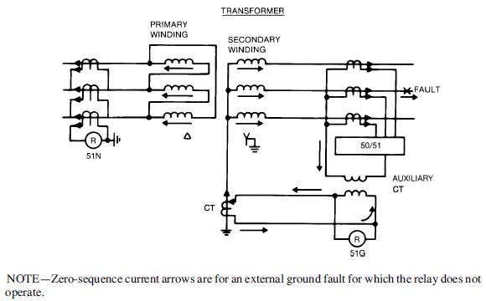
- — Complete ground-fault protection for delta-wye transformer, using residual overcurrent and differentially connected ground relay
Utilizing a directional relay shown in Figure 28 can overcome problems associated with CT saturation on through faults. The currents shown are for an external fault, and the secondary currents circulate as shown. However, upon an internal fault, the secondary currents are additive in the operating coil as shown in Figure 29. This directional relay has the additional element that prevents misoperation and, in fact, permits a faster acting relay: a product relay that can operate in less than a cycle. Comparing this operating time to the seconds taken by a Device 51G relay makes the choice more definitive.
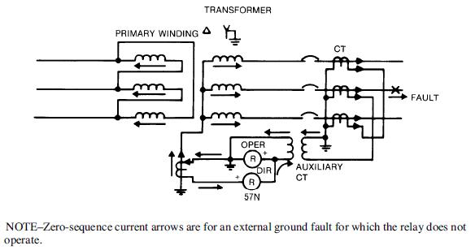
- — Directional relay for detection of ground faults in grounded wye-connected transformer
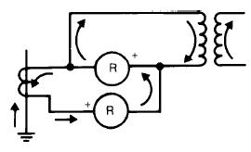
- — Relay current during transformer internal faults
In any ground-fault differential relay application, selection of CT ratios is important. The neutral CT ratio is generally smaller than the phase CT. In such cases, the auxiliary CT in the residual secondary can correct this mismatch if necessary. Some users select the auxiliary CT ratio so that slightly more restraining current flows during an external fault, as shown in Figure 30. In effect, this excess secondary current flows in the opposite direction in the operating winding and precludes false operation.
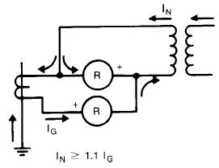
- — Relay current during external fault when auxiliary CT ratio is selected to restrain
      - Network protectors
The network protector is normally flange mounted directly on the network transformer low voltage terminals. The network protector contains the following components: low-voltage air circuit breaker, controls for the air circuit breaker, and network relays. Network protectors trip for faults occurring on the primary side of the network transformer and/or when a power reversal occurs with power flowing from the secondary side of the network transformer to the primary side. The watt-var network master relay has superior operating characteristics over the standard watt network master relay. If a primary-side line-to-ground fault occurs and a single primary fuse operates without tripping the feeder breaker, the unfaulted phases might still supply power to the network. Under these conditions, the net three-phase power flow in the network protector is not in the reverse direction, and the standard watt master relay does not operate. The reactive flow (vars) in the network protector is in the reverse direction. The watt-var master relay properly connected to see this reverse reactive flow operates for this condition.
    - Protection against overvoltages
Transient overvoltages produced by lightning, switching surges, switching of power factor correction capacitors, and other system disturbances can cause transformer failures. High voltage disturbances can be generated by certain types of loads and from the incoming line. A common misconception is that underground services are isolated from these disturbances.
System insulation coordination in the use and location of primary and secondary surge arresters is important. Normally, liquid-insulated transformers have higher basic impulse insulation level (BIL) ratings than standard ventilated dry and sealed dry transformers. Solid dielectric cast coil transformers have BILs equal to liquid-insulated transformers. Ventilated dry transformers and sealed dry transformers can be specified to have BILs equal to the BILs of liquid transformers.
      - Surge arresters
Ordinarily, if the liquid-insulated transformer is supplied by enclosed conductors from the secondaries of transformers with adequate primary surge protection, additional protection might not be required, depending on the system design. However, if the transformer primary or secondary is connected to conductors that are exposed to lightning, the installation of surge arresters is necessary. For best protection, the surge arrester should be mounted as close as possible to the transformer terminals, preferably within 1 m and on the load side of the incoming switch. This location ensures that the lead inductance does not affect the impedance adversely and, therefore, affect the performance of the surge arrester and surge capacitor. If the surge arrester is built into the transformer, further engineering is required to determine whether additional surge protection is required on the secondary.
The degree of surge protection obtained is determined by the amount of exposure, the size and importance of the transformer to the system, and the type and cost of the arresters. In descending order of cost and degree of protection, the types of arresters are station, intermediate, and distribution.
Ventilated dry and sealed dry transformers are normally used indoors, and surge protection is still necessary. Because all systems have the potential for transmitting and reflecting primary and secondary surges caused by lightning and system disturbances, special low-sparkover distribution arresters and low-voltage arresters have been developed for the protection of dry transformers and rotating machinery.
The surge arrester selection (i.e., kV class) should be based on the system voltage and system conditions (i.e., grounded or ungrounded). The arrester kV class is not determined by the kV class of the primary winding of the transformer.
      - Surge capacitors
Additional protection in the form of surge capacitors located as closely as possible to the transformer terminals might be appropriate for all types of transformers. The installation should be examined for excess capacitance already existing in the shielded conductors.
Transformer windings can experience a non-uniform distribution of a fast-front surge in the winding, and this surge can overstress the turn insulation locally in parts of the windings.
Surge capacitors serve a dual function of sloping off fast-rising transients that might impinge on the transformer winding and of reducing the effective surge impedance presented by the transformer to an incoming surge. This type of additional protection is appropriate against voltage transients generated within the system because of circuit conditions such as pre-striking, restriking, high-frequency current interruption, multiple reignitions, voltage escalation, and current suppression (or chopping) as the result of switching, current-limiting fuse operation, thyristor-switching, or ferroresonance conditions.
      - Ferroresonance
Ferroresonance is a phenomenon resulting in the development of a higher than normal voltage in the windings of a transformer. These overvoltages might result in surge arrester operation, damage to the transformer, and electrical shock hazard. The following conditions combine to produce ferroresonance:
- No load on the transformer
- An open circuit on one of the primary terminals of the transformer and, at the same time, an energized terminal. In the case of three-phase transformers, either one or two of the three primary terminals might be disconnected.
- The location of the point of disconnection if it is not close to the transformer
- A voltage potential between the disconnected terminal conductor and ground
The resonant circuit can be traced from the energized terminal through the transformer primary to one of the disconnected terminals, then through the capacitance of the isolated terminal conductor insulation to ground, and then back through the supply system to the energized terminal (see Figure 31). Although more common with underground distribution systems, ferroresonance can occur with overhead lines when the single-phase open point is far enough from the transformer. The typical scenarios for ferroresonance involve single-phase remote switching of an unloaded transformer, remote primary fuse operation on one phase, or failure of all three poles of a three-pole device to properly open accompanied by disconnection of the secondary load.
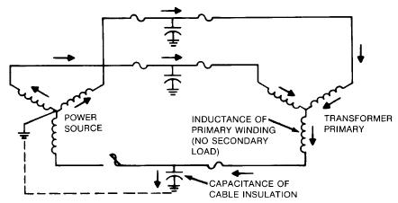
- — One-line diagram showing current flow that might result in ferroresonance
Ferroresonance can be minimized or eliminated by having load connected to the secondary when single-phase switching on the primary; by using gang-operated switches, circuit breakers, or circuit switchers on the primary; or by providing that current-interrupting devices are located next to or on the transformer.
The subject of ferroresonance is complicated, and the literature on this subject should be reviewed by concerned persons to avoid ferroresonance in transformer operation or system design.
  - Protection from the environment
In addition to electrical protection, protection for the transformer against physical conditions is necessary. Physical stressor in the environment can affect reliable performance. Although most of these conditions are obvious, it is important to discuss these conditions. Undesirable conditions include:
- Average ambient temperatures greater than 30 °C when the transformer is loaded at rated kVA or more
- Corrosive agents, abrasive particulate matter, and surface contaminants derived from the surrounding atmosphere
- Conditions that can lead to moisture penetration or to condensation on windings and other internal electrical components
- Submersion in water or mud
- Obstruction to proper ventilation of liquid transformer radiators or, in the case of dry transformers, ventilating openings
- Exposure to damage from collision by vehicles
- Excessive vibration
- Exposure to vandalism
  - Conclusion
Protection of larger and more expensive transformers can be achieved by the proper selection and application of protective devices. Published application guides covering transformers are readily available, for example, ANSI C37.91-2008. The system design engineer should rely heavily on sound engineering judgment to achieve an adequate protection system.

Bibliography
[B1] AIEE Committee Report, “Bibliography of Industrial System Coordination and Protection Literature,” IEEE Transactions on Industry Applications, vol. IA-82, pp. 1–2, Mar. 1963.
[B2] Applied Protective Relaying. Newark, NJ: Westinghouse Electric Corporation, 1976.
[B3] The Art of Protective Relaying. Philadelphia: General Electric Company, Bulletin 1768.
[B4] Beeman, D. L., ed., Industrial Power Systems Handbook. New York: McGraw-Hill, 1955.
[B5] Blackburn, J. L., Protective Relaying, Principles and Applications, 2nd ed. New York: Mercel Dekker, Inc., 1998.
[B6] Boyaris, E., and Buyot, W. S., “Experience with Fault Pressure Relaying and Combustible Gas Detection in Power Transformers,” Proceedings of the American Power Conference, vol. 33, pp. 1116–1126, Apr. 1971.
[B7] Brubaker, J. F., “Fault Protection and Indication on Substation Transformers,” IEEE Transactions on Industry Applications, vol. IA-14, Might/June 1977.
[B8] Burgin, E. R., “A Comparison of Protective Methods and Devices for Industrial Power Transformers,” Proceedings of the American Power Conference, vol. 26, pp. 931–938, Apr. 1964.
[B9] Dickinson, W. H., “Report on Reliability of Electric Equipment in Industrial Plants,” AIEE Transactions on Industry Applications, pt. II, vol. IA-81, pp. 132–151, July 1962.
[B10] Dudor, J. S., and Padden, L. K., “Problems and Solutions for Protective Relay Applications in Petroleum Facilities—Some Protection Applications for Generators and Transformers,” IEEE IAS PCIC Conference Record, pp. 131–144, 1995.
[B11] IEEE Std C57.12.01-1998, IEEE Standard General Requirements for Dry-Type Distribution and Power Transformers Including Those With Solid-Cast and/or Resin-Encapsulated Windings.
[B12] IEEE Std C57.94-1982 (Reaff 1987), IEEE Recommended Practice for Installation, Application, Operation, and Maintenance of Dry-Type General Purpose Distribution and Power Transformers.
[B13] IEEE Std C57.100-1999, IEEE Standard Test Procedures for Thermal Evaluation of Liquid-Immersed Distribution and Power Transformers.
[B14] IEEE Std C57.104-1991, IEEE Guide for the Interpretation of Gases Generated in Oil- Immersed Transformers.
[B15] IEEE Std C57.106-1991 (Reaff 1998), IEEE Guide for Acceptance and Maintenance of Insulating Oil in Equipment.
[B16] IEEE Std C57.110-1998, IEEE Recommended Practice for Establishing Transformer Capability When Supplying Nonsinusoidal Load Currents.
[B17] IEEE Std C57.111-1989 (Reaff 1995), IEEE Guide for Acceptance of Silicone Insulating Fluid and its Maintenance in Transformers.
[B18] IEEE Std C57.115, Loading > 100 MVA.
[B19] IEEE Std C57.121-1998, IEEE Guide for Acceptance and Maintenance of Less Flammable Hydrocarbon Fluid in Transformers.
[B20] Mason, C. R., The Art and Science of Protective Relaying. New York: John Wiley & Sons, 1956. Reprinted by General Electric Company, GER-3738.
[B21] Mathur, B. K., “A Closer Look at the Application and Setting of Instantaneous Devices,” Presented at I&CPS Technical Conference, Seattle, WA, Paper #CH1460-5/79/0000-0107, 1979.
[B22] PES Committee Report, “A Relay Performance Considerations with Low Ratio Cts and High Fault Currents,” IEEE Transactions on Industry Applications, vol. 31, no. 2, pp. 392–393, Mar./Apr. 1995.
[B23] St. Pierre, C. R., and Wolney, T. E., “A Standardization of Benchmarks for Protective Device Time Current Curves,” IEEE Transactions on Industry Applications, vol. 1A-22, no. 4, pp. 623–632, July/Aug. 1986.
[B24] Zolar, D. A., “A Guide to the Application of Surge Arresters for Transformer Protection,” IEEE Transactions on Industry Applications, vol. IA-15, Nov./Dec. 1979.
[B25] Transformer Protection Application Guide, Highland, IL, Basler Electric, 2007

The Institute of Electrical and Electronics Engineers, Inc. 3 Park Avenue, New York, NY 10016-5997, USA Copyright © 20XX by the Institute of Electrical and Electronics Engineers, Inc. All rights reserved. Published <XX Month 20XX>. Printed in the United States of America. IEEE is a registered trademark in the U.S. Patent & Trademark Office, owned by the Institute of Electrical and Electronics Engineers, Incorporated. PDF: ISBN 978-0-XXXX-XXXX-X STDXXXXX Print: ISBN 978-0-XXXX-XXXX-X STDPDXXXXX No part of this publication might be reproduced in any form, in an electronic retrieval system or otherwise, without the prior written permission of the publisher.

