Project | Architecture of a Digital Twin System for Carbon Emission Management  <https://sagroups.ieee.org/2888.7/ >
Title | General architecture of 2888.7
DCN | 2888-24-0063-00-0000
Date Submitted | September 24th, 2024
Source(s) | Hyunjeong Lee, hjlee294@etri.re.kr (Electronics and Telecommunications Research Institute)  Changkyu Lee, changkyu.lee@etri.re.kr (Electronics and Telecommunications Research Institute)
Re: | IEEE 2888 #18 Meeting in Brisbane, Australia
Abstract | The integrated version of P2888.7 D0.1 with input contributions from Session 18
Purpose | To improve P2888.7 Draft for WG Letter Ballot
Notice | Interfacing the cyber and physical worlds provides various opportunities for new services and applications, including VRs, digital twins, IoT, and smart-x industries. This contribution introduces the general architecture necessary to define a VR disaster response training system with six degrees of freedom using standard interfaces between the cyber and physical worlds.
Release | The contributor grants a free, irrevocable license to the IEEE to incorporate material contained in this contribution, and any modifications thereof, in the creation of an IEEE Standards publication; to copyright in the IEEE’s name any IEEE Standards publication even though it may include portions of this contribution; and at the IEEE’s sole discretion to permit others to reproduce in whole or in part the resulting IEEE Standards publication. The contributor also acknowledges and accepts that IEEE 2888 may make this contribution public.
Patent Policy | The contributor is familiar with IEEE patent policy, as stated in Section 6 of the IEEE-SA Standards Board bylaws <http://standards.ieee.org/guides/bylaws/sect6-7.html#6> and in Understanding Patent Issues During IEEE Standards Development http://standards.ieee.org/board/pat/faq.pdf
P2888.7™/D0.1
DrafttxtTrialUseStandard for Standard on Architecture of a Digital Twin System for Carbon Emission Management
Developed by the

Standard Activities Board (SAB)
of the
IEEE Computer Society

Approved varApprovedDate

IEEE SA Standards Board

Copyright © varCRYear by The Institute of Electrical and Electronics Engineers, Inc.
Three Park Avenue
New York, New York 10016-5997, USA
All rights reserved.
This document is an unapproved draft of a proposed IEEE Standard. As such, this document is subject to change. USE AT YOUR OWN RISK! IEEE copyright statements SHALL NOT BE REMOVED from draft or approved IEEE standards, or modified in any way. Because this is an unapproved draft, this document must not be utilized for any conformance/compliance purposes. Permission is hereby granted for officers from each IEEE Standards Working Group or Committee to reproduce the draft document developed by that Working Group for purposes of international standardization consideration. IEEE Standards Department must be informed of the submission for consideration prior to any reproduction for international standardization consideration (stds-ipr@ieee.org). Prior to adoption of this document, in whole or in part, by another standards development organization, permission must first be obtained from the IEEE Standards Department (stds-ipr@ieee.org). When requesting permission, IEEE Standards Department will require a copy of the standard development organization's document highlighting the use of IEEE content. Other entities seeking permission to reproduce this document, in whole or in part, must also obtain permission from the IEEE Standards Department.
IEEE Standards Department
445 Hoes Lane
Piscataway, NJ 08854, USA

Abstract: This standard defines a reference architecture to implement a digital twin system for carbon emission management for the physical world where equipment and facilities emit carbon dioxide. This architecture consists of three main components including:
- The 'physical-to-virtual interface' that transfers carbon emission data from the physical world to the virtual world.
- The 'virtual-to-physical interface' that controls actuators in the physical world based on analyses performed in the virtual world.
- Descriptions of carbon emission management modules within the virtual world.
Keywords: digital twin, architecture, carbon, emission

•Important Notices and Disclaimers Concerning IEEE Standards Documents
IEEE Standards documents are made available for use subject to important notices and legal disclaimers. These notices and disclaimers, or a reference to this page (https://standards.ieee.org/ipr/disclaimers.html), appear in all IEEE standards and may be found under the heading “Important Notices and Disclaimers Concerning IEEE Standards Documents.”

Notice and Disclaimer of Liability Concerning the Use of IEEE Standards Documents
IEEE Standards documents are developed within IEEE Societies and subcommittees of IEEE Standards Association (IEEE SA) Board of Governors. IEEE develops its standards through an accredited consensus development process, which brings together volunteers representing varied viewpoints and interests to achieve the final product. IEEE standards are documents developed by volunteers with scientific, academic, and industry-based expertise in technical working groups. Volunteers involved in technical working groups are not necessarily members of IEEE or IEEE SA and participate without compensation from IEEE. While IEEE administers the process and establishes rules to promote fairness in the consensus development process, IEEE does not independently evaluate, test, or verify the accuracy of any of the information or the soundness of any judgments contained in its standards.
IEEE makes no warranties or representations concerning its standards, and expressly disclaims all warranties, express or implied, concerning all standards, including but not limited to the warranties of merchantability, fitness for a particular purpose and non-infringement IEEE Standards documents do not guarantee safety, security, health, or environmental protection, or compliance with law, or guarantee against interference with or from other devices or networks. In addition, IEEE does not warrant or represent that the use of the material contained in its standards is free from patent infringement. IEEE Standards documents are supplied “AS IS” and “WITH ALL FAULTS.”
Use of an IEEE standard is wholly voluntary. The existence of an IEEE standard does not imply that there are no other ways to produce, test, measure, purchase, market, or provide other goods and services related to the scope of the IEEE standard. Furthermore, the viewpoint expressed at the time a standard is approved and issued is subject to change brought about through developments in the state of the art and comments received from users of the standard.
In publishing and making its standards available, IEEE is not suggesting or rendering professional or other services for, or on behalf of, any person or entity, nor is IEEE undertaking to perform any duty owed by any other person or entity to another. Any person utilizing any IEEE Standards document should rely upon their own independent judgment in the exercise of reasonable care in any given circumstances or, as appropriate, seek the advice of a competent professional in determining the appropriateness of a given IEEE standard.
IN NO EVENT SHALL IEEE BE LIABLE FOR ANY DIRECT, INDIRECT, INCIDENTAL, SPECIAL, EXEMPLARY, OR CONSEQUENTIAL DAMAGES (INCLUDING, BUT NOT LIMITED TO: THE NEED TO PROCURE SUBSTITUTE GOODS OR SERVICES; LOSS OF USE, DATA, OR PROFITS; OR BUSINESS INTERRUPTION) HOWEVER CAUSED AND ON ANY THEORY OF LIABILITY, WHETHER IN CONTRACT, STRICT LIABILITY, OR TORT (INCLUDING NEGLIGENCE OR OTHERWISE) ARISING IN ANY WAY OUT OF THE PUBLICATION, USE OF, OR RELIANCE UPON ANY STANDARD, EVEN IF ADVISED OF THE POSSIBILITY OF SUCH DAMAGE AND REGARDLESS OF WHETHER SUCH DAMAGE WAS FORESEEABLE.

Translations
The IEEE consensus balloting process involves the review of documents in English only. In the event that an IEEE standard is translated, only the English language version published by IEEE is the approved IEEE standard.

Use by artificial intelligence systems
In no event shall material in any IEEE Standards documents be used for the purpose of creating, training, enhancing, developing, maintaining, or contributing to any artificial intelligence systems without the express, written consent of IEEE SA in advance. “Artificial intelligence” refers to any software, application, or other system that uses artificial intelligence, machine learning, or similar technologies, to analyze, train, process, or generate content. Requests for consent can be submitted using the Contact Us form.

Official statements
A statement, written or oral, that is not processed in accordance with the IEEE SA Standards Board Operations Manual is not, and shall not be considered or inferred to be, the official position of IEEE or any of its committees and shall not be considered to be, or be relied upon as, a formal position of IEEE or IEEE SA. At lectures, symposia, seminars, or educational courses, an individual presenting information on IEEE standards shall make it clear that the presenter’s views should be considered the personal views of that individual rather than the formal position of IEEE, IEEE SA, the Standards Committee, or the Working Group. Statements made by volunteers may not represent the formal position of their employer(s) or affiliation(s). News releases about IEEE standards issued by entities other than IEEE SA should be considered the view of the entity issuing the release rather than the formal position of IEEE or IEEE SA.

Comments on standards
Comments for revision of IEEE Standards documents are welcome from any interested party, regardless of membership affiliation with IEEE or IEEE SA. However, IEEE does not provide interpretations, consulting information, or advice pertaining to IEEE Standards documents.
Suggestions for changes in documents should be in the form of a proposed change of text, together with appropriate supporting comments. Since IEEE standards represent a consensus of concerned interests, it is important that any responses to comments and questions also receive the concurrence of a balance of interests. For this reason, IEEE and the members of its Societies and subcommittees of the IEEE SA Board of Governors are not able to provide an instant response to comments or questions, except in those cases where the matter has previously been addressed. For the same reason, IEEE does not respond to interpretation requests. Any person who would like to participate in evaluating comments or revisions to an IEEE standard is welcome to join the relevant IEEE SA working group. You can indicate interest in a working group using the Interests tab in the Manage Profile & Interests area of the IEEE SA myProject system. An IEEE Account is needed to access the application.
Comments on standards should be submitted using the Contact Us form.

Laws and regulations
Users of IEEE Standards documents should consult all applicable laws and regulations. Compliance with the provisions of any IEEE Standards document does not constitute compliance to any applicable regulatory requirements. Implementers of the standard are responsible for observing or referring to the applicable regulatory requirements. IEEE does not, by the publication of its standards, intend to urge action that is not in compliance with applicable laws, and these documents may not be construed as doing so.

Data privacy
Users of IEEE Standards documents should evaluate the standards for considerations of data privacy and data ownership in the context of assessing and using the standards in compliance with applicable laws and regulations.

Copyrights
IEEE draft and approved standards are copyrighted by IEEE under U.S. and international copyright laws. They are made available by IEEE and are adopted for a wide variety of both public and private uses. These include both use by reference, in laws and regulations, and use in private self-regulation, standardization, and the promotion of engineering practices and methods. By making these documents available for use and adoption by public authorities and private users, neither IEEE nor its licensors waive any rights in copyright to the documents.

Photocopies
Subject to payment of the appropriate licensing fees, IEEE will grant users a limited, non-exclusive license to photocopy portions of any individual standard for company or organizational internal use or individual, non-commercial use only. To arrange for payment of licensing fees, please contact Copyright Clearance Center, Customer Service, 222 Rosewood Drive, Danvers, MA 01923 USA; +1 978 750 8400; https://www.copyright.com/. Permission to photocopy portions of any individual standard for educational classroom use can also be obtained through the Copyright Clearance Center.

Updating of IEEE Standards documents
Users of IEEE Standards documents should be aware that these documents may be superseded at any time by the issuance of new editions or may be amended from time to time through the issuance of amendments, corrigenda, or errata. An official IEEE document at any point in time consists of the current edition of the document together with any amendments, corrigenda, or errata then in effect.
Every IEEE standard is subjected to review at least every 10 years. When a document is more than 10 years old and has not undergone a revision process, it is reasonable to conclude that its contents, although still of some value, do not wholly reflect the present state of the art. Users are cautioned to check to determine that they have the latest edition of any IEEE standard.
In order to determine whether a given document is the current edition and whether it has been amended through the issuance of amendments, corrigenda, or errata, visit IEEE Xplore or contact IEEE. For more information about the IEEE SA or IEEE’s standards development process, visit the IEEE SA Website.

Errata
Errata, if any, for all IEEE standards can be accessed on the IEEE SA Website. Search for standard number and year of approval to access the web page of the published standard. Errata links are located under the Additional Resources Details section. Errata are also available in IEEE Xplore. Users are encouraged to periodically check for errata.

Patents
IEEE standards are developed in compliance with the IEEE SA Patent Policy.
Attention is called to the possibility that implementation of this standard may require use of subject matter covered by patent rights. By publication of this standard, no position is taken by the IEEE with respect to the existence or validity of any patent rights in connection therewith. If a patent holder or patent applicant has filed a statement of assurance via an Accepted Letter of Assurance, then the statement is listed on the IEEE SA Website at https://standards.ieee.org/about/sasb/patcom/patents.html. Letters of Assurance may indicate whether the Submitter is willing or unwilling to grant licenses under patent rights without compensation or under reasonable rates, with reasonable terms and conditions that are demonstrably free of any unfair discrimination to applicants desiring to obtain such licenses.
Essential Patent Claims may exist for which a Letter of Assurance has not been received. The IEEE is not responsible for identifying Essential Patent Claims for which a license may be required, for conducting inquiries into the legal validity or scope of Patents Claims, or determining whether any licensing terms or conditions provided in connection with submission of a Letter of Assurance, if any, or in any licensing agreements are reasonable or non-discriminatory. Users of this standard are expressly advised that determination of the validity of any patent rights, and the risk of infringement of such rights, is entirely their own responsibility. Further information may be obtained from the IEEE Standards Association.

IMPORTANT NOTICE
Technologies, application of technologies, and recommended procedures in various industries evolve over time. The IEEE standards development process allows participants to review developments in industries, technologies, and practices, and to determine what, if any, updates should be made to the IEEE standard. During this evolution, the technologies and recommendations in IEEE standards may be implemented in ways not foreseen during the standard’s development. IEEE standards development activities consider research and information presented to the standards development group in developing any safety recommendations. Other information about safety practices, changes in technology or technology implementation, or impact by peripheral systems also may be pertinent to safety considerations during implementation of the standard. Implementers and users of IEEE Standards documents are responsible for determining and complying with all appropriate safety, security, environmental, health, data privacy, and interference protection practices and all applicable laws and regulations.
Participants
At the time this draft txtTrialUsestandard was completed, the Interfacing Cyber and Physical World Working Group had the following membership:
Kyoungro Yoon, Chair
Sang-Kyun Kim, Vice Chair
Sangkwon Peter Jeong, Secretary
Hyunjeong Lee, Task Group Chair
Changkyu Lee, Technical Editor
Misuk Lee, Technical Editor

Participant1
Participant2
Participant3
Participant4
Participant5
Participant6
Participant7
Participant8
Participant9

The following members of the <individual/entity> Standards Association balloting group voted on thistxtTrialUsestandard. Balloters may have voted for approval, disapproval, or abstention.
[To be supplied by IEEE]

Balloter1
Balloter2
Balloter3
Balloter4
Balloter5
Balloter6
Balloter7
Balloter8
Balloter9

When the IEEE SA Standards Board approved thistxtTrialUse standard on varApprovedDate, it had the following membership:
[To be supplied by IEEE]

<Name>, Chair
<Name>, Vice Chair
<Name>, Past Chair
<Name>, Secretary

SBMember1
SBMember2
SBMember3
SBMember4
SBMember5
SBMember6
SBMember7
SBMember8
SBMember9

*Member Emeritus

Introduction
This introduction is not part of P2888.7/D0.1, DrafttxtTrialUseStandard for Architecture of a Digital Twin System for Carbon Emission Management.
This standard defines a reference architecture to implement a digital twin system for carbon emission management for the physical world where equipment and facilities emit carbon dioxide. This structure enables the creation of an integrated system that can effectively monitor and control carbon emissions in physical world environments. By bridging the gap between the physical and virtual worlds, this architecture provides a comprehensive approach to carbon management, allowing for real-time data analysis and responsive control mechanisms.

Contents
1. Overview 11
1.1 Scope 11
1.2 Purpose 11
1.3 Word usage 11
2. Normative references 12
3. Definitions, acronyms, and abbreviations 12
3.1 Definitions 12
3.2 Acronyms and abbreviations 12
4. Concept 12
5. Reference architecture 12
5.1. Reference architecture 12
5.2. Roles and components 13
5.3. Requirements 13
6. Functional entities for carbon emission management 13
6.1. General 13
6.2. Physical world layer 14
6.3. Digital twin system layer 14
6.4. Federation layer 14
6.5. Application layer 14
Annex A (informative) Bibliography 15

DrafttxtTrialUseStandard for Standard on Architecture of a Digital Twin System for Carbon Emission Management

- Overview
  - Scope
This standard defines a reference architecture to implement a digital twin system for carbon emission management for the physical world where equipment and facilities emit carbon dioxide. This architecture consists of three main components including:
- The 'physical-to-virtual interface' that transfers carbon emission data from the physical world to the virtual world.
- The 'virtual-to-physical interface' that controls actuators in the physical world based on analyses performed in the virtual world.
- Descriptions of carbon emission management modules within the virtual world.
​This structure enables the creation of an integrated system that can effectively monitor and control carbon emissions in physical world environments. By bridging the gap between the physical and virtual worlds, this architecture provides a comprehensive approach to carbon management, allowing for real-time data analysis and responsive control mechanisms.
  - Purpose
The purpose of this standard is to provide a guide for designing a digital twin system for carbon emission management. The digital twin system for carbon emission management can provide operational efficiency and cost savings through modeling, simulation, and prediction of an organization's carbon emissions.
  - Word usage
[TBD]
- Normative references
The following referenced documents are indispensable for the application of this document (i.e., they must be understood and used, so each referenced document is cited in text and its relationship to this document is explained). For dated references, only the edition cited applies. For undated references, the latest edition of the referenced document (including any amendments or corrigenda) applies.
IEEE Std 2888.1TM-2023 IEEE Standard for Specification of Sensor Interface for Cyber and Physical Worlds
IEEE Std 2888.2TM-2023 IEEE Standard for Actuator Interface for Cyber and Physical Worlds
IEEE Std 2888.3TM-2024 IEEE Standard for Actuator Interface for Cyber and Physical Worlds
- Definitions, acronyms, and abbreviations
  - Definitions
For the purposes of this document, the following terms and definitions apply. The IEEE Standards Dictionary Online should be consulted for terms not defined in this clause.
  - Acronyms and abbreviations
- Concept
[TBD]
- Reference architecture
  - Reference architecture
This clause defines the overall architecture and requirements of digital twin system for carbon emission management (DTS CEM). Figure 1 shows the basic structure of a digital twin system for carbon emission management. The digital twin system shown in Figure 1 manages and predicts data related to carbon emissions and conducts carbon transactions with other digital twin systems if necessary.
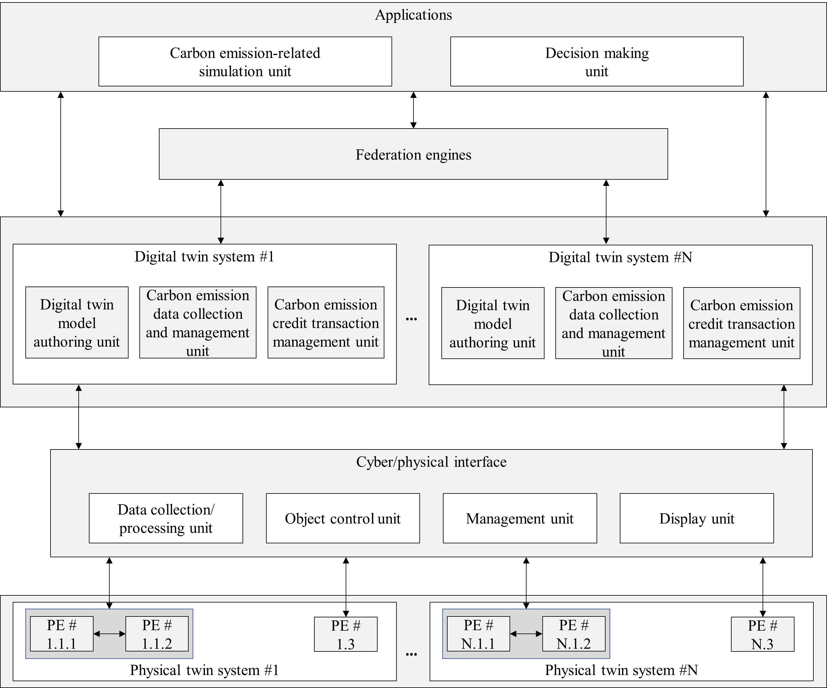
- The basic architecture of digital twin system

  - Roles and components
[TBD]

  - Requirements
[TBD]
- Functional entities for carbon emission management
  - General
[TBD]
  - Physical world layer
[TBD]
  - Digital twin system layer
[TBD]
  - Federation layer
[TBD]
  - Application layer
[TBD]

(informative)
Bibliography
Bibliographical references are resources that provide additional or helpful material but do not need to be understood or used to implement this standard. Reference to these resources is made for informational use only.
[TBD]

•The Institute of Electrical and Electronics Engineers, Inc. 3 Park Avenue, New York, NY 10016-5997, USA Copyright © varCRYear by The Institute of Electrical and Electronics Engineers, Inc. All rights reserved. Published varPublishedDate. Printed in the United States of America. IEEE is a registered trademark in the U.S. Patent & Trademark Office, owned by The Institute of Electrical and Electronics Engineers, Incorporated. PDF: ISBN varISBNpdf varStdIDpdf Print: ISBN varISBNprint varStdIDprint IEEE prohibits discrimination, harassment, and bullying. For more information, visit https://www.ieee.org/about/corporate/governance/p9-26.html. No part of this publication may be reproduced in any form, in an electronic retrieval system or otherwise, without the prior written permission of the publisher.
Available at: https://development.standards.ieee.org/myproject-web/public/view.html#landing.
Available at: https://standards.ieee.org/about/contact/.
Available at: https://ieeexplore.ieee.org/browse/standards/collection/ieee.
Available at: https://standards.ieee.org/standard/index.html.
Available at: https://standards.ieee.org/about/sasb/patcom/materials.html.
IEEE Standards Dictionary Online is available at: http://dictionary.ieee.org. An IEEE account is required for access to the dictionary, and one can be created at no charge on the dictionary sign-in page.

