Project | Specification of Digital Synchronization Framework between Cyber and Physical World  <https://sagroups.ieee.org/2888/3 >
Title | Use Case of Digital Twin for Disaster Management
DCN | 2888-22-0037-00-0003
Date Submitted | February 14th, 2022
Source(s) | Misuk Lee lms@etri.re.kr (Electronics and Telecommunications Research Institute)  Woo-Sug Jung wsjung@etri.re.kr (Electronics and Telecommunications Research Institute)  Changseok Yoon csyoon@keti.re.kr (Korea Electronics Technology Institute)
Re:
Abstract
Purpose | To discuss and define the terminology for digital twin
Notice | This document has been prepared to assist the IEEE 2888 Working Group. It is offered as a basis for discussion and is not binding on the contributing individual(s) or organization(s). The material in this document is subject to change in form and content after further study. The contributor(s) reserve(s) the right to add, amend or withdraw material contained herein.
Release | The contributor grants a free, irrevocable license to the IEEE to incorporate material contained in this contribution, and any modifications thereof, in the creation of an IEEE Standards publication; to copyright in the IEEE’s name any IEEE Standards publication even though it may include portions of this contribution; and at the IEEE’s sole discretion to permit others to reproduce in whole or in part the resulting IEEE Standards publication. The contributor also acknowledges and accepts that IEEE 2888 may make this contribution public.
Patent Policy | The contributor is familiar with IEEE patent policy, as stated in Section 6 of the IEEE-SA Standards Board bylaws <http://standards.ieee.org/guides/bylaws/sect6-7.html#6> and in Understanding Patent Issues During IEEE Standards Development http://standards.ieee.org/board/pat/faq.pdf

Introduction
In the last meeting, based on the various definitions of digital twins suggested by industries, organizations, standard body(consortium) and researcher, we proposed to express an objects/systems/processes that exist in the physical world as virtual objects/virtual systems/virtual processes existing in the virtual world rather than expressing all of them exists in physical world in terms of " things".
And there were a lot of discussion of what is process and system, and we agreed to discuss the use case of digital representation for invisible physical things.
Therefore, we would like to share the concept of invisible physical things by taking the project of digital twin-based disaster management integrated platform technology development we are currently working on as an example.

Use Case of Disaster Management Platform
Figure 1 shows simplified disaster management platform architecture. The disaster management platform of Fig.1 consists of four systems. From a data flow point of view, first, data is acquired from various sensors installed. Second, it detects whether an abnormal case has occurred through data analysis. Third, it infers information to help users make decisions about what to do in unusual situation. In this process, not only the sensor data but also standard operating procedure, patrol inspection report, and equipment maintenance records, etc. are used to infer decision-making support information. Finally, the decision-making support information is displayed on the monitoring screen.
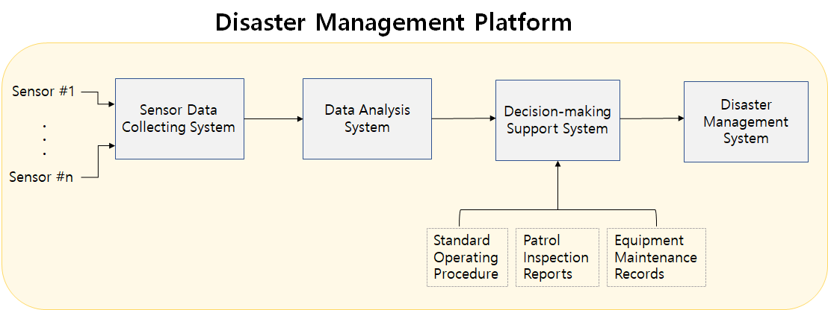
Figure 1. Use Case of Disaster Management Platform
According to Wikipedia's definition, a system is a group of interacting or interrelated elements that act according to a set of rules to form a unified whole. In Fig.1, the system consists with some physical hardware and program etc.
However, systems can be divided into abstract(invisible) and physically(visible) based on properties. Communication systems and transportation systems belong to physical systems, and things like science and thinking systems belong to abstract systems.
In our application, process means turning sensor data into decision-making support information through use of data collecting, preprocessing, transmission and analysis, etc.

Conclusion
In this contribution, we presented some of examples of invisible physical things using a disaster management platform. We would like to propose to revisit the use of the term of virtual thing to represent everything in physical world.

Reference
[1] IEEE P2888.3 “Draft Standard on Orchestration of Digital Synchronization between Cyber and Physical Worlds”, July 2021.
[2] IEEE P2888.3 2888-21-0042-01-0003, “Proposal for Complex Digital Objects of the Digital Twin Framework”, October, 2021.
[3] IEEE P2888.3 2888-21-0093-00-0003, “2888.3 TG Meeting Summary”, October, 2021.

