Project | Orchestration of Digital Synchronization between Cyber and Physical World  <https://sagroups.ieee.org/2888/3 >
Title | Proposal of Automatic Connection of Numerous Physical entities to the System
DCN | 2888-22-0017-00-0003
Date Submitted | February 15th, 2022
Source(s) | Shin Kim new.xin22@gmail.com (Konkuk University)  Yegi Lee zxcasd312@naver.com (Konkuk University)  Kyounro Yoon yoonk@konkuk.ac.kr (Konkuk University)
Re:
Abstract
Purpose
Notice | This document has been prepared to assist the IEEE 2888 Working Group. It is offered as a basis for discussion and is not binding on the contributing individual(s) or organization(s). The material in this document is subject to change in form and content after further study. The contributor(s) reserve(s) the right to add, amend or withdraw material contained herein.
Release | The contributor grants a free, irrevocable license to the IEEE to incorporate material contained in this contribution, and any modifications thereof, in the creation of an IEEE Standards publication; to copyright in the IEEE’s name any IEEE Standards publication even though it may include portions of this contribution; and at the IEEE’s sole discretion to permit others to reproduce in whole or in part the resulting IEEE Standards publication. The contributor also acknowledges and accepts that IEEE 2888 may make this contribution public.
Patent Policy | The contributor is familiar with IEEE patent policy, as stated in Section 6 of the IEEE-SA Standards Board bylaws <http://standards.ieee.org/guides/bylaws/sect6-7.html#6> and in Understanding Patent Issues During IEEE Standards Development http://standards.ieee.org/board/pat/faq.pdf

Introduction
In this paper, we suggest automatic connection process for many physical things/entities to the system. The proposed process is composed of four steps, which are to search for available physical things/entities with specific functionality, to collect information of available things, to assign specific mission or task to selected things, and to establish communication channels for them.

Automatic Connection of physical entities to the system

General
Currently, connecting multiple physical entities, which have same functionality, to the physical system should be carried out one by one. It may be simple in case that there are only a few of physical entities. However, it could be troublesome when there are many physical entities in the physical world to be considered. For example, in case of Smart City, there must be a large number of sensors, actuators and the system developer may need to spend too much time on connecting them to the system.

How to connect
There are 4 steps for automatic connection.
- To search for available physical things/entities matching specific criteria
For the automatic connection, it is necessary to search for available physical things/entities with specific functionality or capability. In this step, available physical thing/entity means that it is online and can be used at that moment. Capability/functionality means that the physical things/entities can provide described service or perform the specific functionality. Figure 1 shows how to search for available physical things/entities. The system broadcast JSON-formatted capability/functionality message to the network to look for available things.
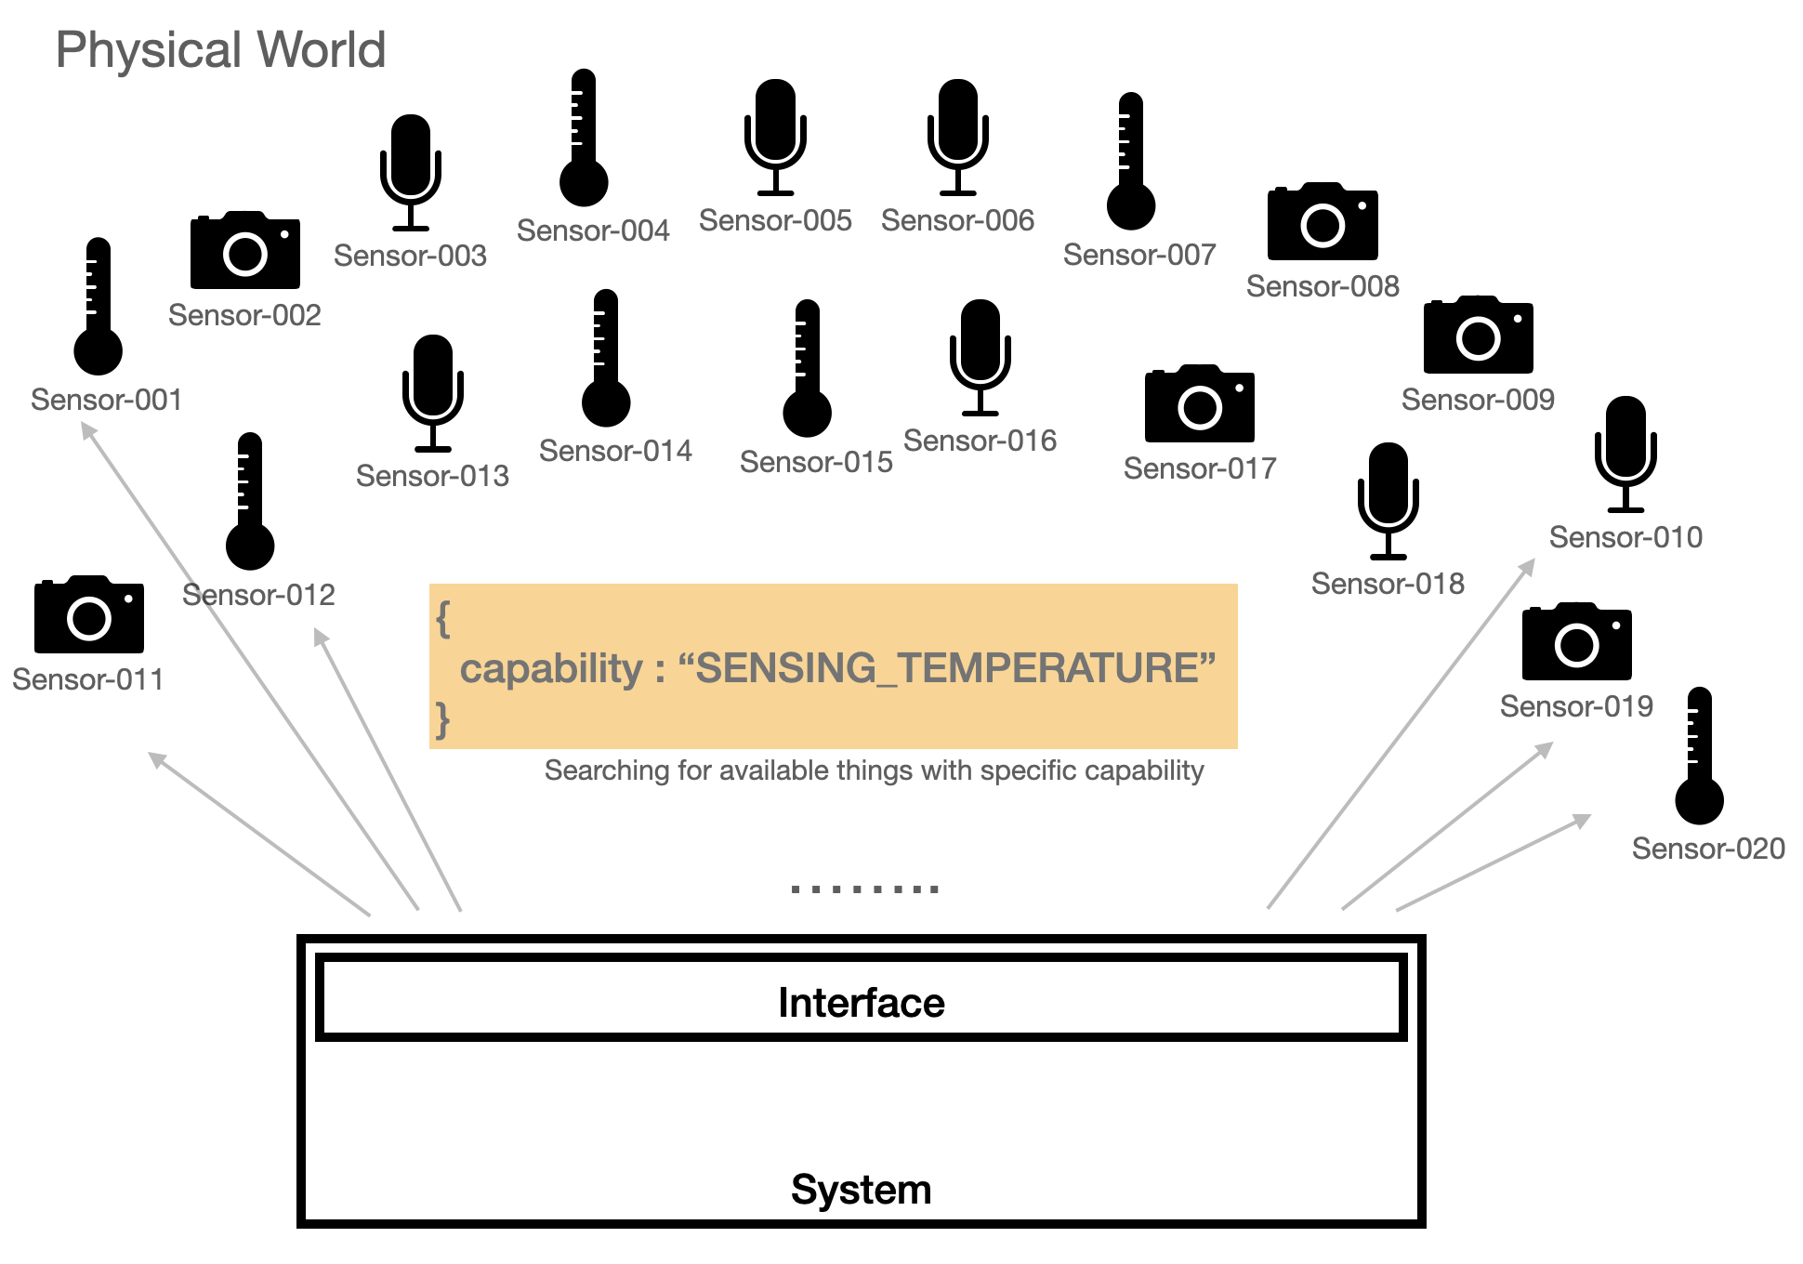
Figure 1. Step 1: Searching for available physical things/entities

- To collect information of available physical things/entities
After step 1, available physical things that can carry out the capability/functionality provide the system feedback. In the Figure 2, there are some sensors such as camera, thermometer, and microphone and three of them sends the feedback to the system that they have the capability and are available. The feedback information may include id, IP address, detailed capability, etc. The system collects the information to build a message to assign a task (or a mission) to them.
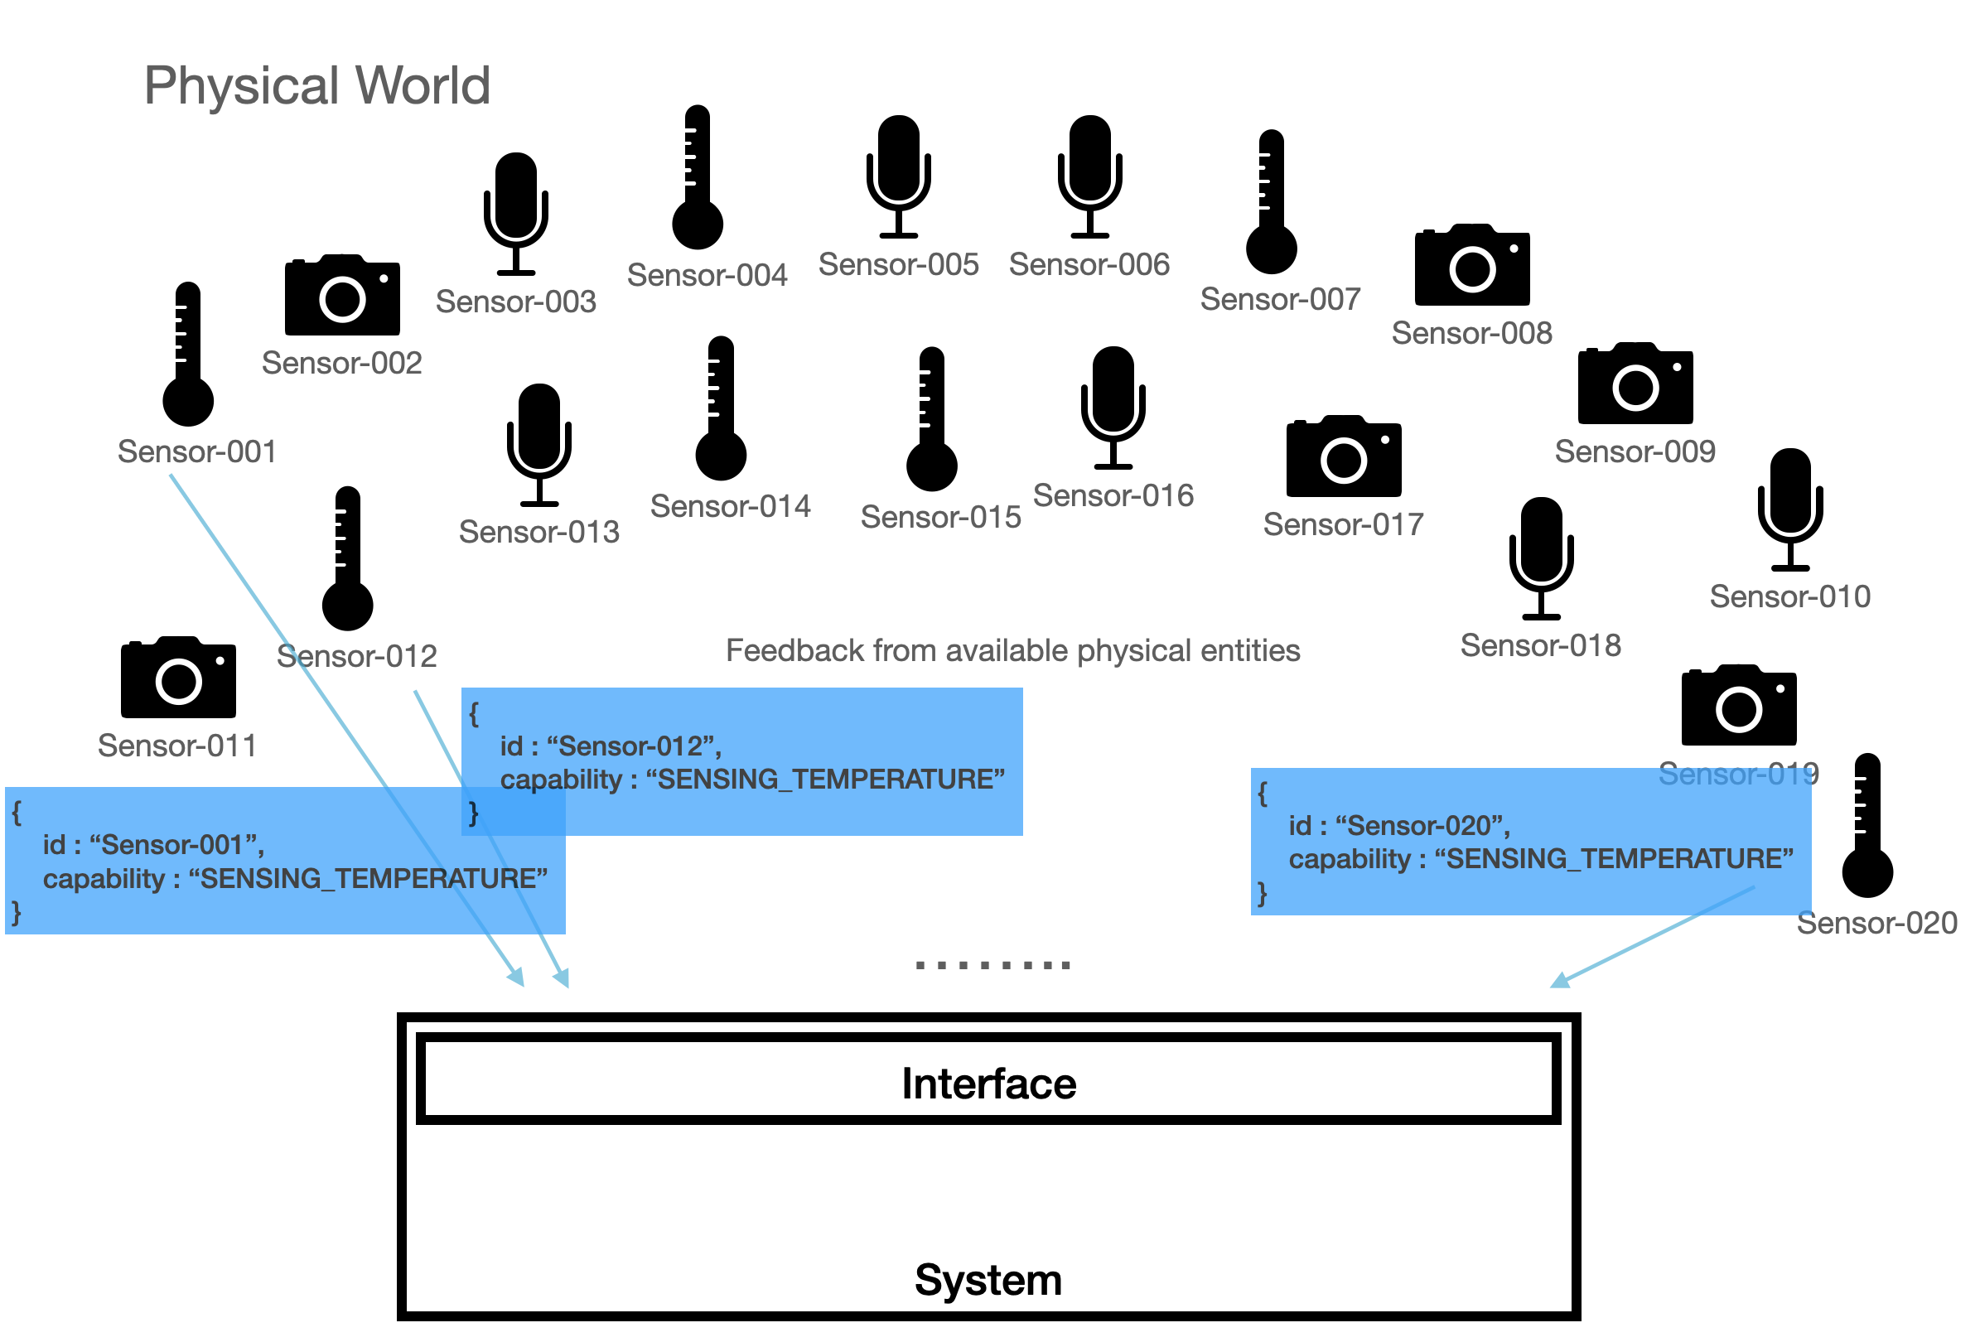
Figure 2. Step 2: Collecting information from available things/entities
- To assign task (or mission) to the selected physical things with unique identification
Using the collected information from the previous step, the system selects specific things to be connected. The system builds a message for assigning a task (or a mission) to the online physical thing as shown in Figure 3. The message must include information of the selected physical things, such as physical things’ ids, capabilities, and unique identifiers for each connection. Each (online) physical thing/entity can read the message and obtain unique identifier from the message sent to them for the automatic connection.
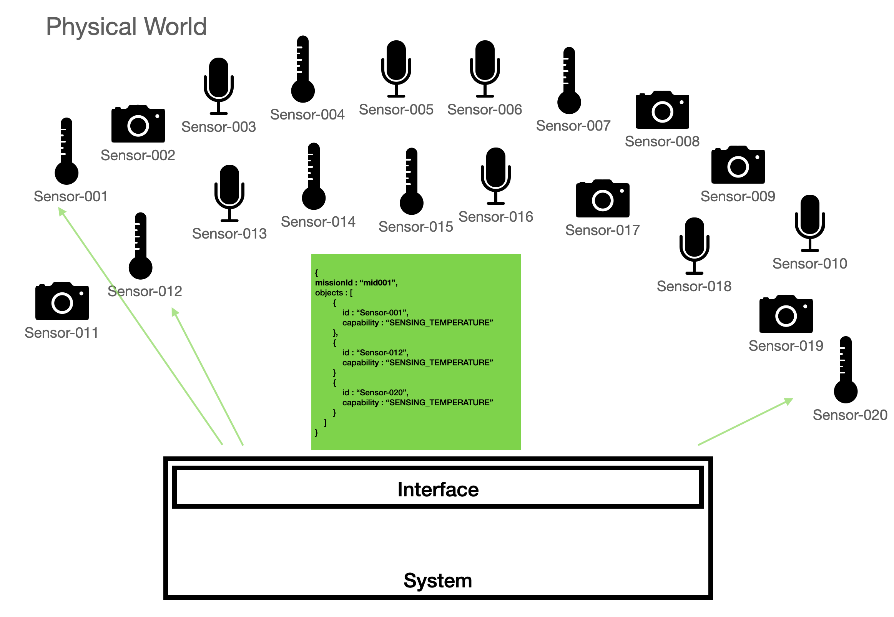
Figure 3. Step 3: Assigning task to the available things/entities

- To establish communication channel between physical things and the system
Communication channel is established using the unique identifier from Step 3 and selected physical things/entities and the system can communicate through the channel as shown in Figure 4.
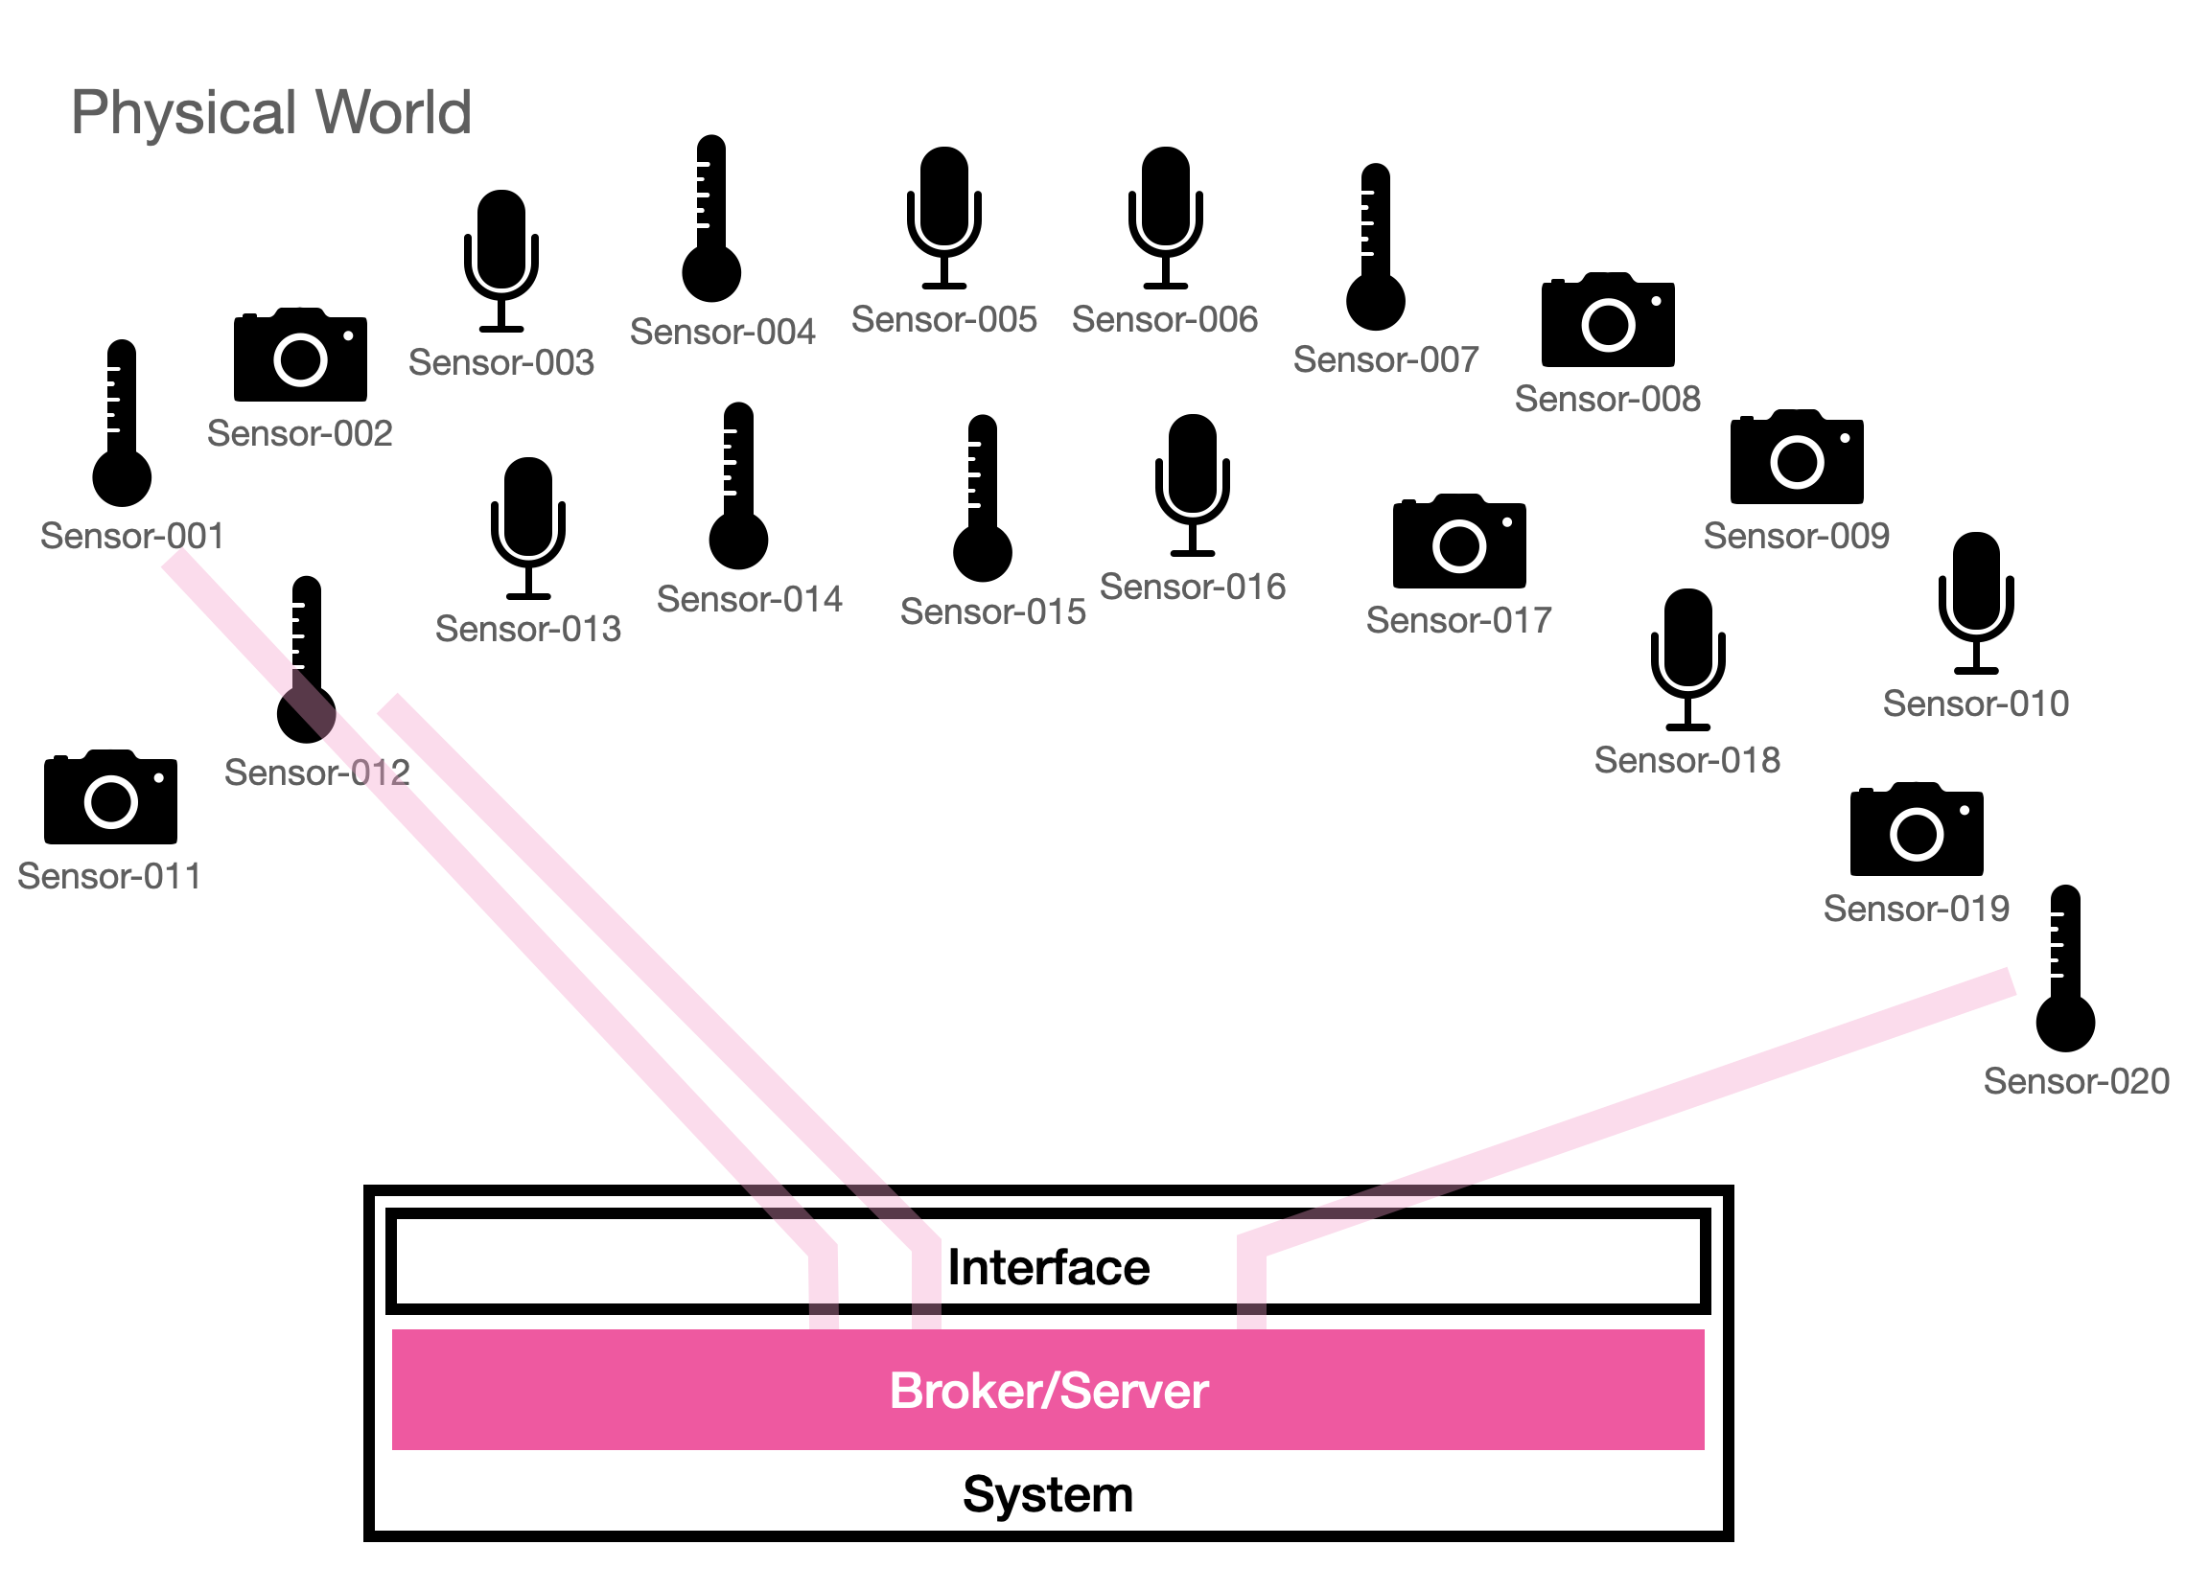
Figure 4. Step 4 : Establishment communication channel with id

Conclusion
We proposed automatic process of connecting the physical things/entities to the system. With the process as suggested, finding physical things/entities one by one is not necessary, because the system broadcasts a message including description of specific capability/functionality of interest and available physical things/entities return feedback message. The system can build and send a message to assign the task (or mission) to them, and the selected physical things/entities and the system can communicate through the channel established with the unique identifier that the system created.

