Project | Specification of Digital Synchronization Framework between Cyber and Physical World  <https://sagroups.ieee.org/2888/3 >
Title | Proposal on the Terminology of Digital Twins
DCN | 2888-21-0082-00-0003
Date Submitted | October 13th, 2021
Source(s) | Misuk Lee lms@etri.re.kr (Electronics and Telecommunications Research Institute)  Woo-Sug Jung wsjung@etri.re.kr (Electronics and Telecommunications Research Institute)  Changseok Yoon csyoon@keti.re.kr (Korea Electronics Technology Institute)
Re:
Abstract
Purpose | To discuss and define the terminology for digital twin
Notice | This document has been prepared to assist the IEEE 2888 Working Group. It is offered as a basis for discussion and is not binding on the contributing individual(s) or organization(s). The material in this document is subject to change in form and content after further study. The contributor(s) reserve(s) the right to add, amend or withdraw material contained herein.
Release | The contributor grants a free, irrevocable license to the IEEE to incorporate material contained in this contribution, and any modifications thereof, in the creation of an IEEE Standards publication; to copyright in the IEEE’s name any IEEE Standards publication even though it may include portions of this contribution; and at the IEEE’s sole discretion to permit others to reproduce in whole or in part the resulting IEEE Standards publication. The contributor also acknowledges and accepts that IEEE 2888 may make this contribution public.
Patent Policy | The contributor is familiar with IEEE patent policy, as stated in Section 6 of the IEEE-SA Standards Board bylaws <http://standards.ieee.org/guides/bylaws/sect6-7.html#6> and in Understanding Patent Issues During IEEE Standards Development http://standards.ieee.org/board/pat/faq.pdf

Introduction
In the last meeting there was a discussion of the terminology of virtual copies of physical objects in digital twins [1]. "Digital Thing", "Digital Entity" and "Virtual Entity" were in the table, but it was not determined which one was appropriate within the working scope of IEEE.2888.3. And in [2], the term "digital thing" is used as a counterpart of a physical thing.
We think it needs to be a consensus within the group on the terminology. Thus, in this contribution, we summarized typical definitions of digital twins suggested by researcher, industry and standard bodies. And we are going to propose a term and scope for virtual replication of physical objects.

Proposal of Key Terms for Digital Twins

2.1 Overview
There is no official definition of digital twins until now but there are many suggestions. Following table shows typical definition of digital twins suggested by industries, consortium, standard body(consortium) and researcher. And we can see some commonly used terms in the table. In other word, things that exist in the real world are called physical objects, asset, entity and in virtual world it is called virtual representation(model), digital representation.

Table 1. Definitions of digital twins
Wiki(https://en.wikipedia.org/wiki/Digital_twin) | A virtual representation that serves as the real-time digital counterpart of a physical object or process.
IBM(https://www.ibm.com/topics/what-is-a-digital-twin) | A virtual model designed to accurately reflect a physical object.
GE(https://www.ge.com/digital/applications/digital-twin) | A software representation of a physical asset, system or process designed to detect, prevent, predict, and optimize through real time analytics to deliver business value.
Microsoft Azure(https://azure.microsoft. com/en-us/services/ digital-twins/) | An IoT platform that enables firms to create a digital representation of real-world things, buildings and business processes.
Gartner(https://www.gartner.com/en/information-technology/glossary/digital-twin) | A digital representation of a real-world entity or system.
Digital twin Consortium (https://www.digitaltwinconsortium.org) | A virtual representation of real-world entities and processes, synchronized at a specified frequency and fidelity.
ISO 23247(Automation systems and integration-Digital twin framework for manufacturing) | A digital representation of an observable manufacturing element with synchronization between the element and its digital representation.
ITU-T SG13/Q22(Requirements and Architecture of Digital Twin Network) [3] | A real-time representation of physical assets in a digital world. (Digital Twin Network is a virtual representation of the physical network, analyzing, diagnosing, simulating and controlling the physical network based on data, model and interface, so asto achieve the real-time interactive mapping between physical network.)
Michael Grieves (https://doi.org/10.5281/ zenodo.1493930)[4] | Virtual representation of what has been produced.

2.1 Proposal of key terms

As can be seen from Table 1, the term digital things is rarely used in the field of digital twins. Also, we think that expressing various physical objects/processes/systems existing in the physical world as one “digital thing” or “digital object” in the cyber world can cause confusion.

We propose to express an object/system/process existing in the physical world as a virtual object/virtual system/virtual process in the virtual world. In addition, we propose that virtual objects/systems/processes be collectively referred to as digital representations such as below table.

Virtual World |  | Physical World (Real World)
Virtual (Digital) representation | Virtual (Digital) Object | (Physical) Object
 | Virtual (Digital) System | (Physical) System
 | Virtual (Digital) Process | (Physical) Process

And According to our proposed terms for digital twin, we also propose to change the figure (Fig. 1) of the “interaction between the physical world and the cyber world” in [1] to Fig. 2.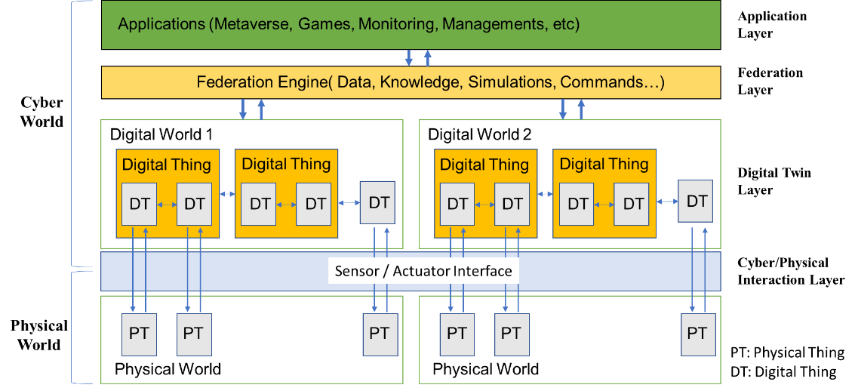
Fig. 1. Physical and Cyber World Interaction [1]

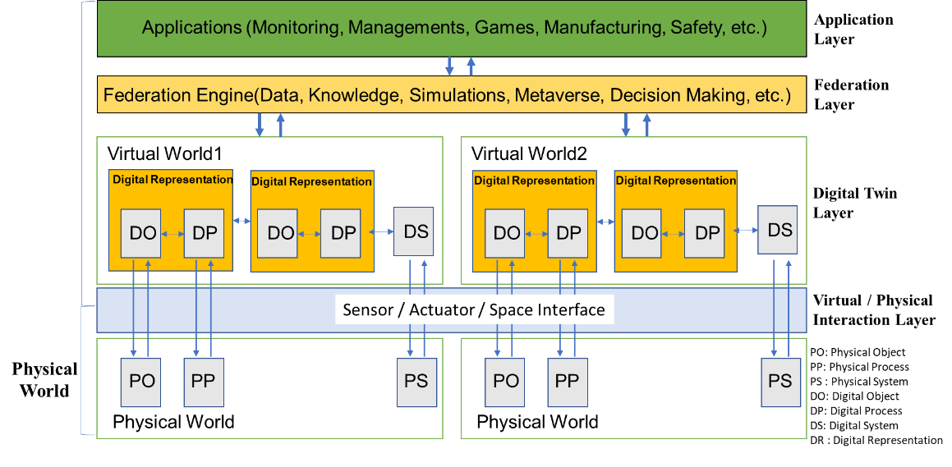
Fig. 2. Virtual and Cyber World Interaction (Our proposal)

Conclusion
There was some discussion on the terminology in digital twins in the last meeting. In this contribution In this contribution, we summarized some definition of digital twins suggested by others and comment for the terminology for further discussion.

Reference
[1] IEEE P2888.3 “Draft Standard on Orchestration of Digital Synchronization between Cyber and Physical Worlds”, July 2021

[2] IEEE2888, “Session 7 2888.3 TG Meeting Summary”, 2021.07.01
[3] ITU-T SG13/Q22 Draft new Recommendation ITU-T Y.DTN-ReqArch: "Requirements and Architecture of Digital Twin Network", 2021.07.13
[4] Grieves, M. (2014). Digital Twin: Manufacturing Excellence Through Virtual Factory Replication. Whitepaper. https://doi.org/10.5281/zenodo.1493930

