P<2888.4>™/D<01>
Draft <Std.> for <Architecture for Virtual Reality Disaster Response Training System with Six degrees of Freedom (6DoF)>
Developed by the

< Interfacing Cyber and Physical World Working Group>
of the
IEEE <Computer Society>

Approved <Date Approved>

IEEE SA Standards Board

Copyright © 2021 by The Institute of Electrical and Electronics Engineers, Inc.
Three Park Avenue
New York, New York 10016-5997, USA
All rights reserved.
This document is an unapproved draft of a proposed IEEE Standard. As such, this document is subject to change. USE AT YOUR OWN RISK! IEEE copyright statements SHALL NOT BE REMOVED from draft or approved IEEE standards, or modified in any way. Because this is an unapproved draft, this document must not be utilized for any conformance/compliance purposes. Permission is hereby granted for officers from each IEEE Standards Working Group or Committee to reproduce the draft document developed by that Working Group for purposes of international standardization consideration. IEEE Standards Department must be informed of the submission for consideration prior to any reproduction for international standardization consideration (stds.ipr@ieee.org). Prior to adoption of this document, in whole or in part, by another standards development organization, permission must first be obtained from the IEEE Standards Department (stds.ipr@ieee.org). When requesting permission, IEEE Standards Department will require a copy of the standard development organization's document highlighting the use of IEEE content. Other entities seeking permission to reproduce this document, in whole or in part, must also obtain permission from the IEEE Standards Department.
IEEE Standards Department
445 Hoes Lane
Piscataway, NJ 08854, USA

Abstract: <Select this text and type or paste Abstract—contents of the Scope may be used> -

- Architecture for Virtual Reality Disaster Response Training System with Six degrees of Freedom (6DoF) is defined.
- (Scope version) This standard defines to provide a standard architecture of a system used when creating VR content for training in preparation for disaster situations that are difficult to implement in the real world.

Keywords: <Select this text and type or paste keywords>
Keywords: Large space, Disaster, VR, Virtual Reality, Training, Motion Tracking, Architecture


Important Notices and Disclaimers Concerning IEEE Standards Documents
IEEE Standards documents are made available for use subject to important notices and legal disclaimers. These notices and disclaimers, or a reference to this page (https://standards.ieee.org/ipr/disclaimers.html), appear in all standards and may be found under the heading “Important Notices and Disclaimers Concerning IEEE Standards Documents.”

Notice and Disclaimer of Liability Concerning the Use of IEEE Standards Documents
IEEE Standards documents are developed within the IEEE Societies and the Standards Coordinating Committees of the IEEE Standards Association (IEEE SA) Standards Board. IEEE develops its standards through an accredited consensus development process, which brings together volunteers representing varied viewpoints and interests to achieve the final product. IEEE Standards are documents developed by volunteers with scientific, academic, and industry-based expertise in technical working groups. Volunteers are not necessarily members of IEEE or IEEE SA, and participate without compensation from IEEE. While IEEE administers the process and establishes rules to promote fairness in the consensus development process, IEEE does not independently evaluate, test, or verify the accuracy of any of the information or the soundness of any judgments contained in its standards.
IEEE makes no warranties or representations concerning its standards, and expressly disclaims all warranties, express or implied, concerning this standard, including but not limited to the warranties of merchantability, fitness for a particular purpose and non-infringement. In addition, IEEE does not warrant or represent that the use of the material contained in its standards is free from patent infringement. IEEE standards documents are supplied “AS IS” and “WITH ALL FAULTS.”
Use of an IEEE standard is wholly voluntary. The existence of an IEEE Standard does not imply that there are no other ways to produce, test, measure, purchase, market, or provide other goods and services related to the scope of the IEEE standard. Furthermore, the viewpoint expressed at the time a standard is approved and issued is subject to change brought about through developments in the state of the art and comments received from users of the standard.
In publishing and making its standards available, IEEE is not suggesting or rendering professional or other services for, or on behalf of, any person or entity, nor is IEEE undertaking to perform any duty owed by any other person or entity to another. Any person utilizing any IEEE Standards document, should rely upon his or her own independent judgment in the exercise of reasonable care in any given circumstances or, as appropriate, seek the advice of a competent professional in determining the appropriateness of a given IEEE standard.
IN NO EVENT SHALL IEEE BE LIABLE FOR ANY DIRECT, INDIRECT, INCIDENTAL, SPECIAL, EXEMPLARY, OR CONSEQUENTIAL DAMAGES (INCLUDING, BUT NOT LIMITED TO: THE NEED TO PROCURE SUBSTITUTE GOODS OR SERVICES; LOSS OF USE, DATA, OR PROFITS; OR BUSINESS INTERRUPTION) HOWEVER CAUSED AND ON ANY THEORY OF LIABILITY, WHETHER IN CONTRACT, STRICT LIABILITY, OR TORT (INCLUDING NEGLIGENCE OR OTHERWISE) ARISING IN ANY WAY OUT OF THE PUBLICATION, USE OF, OR RELIANCE UPON ANY STANDARD, EVEN IF ADVISED OF THE POSSIBILITY OF SUCH DAMAGE AND REGARDLESS OF WHETHER SUCH DAMAGE WAS FORESEEABLE.

Translations
The IEEE consensus development process involves the review of documents in English only. In the event that an IEEE standard is translated, only the English version published by IEEE is the approved IEEE standard.

Official statements
A statement, written or oral, that is not processed in accordance with the IEEE SA Standards Board Operations Manual shall not be considered or inferred to be the official position of IEEE or any of its committees and shall not be considered to be, nor be relied upon as, a formal position of IEEE. At lectures, symposia, seminars, or educational courses, an individual presenting information on IEEE standards shall make it clear that the presenter’s views should be considered the personal views of that individual rather than the formal position of IEEE, IEEE SA, the Standards Committee, or the Working Group.

Comments on standards
Comments for revision of IEEE Standards documents are welcome from any interested party, regardless of membership affiliation with IEEE or IEEE SA. However, IEEE does not provide interpretations, consulting information, or advice pertaining to IEEE Standards documents.
Suggestions for changes in documents should be in the form of a proposed change of text, together with appropriate supporting comments. Since IEEE standards represent a consensus of concerned interests, it is important that any responses to comments and questions also receive the concurrence of a balance of interests. For this reason, IEEE and the members of its Societies and Standards Coordinating Committees are not able to provide an instant response to comments, or questions except in those cases where the matter has previously been addressed. For the same reason, IEEE does not respond to interpretation requests. Any person who would like to participate in evaluating comments or in revisions to an IEEE standard is welcome to join the relevant IEEE working group. You can indicate interest in a working group using the Interests tab in the Manage Profile & Interests area of the IEEE SA myProject system. An IEEE Account is needed to access the application.
Comments on standards should be submitted using the Contact Us form.

Laws and regulations
Users of IEEE Standards documents should consult all applicable laws and regulations. Compliance with the provisions of any IEEE Standards document does not constitute compliance to any applicable regulatory requirements. Implementers of the standard are responsible for observing or referring to the applicable regulatory requirements. IEEE does not, by the publication of its standards, intend to urge action that is not in compliance with applicable laws, and these documents may not be construed as doing so.

Data privacy
Users of IEEE Standards documents should evaluate the standards for considerations of data privacy and data ownership in the context of assessing and using the standards in compliance with applicable laws and regulations.

Copyrights
IEEE draft and approved standards are copyrighted by IEEE under US and international copyright laws. They are made available by IEEE and are adopted for a wide variety of both public and private uses. These include both use, by reference, in laws and regulations, and use in private self-regulation, standardization, and the promotion of engineering practices and methods. By making these documents available for use and adoption by public authorities and private users, IEEE does not waive any rights in copyright to the documents.

Photocopies
Subject to payment of the appropriate licensing fees, IEEE will grant users a limited, non-exclusive license to photocopy portions of any individual standard for company or organizational internal use or individual, non-commercial use only. To arrange for payment of licensing fees, please contact Copyright Clearance Center, Customer Service, 222 Rosewood Drive, Danvers, MA 01923 USA; +1 978 750 8400; https://www.copyright.com/. Permission to photocopy portions of any individual standard for educational classroom use can also be obtained through the Copyright Clearance Center.

Updating of IEEE Standards documents
Users of IEEE Standards documents should be aware that these documents may be superseded at any time by the issuance of new editions or may be amended from time to time through the issuance of amendments, corrigenda, or errata. An official IEEE document at any point in time consists of the current edition of the document together with any amendments, corrigenda, or errata then in effect.
Every IEEE standard is subjected to review at least every 10 years. When a document is more than 10 years old and has not undergone a revision process, it is reasonable to conclude that its contents, although still of some value, do not wholly reflect the present state of the art. Users are cautioned to check to determine that they have the latest edition of any IEEE standard.
In order to determine whether a given document is the current edition and whether it has been amended through the issuance of amendments, corrigenda, or errata, visit IEEE Xplore or contact IEEE. For more information about the IEEE SA or IEEE’s standards development process, visit the IEEE SA Website.

Errata
Errata, if any, for all IEEE standards can be accessed on the IEEE SA Website. Search for standard number and year of approval to access the web page of the published standard. Errata links are located under the Additional Resources Details section. Errata are also available in IEEE Xplore. Users are encouraged to periodically check for errata.

Patents
IEEE Standards are developed in compliance with the IEEE SA Patent Policy.
Attention is called to the possibility that implementation of this standard may require use of subject matter covered by patent rights. By publication of this standard, no position is taken by the IEEE with respect to the existence or validity of any patent rights in connection therewith. If a patent holder or patent applicant has filed a statement of assurance via an Accepted Letter of Assurance, then the statement is listed on the IEEE SA Website at https://standards.ieee.org/about/sasb/patcom/patents.html. Letters of Assurance may indicate whether the Submitter is willing or unwilling to grant licenses under patent rights without compensation or under reasonable rates, with reasonable terms and conditions that are demonstrably free of any unfair discrimination to applicants desiring to obtain such licenses.
Essential Patent Claims may exist for which a Letter of Assurance has not been received. The IEEE is not responsible for identifying Essential Patent Claims for which a license may be required, for conducting inquiries into the legal validity or scope of Patents Claims, or determining whether any licensing terms or conditions provided in connection with submission of a Letter of Assurance, if any, or in any licensing agreements are reasonable or non-discriminatory. Users of this standard are expressly advised that determination of the validity of any patent rights, and the risk of infringement of such rights, is entirely their own responsibility. Further information may be obtained from the IEEE Standards Association.

IMPORTANT NOTICE
IEEE Standards do not guarantee or ensure safety, security, health, or environmental protection, or ensure against interference with or from other devices or networks. IEEE Standards development activities consider research and information presented to the standards development group in developing any safety recommendations. Other information about safety practices, changes in technology or technology implementation, or impact by peripheral systems also may be pertinent to safety considerations during implementation of the standard. Implementers and users of IEEE Standards documents are responsible for determining and complying with all appropriate safety, security, environmental, health, and interference protection practices and all applicable laws and regulations.

Participants
At the time this draft <std.> was completed, the <Working Group Name> Working Group had the following membership:
Jeonghwan Choi, Chair
HyeonWoo Nam,, Technical Editor

Kyoungro Yoon
Sang-Kyun Kim
JaeYeong Kim
Participant5
Participant6
Participant7
Participant8
Participant9

The following members of the <individual/entity> Standards Association balloting group voted on this <gde./rec. prac./std.>. Balloters may have voted for approval, disapproval, or abstention.
[To be supplied by IEEE]

Balloter1
Balloter2
Balloter3
Balloter4
Balloter5
Balloter6
Balloter7
Balloter8
Balloter9

When the IEEE SA Standards Board approved this <gde./rec. prac./std.> on <Date Approved>, it had the following membership:
[To be supplied by IEEE]

<Name>, Chair
<Name>, Vice Chair
<Name>, Past Chair
Konstantinos Karachalios, Secretary

SBMember1
SBMember2
SBMember3
SBMember4
SBMember5
SBMember6
SBMember7
SBMember8
SBMember9

*Member Emeritus

Introduction
This introduction is not part of P<2888.4>/D<01>, Draft <Std> for <Architecture for Virtual Reality Disaster Response Training System with Six degrees of Freedom (6DoF) PAR>.
<Select this text and type or paste introduction text>

Contents
<After draft body is complete, select this text and click Insert Special->Add (Table of) Contents>
1. Overview ...................................................................................................................
1.1 Scope ....................................................................................................
1.2 Purpose ...........................................................................................
1.3 Word usage.......................................................................................................................
2. Normative references.......................................................................................................
3. Definitions, acronyms, and abbreviations ........................................................................
3.1 Definitions .....................................................................................
3.2 Acronyms and abbreviations .................................................................................
4. General Architecture ................................................................................
4.1 Introduction ..................................................................................................
4.2 General design principles ...................................................................................................

5. Large space VR Disaster Response Training System Design......................... ...........................
5.1 General ...............................................................................................................
5.2 General scope ....................................................................................................................
5.3 Use cases
5.4 Requirement ..................................................................................................... .................
6. Large space VR Disaster Response Training Content Design............................................
6.1 General .....................................................................................................
6.2 General scope .....................................................................................................
6.3 Use cases .....................................................................................................
6.4 Scenarios .....................................................................................................
7. Large space VR Disaster Response Training System Construction & Operation Guideline
7.1 General .....................................................................................................
7.2 General scope .....................................................................................................
7.3 Large space VR Disaster Response Training System Construction Guideline ................
7.4 Large space VR Disaster Response Training System Operation Guideline
Annex A(informative) Bibliography .....................................................................................................

Draft < Std.> for <Architecture for Virtual Reality Disaster Response Training System with Six degrees of Freedom (6DoF) PAR>

- Overview
  - Scope
This standard defines a standard architecture for the technology required for “building a large space-based disaster response virtual reality training system” required to simulate a response to a disaster that can occur in a large-scale physical space by applying virtual reality technology.
1) Digital twin-based 6DOF configuration (6DOF sense of space) that delivers multiple sensor data from a wide real space to the virtual world to provide a realistic spatial experience in a virtual space
2) Large space VR Disaster Response Training System Design
3) Large space VR Disaster Response Training Content Design
4) Large space VR Disaster Response Training System Construction & Operation
  - Purpose

  - Word usage
<This subclause is mandatory and shall appear after the Scope and Purpose (if included).>
The word shall indicates mandatory requirements strictly to be followed in order to conform to the standard and from which no deviation is permitted (shall equals is required to).,
The word should indicates that among several possibilities one is recommended as particularly suitable, without mentioning or excluding others; or that a certain course of action is preferred but not necessarily required (should equals is recommended that).
The word may is used to indicate a course of action permissible within the limits of the standard (may equals is permitted to).
The word can is used for statements of possibility and capability, whether material, physical, or causal (can equals is able to).
- Normative references
The following referenced documents are indispensable for the application of this document (i.e., they must be understood and used, so each referenced document is cited in text and its relationship to this document is explained). For dated references, only the edition cited applies. For undated references, the latest edition of the referenced document (including any amendments or corrigenda) applies.
- Sensor gathering shall be in accordance with 2888.1. You just have to write the
~see 2888.2.
~see 2888.3.
- Definitions, acronyms, and abbreviations
  - Definitions
For the purposes of this document, the following terms and definitions apply. The IEEE Standards Dictionary Online should be consulted for terms not defined in this clause.
VR Walkthrough: A technology that allows users to experience virtual objects while walking in virtual reality space. Such technology provides superior experience of freedom, angle diversity and informational and interactive play compared to traditional methods of using controller-to-controller movement.
Disaster response training system: A system applied with technology that allows users to feel realistic in a virtual reality space with 6DoF freedom by walking freely.
Six degrees of freedom (6DoF): The freedom of movement of rigid body in three dimesional space including translational movements along each axis and rotaltional movements around each axis. 6DoF can be used to describe rotational movements (roll, pitch, yaw) and translational movements (forward/back, left/right, up/down).
Six degrees of freedom (6DOF): Six operating elements of a moving object in three dimensional space. 6DOF can be used to describe rotational movements (roll, pitch, yaw) and translational movements (forward/back, left/right, up/down). ( http://dictionary.ieee.org. )
VR (Virtual Reality): A technology that creates a virtual world with a sense of reality on a computer.
VR (Virtual Reality): Refers to any specific environment, situation, or technology that either simulates actual reality or creates virtual spaces and objects according to the imagination of humans using computer graphics or videos. ( http://dictionary.ieee.org. )
AR (Augmented Reality): A technology that overlaps the real world that users see with their eyes and displays virtual objects with additional information in real time in a single image.
MR (Mixed Reality): A realization technology that expresses by mutually augmenting real and virtual objects.
XR (eXtended Reality): An ultra-realistic technology and service that encompasses mixed reality (MR) technology that encompasses virtual reality (VR) and augmented reality (AR).
Metaverse: World in which the cyber world and the physical world interact and resonate to create values through social, economic, and cultural activities.
Realistic Content: Digital content that can recognize and analyze human behavior such as human gestures, movements, and voices using various sensors and interact with objects in the content while feeling real.
Framework: A system that provides functions in a series of collaborative forms so that designs and implementations corresponding to a specific part of software can be reused.
Interaction: An activity in which characters and objects of content induce feedback such as movement, sound, and manipulation according to the user's action.
Motion tracking: A technique for tracking people moving in real space and applying them to characters in virtual space.
Optical cameras: A camera used to track human motion by projecting an object to the same point from at least two cameras and then inverting the three-dimensional coordinates of the object through triangulation.
IoT(Internet of things): Technique that connects to internet using sensor and communication function built into various things.
HMD (Head Mounted Display): A display device that is combined with 3D display technology and worn mainly on the head for virtual reality or augmented reality implementation. It is a display device equipped with sunglasses-type lenses made of light and thin materials such as LCD and OLED so that objects can be seen from the closest place by mounting them on the head.
Digital twin system: A system that enables the real world to connect and interact with each other by implementing machines, equipment, and objects in the real world equally in the virtual world in the computer.
Haptics: A technology used to verify product design and process design, allowing users to feel reactions or loads to movement using devices that can feel the touch in virtual space.
Tracking server: A server that provides information on the location and direction of objects and people collected from various tracking sensors.
Tracking marker: A marker for recognizing by attaching it to an object or human body to be tracked in a motion capture system. The 'passive marker' is covered with a material that reflects infrared rays generated by the IR camera, and the 'active marker' uses the flashing of the LED itself.
VR Backpack PC: A backpack-shaped PC equipped with high-performance CPUs and GPUs and powered by batteries so that users can freely move around virtual spaces and run VR content with stable frames.
Calibration: A technology that provides more accurate motion tracking by calculating the position and direction of each IR camera used for motion tracking and the degree of distortion of the captured image. These calculations should be performed periodically due to ambient factors such as temperature fluctuations or other environmental conditions that may naturally degrade calibration accuracy over time.
Rigidbody: A collection of three or more markers on objects interconnected with each other, assuming that objects tracked by the IR camera are impossible to deform. Each object can be distinguished by a pattern of three or more markers.
Latency: The delayed time occurring at the runtime of content (e.g., game or simulation) that appears on the screen as a result value when a user performs a task or task.
IMU(Inertial Measurement Unit): A unit device that measure power, angle and ratio using accelerometer and tachometer.
Gloves: Devices for tracking hands
Accelerometer: A sensor for measuring linear acceleration or angular acceleration by measuring inertia-induced reaction.
Device Controller: A physical device that generates an interactive elements in a virtual space through a physical input signal.
Physical space: A space of reality where a substance or object may exist or something can happen.
Virtual space: A space created virtually by computers and the Internet and is not a real world.
Vitual Object: Objects for interaction in virtual space.

  - Acronyms and abbreviations
fps frame per second
HMD head-mounted display
IMU inertial measurement unit
6DoF six degrees of freedom
VR virtual reality
AR augmented Reality
MR mixed reality
XR extended reality

4.General Architecture
4.1.Introduction
4.1.1.General
This standard describes: In a virtual reality space composed of a three-dimensional digital space, all movements are projected as they are in the real space, and the following four factors must be met as important factors to consider in order to feel immersive that you are walking naturally like in reality. .
1) Digital twin-based 6DOF configuration (6DOF sense of space) that delivers multiple sensor data from a wide real space to the virtual world to provide a realistic spatial experience in a virtual space
2) Large space VR Disaster Response Training System Design
3) Large space VR Disaster Response Training Content Design
4) Large-space VR Disaster Response Training System Construction & Operation Guideline

This standard enables the realization of digital twin technology in which the information of physical behavior in the real space that makes the above four possible can be delivered to the virtual world as it is, and it is a technology developed to move on foot using a wide space “large space virtual reality walk” It is based on a “through system”.
In general, it is difficult to use content while moving in VR without the constraints of space like reality. A space plan is needed to allow the use of a large virtual reality space in a somewhat limited real space. As such, the 6DOF sense of space like in reality, interaction technology in the virtual world and walking movement, and digital twin technology that connects reality and virtual reality will be of great help in realizing virtual reality contents in response to disasters that can occur in large-scale physical spaces. is. The following subsections provide an overview of these areas.
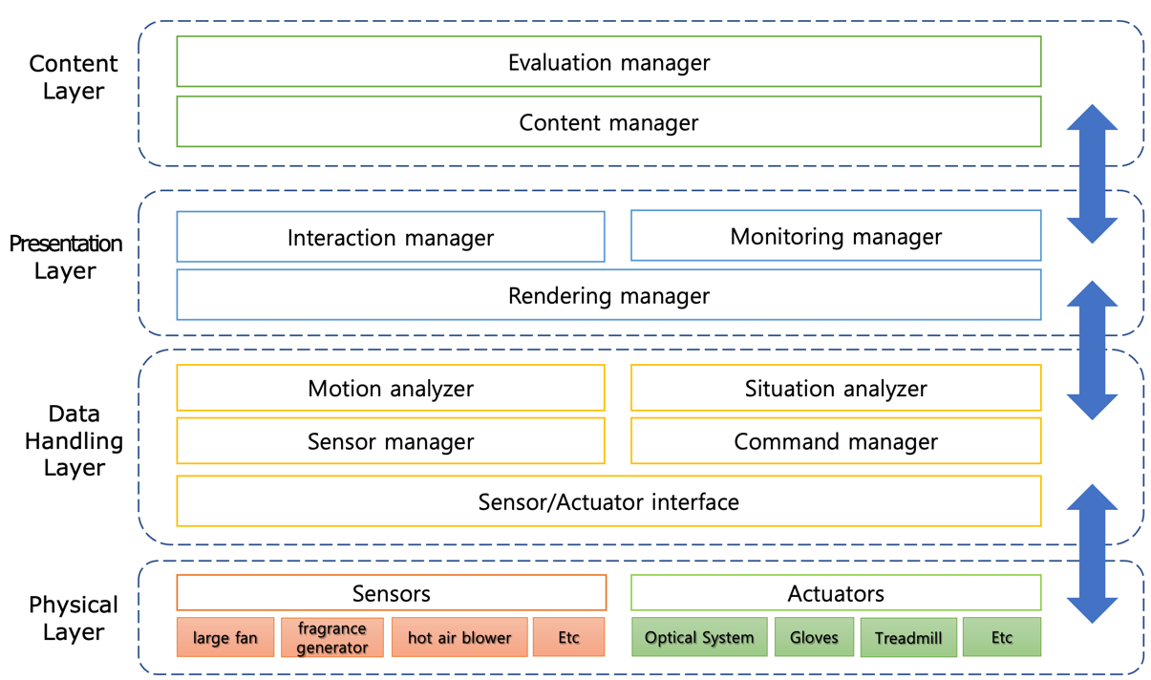
<Reference architecture of a digital twin 6DOF disaster response system>
4.1.2.6DOF
4.1.3.Large space VR Disaster Response Training System Design
4.1.4.Large space VR Disaster Response Training Content Design
4.1.5.Large space VR Disaster Response Training System Construction & Operation Guideline

4.2.General design principles
4.2.1.6DOF
4.2.2.Large space VR Disaster Response Training System Design
4.2.3.Large space VR Disaster Response Training Content Design
4.2.4.Large space VR Disaster Response Training System Construction & Operation Guideline

5. Large space VR Disaster Response Training System Design

5.1.General

5.2.General scope
To develop the object recognition module in the large space for the disaster response training system, the following detailed development goals are derived
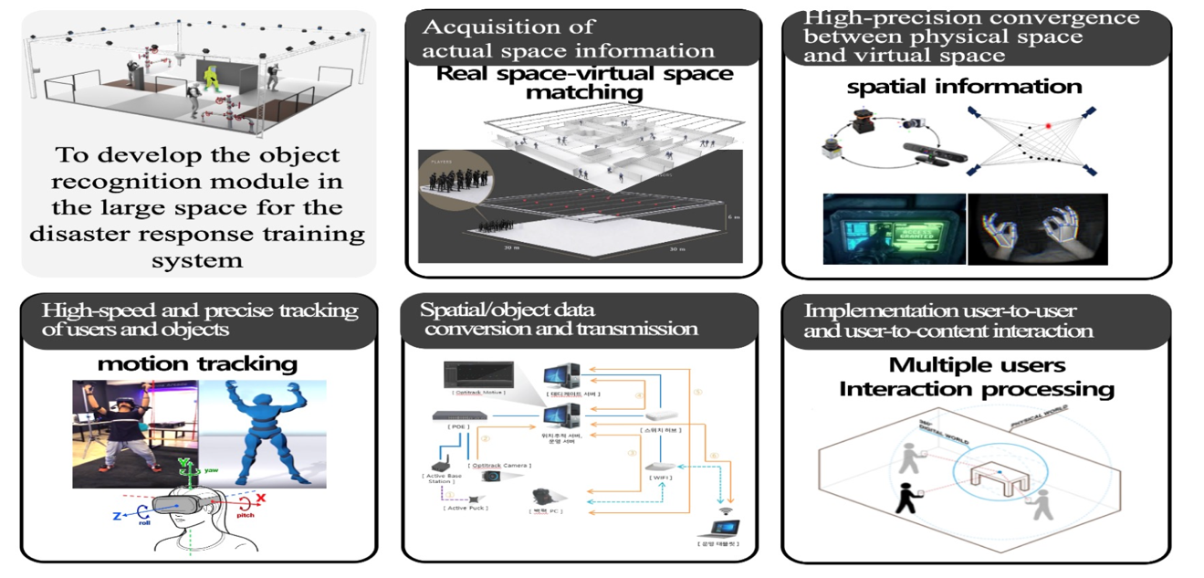
<2 Large space VR Walk through System>
1. Acquisition of actual space information
2. Spatial/object data conversion and transmission
3. High-speed and precise tracking of users and objects
4. High-precision convergence between physical space and virtual space
5. Implementation user-to-user and user-to-content interaction

5.3.Use cases

5.3.1.Use cases of Large space VR Walk through System
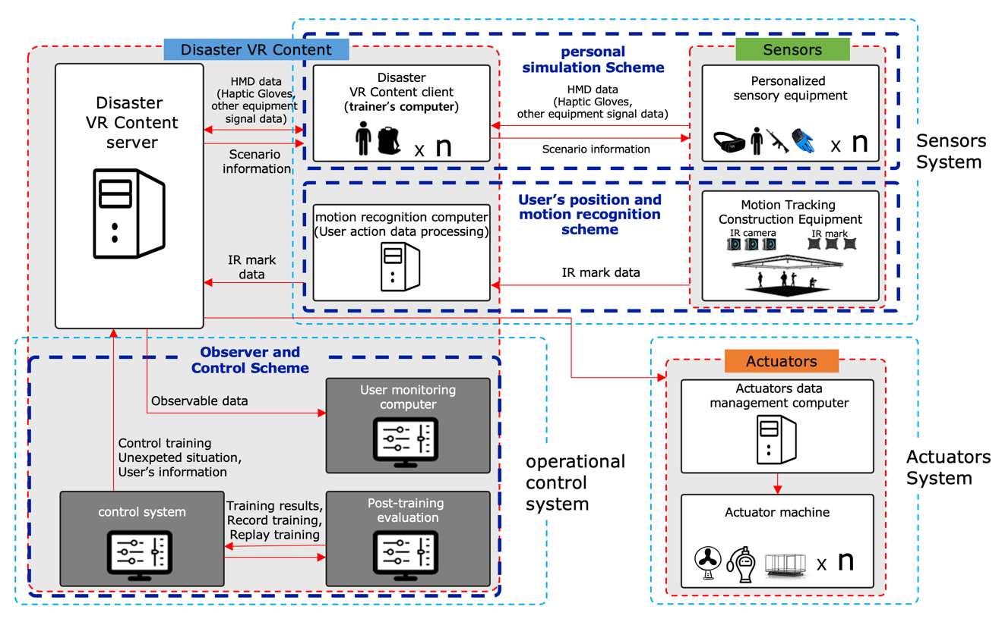
<Use cases of Large space VR Walk through System>

- In the Sensors part, the data obtained from the position and motion recognition sensors are delivered to Disaster VR Content clients through the sensor data converter.
- In the Disaster VR Content part, the data received from the Sensor part is reflected to the content client, and the Disaster Anlayzer sends it to the Actuators part through the Command Data Converter.
- (Also the observer is a client too, it does not receive sensor data and reflects the user's position and motion to the observer in real time.)
- In the Actuators part, the data received from the Disaster VR Content part is operated through the Command Data converter.

5.3.2.Large space VR Disaster Response Training System of User Tracking Use case

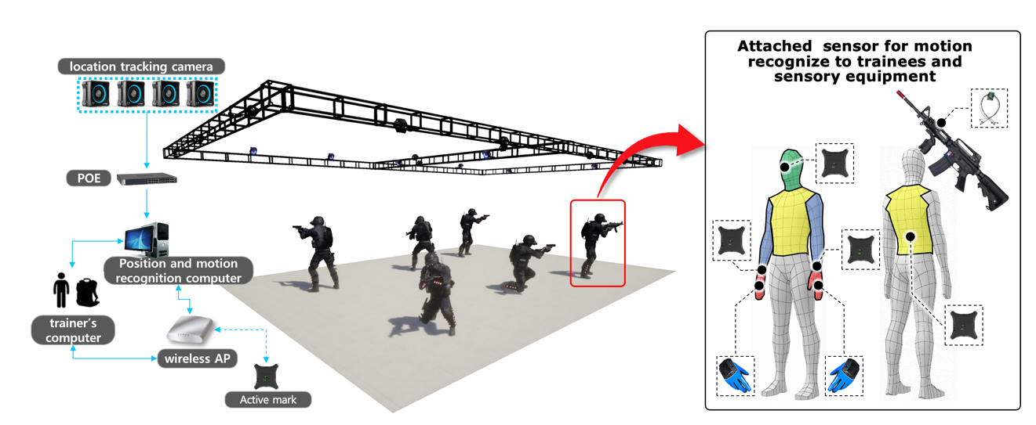

- It is possible to check the sensory equipment data that is converted according to the user's interaction by enhancing the matching precision between the real space and the VR space.
- Based on 3D spatial location information matching technology, direct interaction is possible by matching the location of objects in the real space with the 3D virtual image in the virtual space using sensory equipment.
- It proceeds to enable precise tracking by attaching a marker that can recognize the location and motion to the user.
- Motion sensors are attached to the location of the user's head, upper body, arms, and HMD is worn to enable walking like in real life, providing a maximized sense of reality like a real situation.

5.4.Requirement

6. Large space VR Disaster Response Training Content Design

6.1.General

6.2.General scope

6.3.Use cases

6.3.1.Chemical Accident Disaster Prevention Training System

- Example of development of a virtual reality training program capable of chemical accident disaster prevention training

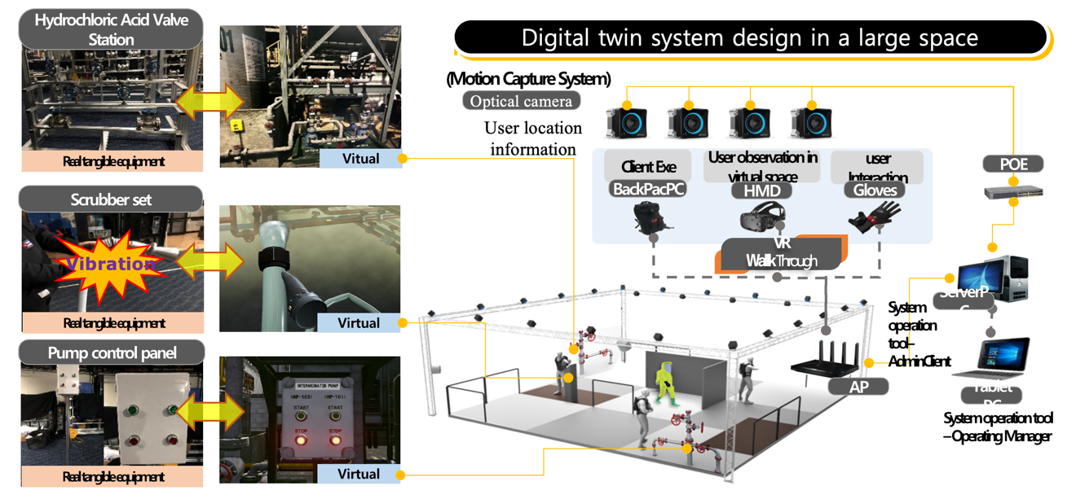
<Large-space chemical accident response training system>

- Establishment of a large space virtual environment based on actual chemical facilities
- Applied haptic VR technology based on real-time user location/motion tracking
- Development of training scenarios for collaboration with 4-5 people and design of multi-user flow
- Accurate interaction between real tangible equipment and virtual equipment is applied
- Establish a training evaluation system using data of users in a large space acquired during training

- Matching real objects and objects in virtual space

- It is a technology that allows users to feel the sense of touch by matching real objects with virtual objects. It provides objects that can be touched in real space, and it provides excellent immersion to users by matching the objects in various forms in the virtual space. .

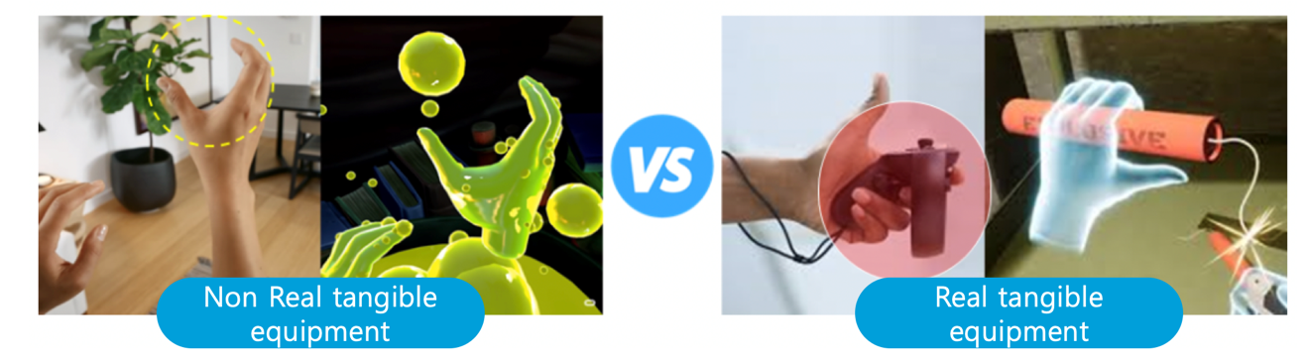
<Matching real and virtual objects>

- By adding a vibration function or button to an actual object, you can provide feedback on the interaction to the user in the form of vibration.
- As shown in the picture above, real objects can be expressed in various forms in virtual space, so you can freely express them according to the purpose and purpose of the content.

- Benefit

- By giving various shapes and functions to one object in the real space to be matched, there is no need to produce objects according to functions, so development cost is reduced.
- In reality, objects with problems such as cost and size can be implemented in virtual space, so it is possible to provide various experiences to users.

6.3.2.Public security response training system linked with large space & actuator

- Example of system development
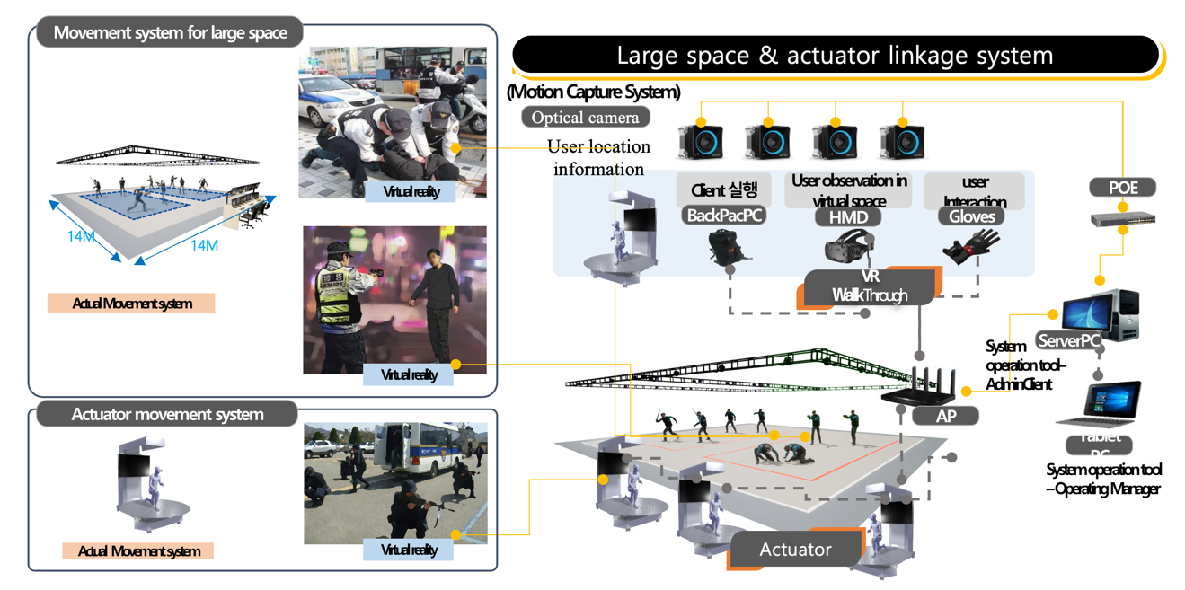
<Public security response training system linked with large space & actuator>

- Building a virtual environment at the actual measurement level of practical security incidents of natural walking movement based on large space
- Long-distance travel is built with actuator movement system
- Application of tangible VR technology based on real-time user location/motion tracking
- Developing collaborative training scenarios and designing multi-user movement lines by interlocking large spaces and actuators
6.4.Scenarios

7. Large space VR Disaster Response Training System Construction & Operation Guideline

7.1.General

7.2.General scope

7.3. Large space VR Disaster Response Training System Construction Guideline

7.4. Large space VR Disaster Response Training System Operation Guideline

(informative)Bibliography
Bibliographical references are resources that provide additional or helpful material but do not need to be understood or used to implement this standard. Reference to these resources is made for informational use only.

The Institute of Electrical and Electronics Engineers, Inc. 3 Park Avenue, New York, NY 10016-5997, USA Copyright © 2020 by The Institute of Electrical and Electronics Engineers, Inc. All rights reserved. Published <Date Published>. Printed in the United States of America. IEEE is a registered trademark in the U.S. Patent & Trademark Office, owned by The Institute of Electrical and Electronics Engineers, Incorporated. PDF: ISBN 978-0-XXXX-XXXX-X STDXXXXX Print: ISBN 978-0-XXXX-XXXX-X STDPDXXXXX IEEE prohibits discrimination, harassment, and bullying. For more information, visit https://www.ieee.org/about/corporate/governance/p9-26.html. No part of this publication may be reproduced in any form, in an electronic retrieval system or otherwise, without the prior written permission of the publisher.
The use of the word must is deprecated and cannot be used when stating mandatory requirements, must is used only to describe unavoidable situations.
The use of will is deprecated and cannot be used when stating mandatory requirements, will is only used in statements of fact.
IEEE Standards Dictionary Online is available at: http://dictionary.ieee.org. An IEEE Account is required for access to the dictionary, and one can be created at no charge on the dictionary sign-in page.

