Project | Standard on Orchestration of Digital Synchronization between Cyber and Physical World  <https://sagroups.ieee.org/2888/ >
Title | Proposal for Behavior of the Digital Entity Associated with Physical Entity
DCN | 2888-21-0044-01-0003
Date Submitted | June 29, 2021
Source(s) | Tai-Gil Kwon tgkwon@keti.re.kr (Korea Electronics Technology Institute),  Changseok Yoon csyoon@keti.re.kr (Korea Electronics Technology Institute),  Tae-Beom Lim tblim@keti.re.kr (Korea Electronics Technology Institute),  Kyoungro Yoon yoonk@konkuk.ac.kr (Konkuk University)  Kwanghyun Ro khrho@hansung.ac.kr(Hansung University)
Re:
Abstract
Purpose | To discuss and define the behavior of digital entity associated with physical entity
Notice | This document has been prepared to assist the IEEE 2888 Working Group. It is offered as a basis for discussion and is not binding on the contributing individual(s) or organization(s). The material in this document is subject to change in form and content after further study. The contributor(s) reserve(s) the right to add, amend or withdraw material contained herein.
Release | The contributor grants a free, irrevocable license to the IEEE to incorporate material contained in this contribution, and any modifications thereof, in the creation of an IEEE Standards publication; to copyright in the IEEE’s name any IEEE Standards publication even though it may include portions of this contribution; and at the IEEE’s sole discretion to permit others to reproduce in whole or in part the resulting IEEE Standards publication. The contributor also acknowledges and accepts that IEEE 2888 may make this contribution public.
Patent Policy | The contributor is familiar with IEEE patent policy, as stated in Section 6 of the IEEE-SA Standards Board bylaws <http://standards.ieee.org/guides/bylaws/sect6-7.html#6> and in Understanding Patent Issues During IEEE Standards Development http://standards.ieee.org/board/pat/faq.pdf

Introduction

A digital twin is expressed in the digital world by abstracting the information representing the properties and behaviors of the entity in order to replicate the physical entity in the digital world. The properties of an entity represent various types of information such as identifier and relationships, and the behaviors of an entity means functions, actions, and works. In particular, the behaviors of an entity can be defined as several fragmentary behaviors without overlapping, and it is also possible to create new behaviors that can perform complex missions by combining these behaviors.

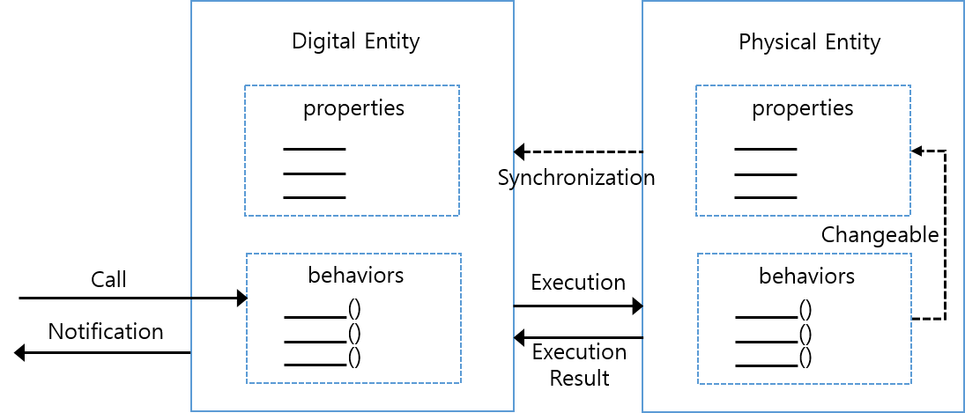
Fig. 1 The concept of the behavior of a digital entity associated with a physical entity.

Each of the behaviors defined in the digital entity should be mapped one-to-one with the functions, actions, and works included in the physical entity, and the behaviors of the digital entity can be accessed from application. By doing so, it should be possible to control the behavior of physical entities. a digital entity sends commands to the physical entity that can execute a specific behavior of the physical entity. The physical entity that receives the command executes the execution command, and then notify the execution result to the application through a digital entity. If the property of the physical entity is changed according to a specific command while the physical entity executes the execution command, the property of the digital entity may also be automatically changed through the synchronization mechanism.

Behavior of digital entity

Overview

By expressing the unique functions, actions, and works of a physical entity as behaviors on the digital entity, it is possible to control or manage the physical entity through the digital entity outside the digital entity.

Conclusion

In this proposal, we propose the concept of how to express behavioral elements such as functions, actions, and works of physical entity in the digital world. However, it does not deal with the interface contents for the execution and synchronization between digital entity and physical entity related to this.

