hProject | Specification of Digital Synchronization Framework between Cyber and Physical World  <https://sagroups.ieee.org/2888/3 >
Title | Proposal for Defining the Requirements of Digital Synchronization Framework
DCN | 2888-21-0043-00-0003
Date Submitted | June 29, 2021
Source(s) | Changseok Yoon csyoon@keti.re.kr (Korea Electronics Technology Institute),  Tai-Gil Kwon tgkwon@keti.re.kr (Korea Electronics Technology Institute)  Tae-Beom Lim tblim@keti.re.kr (Korea Electronics Technology Institute),  Kyoungro Yoon yoonk@konkuk.ac.kr (Konkuk University)
Re:
Abstract
Purpose | To discuss and define digital models’ structure for the framework of the standard
Notice | This document has been prepared to assist the IEEE 2888 Working Group. It is offered as a basis for discussion and is not binding on the contributing individual(s) or organization(s). The material in this document is subject to change in form and content after further study. The contributor(s) reserve(s) the right to add, amend or withdraw material contained herein.
Release | The contributor grants a free, irrevocable license to the IEEE to incorporate material contained in this contribution, and any modifications thereof, in the creation of an IEEE Standards publication; to copyright in the IEEE’s name any IEEE Standards publication even though it may include portions of this contribution; and at the IEEE’s sole discretion to permit others to reproduce in whole or in part the resulting IEEE Standards publication. The contributor also acknowledges and accepts that IEEE 2888 may make this contribution public.
Patent Policy | The contributor is familiar with IEEE patent policy, as stated in Section 6 of the IEEE-SA Standards Board bylaws <http://standards.ieee.org/guides/bylaws/sect6-7.html#6> and in Understanding Patent Issues During IEEE Standards Development http://standards.ieee.org/board/pat/faq.pdf

Introduction
The digital twin framework should provide a framework that can sufficiently describe and manage the objects in virtual world and interactions with object in physical world for constructing a Cyber Physical System (CPS) or Digital Twin System (DTS).
Each physical thing should be effectively converting into digital thing and interact through this framework, and it should be possible to effectively describe the virtual world by determining the effective physical object unit according to the purpose and combining them appropriately according to the relationship.
In addition, each generated virtual world should provide a connection to enable interaction, enabling federated, synchronized, and interactive operation between multiple virtual worlds to enable multi-disciplinary decision making.
A digital object must contain all physical, relational, and intelligent information of a physical object so that it can operate independently in virtual space even when the connection with the physical device is disconnected, and can synchronize the state when the connection is restored.
In this document, we propose common requirements of digital synchronization framework to realize the above-mentioned functions. In other words, we describe the creation and management of digital thing entity that is the basis of the cyber world.

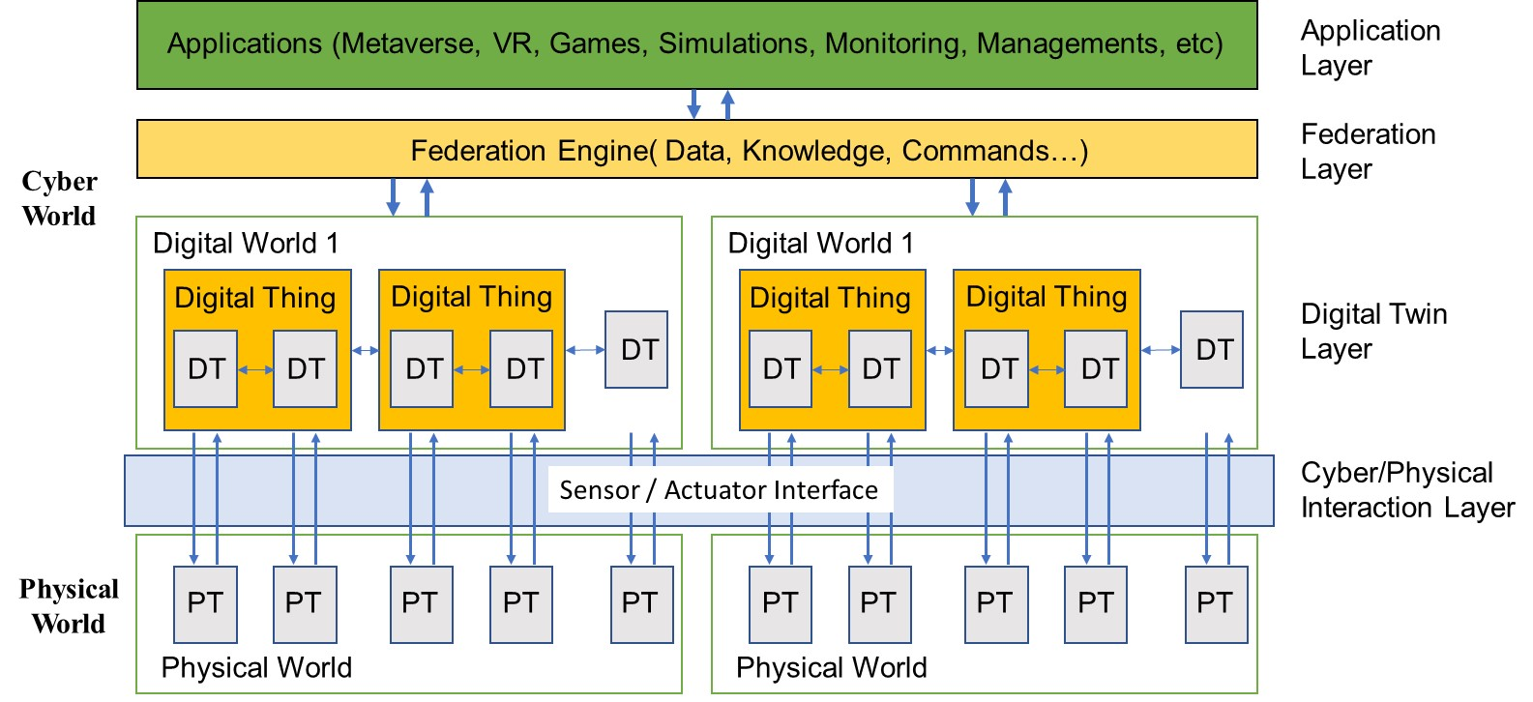
Fig. 1 Configuration of Physical and Cyber World
q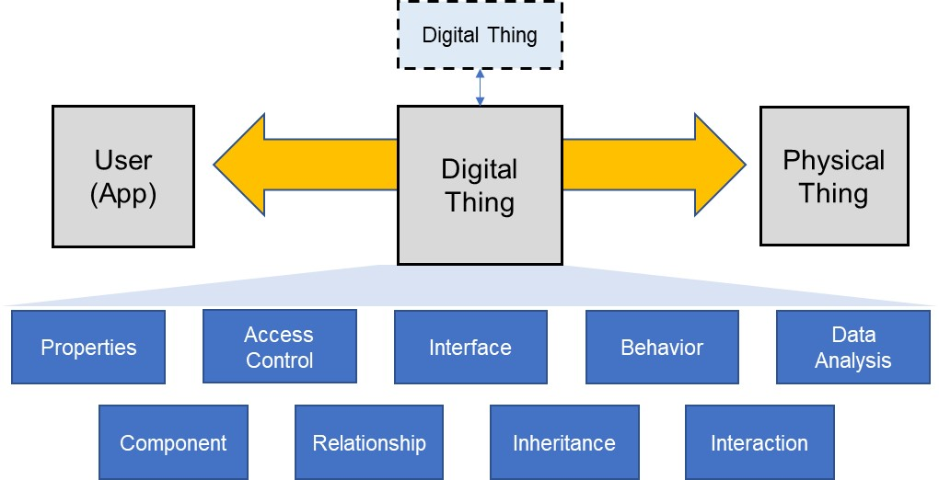
Fig. 2 The requirements for digital synchronization
In this proposal, we suggest the “Common Requirement” concept between the digital objects that can be used for categorizing digital twin entities.

Common Requirements

Overview
The link is the flexible classification structure to represent common requirements for the digital synchronization between cyber and physical world.

    - General
This subclause describes the common requirement for digital synchronization framework.
    - Interfaces between physical and digital objects
The digital object is required to include the sensor and actuator interface to enable interaction with external physical objects. An interface adapter is introduced so that data can be transmitted through a defined interface in the physical object, and through this, it is connected to the inside of the physical thing.
    - Access control policy
Each digital object must have a basic element defining access control. Access control capacity should be able to selectively control access according to the access level as well as the owner who owns the object. For example, it should be possible to include the Read function but not the Write function. Or, it should be possible to control each function as well. (User, Access Control, Partial)
    - Digital object property
As a characteristic value of an individual object, it can have a value regardless of whether it is connected to the Sensor/Actuator Interface, and has a parameter and a corresponding value. The user can collect or write the data of the property area of the digital object synchronized with the physical object through external access to this digital object.
    - Component for constructing the complex digital object
Each digital object may create a new digital object using a plurality of digital objects. As an element to compose this, a Component object representing an individual instance of another Digital Object is required. These components having the definition of the digital object as it is, and are included in the digital object in the form of sub-components and combined to create a new digital object.
    - Relationship between digital objects
Digital objects are related to each other and effective control is possible through this. Various types of relationships can exist, and basically, there can be relationships with various semantic meanings as well as relationships such as group and link.
    - Digital object inheritance
Each digital object may have similar characteristics, and individual digital objects must be reconstructed according to the situation. Digital objects should provide a function to extend the existing structure between objects so that they can be transformed and composed based on this.
    - Behavior for autonomous operation
This part is composed assuming the autonomous operation of individual digital objects, and through this, the operation can be configured effectively. Services Describes actions and reference links to provide services for each object. Motion service enables not only users but also voluntary actions for intelligent objects.

    - Data analysis for self-model update
It includes individual data processing tasks for updating the object internal model. It is not a passive model update involving users, but a digital twin object through voluntary model update. Through this, even if the model is not updated by performing external data analysis with the user, data can be collected from the physical object and the model can be continuously evolved through the data analysis function defined inside.

    - Interaction between digital objects
In cyber space, a specific action is performed using data from other digital objects that have a relationship with a specific digital object, or a specific reaction is performed by notifying other related digital objects when a change in the state of data occurs in a specific digital object. It can collect machine learning data necessary for autonomous judgment in the intelligent digital object from the general digital object

Conclusion
In this proposal, we have described the common requirement for composing digital objects in the virtual world. Digital objects first need parameters and values that reflect the characteristics of physical objects, and methods to effectively manage and extend them are needed. Also, methods and rules for interfacing it with the outside are needed. It should also be able to describe the relationship of each digital object. In addition, methods in which individual objects can operate independently should be proposed.

