Project | Specification of Digital Synchronization Framework between Cyber and Physical World  <https://sagroups.ieee.org/2888/3 >
Title | Proposal for Complex Digital Objects of the Digital Twin Framework
DCN | 2888-21-0042-00-0003
Date Submitted | June 29, 2021
Source(s) | Changseok Yoon csyoon@keti.re.kr (Korea Electronics Technology Institute),  Tai-Gil Kwon tgkwon@keti.re.kr (Korea Electronics Technology Institute)  Tae-Beom Lim tblim@keti.re.kr (Korea Electronics Technology Institute),  Kyoungro Yoon yoonk@konkuk.ac.kr (Konkuk University)
Re:
Abstract
Purpose | To discuss and define digital models’ structure for the framework of the standard
Notice | This document has been prepared to assist the IEEE 2888 Working Group. It is offered as a basis for discussion and is not binding on the contributing individual(s) or organization(s). The material in this document is subject to change in form and content after further study. The contributor(s) reserve(s) the right to add, amend or withdraw material contained herein.
Release | The contributor grants a free, irrevocable license to the IEEE to incorporate material contained in this contribution, and any modifications thereof, in the creation of an IEEE Standards publication; to copyright in the IEEE’s name any IEEE Standards publication even though it may include portions of this contribution; and at the IEEE’s sole discretion to permit others to reproduce in whole or in part the resulting IEEE Standards publication. The contributor also acknowledges and accepts that IEEE 2888 may make this contribution public.
Patent Policy | The contributor is familiar with IEEE patent policy, as stated in Section 6 of the IEEE-SA Standards Board bylaws <http://standards.ieee.org/guides/bylaws/sect6-7.html#6> and in Understanding Patent Issues During IEEE Standards Development http://standards.ieee.org/board/pat/faq.pdf

Introduction
A digital thing object is defined with various parameters and their values, properties and interfaces, etc. However, in order to describe a complicated physical thing target, digital objects may have to contain several digital objects as sub-elements as well as basic definition elements. A primitive digital object is a basic element of a digital twin that does not have sub-digital objects and has general conditions. We can also effectively compose digital twin objects using these multiple primitive digital objects without describing each device independently. In addition, it is possible to design the digital object assuming various combination of conventional digital models, so you can easily configure digital objects. For example, in a DSLR camera digital object, the zoom lens object and the image sensor object are independent and various combinations are possible depending on which lens and image sensor is selected.. Also, IoT devices with multiple sensors are combined differently depending on the situation.

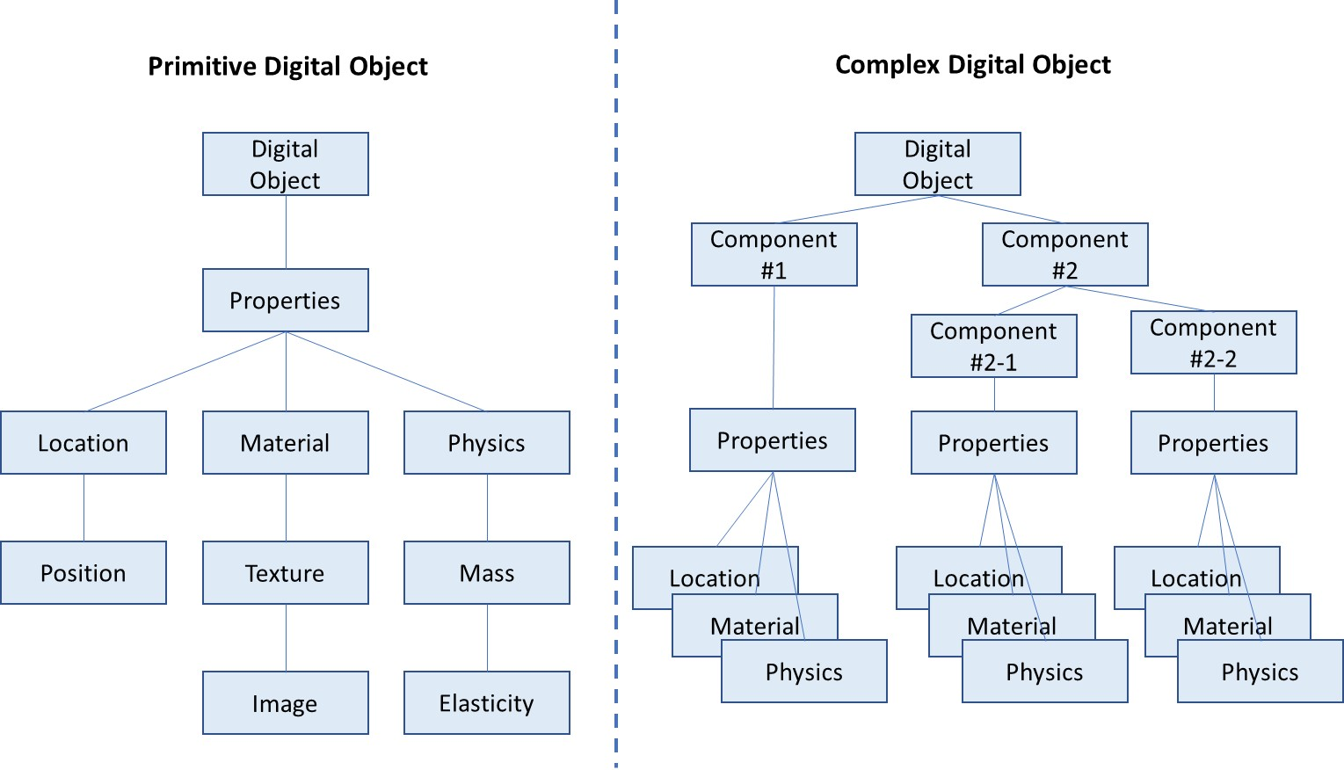
Fig. 1 The Data Structure of a Complex Digital Twin Object

Complex Digital Object

Overview

    - General

Describes attributes of the complex digital object, attributes of the corresponding complex physical object, authority to access the physical object, and types of sensing data.

    - Syntax
{
"$schema": "http://json-schema.org/draft-07/schema#",
"title": "Complex Digital Thing Entity",
"description": "Schema for Digital Thing",
"type": "object",
"properties": {
"thingId": {"type": "string"},
"thingIdRef": {"type": "string"},
"groupId": {"type": "string"},
"accessControl": {"type": ["READ", "WRITE","ADMIN"]},
“subComponent”: {“type”: “array”
“items”: {“$ref”: “#/definitions/component}
},
"$comment": "This is where the things (primitive, complex) are declared by reference"
},

"additionalProperties": false,
"required": ["thingId","thingIdRef","accessControl"],
"definitions": {
"component": {
“type”: “object”,
“properties”: {
“compID”: {
“type”: “string”,
“description”: “sub-component ID for composing a digital object”
},
“compName”: {
“type”: “string”,
“description”: “sub-component name for composing a digital object”
},
“compThingId”: {
“type”: “string”,
“description”: “thingId for the corresponding component”
}
},
“required”: [“compID”, “compThingId”]
}
}
}

    - Semantics
Name | Definition
Complex Digital Thing Entity | “Complex Digital Thing Entity” serves as an abstract primitive type for implementing digital objects that synchronize with complex physical objects or processes in the physical world. Through this, it is possible to create and expand a complex virtual world using a simple Digital Thing Entity.
component | component is sub-element for digital thing entity
compID | Describes the unique identifier for component
compName | Describes the external name for component
compThingID | Describes the unique identifier for thingID for corresponding component
subComponent | Describes the array list of components composing this digital object

    - Examples
{
“thingId”: “Camera”,
...
“subComponent” {
{
“compID”: “zoomLens_1”
“compName”: “mainLens
“compThingID”: “lens”
},
{
“compID”: “imageSensor_1”
“compThingID”: “imageSensor”

}
}
}

Conclusion
In this proposal, we describe the need for digital objects to describe physical objects (assets, devices, processes, etc.) with complex structures and proposed a type of “Complex Digital Thing Entity” that can be used in the advanced stage of CPS or DTS. Through this, not only can digital objects of various levels be described, but also existing digital thing entities can be reused, enabling rapid expansion of the virtual world.

