Project | Specification of Sensor Interface for Cyber and Physical World  <https://sagroups.ieee.org/2888/ >
Title | Proposal for Defining Relationship between Digital Twin Objects
DCN | 2888-20-0021-00-0000
Date Submitted | July 17, 2020
Source(s) | Changseok Yoon csyoon@keti.re.kr (Korea Electronics Technology Institute),  Geonjae Joo wnrjswo@keti.re.kr (Korea Electronics Technology Institute),  Nam Kyung Yoon nkyoon93@keti.re.kr (Korea Electronics Technology Institute),  Tae-Beom Lim tblim@keti.re.kr (Korea Electronics Technology Institute, Konkuk University),
Re:
Abstract
Purpose | To discuss and define digital models’ structure for the framework of the standard
Notice | This document has been prepared to assist the IEEE 2888 Working Group. It is offered as a basis for discussion and is not binding on the contributing individual(s) or organization(s). The material in this document is subject to change in form and content after further study. The contributor(s) reserve(s) the right to add, amend or withdraw material contained herein.
Release | The contributor grants a free, irrevocable license to the IEEE to incorporate material contained in this contribution, and any modifications thereof, in the creation of an IEEE Standards publication; to copyright in the IEEE’s name any IEEE Standards publication even though it may include portions of this contribution; and at the IEEE’s sole discretion to permit others to reproduce in whole or in part the resulting IEEE Standards publication. The contributor also acknowledges and accepts that IEEE 2888 may make this contribution public.
Patent Policy | The contributor is familiar with IEEE patent policy, as stated in Section 6 of the IEEE-SA Standards Board bylaws <http://standards.ieee.org/guides/bylaws/sect6-7.html#6> and in Understanding Patent Issues During IEEE Standards Development http://standards.ieee.org/board/pat/faq.pdf

Introduction
The digital twin world has the huge number of digital entities (objects) mapping to the physical objects. Sometimes, the method for accessing and controlling the digital entities respectively is inefficient for the users using the digital twin world, because it requires the repetitive processes of similar tasks for multiple entities. So, it is necessary to provide mechanisms to access the set of digital entities simultaneously and improve accessibility to search and control easily. The digital entities have the relationship between the digital entities according to their characteristics from various aspects. If we provide the mechanism of describing relationships among digital entities, the users can quickly and effectively identify and recognize the classified entities. In addition, the users can effectively search, access, and control the group of the classified objects at the same time. This relationship concept can be expressed using the new “grouping mechanism” that separates and includes the digital entities, or it can be expressed as the “link mechanism” included in the digital entities.

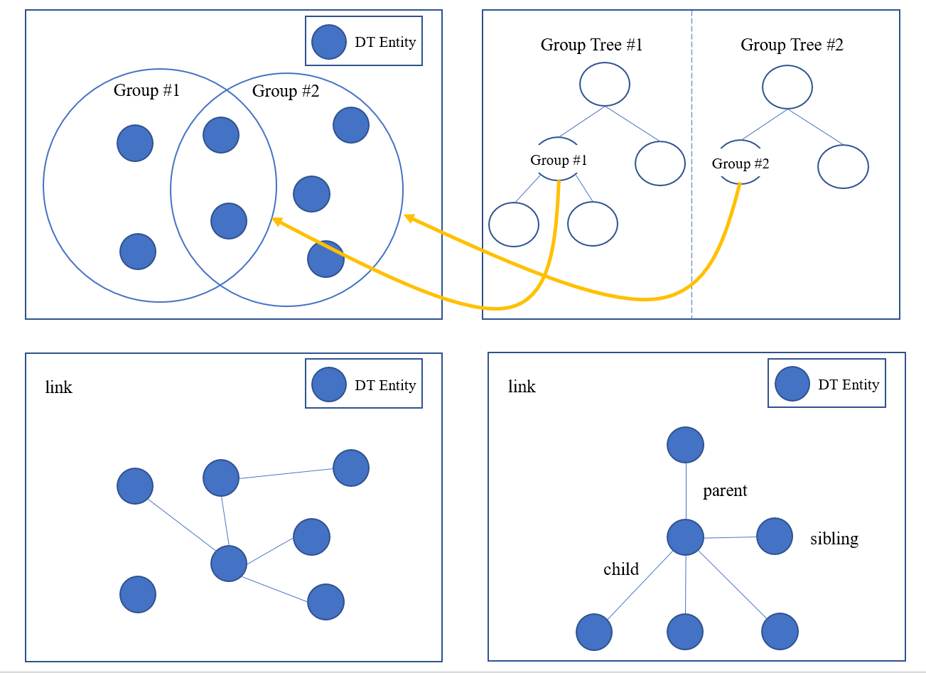
Fig. 1 The concept of relationship between digital entities

In this proposal, we suggest the “Relationship” concept between the digital objects that can be used for categorizing digital twin entities.

Link mechanism

Overview
The link is the flexible classification structure to represent relationship between digital entities using link as common index.

    - General
Describe relationship of digital entities, attributes of relationship to other digital twin entities

    - Syntax
{
"$schema": "http://json-schema.org/draft-07/schema#",
"title": "Digital Thing Entity",
"description": "Schema for Digital Thing(sensor device, asset, process etc.)",
"type": "object",
"properties": {
"thingId": {"type": "string"},
"thingIdRef": {"type": "string"},
"groupId": {"type": "string"},
"accessControl": {"type": ["READ", "WRITE","ADMIN"]},
"link": {“type”: “array”},
"sensorData": {
"$ref": "#/definitions/sensedDataBaseAttributes"
},
"$comment": "This is where the properties of each type of thing is declared by reference"
},
"additionalProperties": false,
"required": ["id","thingIdRef","accessControl"],

"definitions": {
"sensedDataBaseAttributes": {
"title": "Sensor data",
"description": "Schema for sensor data",
"type": "object",
"properties": {
"timeStamp": {"type": "datetime"},
"sensorInfoBaseAttributes": {
"$ref": "#/definitions/sensedInfoBaseAttributes"
},
"$comment": "This is where the properties of each type of sensor data is declared by reference."
},
"additionalProperties": false,
"required": [ "sensedInfoBaseAttributes"],
"minProperties": 2,
"maxProperties": 3,
"definitions": {
"sensedInfoBaseAttributes": {
"additionalProperties": false,
"type": "object",
"properties": {
"id": {"type": "string"},
"sensorIdRef": {"type": "string"},
"linkedList": {"type": "string"},
"groupID": {"type": "string"},
"activate": {"type": "boolean"},
"priority": {
"type": "integer",
"minimum": 0
}
}
},
"$comment": "This is where the properties of each type of sensor data is actually defined(e.g. microphoneSensorType"
}
}
}
}

    - Semantics
Name | Definition
Digital Thing Entity | Serves as the abstract basic type for implementing a digital object that communicates with the corresponding physical object or process in the target physical world. This type can describe a physical device, a virtual device (e.g. the weather information for specific location collected from web sites, a device that consists of the combination of sub-functions of various devices, etc), or anything that can be modeled and managed appropriately by the supported concepts/capabilities.
ThingId | Describes the unique identifier of a digital thing.
thingIdRef | Describes the reference of a ThingId as any URI.
groupId | Describes thingIds of the groups to which the digital thing belongs.
accessControl | Provides the information on accessibility of the digital thing. Also, this means the permission for accessing corresponding physical object is same. [“READ”, ”WRITE”, ”ADMIN”]  “READ” permission is allowed to read all data of the digital thing.  “WRITE” permission is allowed to be able to set data of the digital thing, or send messages to the digital thing.  “ADMIN” permission is allowed to modify this accessControl itself.
link | Describes the thing of the defining data or attribute digital entities by applying name/value pair. Link can organize them into a relationship taxonomy and indicate a thing within a property or it can indicate multiple properties.
sensorData | Dsescribes the information of the corresponding physical object(sensor), data that can be gotten from the physical object.
    - Examples
{
"thingId": "KETI_DT01",
"groupId": "KETI_SEOUL_G01",
"accessControl": ["READ", "WRITE"],
“link”: [“KETI_DT02”, “KETI_DT03”],

“sensorData” :
.
.
.
}

Group Entity

Overview
Group Entity allow you to manage several digital thing entities together by categorizing them into groups. Group entity contains a group of digital things and can also contain other Group entities

    - General
Group Entity would be organized as a tree structure. It means that group entity can only have one direct parent entity. Digital things are added to a group or to more than a group, but not in same hierarchy.

    - Syntax
{
"$schema": "http://json-schema.org/draft-07/schema#",
"title": "Group Entity",
"description": "Schema for Group entity",
"type": "object",
"properties": {
"groupId": {"type": "string"},
“members”: {"type": "array"},
"parentId": {"type": "string”},
"groupHierarchy": {"type": "array”}
“groupAttributes”: [
{“name”: {“type”:"string"}
],
"groupDescription": {"type": "string”}
}
}
}

    - Semantics
Name | Definition
Group Entity | Serves as a group element for implementing the grouping mechanism. Group Entity describe member of digital things, common attribute of member, and hierarchy of groups.  - What Users can do:  Create, retrieve or delete a group.  Add digital things to a group, or to more than one.  Remove digital things from a group.  Add, delete or update the attributes of a group
groupId | Describes the unique identifier of a group entity.
memberThingIds | Give ThingIds which are belonging to the group.  Can’t add ThingId to two groups that share a common parent.
parentId | Provides information of identifier of parent Group Entity.  If a group is a child of another group, user must specify this at the time it is created. Once created, it parent can’t be changed.
groupHierarchy | Describes information of all ancestor group entities. The sequence of IDs in this field is listed from parent group Id to root group ID.
groupAttributes | Describes the common attributes of member of the group.
groupDescription | Describes additional description.

    - Examples
{
"groupId": "KETI_SEOUL_G01",
“memberThingds”: [“KETI_DT01”, “KETI_DT02”, “KETI_DT03”]
“parentId”: “KETI_SEOUL”,
"groupHierarchy": [“KETI_GLOBAL”, "KETI_KOREA", ”KETI_SEOUL”],
“groupAttributes”: [{“AREA_NUM”:1}, {“SENSOR”: “TEMP_SENSOR”}],
“groupDescription”: “CREATED BY TEAM 1 IN NOV 2020”
}

