Project | Specification of Sensor Interface for Cyber and Physical World  <https://sagroups.ieee.org/2888/ >
Title | Proposal for Defining Relationship between Digital Twin Objects
DCN | 2888-20-0021-00-0000
Date Submitted | July 17, 2020
Source(s) | Changseok Yoon csyoon@keti.re.kr (Korea Electronics Technology Institute),  Geonjae Joo wnrjswo@keti.re.kr (Korea Electronics Technology Institute),  Nam Kyung Yoon nkyoon93@keti.re.kr (Korea Electronics Technology Institute),  Tae-Beom Lim tblim@keti.re.kr (Korea Electronics Technology Institute),
Re:
Abstract
Purpose | To discuss and define digital models’ structure for the framework of the standard
Notice | This document has been prepared to assist the IEEE 2888 Working Group. It is offered as a basis for discussion and is not binding on the contributing individual(s) or organization(s). The material in this document is subject to change in form and content after further study. The contributor(s) reserve(s) the right to add, amend or withdraw material contained herein.
Release | The contributor grants a free, irrevocable license to the IEEE to incorporate material contained in this contribution, and any modifications thereof, in the creation of an IEEE Standards publication; to copyright in the IEEE’s name any IEEE Standards publication even though it may include portions of this contribution; and at the IEEE’s sole discretion to permit others to reproduce in whole or in part the resulting IEEE Standards publication. The contributor also acknowledges and accepts that IEEE 2888 may make this contribution public.
Patent Policy | The contributor is familiar with IEEE patent policy, as stated in Section 6 of the IEEE-SA Standards Board bylaws <http://standards.ieee.org/guides/bylaws/sect6-7.html#6> and in Understanding Patent Issues During IEEE Standards Development http://standards.ieee.org/board/pat/faq.pdf

Introduction
The digital twin world has the huge number of digital entities (objects) mapping to the physical objects. Sometimes, the method for accessing and controlling the digital entities respectively is inefficient for the users using the digital twin world, because it requires the repetitive processes of similar tasks for multiple entities. So, it is necessary to provide mechanisms to access the set of digital entities simultaneously and improve accessibility to search and control easily. The digital entities have the relationship between the digital entities according to their characteristics from various aspects. If we provide the mechanism of describing relationships among digital entities, the users can quickly and effectively identify and recognize the classified entities. In addition, the users can effectively search, access, and control the group of the classified objects at the same time. This relationship concept can be expressed using the new “group entities” that separates and includes the digital entities, or it can be expressed as the “link mechanism” included in the digital entities.

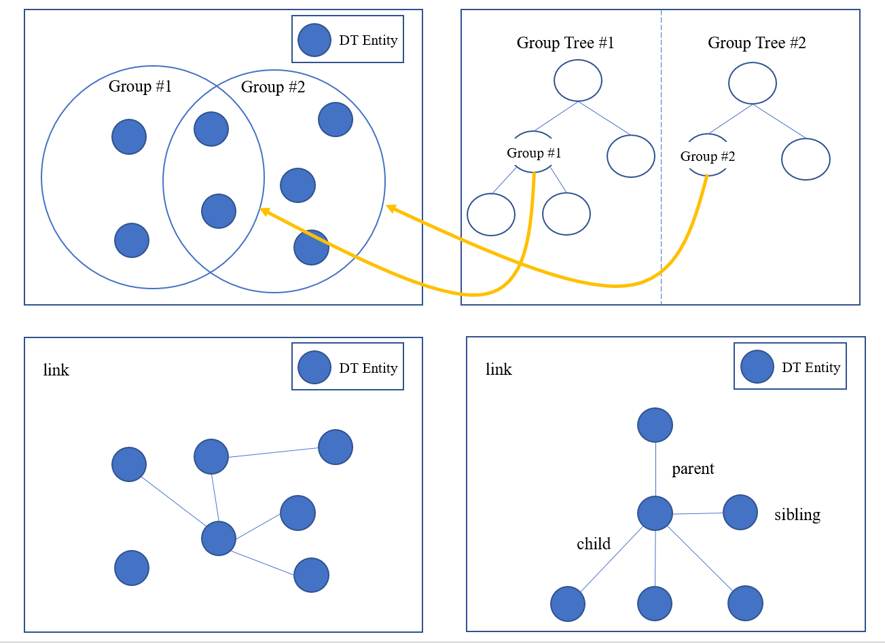
Fig. 1 The concept of relationship between digital entities

In this proposal, we suggest the “Relationship” concept between the digital objects that can be used for categorizing digital twin entities.

Link mechanism

Overview
The Link mechanism is the horizontal structure to represent relationship table of digital object which communicates with corresponding a real object or a process in the target real world.

    - General
Describes relationship of the digital object, attributes of relate to other digital twin object, and types of sensing data including JSON and binary serialization format.

    - Syntax
{
"$schema": "http://json-schema.org/draft-07/schema#",
"title": "Link mechanism",
"description": "Schema for Link mechanism (Relationship of Things, categorize)
"type": "object",
"properties": {
"thingId": {"type": "string"},
"thingIdRef": {"type": "string"},
"Link": {"type": "string"},
"$comment": "This is where the properties of each type of thing is declared by reference"
},
"required": ["thingid","Link"],

    - Semantics
Name | Definition
Link mechanism | Serves as the standard for describing a digital object that definition the mechanism in distributed and extensible way. This way can describe a digital twin modeling. That can be modeled and managed appropriately by the supported concepts/capabilities.
thingId | Describes the unique identifier of a digital thing.
thingIdRef | Describes the reference of a thingId as any URI.
Link | Describes the thing of the defining data or attribute object by applying name/value pair, data that can be gotten from the physical object.

    - Examples
{
"Link": "Digital",
"schema":{
"name": {
"Link": "Digitaltwin",
"thingId": "KETI_DT01",
"schema": "string"
.
.
}

{
"name": {
"Link": "Digitaltwin2",
"thingId": "ETRI_DT02",
"schema": "string"
}
.
.
}
}
.
.
}

Grouping mechanism

Overview
Group Entity allow you to manage several digital thing entities at once by categorizing them into groups. Group entity contains a group of digital things and can also contain other Group entities — you can build a hierarchy of groups.

    - General
Group Entity architecture is a tree architecture, and the Digital thing can be depicted as “apple” of the tree.

    - Syntax
{
"$schema": "http://json-schema.org/draft-07/schema#",
"title": "Group Entity",
"description": "Schema for Group entity",
"type": "object",
"properties": {
"groupId": {"type": "string"},
“members”: [{"type": "string"}, {"type": "string"}]
"parentId": {"type": "string”},
"groupHierarchy": [{"type": "string”}]
“groupAttributes”: [
{“name”: {“type”:"string"}},{“name”: {“type”:"string"}}
],
"groupDescription": {"type": "string”}
}
}
}

    - Semantics
Name | Definition
Group Entity | Defines grouping mechanism between Digital Thing and Group, and describe the hierarchy it has. Group Entity also describe the common attributes of member of the group.  - What Users can do:  Create, retrieve or delete a group.  Add a digital thing to a group, or to more than one.  Remove digital thing from a group.  Add, delete or update the attributes of a group
GroupId | Describes the unique identifier of a group entity.
members | Give thingIds which are contained by the group.
parentId | Provides information of identifier of parent entity, a group entity can only have one direct parent entity.  If a group is a child of another group, user must specify this at the time it is created. Once created, it parent can’t be changed.  Can’t add a thing to two groups that share a common parent.
groupHierarchy | Provides information of all ancestor entities from the root one.
groupAttributes | Describes the common attributes of member of the group. The number of attributes are limited.
groupDescription | Describes additional description.

    - Examples
{
"groupId": "KETI_SEOUL_GROUP_1",
“members”: [“KETI_SEOUL_GO_1”, “KETI_SEOUL_GO_2”, “KETI_SEOUL_GO_3”]
“parentId”: “KETI_SEOUL”,
"groupHierarchy": [“KETI_GLOBAL”, "KETI_KOREA", ”KETI_SEOUL”],
“groupAttributes”: [{“AREA_NUM”:1}, {“SENSOR”: “TEMP_SENSOR”}],
“groupDescription”: “CREATED BY TEAM 1 IN NOV 2020”
}

