Project | Specification of Sensor Interface for Cyber and Physical World  <https://sagroups.ieee.org/2888/ >
Title | Proposal for Structuring Digital Objects of the Digital Twin Framework
DCN | 2888-20-0021-00-0000
Date Submitted | July 17, 2020
Source(s) | Tae-Beom Lim tblim@keti.re.kr (Korea Electronics Technology Institute),  Changseok Yoon csyoon@keti.re.kr (Korea Electronics Technology Institute),  Young-Han Kim ekmyph@keti.re.kr (Korea Electronics Technology Institute),  Hyun-Soek Ahn hsahn@keti.re.kr (Korea Electronics Technology Institute),  Kyoungro Yoon yoonk@konkuk.ac.kr (Konkuk University)
Re:
Abstract
Purpose | To discuss and define digital models’ structure for the framework of the standard
Notice | This document has been prepared to assist the IEEE 2888 Working Group. It is offered as a basis for discussion and is not binding on the contributing individual(s) or organization(s). The material in this document is subject to change in form and content after further study. The contributor(s) reserve(s) the right to add, amend or withdraw material contained herein.
Release | The contributor grants a free, irrevocable license to the IEEE to incorporate material contained in this contribution, and any modifications thereof, in the creation of an IEEE Standards publication; to copyright in the IEEE’s name any IEEE Standards publication even though it may include portions of this contribution; and at the IEEE’s sole discretion to permit others to reproduce in whole or in part the resulting IEEE Standards publication. The contributor also acknowledges and accepts that IEEE 2888 may make this contribution public.
Patent Policy | The contributor is familiar with IEEE patent policy, as stated in Section 6 of the IEEE-SA Standards Board bylaws <http://standards.ieee.org/guides/bylaws/sect6-7.html#6> and in Understanding Patent Issues During IEEE Standards Development http://standards.ieee.org/board/pat/faq.pdf

Introduction

The digital twin is another concept associated with cyber-physical integration. It is a real mapping of all components in the product life cycle using physical data, virtual data and interaction data between an object (e.g. asset, device, process etc.) in the physical world and a corresponding digital object in CPS or DTS. A physical entity(object) can be represented as a digital entity(object) which consists of one digital model or a combination of multiple digital models. Each digital model should be declared for its own distinct purposes and be mapped into one physical object. So, a framework should provide capabilities to interact with physical objects in a digital twin system and ensure that access to digital twin systems can only be done by authorized parties.

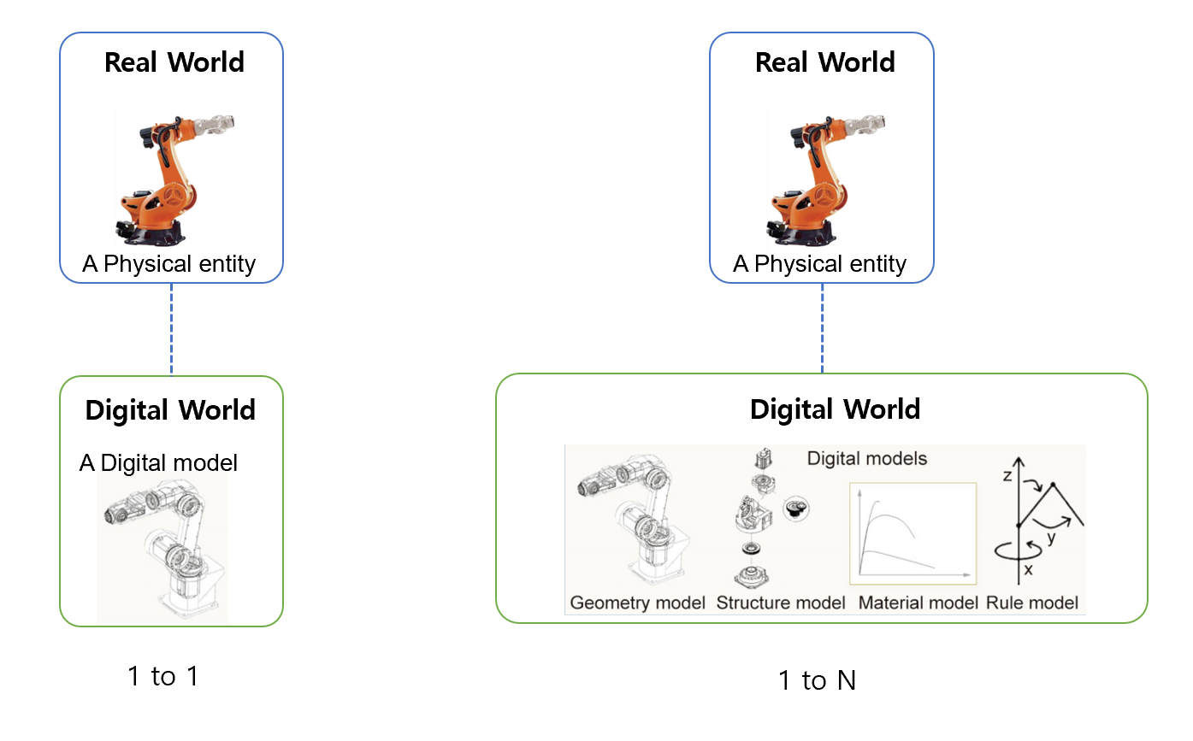
Fig. 1 The concept of mapping between a physical object and digital objects

In this proposal, we suggest the “Digital Thing Entity” type that describes digital objects for physical objects (asset, device, process etc.) and can be used in the initializing step in CPS or DTS.

Digital Thing Entity

Overview

The Digital Thing Entity type is the abstract structure for implementing a digital object that communicates with the corresponding physical object or process in the target physical world.

    - General

Describes attributes of the digital object, attributes of the corresponding physical object, authority to access the physical object, and types of sensing data.

    - Syntax
{
"$schema": "http://json-schema.org/draft-07/schema#",
"title": "Digital Thing Entity",
"description": "Schema for Digital Thing(sensor device, asset, process etc.)",
"type": "object",
"properties": {
"thingId": {"type": "string"},
"thingIdRef": {"type": "string"},
"groupId": {"type": "string"},
"accessControl": {"type": ["READ", "WRITE","ADMIN"]},
"sensorData": {
"$ref": "#/definitions/sensedDataBaseAttributes"
},
"$comment": "This is where the properties of each type of thing is declared by reference"
},
"additionalProperties": false,
"required": ["id","thingIdRef","accessControl"],

"definitions": {
"sensedDataBaseAttributes": {
"title": "Sensor data",
"description": "Schema for sensor data",
"type": "object",
"properties": {
"timeStamp": {"type": "datetime"},
"sensorInfoBaseAttributes": {
"$ref": "#/definitions/sensedInfoBaseAttributes"
},
"$comment": "This is where the properties of each type of sensor data is declared by reference."
},
"additionalProperties": false,
"required": [ "sensedInfoBaseAttributes"],
"minProperties": 2,
"maxProperties": 3,
"definitions": {
"sensedInfoBaseAttributes": {
"additionalProperties": false,
"type": "object",
"properties": {
"id": {"type": "string"},
"sensorIdRef": {"type": "string"},
"linkedList": {"type": "string"},
"groupID": {"type": "string"},
"activate": {"type": "boolean"},
"priority": {
"type": "integer",
"minimum": 0
}
}
},
"$comment": "This is where the properties of each type of sensor data is actually defined(e.g. microphoneSensorType"
}
}
}
}

    - Semantics
Name | Definition
Digital Thing Entity | Serves as the abstract basic type for implementing a digital object that communicates with the corresponding physical object or process in the target physical world. This type can describe a physical device, a virtual device (e.g. the weather information for specific location collected from web sites, a device that consists of the combination of sub-functions of various devices, etc), or anything that can be modeled and managed appropriately by the supported concepts/capabilities.
ThingId | Describes the unique identifier of a digital thing.
thingIdRef | Describes the reference of a ThingId as any URI.
groupId | Describes thingIds of the groups to which the digital thing belongs.
accessControl | Provides the information on accessibility of the digital thing. Also, this means the permission for accessing corresponding physical object is same. [“READ”, ”WRITE”, ”ADMIN”]  “READ” permission is allowed to read all data of the digital thing.  “WRITE” permission is allowed to be able to set data of the digital thing, or send messages to the digital thing.  “ADMIN” permission is allowed to modify this accessControl itself.
sensorData | Dsescribes the information of the corresponding physical object(sensor), data that can be gotten from the physical object.

    - Examples
{
"thingId": "KETI_DT01",
"groupId": "KETI_SEOUL_G01",
"accessControl": ["READ", "WRITE"],

“sensorData” :
.
.
.
}

Conclusion

In this proposal, we suggested the “Digital Thing Entity” type that describes digital objects for physical objects (asset, device, process etc.) and can be used in the initializing step in CPS or DTS. But we didn’t mention how to describe models and data that work and exchange between physical objects and digital objects in CPS or DTS in more details.

