Project | Specification of Sensor Interface for Cyber and Physical World  <https://sagroups.ieee.org/2888/ >
Title | Location-related sensor data formats
DCN | 2888-20-0010-01-0001
Date Submitted | Feb. 23, 2020
Source(s) | Sang-Kyun Kim, goldmunt@gmail.com (Myongji University)  Kyoungro Yoon, yoonk@konkuk.ac.kr (Konkuk University)  Sangkwon Jeong, ceo@joyfun.kr (Joyfun)
Re:
Abstract | Location sensors like a compass, a gyro, an accelerometer, GPS are the basic sensors for acquiring the position and posture information of the physical world objects, and the data through them are important information for determining the characteristics and motion of cyber objects in the cyber world. This contribution proposes a schema for defining sensor data input from location-related sensors.
Purpose | To start discussion on purpose of the standard
Notice | This document has been prepared to assist the IEEE 2888 Working Group. It is offered as a basis for discussion and is not binding on the contributing individual(s) or organization(s). The material in this document is subject to change in form and content after further study. The contributor(s) reserve(s) the right to add, amend or withdraw material contained herein.
Release | The contributor grants a free, irrevocable license to the IEEE to incorporate material contained in this contribution, and any modifications thereof, in the creation of an IEEE Standards publication; to copyright in the IEEE’s name any IEEE Standards publication even though it may include portions of this contribution; and at the IEEE’s sole discretion to permit others to reproduce in whole or in part the resulting IEEE Standards publication. The contributor also acknowledges and accepts that IEEE 3079 may make this contribution public.
Patent Policy | The contributor is familiar with IEEE patent policy, as stated in Section 6 of the IEEE-SA Standards Board bylaws <http://standards.ieee.org/guides/bylaws/sect6-7.html#6> and in Understanding Patent Issues During IEEE Standards Development http://standards.ieee.org/board/pat/faq.pdf

Introduction
Location sensors like a compass, a gyro, an accelerometer, GPS are the basic sensors for acquiring the position and posture information of the physical world objects, and the data through them are important information for determining the characteristics and motion of cyber objects in the cyber world. This contribution proposes a schema for defining sensor data input from location-related sensors.

Schema for location sensor data

Compass sensor

Syntax of compass sensor data format
"compassSensorType": {
"type": "object",
"properties": {
"azimuth": {
"type": "number",
"minimum": 0,
"maximum": 360
},
"unit": {
"$ref": "#/definitions/unitType"
}
},
"additionalProperties": false
},
figure 1. Schema for compass sensor
Figure 1 shows the data schema of a compass sensor. The compass sensor has azimuth and unit values as properties. The azimuth value is a value between 0 and 360. The unit is a property that represents the unit of azimuth, referring to unitType.

Example of compass sensor data instance
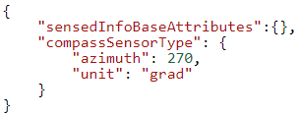
figure 2. Example of compass sensor data JSON instance
Figure 2 shows the JSON instance of the compass sensor. azimuth is 270 and the unit is grad (gradian).

Orientation sensor

Syntax of orientation sensor data format
"orientationSensorType": {
"type": "object",
"properties": {
"orientation": {
"type": "array",
"items": {
"type": "number",
"minItems": 3,
"maxItems": 3
}
}
}
},
figure 3. Schema for orientation sensor
Figure 3 shows the data schema of the orientationSensor. Represents yaw, pitch, and roll. You must represent all three values by setting minItems and maxItems to 3.

Example of orientation sensor data instance
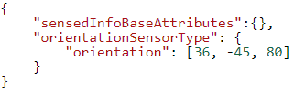
figure 4. Example of orientation sensor data JSON instance
Figure 4 shows an example JSON instance of an orientationSensor. Orientation has yaw, pitch, and roll values of 36, -45, and 80, respectively.

Position sensor

Syntax of position sensor data format
"positionSensorType": {
"type": "object",
"properties": {
"position": {
"$ref": "#/definitions/float3DVectorType"
},
"unit": {
"$ref": "#/definitions/unitType"
}
}
},
figure 5. Schema for position sensor
Figure 5 shows the data schema of positionSensor. The 3D value of the position sensor is described in meters (m). The coordinate origin is the position of the object detected when the sensor is activated.

Example of position sensor data instance
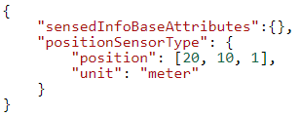
figure 6. Example of position sensor data JSON instance
Figure 6 shows the JSON instance of positionSensor. The sensor sensed that it moved 20 meters in the x direction, 20 meters in the y direction, and 1 meter in the z direction.

Distance sensor

Syntax of distance sensor data format
"distanceSensorType": {
"type": "object",
"properties": {
"value": {
"type": "number"
},
"unit": {
"$ref": "#/definitions/unitType"
}
}
},
figure 7. Schema for distance sensor
Figure 7 shows the data schema of the distanceSensor. The value indicates the distance from the target in meters.

Example of distance sensor data instance
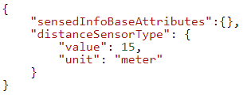
figure 8. Example of distance sensor data JSON instance
Figure 8 shows the JSON instance of the distanceSensor. The distance from the distanceSensor to the object is 15 meters.

Conclusion
It is recommended to adopt the JSON-based schema proposed in this contribution as the location-related sensor data schema of IEEE 2888.1. In addition, it is recommended to improve the data schema in the future by adding location-related sensor data information actually used in the industry.

