Project | Specification of Sensor Interface for Cyber and Physical World  <https://sagroups.ieee.org/2888/ >
Title | Sensor data formats for microphones and color cameras
DCN | 2888-20-0009-01-0001
Date Submitted | Feb. 23, 2020
Source(s) | Sang-Kyun Kim, goldmunt@gmail.com (Myongji University)  Kyoungro Yoon, yoonk@konkuk.ac.kr (Konkuk University)  Sangkwon Jeong, ceo@joyfun.kr (Joyfun)
Re:
Abstract | Microphones and cameras are the most basic sensors for acquiring audio and visual information of the physical world, and the data through them are important information for determining the characteristics and motion of cyber objects in the cyber world. This contribution proposes a schema for defining sensor data input from microphones and color camera sensors.
Purpose | To start discussion on purpose of the standard
Notice | This document has been prepared to assist the IEEE 2888 Working Group. It is offered as a basis for discussion and is not binding on the contributing individual(s) or organization(s). The material in this document is subject to change in form and content after further study. The contributor(s) reserve(s) the right to add, amend or withdraw material contained herein.
Release | The contributor grants a free, irrevocable license to the IEEE to incorporate material contained in this contribution, and any modifications thereof, in the creation of an IEEE Standards publication; to copyright in the IEEE’s name any IEEE Standards publication even though it may include portions of this contribution; and at the IEEE’s sole discretion to permit others to reproduce in whole or in part the resulting IEEE Standards publication. The contributor also acknowledges and accepts that IEEE 3079 may make this contribution public.
Patent Policy | The contributor is familiar with IEEE patent policy, as stated in Section 6 of the IEEE-SA Standards Board bylaws <http://standards.ieee.org/guides/bylaws/sect6-7.html#6> and in Understanding Patent Issues During IEEE Standards Development http://standards.ieee.org/board/pat/faq.pdf

Introduction
Microphones and cameras are the most basic sensors for acquiring audio and visual information of the physical world, and the data through them are important information for determining the characteristics and motion of cyber objects in the cyber world. This contribution proposes a schema for defining sensor data input from microphones and color camera sensors.

Schema for A/V sensor data
This section describes the data types of AV sensors, which collect audio and visual information from the physical world.

Microphone sensor

Syntax of microphone sensor data type
"microphoneSensorType": {
"type": "object",
"properties": {
"orientation": {
"$ref": "#/definitions/float3DVectorType"
},
"location": {
"$ref": "#/definitions/float3DVectorType"
},
"audioData": {
"$ref": "#/definitions/rawAudioType"
}
},
"additionalProperties": false
},
"rawAudioType": {
"type": "object",
"properties": {
"sample_rate": {
"$ref": "#/definitions/sampleRateType"
},
"byte_order": {
"$ref": "#/definitions/byteOrderType"
},
"sign": {
"$ref": "#/definitions/signType"
},
"resolution": {
"$ref": "#/definitions/resolutionType"
}
},
"additionalProperties": false
},
"sampleRateType": {
"type": "number",
"enum": [
8.0,
11.025,
16.0,
22.05,
32.0,
44.056,
44.1,
47.25,
48.0,
50.0,
50.4,
88.2,
96.0,
176.4,
192.0,
352.8,
2822.4,
5644.8
]
},
"byteOrderType": {
"type": "string",
"enum": [
"littleEndian",
"bigEndian"
]
},
"signType": {
"type": "string",
"enum": [
"signed",
"unsigned"
]
},
"resolutionType": {
"type": "integer",
"enum": [
4,
8,
12,
16,
20,
24,
32,
48,
64
]
},
figure 1. Schema for microphone sensor
Figure 1 shows the schema of a microphone sensor. Microphone sensor data includes orientation, location and audioData.
The orientation and location indicate the microphone's orientation and location, respectively. The orientation indicates the direction through yaw, pitch, and roll. The location represents x, y, z coordinates. The audioData refers to rawAudioType with audioData16, audioData64, sample_rate, byte_order, sign, and resolution.
The audioData16 is audio binary data in string format encoded in base-16 format. The audioData64 is audio binary data in string format encoded in base-64 format. You must choose either audioData16 or audioData64.
The sample_rate represents a sampling rate of recorded audio, and a unit is kHz. It uses predefined values ​​from 8.0 to 5644.8. The byte_order is used to specify whether the byte representing the audio data follows a big or little-endian. The sign indicates whether audio data is a signed value or an unsigned value. The resolution indicates how many bits the sample uses. Typically, 8 bits are used.

Example of microphone sensor data instance
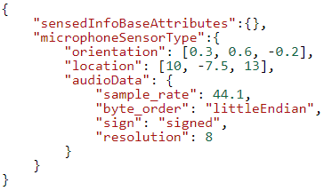
figure 2. Example of microphone sensor data JSON instance

Figure 2 shows a JSON instance of microphone sensor data. The orientation has [0.3, 0.6, -0.2], the altitude is 123.21 and the location is [10, -7.5, 13]. The sample_rate is 44.1kHz and byte_order follows the little-endian method. It is signed data and its resolution is 8 bits.

Color camera sensor

Syntax of color camera sensor data type
"colorCameraSensorType": {
"type": "object",
"properties": {
"cameraSensor": {
"$ref": "#/definitions/cameraSensorType"
},
"rawVideo": {
"$ref": "#/definitions/rawVideoType"
}
}
},
"rawVideoType": {
"type": "object",
"properties": {
"videoData16": {
"type": "string"
},
"videoData64": {
"type": "string"
},
"width": {
"type": "integer"
},
"height": {
"type": "integer"
},
"bit_depth": {
"type": "integer"
},
"stride": {
"type": "integer"
},
"coding4CC": {
"type": "integer"
},
"fps": {
"type": "integer"
},
"use_frame_packing": {
"type": "integer"
},
"frame_packing": {
"type": "integer"
}
}
},
"cameraSensorType": {
"type": "object",
"properties": {
"cameraOrientation": {
"$ref": "#/definitions/orientationSensorType"
},
"cameraLocation": {
"$ref": "#/definitions/globalPositionSensorType"
},
"cameraAltitude": {
"$ref": "#/definitions/altitudeSensorType"
},
"focalLength": {
"type": "number"
},
"aperture": {
"type": "number"
},
"shutterSpeed": {
"type": "number"
},
"filter": {
"type": "string",
"enum": [
"UV",
"Polarizing",
"NB",
"Diffusion",
"Star"
]
}
},
"additionalProperties": false
},
"globalPositionSensorType": {
"type": "object",
"properties": {
"longitude": {
"type": "number",
"minimum": -180.0,
"maximum": 180.0
},
"latitude": {
"type": "number",
"minimum": -90.0,
"maximum": 90.0
}
},
"required": [
"longitude",
"latitude"
],
"additionalProperties": false
},
figure 3. Schema for color camera sensor
Figure 3 shows the schema of a color camera sensor. The color camera sensor includes a basic camera cameraSensor and rawVideo representing video data.
The cameraSensor has cameraOrientation, cameraAltitude, cameraLocation, focalLength, aperture, shutterSpeed, and filter. The cameraOrientation refers to the orientation sensor, which is a location sensor, to indicate the orientation of the camera. The cameraLocation indicates the global position of the camera by referring to the global position sensor, which is a location sensor. The focalLength describes the distance in millimeters (mm) between the lens and the image sensor when the subject is in focus. The aperture represents the diameter of the aperture. For example, if the diaphragm is f/2.8, it is written as 2.8. The shutterSpeed ​​represents the camera shutter speed. The shutter speed is expressed in seconds. The filter represents a camera filter and can only be used among the specified filters.
The rawVideo includes videoData16, videoData64, width, height, bit_depth, stride, use_frame_packing, and frame_packing. The videoData16 is video binary data in string format encoded in base-16 format. The videoData64 is video binary data in string format encoded in base-64 format. You must choose either videoData16 or videoData64. The width and height represent the width and height of the video in pixels. The bit_depth represents the number of bits of each channel sample in the set of allowed values ​​defined by coding4CC. The stride represents the size of the horizontal byte. The coding4CC is a four letter code representing the raw data parameter specified by MP4RA. The fps represents frames per second. The use_frame_packing Indicates whether two or more views are included in the frame. The frame_packing represents a frame packing value.

Example of color camera sensor data instance
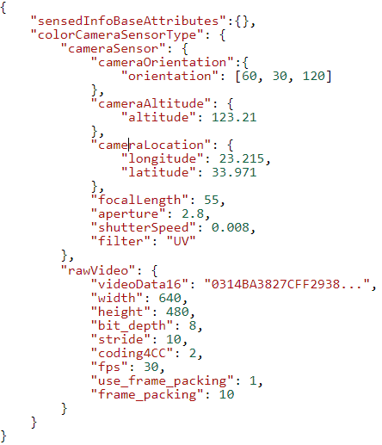
figure 4. Example of color camera sensor data JSON instance
Figure 4 shows a JSON instance of color camera sensor data. The cameraOrientation values are yaw, pitch, and roll values of 60, 30, and 120, respectively. The cameraAltitude is 123.21 and the cameraLocation has longitude 23.215 and latitude 33.971. The flocalLength is 55mm and the aperture is f / 2.8. The shutterSpeed is 0.008sec and the filter indicates that a UV filter is used.
The videoData16 is base-16 encoded data starting with "0314BA3827CFF2938 ..". The width and height of the image are 640 and 480 pixels, respectively. The bit_depth is 8 and stride is 10. The coding4CC is 2 and the fps of the image is 30 frames/sec. The use_frame_packing is 1 and the frame_packing is 10.

Conclusion
It is recommended to adopt the JSON-based microphone and color camera sensor data schema proposed in this contribution as the audio/visual sensor data schema of IEEE 2888.1. In addition, it is recommended to improve the data schema in the future by adding AV sensor data information actually used in the industry.

