Project | Specification of Sensor Interface for Cyber and Physical World  <https://sagroups.ieee.org/2888/ >
Title | Proposal of JSON-formatted weather information for synchronizing virtual- and real-world environments
DCN | 2888-20-0002-00-0001
Date Submitted | February 20, 2020
Source(s) | Sangkwon Jeong ceo@joyfun.kr  Shin Kim new.xin22@gmail.com  Kyoungro Yoon yoonk@konkuk.ac.kr  Sang-Kyun Kim goldmunt@gmail.com
Re:
Abstract | Proposing JSON-formatted weather information in order to obtain weather information of real world and synchronize real world and cyber space
Purpose | To start discussion on purpose of the standard
Notice | This document has been prepared to assist the IEEE 2888 Working Group. It is offered as a basis for discussion and is not binding on the contributing individual(s) or organization(s). The material in this document is subject to change in form and content after further study. The contributor(s) reserve(s) the right to add, amend or withdraw material contained herein.
Release | The contributor grants a free, irrevocable license to the IEEE to incorporate material contained in this contribution, and any modifications thereof, in the creation of an IEEE Standards publication; to copyright in the IEEE’s name any IEEE Standards publication even though it may include portions of this contribution; and at the IEEE’s sole discretion to permit others to reproduce in whole or in part the resulting IEEE Standards publication. The contributor also acknowledges and accepts that IEEE 3079 may make this contribution public.
Patent Policy | The contributor is familiar with IEEE patent policy, as stated in Section 6 of the IEEE-SA Standards Board bylaws <http://standards.ieee.org/guides/bylaws/sect6-7.html#6> and in Understanding Patent Issues During IEEE Standards Development http://standards.ieee.org/board/pat/faq.pdf

Introduction

At before, we proposed about weather information that can synchronize real world and virtual world. Using some sensors, we can construct cyber space which is integrated with the real world, or which can simulate the real-world environment. In order to synchronize virtual space and real environment, it is necessary to communicate the weather information with formatting data. In this document, we discuss about necessary sensors for representing weather of real world into cyber space and contribute JSON data format for synchronizing two worlds.

Weather information
People can obtain weather information via mobile weather application. Below figure is showing the weather information we obtained.
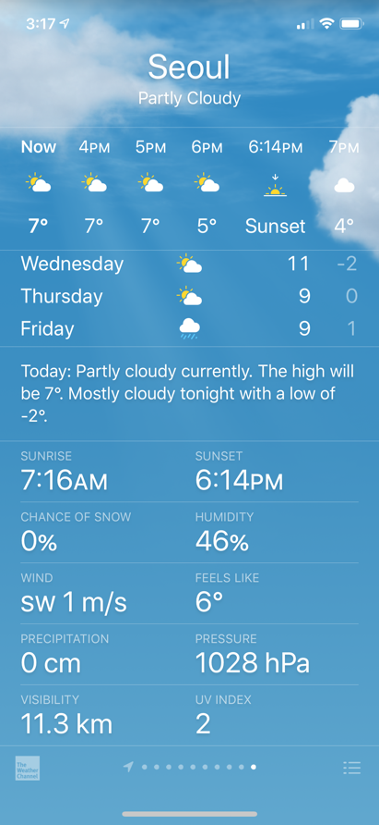
Figure 1. Weather information (By Weather app of iPhone)
According to provided information, weather information is including:
- Cloud(Atmospheric Condition)
- Degree
- Humidity
- Wind (Direction of wind and wind speed)
- Precipitation
- Pressure
- Visibility
- Sunrise
- Sunset

For synchronizing real world and cyber space, we should check which sensor is needed. Below figures show changes in the weather of virtual world.

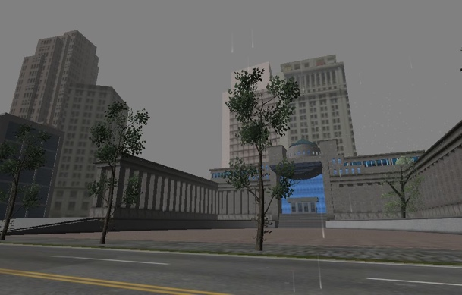
Figure 2. Weather Changes in the Virtual World
((a) Snow (b) Rain (c) Partly Clouded (d) Partly Clouded and Sunset)

According to the figures, weather information can be including not only temperature, humidity, wind, pressure but also cloud, precipitation (snowfall, rainfall), sunset and sunrise. Information related to temperature, humidity, wind, pressure and cloud (Sky temperature) can be obtained through physical sensors directly. In addition, we can also get information about precipitation, sunrise and sunset that are provided by weather service provider.
To sum up, weather information we can obtain through sensors and weather service provider is as following:
- Temperature
- Humidity
- Wind (Direction and Speed)
- Atmospheric Condition (Sky Temperature by IR sky temperature sensor or weather information provided by weather service provider)
- Pressure
- Precipitation
- Sunset
- Sunrise

JSON-Formatting Weather Information
We checked which data/information are necessary for synchronizing real world and cyber space. and we propose formatting syntax and example of weather information in order to synchronize the worlds. We selected JSON to represent weather information. JSON (JavaScript Object Notation) is a data exchange format that uses human-readable text to transmit data objects consisting of attribute-value pairs and array data types and language-independent data format. Due to that JSON has a property that is lightweight and has high readability, various fields use JSON for exchanging data.
We created JSON-formatted syntax and example with above weather information of Seoul. Figure 3 represent JSON scheme for representing weather information. We made an example of weather information like Figure 4. Figure 4 is a JSON example with above weather information of Seoul.
{
"$Schema" : "http://json-schema.org/draft-04/schema#",
"title" : "Weather Information Scheme",
"type" : "object",
"properties" : {
"Region" : {"type" : "string"},
"Date" : {"type" : "string"},
"Atmospheric-Condition" : {"type" : "string"},
"Temperature" : {
"Value" : {"type" : "number"},
"Unit" : {"type" : "string"}
},
"Wind" : {
"Direction" : {"type" : "string"},
"Speed" : {
"Value" : {"type" : "number"},
"Unit" : {"type" : "string"}
}
},
"Precipitation" : {
"Value" : {"type" : "number"},
"Unit" : {"type" : "string"}
},
"Pressure" : {
"Value" : {"type" : "number"},
"Unit" : {"type" : "string"}
},
"Sunrise" : {"type" : "string"},
"Sunset" : {"type" : "string"}
}
}
Figure 3. JSON Scheme for weather information
{
"Region" :"Seoul",
"Date" : "2020-02-19",
"Atmospheric-Condition" : "Partly Cloudy",
"Temperature" : {
"Degree" : 7,
"Unit" : "Celsius"
},
"Humidity" : {
"Value" : 48,
"Unit" : "Percent"
},
"Wind" : {
"Direction" : "sw",
"Speed" : {
"Value" : 1,
"Unit" : "m/s"
}
},
"Precipitation" : {
"Value" : 0,
"Unit" : "cm"
},
"Pressure" : {
"Value" : 1028,
"Unit" : "hPa"
},
"Sunrise" : "2020-02-19T1107:16:00",
"Sunset" : "2020-02-19T1118:14:00"
}

Figure 4. An example of JSON-formatting weather information

Conclusion
In this contribution, we discussed about which data is needed for expressing weather information and proposed JSON-formatted weather information. With values obtained by sensors in the real world, weather information can be generated through JSON format and then with the JSON-formatted weather information we can construct cyber space and synchronize weather of cyber world and real world.

