1903-14-0035-00-INVT
MEETING INVITATION

IEEE P1903 NGSON
18-20 September 2014
Host: King’s College London
London, UK
Chair: Ulema Mehmet
Vice-Chair: Ashutosh Dutta
Secretary: Niranth Amogh
We invite you to participate in the IEEE P1903 WG standardization meeting.

Please note the following details for participating in the London Meeting:
1. Date and Venue

18th Sept 2014 - 9:00 AM to 5:00 PM – Somerset House East Wing (Room 1.09)
19th Sept 2014 – 9:00 AM to 5:00 PM – Somerset House East Wing (Room 1.24)
20th Sept 2014 – 9:00 AM to 5:00 PM– Somerset House East Wing (Room 1.24)

Host Information:
Nishanth Sastry (nishanth.sastry@kcl.ac.uk)
King’s College London

Venue:
Somerset House East Wing
Strand, London WC2R 2LS
Website: http://www.kingsvenues.com/Conferences-Meetings/Somerset-House/East-Wing.aspx

Phone: +44 (0)20 7845 4600
Email: info@somersethouse.org.uk
Website: http://www.somersethouse.org.uk

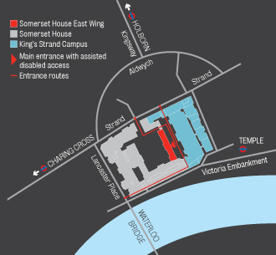

2. Registration
Registration is free for participating in IEEE P1903 WG meeting. You must provide your registration details using this link ->
https://iecs.memberclicks.net/index.php?option=com_mc&view=mc&mcid=form_173941

3. IEEE P1903 WG Meeting Agenda
18th Sep’14, 9:00 AM to 5:00 PM – IEEE P1903 WG Meeting (Opening Plenary, Contributions for P1903.1, P1903.2, P1903.3)
19th Sep’14, 9 AM to 5:00 PM – IEEE P1903 WG Meeting (Continued Contributions Discussion for P1903.1, P1903.2, P1903.3)
20th Sep’14, 9 AM to 5:00 PM – IEEE P1903 WG Meeting (Contd. Contributions Discussion, Informational Contributions, Closing Plenary)

4. Call for Contributions
We invite you to provide contributions towards the specifications of P1903.1 (Content Delivery), P1903.2 (Service Composition) and P1903.3 (Self Organization).

In order to be able to upload your contributions, you need to create an IEEE account and access the IEEE mentor system. The information regarding account creation can be found in Lisa’s presentation slides (Last slides) in the link -> https://mentor.ieee.org/1903/dcn/13/1903-13-0003-00-TUTL-p1903-ngson-webinar-slides.pdf

Please use the following templates for contributions:
PPT Format -> https://mentor.ieee.org/1903/dcn/13/1903-13-0008-00-TMPL-p1903-contribution-presentation-template.ppt
P1903.1 Word Format -> https://mentor.ieee.org/1903/dcn/13/1903-13-0009-00-TMPL-p1903-1-contribution-word-template.doc
P1903.2 Word Format -> https://mentor.ieee.org/1903/dcn/13/1903-13-0010-00-TMPL-p1903-2-contribution-word-template.doc
P1903.3 Word Format -> https://mentor.ieee.org/1903/dcn/13/1903-13-0011-00-TMPL-p1903-3-contribution-word-template.doc

5. VISA Assistance
You can request the Visa assistance from the Host – King’s College London by sending an email to the following members:
Nishanth Sastry (nishanth.sastry@kcl.ac.uk)
Agustin Cabrera (agustin.cabrera@kcl.ac.uk)

Please provide your following information in your email request to KCL contacts:
- Full Name as in Passport
- Organization Name
- Organization Postal Address
- Require Hard Copy of the Letter?: Yes/No

In the request, please mention that you will participate in the IEEE P1903 WG Sep’14 Meeting at London.

You will receive the scanned/digital copy of the visa assistance letter from the KCL team through email.

IEEE cannot supply letters of "invitation", and does not "Host" its registrants. Also it is not its policy to include personal information such as Passport number in the correspondence.

For some countries the VISA processing may take around 20 days. Request you to initiate the VISA assistance request as soon as possible.

6. General Arrangements
The general arrangements (travel, hotel, weather, etc) information is as follows:

Travel:
Regarding your travel to venue: http://www.somersethouse.org.uk/plan-your-visit/directions-and-map

The nearest mainline rail stations are:
Charing Cross, Waterloo and Blackfriars.

The nearest underground stations are:
Temple, Covent Garden, Charing Cross and Embankment.

Buses servicing the Strand include numbers 6, 9, 11, 13, 15, 23, 77a, 91 and 176, while the River Bus Service can be taken to Embankment and Savoy piers.

Pedestrian access to Somerset House is available from Victoria Embankment, Waterloo Bridge (via a new footbridge link) or from the Strand.

Hotels Information:
Participants are responsible for their own reservations/bookings to the hotel.

There are a number of central hotels we provide good rates for visiting academics, depending on budget, ordered from most expensive first.

The Goodenough Club is the nicest and situated in Mecklenburgh Square. Academics (those invoicing academic institutions) are automatically members and get a discount rate: http://www.club.goodenough.ac.uk/

The Bedford Hotel in Southampton Row and The Tavistock Hotel in Tavistock Square: http://www.imperialhotels.co.uk/

The Strand Hotel on the Strand. Tel: 020 7379 4737,
http://www.strandpalacehotel.co.uk

The Crescent Hotel, 49-50 Cartwright Gardens, WC1H 9EL; Tel: 020 7387 155,
http://www.crescenthoteloflondon.com

Hotels information nearby to the Venue: http://www.booking.com/landmark/gb/the-strand.en-gb.html

Weather:
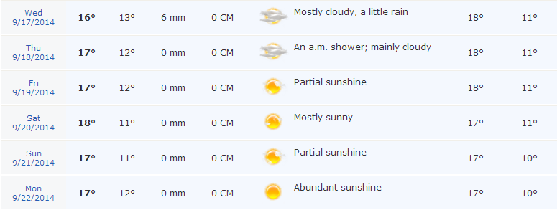

Electrical Specification:
This is a paper-less meeting, so please carry your laptops. Please refer the following link for the electrical specification in UK ->
http://www.adaptelec.com/index.php?main_page=document_general_info&cPath=15&products_id=224

Hoping to see you all in London!

