an Working Group | IEEE DYSPAN-SC 1900.5
Title | Meeting minutes 0273 for the P1900.5 Meetings of June 2, 2023
DCN | 5-23-0023-00-mins
Date Submitted | 12/01/2023
Source(s) | Eric Lindahl (AMT66)  email: eric@sciumo.com
Abstract | Minutes for the IEEE 1900.5 meetings held on Sep 1, 2023
Notice | This document has been prepared to assist the IEEE DYSPAN-SC. It is offered as a basis for discussion and is not binding on the contributing individual(s) or organization(s). The material in this document is subject to change in form and content after further study. The contributor(s) reserve(s) the right to add, amend or withdraw material contained herein.
Release | The contributor grants a free, irrevocable license to the IEEE to incorporate material contained in this contribution, and any modifications thereof, in the creation of an IEEE Standards publication; to copyright in the IEEE’s name any IEEE Standards publication even though it may include portions of this contribution; and at the IEEE’s sole discretion to permit others to reproduce in whole or in part the resulting IEEE Standards publication. The contributor also acknowledges and accepts that IEEE DYSPAN SC may make this contribution public.
Patent Policy | The contributor is familiar with IEEE patent policy, as outlined in Section 6.3 of the IEEE-SA Standards Board Operations Manual <http://standards.ieee.org/guides/opman/sect6.html#6.3> and in Understanding Patent Issues During IEEE Standards Development <http://standards.ieee.org/board/pat/guide.html>.

1. Administrivia

1.a Roll Call

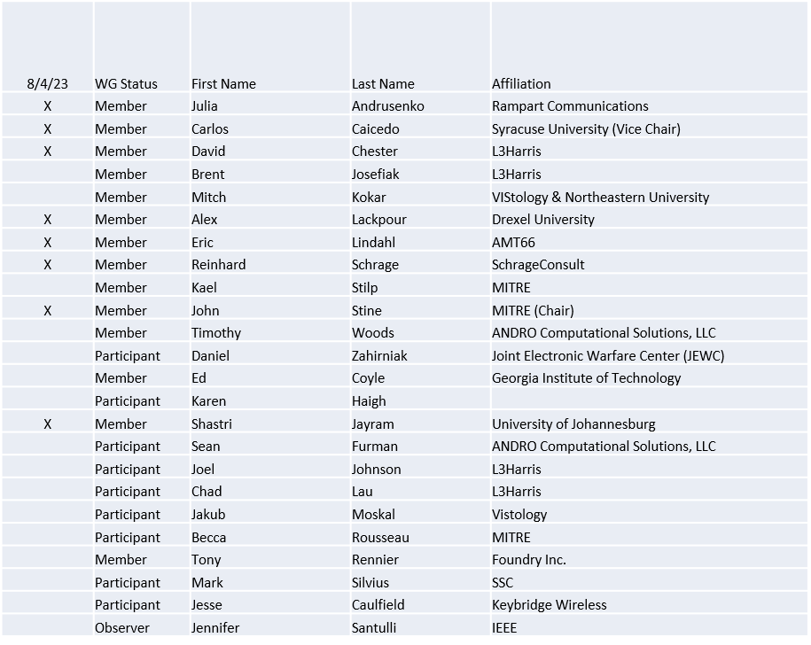
(correction 9/1/23)

Quorum achieved Yes

1.b. Approval of Agenda
Approval of Agenda from 5-23-0010-00-agen

- Mover: Eric
Second: Carlos
Vote: UC

1.c. Copyright slides
Copyright policy slides were presented. No comments came forward.

1.d. Patent slides / Notes on status
Patent related slides were presented. No issues came forward

1.e. Approval of recent minutes
Approval of WG minutes: 1/6/23
Note: Missing, submitted by Eric Lindahl 7/4/2023
Approval of WG minutes: 3/3/23
Note: Missing, submitted by Eric Lindahl 7/4/2023
Approval of minutes 8/4/23 WG

2. Status of 1900.5 Revision
- 7/7/23
  - Went over possible enumerations of classes of systems, actors, and components
  - Won’t be done by December and not within a year so we will seek an extension
  - Eric presented the C4 model for the concepts and providing visualization of them – Shastri created a UML model which we will discuss at the next ad hoc
- 8/4/23
  - PAR Extension approved by DySPAN SC and submitted to NesCom
  - Carlos briefed the group on the history of our standards work and identified the good material that is available and proposed a direction that the group agreed to
- 9/1/23
  - PAR strategy established. Will create a new PAR if it has no effect on the existing standard or will push for extension if it does
A document that covers current discussion will be posted by 4 Sep

2. Status of 1900.5 Revision PAR Strategy
- The workgroup should cancel the PAR extension and the PAR and submit a new PAR if this does not affect the status of the current standard and if it does defend the extension
- Mover: Dave
- Second: Carlos
- Vote: UC

3. Status of 1900.5.1
- 7/7/23
  - Had an ad hoc on 29 June
  - PAR for the augmented language was uploaded on the 9th of May
  - Continuing to work – hope to bring the PAR and working on the policy language – the interpreter and the compiler.
  - Will write down a scope to be pushed forward with the PAR and the new draft
- 8/4/23
  - Updated a revision PAR and will be discussed at the follow-on ad hoc.
- 9/1/23
  - Finishing a new version of the 1900.5.1R PAR. Will distribute. Posted on MyProject. Will vote on accepting next WG meeting.

4. Status of 1900.5.2 Revision
- 7/7/23
  - CRG meeting and we are working the comments.
  - Worked through some comments
- 8/4/23
  - Held three CRG meetings and in those meetings
    - Updated the scanning methods
    - Added a Minimum separation distance
    - Provided informative annexes on the spherical direct and inverse problems
    - Add a better description of pointing for power maps
    - And more
  - Expect completion by the end of September
- 9/1/23
  - Held one CRG meeting and in that meeting
    - Updated descriptions of Order 1 IM effects (harmonic transmission and image frequencies)
    - Added informative annex on computing areas of ellipsoidal triangles
  - Today’s CRG meeting is canceled and an additional CRG meeting will be scheduled for 29 Sep

5. Opensource Repository
- Lead – Eric Lindahl
- Maintainer – Carlos Caicedo, Becca Rousseau
- 7/7/23
  - Alex and Eric will contact on the PURL status as well as support 1900.8
- 8/4/23
  - Plan to have schemas ready in a couple of weeks.
  - We still have not made progress using PURL
- 9/1/23
  - No changes – need to schedule a new meeting with the IEEE SA contact – Joshua Gay j.gay@ieee.org
  - Work with schemas to update their namespaces to match the PURL
  - Alex and Eric will review the steps for creating the PURL and will inform the group of the choice
- Choice of CLA
  - The workgroup will use the Apache 2.0 as the CLA for our contributions: https://www.apache.org/licenses/LICENSE-2.0
  - Mover: Eric
  - Second: Carlos
  - Vote: UC

6. Review of other DySPAN-SC activities
- Met on 15 Aug–notes follow
- Treasurer – Reinhard has received a credit card and it has been activated
- Selected updates
  - 1900.2 – No report
  - 1900.6 – Creating a PAR to work on the baseline standard. Would bring in any amendments. Want one standard and so one document. Looking at standard 6a to manage spectrum data – Not much progress
  - 1900.8 – Goal is to create a standard for collecting RF data to input into RF ML algorithms. Work focuses on the data and its associated meta data. Need to ensure all use cases are addressed. – Made good progress defining terms
- Updating the 1900 web site
  - Each workgroup has been tasked with updating their specific content
  - The Secretary’s (Alex Lackpour’s) role is to update our web site. Recommended reviewing and editing our website as a word document and he would then make changes based on the word document to the web page
- Funds are available to support publishing and promotion
- Two potential new projects
  - DySPAN-SC will be gauging the interest to standardize CIL – was developed by the DARPA Spectrum Collaboration Challenge (SC2) – At present does not appear to be a good project
    - Challenge is the CIL is just code, there is no documentation
    - Appears to be too simplistic and centralized – a decentralized approach would likely be better
    - Prefer to pause and look for a better approach that would exchange SCMs
  - Standards linked to the National Spectrum Consortiums (NSC): SSC’s MICCA radio control channel technology – issue is that it needs both the government and the prime contractor, SSC, to permit to be standardized – Alex is taking the lead on this activity.
    - Pause for at least a year since SSC is very busy and unlikely to want to move forward right away
- Oliver and Alex will be giving a briefing at the Alan Turing Institute conference discussing the use of AI/ML in September
- Still hoping for a face-to-face SC meeting at the DySPAN Conference in DC in May 24

7. Website
- IEEE 1900.5 | DySPAN Standards Committee
- Word version on iMeet – volunteers to update
  - Images: Authors
  - Scope: John
  - 1900.5R: Eric
  - 1900.5.1 & 1900.5.1R: Reinhard
  - 1900.5.2 & 1900.5.2R: John Stine
8. 1900.5 Marketing Opportunities

- 6/2/23
  - We should seek DoD participation in the 2024 DySPAN conference and seek their guidance on what the WG should be addressing
    - Maybe Tom Rondeau or others in OSD (Brent).
    - Eric may be able to reach out to the JEWC and DSO
  - R&E is interested in establishing standards around the pieces of Hill AFB work – detect and mitigate interference to incumbents. Tony volunteered to introduce the idea to 1900. Some could be in 1900.5 and other projects may be started elsewhere.
- 7/7/23
  - Carlos and John submitted a tutorial proposal on SCMs to MILCOM 23 which will occur in late October
  - Julia – submitted proposal to MILCOM on intelligent algorithms and their applications to communications
  - Keybridge runs CBRS SAS and a TV Whitespace database and are considering a frequency coordination system in the 6 GHz. We want to squeeze performance out of the CBRS SAS. Assignments do not scale well. Looking at alternate methods that scale better and SCM is one of them interested in the spec and data model. Wants to use SCMs as a logical data model – want to come up with equivalent CBRS solution. Answers need to match. Want to turn an n! problem into a log n problem. Aggregate interference is a big issue. Seeks channel assignment and power limitation to optimize the outcomes. Wants computational simplicity.
- 8/4/23
  - Carlos and John will be presenting a 1900.5.2 tutorial at MILCOM 2023 an Oct 30th.
  - John submitted an abstract to do a presentation on using standards in EMSO to AOC
  - Consider having a booth at DySPAN 24
- 9/1/23
  - Team from NW and MIT that has a NSF grant under the NRDZ program. It is a supplement to the grant that Carlos has. They are looking at market structures and the spectrum access agreements. Carlos will be collaborating with them and they are likely to use SCMs.

9. 1900.5 meeting planning and review
- P1900.5 WG Mtg 5/5/23 0800 ET
- P1900.5.2 CRG 5/5/23 1300 ET
- P1900.5 Revision Ad-hoc 5/12/23 1330 ET
- P1900.5.2 CRG 5/19/23 1300 ET
- P1900.5.2 CRG 6/2/23 1300 ET
- P1900.5 WG Mtg 6/2/23 1430 ET
- P1900.5 Revision Ad-hoc 6/9/23 1330 ET
- P1900.5.1 ad hoc 6/15/23 1430 ET
- P1900.5.2 CRG 6/16/23 1300 ET
- P1900.5 Revision Ad-hoc 6/23/23 13o0 ET
- P1900.5 WG Mtg 7/7/23 0800 ET
- P1900.5.2 CRG 7/7/23 1300 ET
10. AoB
- None

Meeting adjourned at 3:30 P.M. EST

