an Working Group | IEEE DYSPAN-SC 1900.5
Title | Meeting minutes 0273 for the P1900.5 Meetings of July 7, 2023
DCN | 5-23-0018-00-mins
Date Submitted | 09/01/2023
Source(s) | Eric Lindahl (AMT66)  email: eric@sciumo.com
Abstract | Minutes for the IEEE 1900.5 meetings held on July 7, 2023
Notice | This document has been prepared to assist the IEEE DYSPAN-SC. It is offered as a basis for discussion and is not binding on the contributing individual(s) or organization(s). The material in this document is subject to change in form and content after further study. The contributor(s) reserve(s) the right to add, amend or withdraw material contained herein.
Release | The contributor grants a free, irrevocable license to the IEEE to incorporate material contained in this contribution, and any modifications thereof, in the creation of an IEEE Standards publication; to copyright in the IEEE’s name any IEEE Standards publication even though it may include portions of this contribution; and at the IEEE’s sole discretion to permit others to reproduce in whole or in part the resulting IEEE Standards publication. The contributor also acknowledges and accepts that IEEE DYSPAN SC may make this contribution public.
Patent Policy | The contributor is familiar with IEEE patent policy, as outlined in Section 6.3 of the IEEE-SA Standards Board Operations Manual <http://standards.ieee.org/guides/opman/sect6.html#6.3> and in Understanding Patent Issues During IEEE Standards Development <http://standards.ieee.org/board/pat/guide.html>.

1. Administrivia

1.a Roll Call

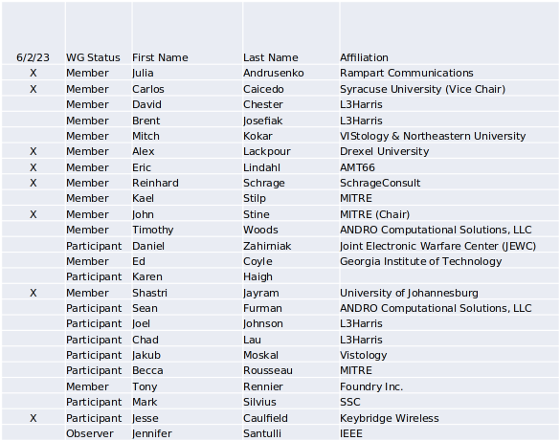
Quorum > ½ membership (7 members)
Quorum achieved Yes

1.b. Approval of Agenda
Approval of Agenda from 5-23-0010-00-agen

- Mover: Alex
Second: Eric
Vote: UC

1.c. Copyright slides
Copyright policy slides were presented. No comments came forward.

1.d. Patent slides / Notes on status
Patent related slides were presented. No issues came forward

1.e. Approval of recent minutes
Approval of minutes 7/2/23 WG
Mover: Alex
Second: Carlos
Approval of minutes 5/5/23 WG
Mover: Alex
Second: Carlos
Approval of minutes 6/2/23 WG
Mover: Reinhard
Second: Carlos

2. Status of 1900.5 Revision
- 7/7/23
  - Went over possible enumerations of classes of systems, actors, and components
  - Won’t be done by December and not within a year so we will seek an extension
  - Eric presented the C4 model for the concepts and providing visualization of them – Shastri created a UML model which we will discuss at the next ad hoc

3. Status of 1900.5.1
- 7/7/23
  - Had an ad hoc on 29 June
  - PAR for the augmented language was uploaded on the 9th of May
  - Continuing to work – hope to bring the PAR and working on the policy language – the interpreter and the compiler.
  - Will write down a scope to be pushed forward with the PAR and the new draft

4. Status of 1900.5.2 Revision
- 7/7/23
  - CRG meeting and we are working the comments.
  - Worked through some comments

5. Review of other DySPAN-SC activities

- Met on 20 Jun–notes follow
- Reinhard Schrage volunteered to serve as treasurer.
- Selected updates
  - 1900.6 – Creating a PAR to work on the baseline standard. Would bring in any amendments. Want one standard and so one document.
  - 1900.8 – Goal is to create a standard for collecting RF data to input into RF ML algorithms. Work focuses on the data and its associated meta data. Need to ensure all use cases are addressed.
- Updating the 1900 web site
  - Added a spectrogram to the website and want to use it to convey the idea of whitespace
  - The Secretary’s (Alex Lackpour’s) role is to update our web site. Recommended reviewing and editing our website as a word document and he would then make changes based on the word document to the web page
- Two potential new projects
  - DySPAN-SC will be gauging the interest to standardize CIL – was developed by the DARPA Spectrum Collaboration Challenge (SC2) – Carlos to take the lead on that
    - Sherman et al wrote a paper on VITA 49 carrying SCM – adapted CIL could carry SCMs and want to contrast it with the approach with VITA 49. It will likely move forward with standardization.
    - Challenge is the CIL is just code, there is no documentation
    - Not certain where it should be standardized but most likely within IEEE 1900.5 WG
  - Standards linked to the National Spectrum Consortiums (NSC): SSC’s MICCA radio control channel technology – issue is that it needs both the government and the prime contractor, SSC, to permit to be standardized – Alex is taking the lead on this activity.
    - Submitting a paper to MILCOM – describes the functions of the control channel technology and some experimentation results
- Still hoping for a face-to-face SC meeting at the DySPAN Conference in DC in May 24
- Website
  - Word version on mentor – volunteers to update
    - Images: Eric,
    - Scope: John
    - 1900.5: Eric and Alex
    - 1900.5.1: Reinhard
    - 1900.5.2: John Stine

6. 1900.5 marketing opportunities

- 7/7/23
  - Carlos and John submitted a tutorial proposal on SCMs to MILCOM 23 which will occur in late October
  - Julia – submitted proposal to MILCOM on intelligent algorithms and their applications to communications
  - Keybridge runs CBRS SAS and a TV Whitespace database and are considering a frequency coordination system in the 6 GHz. We want to squeeze performance out of the CBRS SAS. Assignments do not scale well. Looking at alternate methods that scale better and SCM is one of them interested in the spec and data model. Wants to use SCMs as a logical data model – want to come up with equivalent CBRS solution. Answers need to match. Want to turn an n! problem into a log n problem. Aggregate interference is a big issue. Seeks channel assignment and power limitation to optimize the outcomes. Wants computational simplicity.

7. 1900.5 meeting planning and review
- P1900.5 Revision Ad-hoc 6/9/23 1330 ET
- P1900.5.2 CRG 6/16/23 1300 ET
- P1900.5 Revision Ad-hoc 6/23/23 13o0 ET
- P1900.5.1 ad hoc 6/29/23 1430 ET
- P1900.5 WG Mtg 7/7/23 0800 ET
- P1900.5.1 Ad hoc 7/7/23 0800+ ET
- P1900.5.2 CRG 7/7/23 1300 ET
- P1900.5 Revision Ad-hoc 7/14/23 1330 ET
- P1900.5.2 CRG 7/21/23 1300 ET
- P1900.5 Revision Ad Hoc 7/28/23 1330 ET
- P1900.5.2 CRG 8/4/23 1300 ET
- P1900.5 WG Mtg 8/4/23 1130 ET
8. AoB
- Workshop at the FCC on AI applied to communications https://www.fcc.gov/fcc-nsf-ai-workshop

Meeting adjourned at 9:45 A.M. EST

