an Working Group | IEEE DYSPAN-SC 1900.5
Title | Meeting minutes 0275 for the P1900.5 Meetings of April 7, 2023
DCN | 5-23-0007-00-mins
Date Submitted | 04/12/2023
Source(s) | Eric Lindahl (AMT66)  email: eric@sciumo.com
Abstract | Minutes for the IEEE 1900.5 meetings held on April 7, 2023
Notice | This document has been prepared to assist the IEEE DYSPAN-SC. It is offered as a basis for discussion and is not binding on the contributing individual(s) or organization(s). The material in this document is subject to change in form and content after further study. The contributor(s) reserve(s) the right to add, amend or withdraw material contained herein.
Release | The contributor grants a free, irrevocable license to the IEEE to incorporate material contained in this contribution, and any modifications thereof, in the creation of an IEEE Standards publication; to copyright in the IEEE’s name any IEEE Standards publication even though it may include portions of this contribution; and at the IEEE’s sole discretion to permit others to reproduce in whole or in part the resulting IEEE Standards publication. The contributor also acknowledges and accepts that IEEE DYSPAN SC may make this contribution public.
Patent Policy | The contributor is familiar with IEEE patent policy, as outlined in Section 6.3 of the IEEE-SA Standards Board Operations Manual <http://standards.ieee.org/guides/opman/sect6.html#6.3> and in Understanding Patent Issues During IEEE Standards Development <http://standards.ieee.org/board/pat/guide.html>.
>.

1. Administrivia

1.a Roll Call

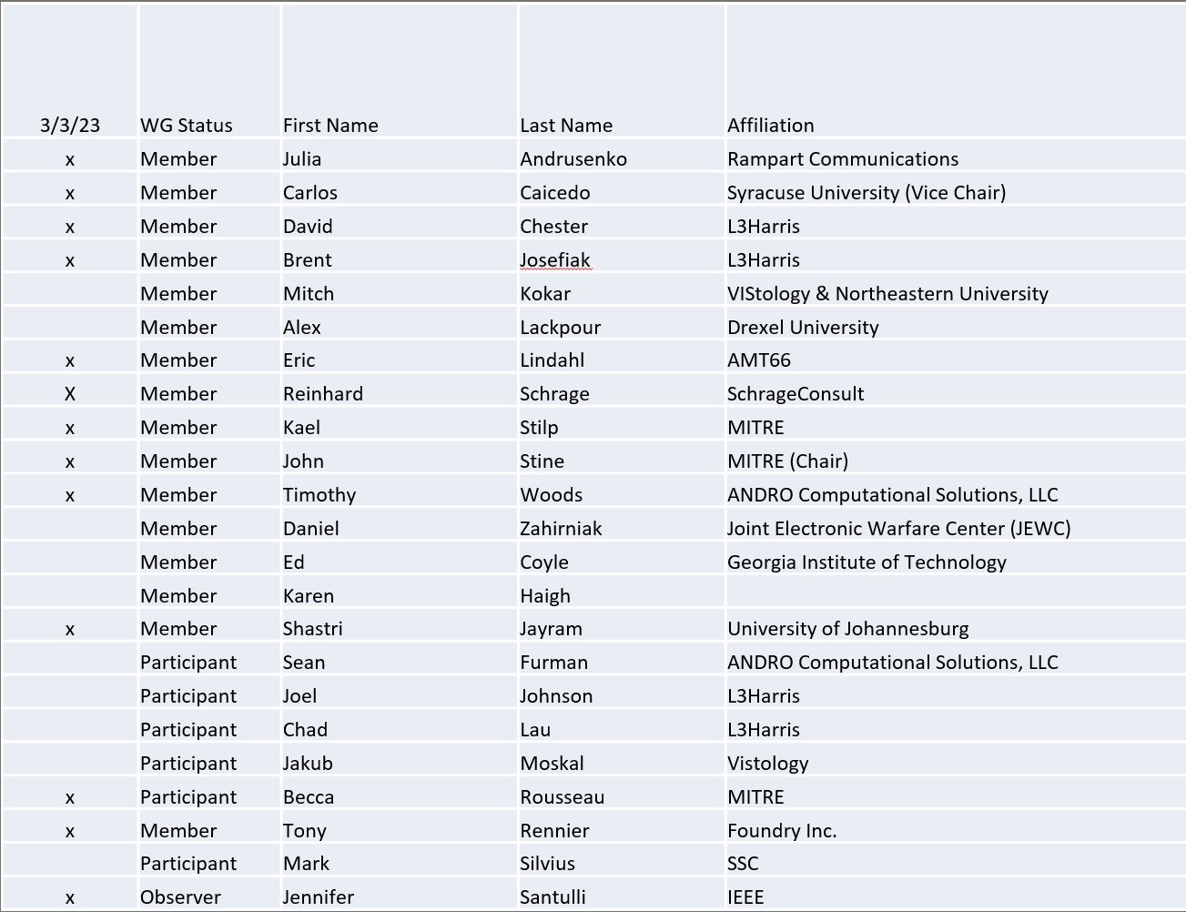
Quorum achieved

1.b. Approval of Agenda
Approval of Agenda from 5-23-0005-02-agen

- Mover: Carlos
Second: Dave
Vote: UC

1.c. Copyright slides
Copyright policy slides were presented. No comments came forward.

1.d. Patent slides / Notes on status
Patent related slides were presented, no issues came forward

1.e. Approval of recent minutes
Deferred to next session
Secretary
- Eric Lindahl ran for secretary, and received 10 votes.

2. Status of 1900.5 Revision
- 2/3/23
  - Want to convert the high-level representation of the CBRS architecture into a 1900.5 representation. Alex and Eric volunteered to put this together for the next meeting.
- 3/3/23
  - Looked into the JSON schema in the CBRS at the GitHub website. Want to correlate the sequence diagram with the existing XSDs. WE are looking at the traceability. We believe they will show the same essential data elements.
    - Will schedule a meeting for developing the traceability –
    - The output will be the original Excel spreadsheet from WINNFORUM and a column with our rules
    - Will make an enumeration for traceability
- 4/7/23
  - Discussed the enumeration and traceability.
  - Reinhard was to give an example of the policy language
  - Goal is to show traceability to the CBRS worksheet of data – we should be able to show traceability or our approach is malformed at this point. Do not need to show provability. If we cannot show traceability to a conformant implementation then we won’t be able to make the standard operational. Want the standard to inform acquisition of systems.
    - Want to see both policy and architectural elements

3. Status of 1900.5.1
- 4/7/23
  - Will schedule an ad hoc to discuss traceability of policy – targeting last week of April
  - Sent a draft for a PAR for an augmented policy language. - Make part of the agenda for May WG meeting.
  - Making progress on explaining and documenting the language, also writing a compiler and interpreter for the augmented policy language.

4. Status of 1900.5.2 Revision
- 4/7/23
  - Revisions over the past month have focused on those parts of the standard that affect the schema. These include some additional data elements and the changing of some element and attribute names to be consistent across the standard.
  - Met with the IEEE Opensource

5. Review of other DySPAN-SC activities

- DySPAN-SC Leadership
  - Volunteers for Opensource Repostiory
  - Require two positions
    - Lead – an officer level
    - Maintainer – Volunteer
    - Proposed volunteers
      - Lead – Eric Lindahl
      - Maintainer – Carlos Caicedo, Becca Rousseau
  - Still need to fill the treasurer’s position. Currently, would manage a $45K account.
  - The Secretary’s (Alex Lackpour’s) role is to update our web site. We should review our website and identify the changes we should make

- DySPAN-SC will be gauging the interest to standardize CIL – was developed by the DARPA Spectrum Collaboration Challenge (SC2) – Carlos to take the lead on that
  - Research work modified SCM to carry CIL – so a relationship with our current standards.
  - Also considering its relation to VITA 49 standards
  - Most likely within IEEE 1900.5 WG
- Discussed have face-to-face meetings again – no decisions

- 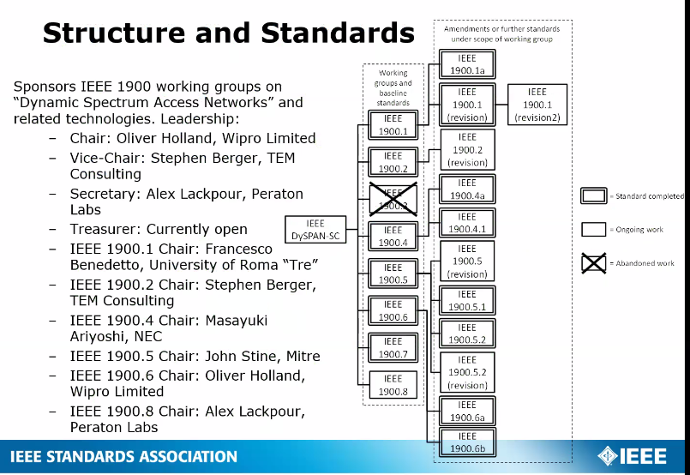

6. 1900.5 marketing opportunities

- 3/3/23
  - Carlos is presenting a paper at WCNC at the end of the month which involves the use of SCMs
  - Julia will educate her colleagues in Rampart Communications on 1900.5 WG standards
  - Eric L has been supporting internal information inquiries about SCM at DSO

- 4/7/23
  - Carlos presented the paper WCNC
  - Julia gave a tutorial on the 1900.5 WG Standards to her colleagues
  - Student from Rutgers and a post doc from Columbia is going to Northwestern and used SCM a lot.
  - Dave recommends we put greater effort to get students to use our standards. Carlos is presenting them to a larger audience
  - Carlos recommends preparing a good tutorial – maybe one of the future big conferences – also a recorded tutorial on the IEEE YouTube channel

7. 1900.5 meeting planning and review
- P1900.5 Revision Ad-hoc 3/24/23 1300 ET
- P1900.5.2 Open Source Hosting Meeting 3/31/23
- P1900.5.2 CRG 4/7/23 1300 ET
- P1900.5 WG Mtg 4/7/23 1430 ET
- P1900.5 Revision Ad-hoc 4/14/23 1330 ET
- P1900.5.2 CRG 4/21/23 1300 ET
- P1900.5 Revision Ad-hoc 4/28/23 1300 ET
- P1900.5 WG Mtg 5/5/23 0800 ET
- P1900.5.2 CRG 5/5/23 1300
8. AoB
- None

Meeting adjourned at 3:30 P.M. EST

