an Working Group | IEEE DYSPAN-SC 1900.5
Title | Meeting minutes 0273 for the P1900.5 Meetings of February 3, 2023
DCN | 5-23-0006-00-mins
Date Submitted | 04/06/2023
Source(s) | Carlos Caicedo (Syracuse University)  email: ccaicedo@syr.edu
Abstract | Minutes for the IEEE 1900.5 meetings held on February 3, 2023
Notice | This document has been prepared to assist the IEEE DYSPAN-SC. It is offered as a basis for discussion and is not binding on the contributing individual(s) or organization(s). The material in this document is subject to change in form and content after further study. The contributor(s) reserve(s) the right to add, amend or withdraw material contained herein.
Release | The contributor grants a free, irrevocable license to the IEEE to incorporate material contained in this contribution, and any modifications thereof, in the creation of an IEEE Standards publication; to copyright in the IEEE’s name any IEEE Standards publication even though it may include portions of this contribution; and at the IEEE’s sole discretion to permit others to reproduce in whole or in part the resulting IEEE Standards publication. The contributor also acknowledges and accepts that IEEE DYSPAN SC may make this contribution public.
Patent Policy | The contributor is familiar with IEEE patent policy, as outlined in Section 6.3 of the IEEE-SA Standards Board Operations Manual <http://standards.ieee.org/guides/opman/sect6.html#6.3> and in Understanding Patent Issues During IEEE Standards Development <http://standards.ieee.org/board/pat/guide.html>.
>.

1. Administrivia

1.a Roll Call

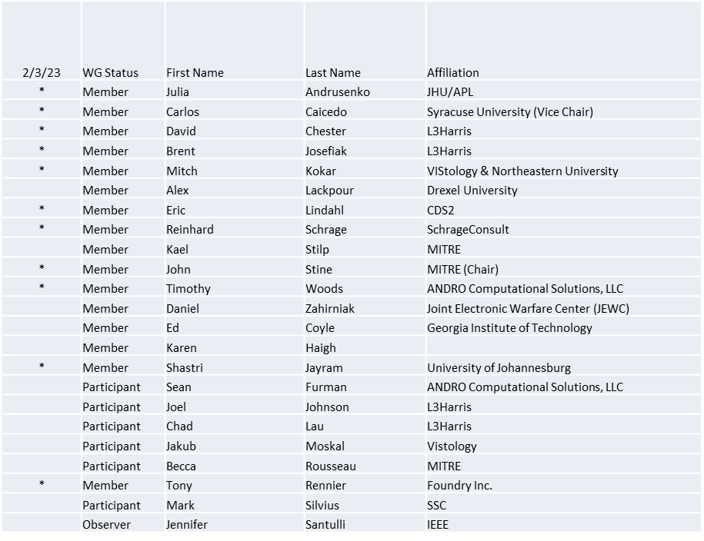
Quorum achieved

1.b. Approval of Agenda
Approval of Agenda from 5-23-0002-01-agen

- Mover: Tony
Second: Reinhard
Vote: UC

1.c. Copyright slides
Copyright policy slides were presented. No comments came forward.

1.d. Patent slides / Notes on status
Patent related slides were presented, no issues came forward

1.e. Approval of recent minutes
Deferred to next session
Secretary
- No one ran for the office of secretary in our recent election and so a secretary must be identified for today’s meeting
  - Secretary for 3 February meeting – Carlos Caicedo
- Candidates for taking this role for the rest of the term should announce their intention by our next meeting

2. Status of 1900.5 Revision
- Want to convert the high-level representation of the CBRS architecture into a 1900.5 representation. Alex and Eric volunteered to put this together for the next meeting.

3. Status of 1900.5.1
- Preparing for the Ad hoc meeting at 1:00 PM ET on 7 February

4. Status of 1900.5.2 Revision
- Presented a new approach to show and document verification rules in a tabular format that supports the enumeration of rules
- Added comments concerning location models with transmitter densities. Rather than assuming a lattice of transmitter develop a calculus approach that will simplify subsequent compatibility computations.
- Added a number of additional comments concerning three-dimensional objects that map to the Earth’s surface and on techniques to subdivide large objects and retain consistency of altitudes above the Earth
  - Dave Chester recommended considering the use of Quaternions for this purpose

5. Review of other DySPAN-SC activities
- DySPAN-SC Leadership
  - Oliver Holland has returned and monthly meetings are now scheduled for the third Tuesday each month at 8:00 PM UTC
- Lynn has resigned from the standards committee and so the office of treasurer is open. No one has taken on the outreach role she volunteered to do.
- P1900.8 Looking at a late spring 2023 draft

6. 1900.5 marketing opportunities

- MITRE has been engaging government sponsors on the merits of using SCMs in their tool sets

7. 1900.5 meeting planning and review
- P1900.5.1 Ad Hoc 2/7/23 1300 ET
- P1900.5 Revision Ad-hoc 2/10/23 1330 ET
- P1900.5.2 CRG 2/17/23 1300 ET
- P1900.5 Revision Ad-hoc 2/24/23 1300 ET
- P1900.5 WG Mtg 3/3/23 0800 ET
- P1900.5.2 CRG 3/3/23 1300 ET

8. AoB
- None

Meeting adjourned at 3:30 P.M. EST

