an Working Group | IEEE DYSPAN-SC 1900.5
Title | Meeting minutes 0272 for the P1900.5 Meetings of December 2, 2022
DCN | 5-23-0003-00-mins
Date Submitted | 02/25/2023
Source(s) | Carlos Caicedo (Syracuse University)  email: ccaicedo@syr.edu
Abstract | Minutes for the IEEE 1900.5 meetings held on December 2, 2022
Notice | This document has been prepared to assist the IEEE DYSPAN-SC. It is offered as a basis for discussion and is not binding on the contributing individual(s) or organization(s). The material in this document is subject to change in form and content after further study. The contributor(s) reserve(s) the right to add, amend or withdraw material contained herein.
Release | The contributor grants a free, irrevocable license to the IEEE to incorporate material contained in this contribution, and any modifications thereof, in the creation of an IEEE Standards publication; to copyright in the IEEE’s name any IEEE Standards publication even though it may include portions of this contribution; and at the IEEE’s sole discretion to permit others to reproduce in whole or in part the resulting IEEE Standards publication. The contributor also acknowledges and accepts that IEEE DYSPAN SC may make this contribution public.
Patent Policy | The contributor is familiar with IEEE patent policy, as outlined in Section 6.3 of the IEEE-SA Standards Board Operations Manual <http://standards.ieee.org/guides/opman/sect6.html#6.3> and in Understanding Patent Issues During IEEE Standards Development <http://standards.ieee.org/board/pat/guide.html>.
>.

1. Administrivia

1.a Roll Call
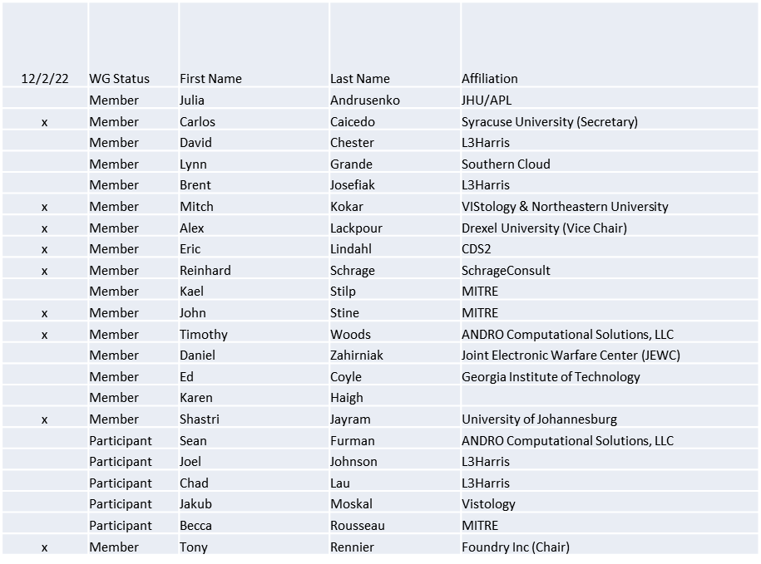

Quorum achieved

1.b. Approval of Agenda
Approval of Agenda from 5-22-0025-00-agen

- Mover: Reinhard
Second: Alex
Vote: UC

1.c. Copyright slides
Copyright policy slides were presented. No comments came forward.

1.d. Patent slides / Notes on status
Patent related slides were presented, no issues came forward

1.e. Approval of recent minutes
Motion to approve 11/4/22 WG minutes contained in Doc #: 5-22-0024-00-mins
Mover: John
Second: Reinhard
Vote: UC

2. Status of 1900.5 Revision
  - Reworking the architecture
    - Looking at CBRS band and associated rules, converting to human readable, preparing for a map to a policy language
  - Awaiting feedback from IEEE on hosting a license server for EA Enterprise Architect

3. Status of 1900.5.1
- Using the modeler to create policies and express them into P1900.5.1 standard augmented (with user-friendly structures) policy language
- Creating utilities to score each policy
  - Score to be used in a Nash equilibrium algorithm
- Shooting for an ad-hoc in January

4. Status of 1900.5.2 Revision
- CRG work temporarily delayed

5. Review of other DySPAN-SC activities
- Lynn is working on an outreach effort that would include YouTube videos to highlight DySPAN-SC activities
- P1900.8 Looking at a late spring 2023 draft

6. 1900.5 marketing opportunities
  - Alex contributed to a MILCOM 2022 paper with SSC on MICA
  - ITC conference took place in Arizona University
    - Alex contributed to papers published both MICA and OSCAR papers.

7. 1900.5 meeting planning and review
- P1900.5 Revision Ad-hoc 12/16/22 1300 ET
- P1900.5 Revision Ad-hoc 12/23/22 1300 ET
- P1900.5 WG Mtg 1/6/23 0800 ET

8. 1900.5 Elections
- Election Officer’s Report (Dave Chester)
  - 12/2/22 - We now have three candidates for Chair and two candidates for Vice Chair. I am checking the rules because there may be an issue with Secretary. I will send out the ballot as soon as I determine if an issue exists.

9. AoB
- None

Meeting adjourned at 3:25 P.M. EST

