|  |  |  |
| --- | --- | --- |
| an Working Group | **IEEE DYSPAN-SC 1900.5** |  |
| Title | ***Meeting minutes 0271 for the P1900.5 Meetings of November 4, 2022*** |  |
| DCN | ***5-22-0024-00-mins*** |  |
| Date Submitted | ***11/28/2022*** |  |
| Source(s) | ***Carlos***  ***Caicedo (Syracuse University)***  ***email:*** [***ccaicedo@syr.edu***](mailto:ccaicedo@syr.edu) |  |
|  |  |  |
| Abstract | ***Minutes for the IEEE 1900.5 meetings held on November 4, 2022*** |  |
|  |  |  |
| Notice | This document has been prepared to assist the IEEE DYSPAN-SC. It is offered as a basis for discussion and is not binding on the contributing individual(s) or organization(s). The material in this document is subject to change in form and content after further study. The contributor(s) reserve(s) the right to add, amend or withdraw material contained herein. |  |
| Release | The contributor grants a free, irrevocable license to the IEEE to incorporate material contained in this contribution, and any modifications thereof, in the creation of an IEEE Standards publication; to copyright in the IEEE’s name any IEEE Standards publication even though it may include portions of this contribution; and at the IEEE’s sole discretion to permit others to reproduce in whole or in part the resulting IEEE Standards publication. The contributor also acknowledges and accepts that IEEE DYSPAN SC may make this contribution public. |  |
| Patent Policy | The contributor is familiar with IEEE patent policy, as outlined in [Section 6.3 of the IEEE-SA Standards Board Operations Manual](http://standards.ieee.org/guides/opman/sect6.html#_blank) <<http://standards.ieee.org/guides/opman/sect6.html#6.3>> and in *Understanding Patent Issues During IEEE Standards Development* <<http://standards.ieee.org/board/pat/guide.html>>. |  |

**>.**

**1. Administrivia**

**1.a Roll Call**

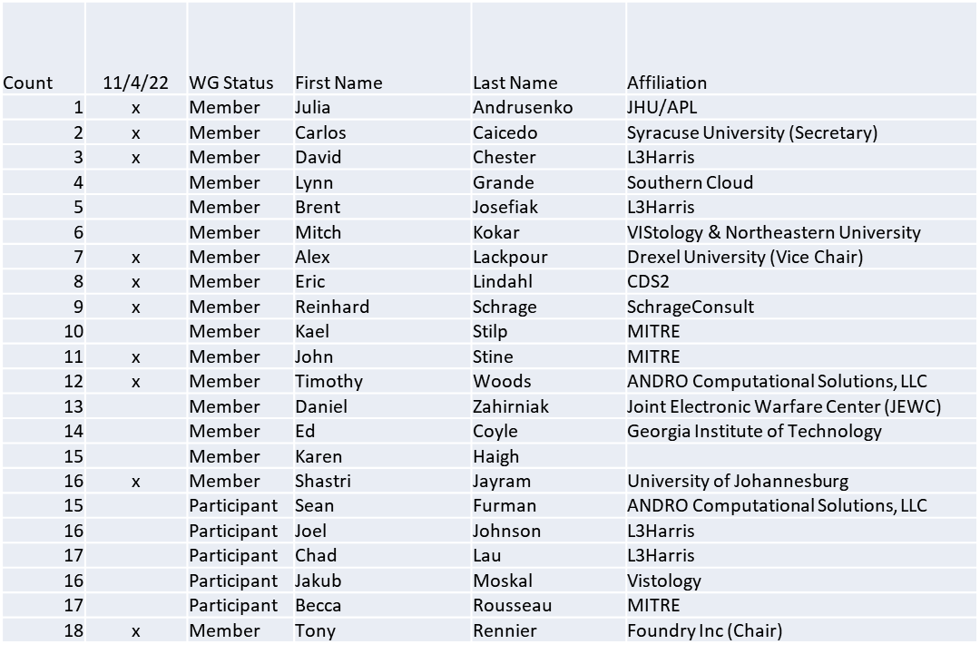

Quorum achieved

**1.b. Approval of Agenda**

Approval of Agenda from 5-22-0023-00-agen

* Mover: Reinhard

Second: Alex

Vote: UC

**1.c. Copyright slides**

Copyright policy slides were presented. No comments came forward.

**1.d. Patent slides / Notes on status**

Patent related slides were presented, no issues came forward

**1.e. Approval of recent minutes**

Motion to approve 10/7/22 WG minutes contained in Doc #: 5-22-0022-00-mins

Mover: Alex

Second: Dave

Vote: UC

**2. Status of 1900.5 Revision**

* Ad-hoc meeting 10/28
  + Discussed US CBRS and RADAR sharing use case
    - Established rules in the CBRS band make it a good candidate
    - Creating a language-independent model (MBSE)
    - Alex to generate rules from the FCC proceedings
    - Eric to express the rules in JSON logic
  + Still planning to use EA (Enterprise Architect)
    - Talked with IEEE about hosting the license server for EA
    - Finding from IEEE IT pending

**3. Status of 1900.5.1**

* Still looking at 1900.5.2
* Looking into policies as a non-cooperative game
  + Nash equilibrium exists and is achievable
  + Different than Pareto optimality and sometimes conflicts
* Planning a new ad-hoc TBD. Target to meet is 4 weeks from today.

**4. Status of 1900.5.2 Revision**

* No updates
* CRG at 1 pm today
* Schema edits pending return of support personnel

**5. Review of other DySPAN-SC activities**

* Planning a Webinar in lieu of a Plenary
  + Overview of all DySPAN-SC work
  + Related standards work (e.g.; WINNFORUM)

**6. 1900.5 marketing opportunities**

* Nothing to report

**7. 1900.5 meeting planning and review**

* P1900.5.2 Revision CRG 11/4/22 1300 ET
* P1900.5.2 Revision CRG 11/18/22 1300 ET
* P1900.5 Revision Ad-hoc 11/18/22 1430 ET
* P1900.5 WG Mtg 12/2/22 1430 ET

**8. 1900.5 Elections**

* Tony will not pursue the chair position for 2023/2024
* Elections to be performed in December

**9. AoB**

* None

Meeting adjourned at 9:25 A.M. EST