an Working Group | IEEE DYSPAN-SC 1900.5
Title | Meeting minutes 0270 for the P1900.5 Meetings of October 7, 2022
DCN | 5-22-0022-00-mins
Date Submitted | 10/31/2022
Source(s) | Carlos Caicedo (Syracuse University)  email: ccaicedo@syr.edu
Abstract | Minutes for the IEEE 1900.5 meetings held on October 7, 2022
Notice | This document has been prepared to assist the IEEE DYSPAN-SC. It is offered as a basis for discussion and is not binding on the contributing individual(s) or organization(s). The material in this document is subject to change in form and content after further study. The contributor(s) reserve(s) the right to add, amend or withdraw material contained herein.
Release | The contributor grants a free, irrevocable license to the IEEE to incorporate material contained in this contribution, and any modifications thereof, in the creation of an IEEE Standards publication; to copyright in the IEEE’s name any IEEE Standards publication even though it may include portions of this contribution; and at the IEEE’s sole discretion to permit others to reproduce in whole or in part the resulting IEEE Standards publication. The contributor also acknowledges and accepts that IEEE DYSPAN SC may make this contribution public.
Patent Policy | The contributor is familiar with IEEE patent policy, as outlined in Section 6.3 of the IEEE-SA Standards Board Operations Manual <http://standards.ieee.org/guides/opman/sect6.html#6.3> and in Understanding Patent Issues During IEEE Standards Development <http://standards.ieee.org/board/pat/guide.html>.
>.

1. Administrivia

1.a Roll Call
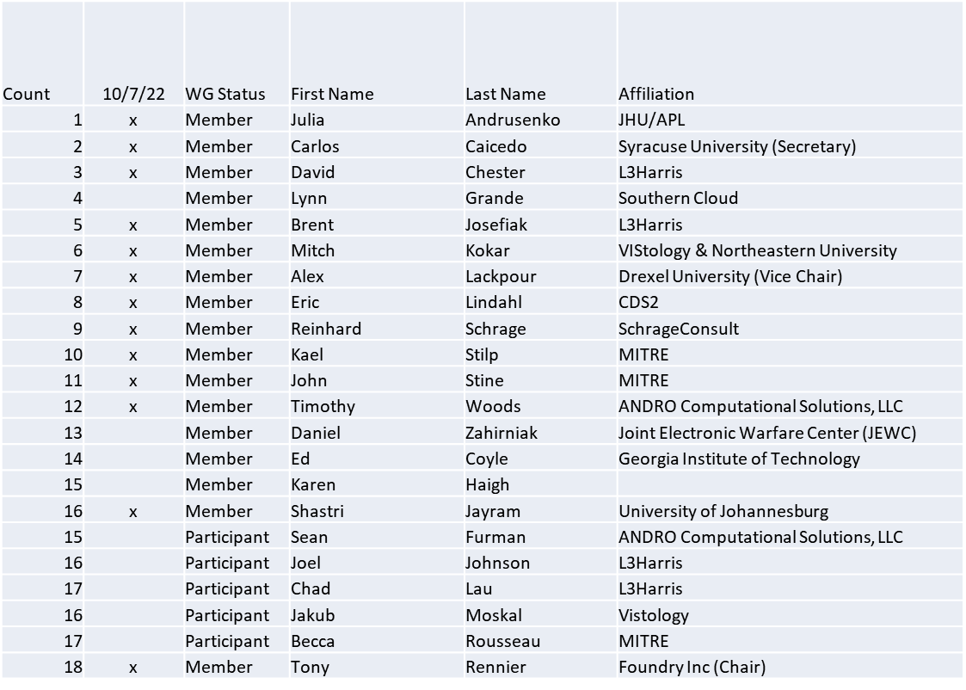

Quorum achieved

1.b. Approval of Agenda
Approval of Agenda from 5-22-0021-00-agen

- Mover: Dave
Second: John
Vote: UC

1.c. Copyright slides
Copyright policy slides were presented. No comments came forward.

1.d. Patent slides / Notes on status
Patent related slides were presented, no issues came forward

1.e. Approval of recent minutes
Motion to approve 7/1/22 WG minutes contained in Doc #: 5-22-0018-00-mins
Mover: Alex
Second: Reinhard
Vote: UC

Motion to approve 8/5/22 WG minutes contained in Doc #: 5-22-0019-00-mins
Mover: Reinhard
Second: Dave
Vote: UC

Motion to approve 9/2/22 WG minutes contained in Doc #: 5-22-0020-00-mins
Mover: Dave
Second: Reinhard
Vote: UC

2. Status of 1900.5 Revision
- Experiments in real-time on CAMEO and EA exchanging files ended in a fail
  - No diagrams moving back and forth
- Standardizing on EA (Enterprise Architect)
  - Research shared licenses (simultaneous is preferable)
- SysML is the target

3. Status of 1900.5.1
- Had an ad-hoc 10/7/22
- Next ad-hoc focused on distributed optimization

4. Status of 1900.5.2 Revision
- Addressed 153 of comments of a 173 looking like March now
- Went back to COMSOC but no further discussion on SCM

5. Review of other DySPAN-SC activities
- Planning a Webinar in lieu of a Plenary
  - Overview of all DySPAN-SC work
  - Related standards work (e.g.; WINNFORUM)

6. 1900.5 marketing opportunities
- Nothing to report

7. 1900.5 meeting planning and review
- P1900.5.1 Ad-hoc 10/7/22 1300 ET
- P1900.5 WG Mtg 10/7/22 1430 ET
- P1900.5 Revision Ad-hoc 10/14/22 1300 ET
- P1900.5.2 Revision CRG 10/21/22 1300 ET
- P1900.5 Revision Ad-hoc 10/28/22 1300 ET

8. AoB
- None

Meeting adjourned at 3:35 P.M. EST

