an Working Group | IEEE DYSPAN-SC 1900.5
Title | Meeting minutes 0269 for the P1900.5 Meetings of September 2, 2022
DCN | 5-22-0020-00-mins
Date Submitted | 8/31/2022
Source(s) | Carlos Caicedo (Syracuse University)  email: ccaicedo@syr.edu
Abstract | Minutes for the IEEE 1900.5 meetings held on September 2, 2022
Notice | This document has been prepared to assist the IEEE DYSPAN-SC. It is offered as a basis for discussion and is not binding on the contributing individual(s) or organization(s). The material in this document is subject to change in form and content after further study. The contributor(s) reserve(s) the right to add, amend or withdraw material contained herein.
Release | The contributor grants a free, irrevocable license to the IEEE to incorporate material contained in this contribution, and any modifications thereof, in the creation of an IEEE Standards publication; to copyright in the IEEE’s name any IEEE Standards publication even though it may include portions of this contribution; and at the IEEE’s sole discretion to permit others to reproduce in whole or in part the resulting IEEE Standards publication. The contributor also acknowledges and accepts that IEEE DYSPAN SC may make this contribution public.
Patent Policy | The contributor is familiar with IEEE patent policy, as outlined in Section 6.3 of the IEEE-SA Standards Board Operations Manual <http://standards.ieee.org/guides/opman/sect6.html#6.3> and in Understanding Patent Issues During IEEE Standards Development <http://standards.ieee.org/board/pat/guide.html>.
>.

1. Administrivia

1.a Roll Call
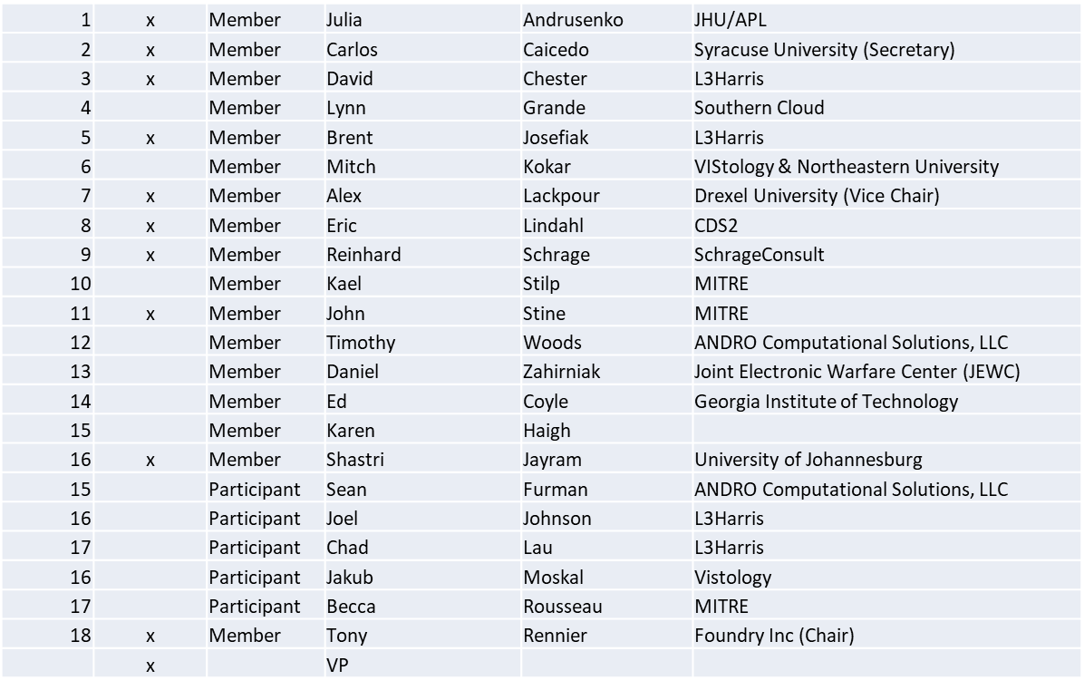

Quorum achieved

1.b. Approval of Agenda
Approval of Agenda from 5-22-0017-00-agen

- Mover: Dave
Second: Julia
Vote: UC

1.c. Copyright slides
Copyright policy slides were presented. No comments came forward.

1.d. Patent slides / Notes on status
Patent related slides were presented, no issues came forward

1.e. Approval of recent minutes
Approval of 7/1/22 WG minutes postponed to next WG meeting
Approval of 8/5/22 WG minutes postponed to next WG meeting

2. Status of 1900.5 Revision
- MBSE approach using NoMagic Cameo to capture architecture
  - Using Classes/Objects and associated views (e.g.; Sequence Diagrams) to document structure and behavior
  - Extending P1900.5-2011 to implement Dynamic Policy Management amongst a set of PMPs
  - Still incorporates Dynamic Spectrum Access at the SDS
- Adopting O-RAN as an exemplar system that could implement the enhanced standard

3. Status of 1900.5.1
- Reran and recorded the last ad-hoc
- Demonstrated that complex policy requirements can be implemented
- Exploring MBSE approaches/tools/languages as meta tools

4. Status of 1900.5.2 Revision
- 139 comments resolved of 169
- Expecting to complete comment resolution by the end of October
- Met with CommSoc Standardization Programs Development committee to discuss SCMs having a follow-up meeting on 9/29/22

5. Review of other DySPAN-SC activities
- Planning a Webinar in lieu of a Plenary
  - Overview of all DySPAN-SC work
  - Related standards work (e.g.; WINNFORUM)

6. 1900.5 marketing opportunities
- Nothing to report

7. 1900.5 meeting planning and review
- P1900.5 WG Mtg 9/2/22 0800 ET
- P1900.5.2 Revision CRG 9/2/22 1300 ET
- P1900.5 Revision Ad-hoc 9/9/22 1300 ET
- P1900.5.2 Revision CRG 9/18/22 1300 ET
- P1900.5 Revision Ad-hoc 9/25/22 1300 ET
- P1900.5.2 Revision CRG 9/30/22 1300 ET
- P1900.5 WG Mtg 10/7/22 1430 ET
- P1900.5.1 Ad-hoc 10/7/22 1300 ET

8. AoB
- None

Meeting adjourned at 9:25 A.M. EST

